NAME: ADEKUNLE ABDULQUADRI AYOMIDE
MATRIC NO: 19/MHS01/028
DEPARTMENT: MEDICINE AND SURGERY
COURSE: BIO 102
- How are fungi important to mankind?
- Fungi e.g. mushrooms serves as a source of food to man
- Decomposition by fungi also releases nitrogen for use by man.
- They help in material cycling
- They help to control the population of damaging pests
- Fungi e.g. yeast are important in food industry
- Fungi are responsible for the mediation of decay of organic matter

- Illustrate the cell structure of a unicellular fungus with a well labelled diagram
Most Saccharomyces species are heterothallic, but a few are homothallic. If sexual reproduction occurs, vegetative cells act as asci. Four ascospores are formed during meiosis. Once released, these ascospores germinate, producing haploid strains. To return to the diploid state, mating between haploid cells must occur. Haploid and diploid phases are morphologically similar, but diploid cells are larger. In asexual reproduction, bud grows to reach the size of the mother cell while nuclear division occurs. After a nucleus is passed to the daughter cells, separation occurs.
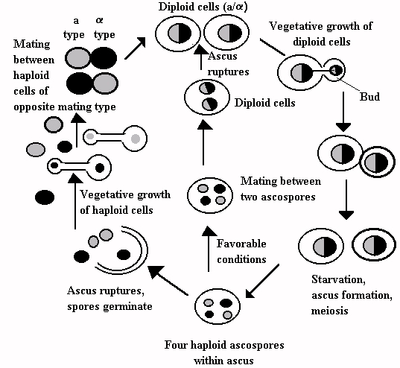

- Outline the sexual reproduction in a typical filamentous form of fungi
Sexual reproduction occurs when two mating types of hyphae grow in the same medium. Chemical in the two mating types of hyphae induce growth perpendicular to the hyphae in opposite direction. The two gametangia fuse (plasmogamy) and a zygote is formed which may undergo prolonged dormancy or resting stage. The nucleus in the zygote fuses in twos and undergo meiosis independently. The zygote germinates under favourable conditions to produce a fruiting which at maturity liberates the haploid spores.

- How do bryophytes adapt to their environment?
- They have definite structures for water and nutrient absorbent in the soil
- The aerial portion being exposed to the atmosphere demands some modifications that prevent excessive loss of water through the body surface.
- Some other modification that permits elimination of excess water from the plant body and not only exchange of gases between the internal parts of the plant and the atmosphere therefore openings are available on the aerial parts of the plant.

- Describe with illustration the following terminologies: (a) eusteles (b) atactostele (c) siphonostele (d) dictyostele.
- Eusteles
A type of siphonostele, in which the vascular tissue in the stem forms a central ring of bundles around pith.
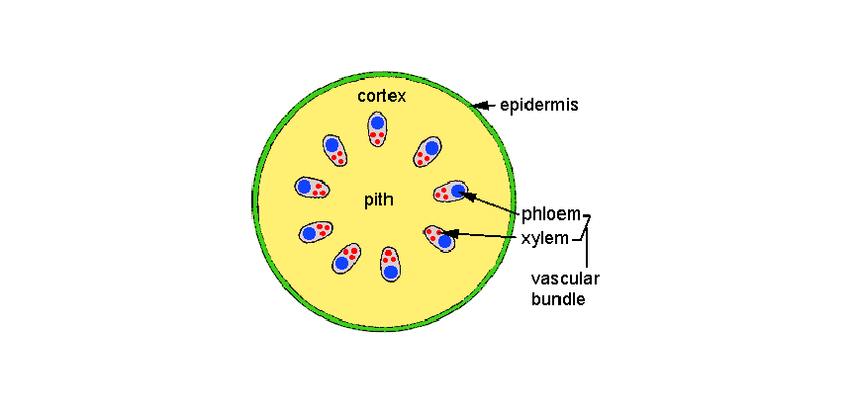
(b) Atactostele
A type of eustele, found in monocots, in which the vascular tissue in the stem exists as scattered bundles.
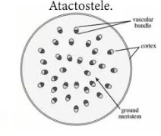

(C) Siphonostele
a stele consisting of a core of pith surrounded by concentric layers of xylem and phloem.
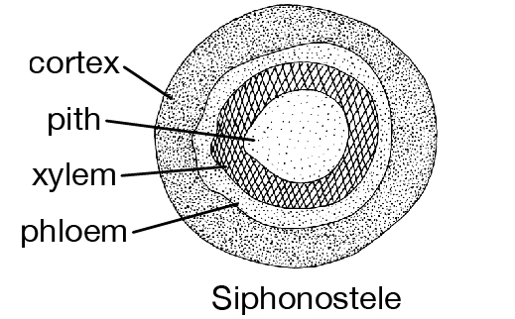
(d) Dictyostele
a stele in which the vascular cylinder is broken up into a longitudinal series or network of vascular strands around a central pith (as in many ferns) 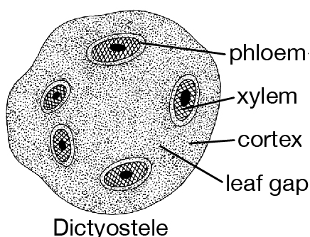

- Illustrate the life cycle of a primitive vascular plant
When mature, the synangia release yellow to whitish spores which develop into a gametophyte less than 2 mm (0.08 in) long. The gametophyte lives underground as a saprophyte, sometimes in a mycorrhizal association. When the gametophyte is mature, it produces both egg and sperm cells.
