Name: ROTIMI OLUWATOMINI GODSFAVOUR

DEPT: MBBS/ MHS.
MATRIC NO: 19/MHS01/387
COURSE CODE: BIO 102

Importance of fungi to man
* Fungi are important in the food industry. I.e yeast (saccharomyces cerevisiae) are used as rising agents in bakeries. Some fungi are also used as food e.g mushrooms.
* A particular species of fungi is also used to produce antibacteria, penicillium notanum. Fungi are also used to produce an immunosuppressant drug cyclosporine which reduces the risk of rejection after organ transplant.
* some fungi serve as parasites to pests like grasshoppers.
* They help in breweries in the fermentation process. They also help in the fermentation of palmwine.

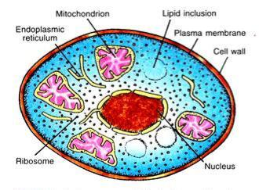
2) cell structure of unicellular fungus

3) Sexual Reproduction of typical filamentous form of fungus
1. It takes place by the fusion of multinucleate gimleting. Species are dioecious or heterothallic.
2. Two fusing gametangia (male and famale, or + and -) are morphologically similar but physiologically different.
3. Developing gametangia are known as progametangia. These are filled with cytoplasm and nuclei in their swollen tip.
4. At the time of their fusion each gametangium is separated from the ‘suspensor’ with the help of a septum.
5. The multinucleate protoplasm of each gametangium is known as coenogamete
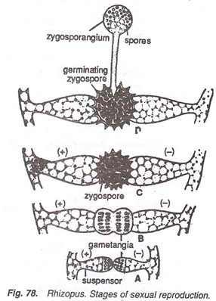
6. Fusion of two gametangia takes place. The nuclei of + gametangium fuse with those of -, and thus many diploid nuclei are formed. Around this fusion product, a thick, spiny wall develops, and now it is called zygospore.
7. Zygospore germinates meiotically by producing a long sporangiophore bearing a sporangium at the tip.
4. HOW BRYOPHYTES ADAPT TO THEIR ENVIRONMENT
* They have definate structures for water and nutrient absorption from the soil . The plant body is divided into the : - aerial portion and the subterranean portion. The subterranean portion is a rhizoid and not a true root as in the case of terrestrial plants.
* The aerial portion that is being exposed to the atmosphere has a modification know as “desiccation” which prevents loss of water through the body surface.
* Bryophytes have modifications that allow elimination of excess water through the body of the plants and not only gaseous exchange between the internal part of the plant and the atmosphere , therefore openings are available on the aerial part of the plant.
5)Definitions of terms
a) Eusteles: stele typical of dicotyledonous plants that consists of vascular bundles of xylem and phloem strands with parenchymal cells between the bundles
b) Atactostele: A type of eustele, found in monocots, in which the vascular tissue in the stem exists as scattered bundle.
c)siphonostele: stele consisting of a core of pith surrounded by concentric layers of xylem and phloem.
d) Dictyostele: stele in which the vascular cylinder is broken up into a longitudinal series or network of vascular strands around a central pith (as in many ferns)
6) LIFE CYCLE OF PRIMATIVE VASCULAR PLANTS
Primative vascular plants pteridophytes commonly known as ferns.
Ferns, unlike some other plants, do not flower in order to propagate. Instead, they reproduce sexually from spores. The life cycle of a fern is very different from the life cycle of many other plants. While many plants grow a mature adult form straight out of the seed, ferns have an intermediate stage, called a gametophyte, which then grows into a mature fern. There are two distinct stages in the life cycle of ferns.
The first stage is that of the gametophyte. Spores are produced on the underside of mature plants. These will germinate and grow into small, heart-shaped plants called gametophytes. The gametophytes produce both sperm and egg cells, and will fertilize itself, or others. Once the fertilization occurs, the adult fern will begin growing.
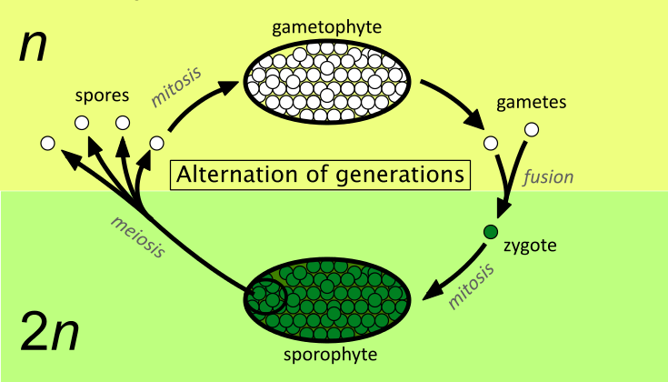
The second stage in the life cycle of a fern is the adult stage. The fertilized gametophytes begin to look like a mossy growth. After some time, young fronds will appear, rising out of the moss. If direct sunlight falls onto the young fronds for an extended period of time, the plant may die easily. This is because the tiny stems are not strong enough to sustain direct light and will dry out.
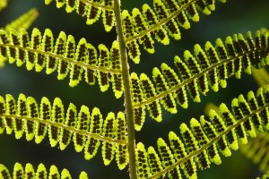
Once these tiny fronds grow larger, the plant has a better chance of survival. When the veins are matured, moisture from the ground will be transported easily to the outermost leaves and the plant can withstand periods of direct sunlight. After the plant is large and mature, it will grow spores on the undersides of its leaves and the life cycle of a fern will begin again.

