EMENIKE ESTHER IFEOMA
NURSING DEPARTMENT
19/MHS02/047
Importance of farming to mankind
- Farming
The mycorrhizal relationship between fungi and plant roots is essential for the productivity of farm land. Without the fungal partner in root systems, 80–90 percent of trees and grasses would not survive. Mycorrhizal fungal inoculants are available as soil additives from gardening supply stores and are promoted by supporters of organic agriculture.
2. Food
Fungi figure prominently in the human diet. Morels, shiitake mushrooms, chanterelles, and truffles are considered delicacies. The meadow mushroom, Agaricuscampestris, appears in many dishes. Molds of the genus Penicillium ripen many cheeses. They originate in the natural environment such as the caves of Roquefort, France, where wheels of sheep milk cheese are stacked to capture the molds responsible for the blue veins and pungent taste of the cheese.
Fermentation of grains to produce beer and of fruits to produce wine is an ancient art that humans in most cultures have practiced for millennia. Ancient humans acquired wild yeasts from the environment and used them to ferment sugars into CO2 and ethanol under anaerobic conditions. It is now possible to purchase isolated strains of wild yeasts from different wine-making regions. Louis Pasteur was instrumental in developing a reliable strain of brewer’s yeast, Saccharomyces cerevisiae, for the French brewing industry in the late 1850s.
Saccharomyces cerevisiae, also know as baker’s yeast, is an important ingredient in bread, a food that has been considered a staple of human life for thousands of years. Before isolated yeast became available in modern times, humans simply let the dough collect yeast from the air and rise over a period of hours or days. A small piece of this leavened dough was saved and used as a starter (source of the same yeast) for the next batch, much in the same way sourdough bread is made today.
- Medicine
Many secondary metabolites of fungi are of great commercial importance. Fungi naturally produce antibiotics to kill or inhibit the growth of bacteria, limiting their competition in the natural environment. Important antibiotics, such as penicillin and the cephalosporins, can be isolated from fungi. Valuable drugs isolated from fungi include the immunosuppressant drug cyclosporine (which reduces the risk of rejection after organ transplant), the precursors of steroid hormones, and ergot alkaloids used to stop bleeding. Psilocybin is a compound found in fungi such as Psilocybesemilanceata and Gymnopilusjunonius, which have been used for their hallucinogenic properties by various cultures for thousands of years.
As simple eukaryotic organisms, fungi are important model research organisms. Many advances in modern genetics were achieved by the use of the red bread moldNeurosporacrassa. Additionally, many important genes originally discovered in S. cerevisiae served as a starting point in discovering analogous human genes. As a eukaryotic organism, the yeast cell produces and modifies proteins in a manner similar to human cells, as opposed to the bacterium Escherichia coli, which lacks the internal membrane structures and enzymes to tag proteins for export. This makes yeast a much better organism for use in recombinant DNA technology experiments. Like bacteria, yeasts grow easily in culture, have a short generation time, and are amenable to genetic modification.

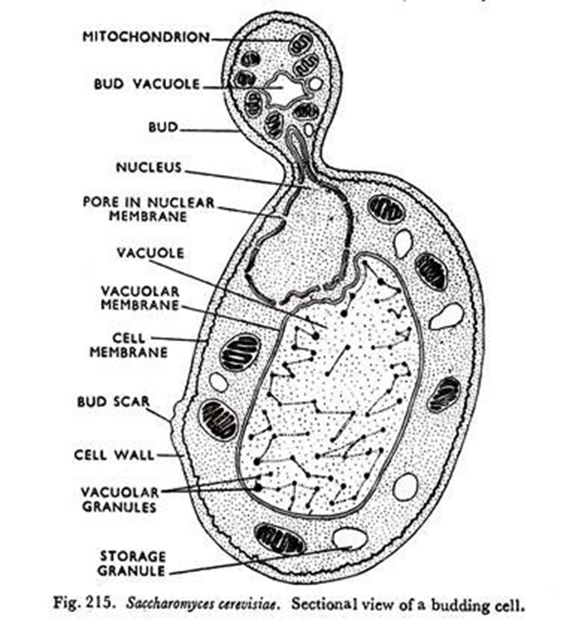
- Sexual reproduction
Sexual reproduction, an important source of genetic variability, allows the fungus to adapt to new environments. The process of sexual reproduction among the fungi is in many ways unique. Whereas nuclear division in other eukaryotes, such as animals, plants, and protists, involves the dissolution and re-formation of the nuclear tomembrane, in fungi the nuclear membrane remains intact throughout the process, although gaps in its integrity are found in some species. The nucleus of the fungus becomes pinched at its midpoint, and the diploid chromosomes are pulled apart by spindle fibres formed within the intact nucleus.
Sexual reproduction in the fungi consists of three sequential stages: plasmogamy, karyogamy, and meiosis. The diploid chromosomes are pulled apart into two daughter cells, each containing a single set of chromosomes (a haploid state). Plasmogamy, the fusion of two protoplasts (the contents of the two cells), brings together two compatible haploid nuclei. At this point, two nuclear typesare present in the same cell, but the nuclei have not yet fused. Karyogamy results in the fusion of these haploid nuclei and the formation of a diploid nucleus (i.e., a nucleus containing two sets of chromosomes, one from each parent). The cell formed by karyogamy is called the zygote. In most fungi the zygote is the only cell in the entire life cycle that is diploid. The dikaryotic state that results from plasmogamy is often a prominent condition in fungi and may be prolonged over several generations..
Fungi employ a variety of methods to bring together two compatible haploid nuclei (plasmogamy). Some produce specialized sex cells (gametes) that are released from differentiated sex organs called gametangia. In other fungi two gametangia come in contact, and nuclei pass from the male gametangium into the female, thus assuming the function of gametes. In still other fungi the gametangia themselves may fuse in order to bring their nuclei together. Finally, some of the most advanced fungi produce no gametangia at all; the somatic (vegetative) hyphae take over the sexual function, come in contact, fuse, and exchange nuclei.
Fungi in which a single individual bears both male and female gametangia are hermaphroditic fungi. Rarely, gametangia of different sexes are produced by separate individuals, one a male, the other a female. Such species are termed dioecious. Dioecious species usually produce sex organs only in the presence of an individual of the opposite sex.

- Two adaptations made the move from water to land possible for Bryophytes: a waxy cuticle and gametangia. The waxy cuticle helped to protect the plants tissue from drying out and the gametangia provided further protection against drying out specifically for the plants gametes. Bryophytes also show embryonic development which is a significant adaptation that links them to the vascular land plants.
1. Protostele:
It is the simplest and most primitive type of stele. The vascular cylinder consists of solid core of xylem surrounded by phloem, pericycle and endodermis. There is no pith e.g., Selaginella, Lycopodium, Lygodium, Gleichenia etc.
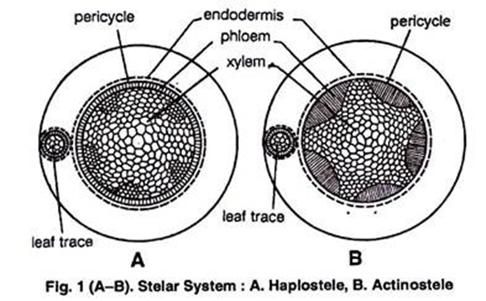
A protostele having a central smooth core of xylem (almost circular in transverse section) surrounded by the phloem and the pericycle is known as haplostele (Fig. 1A) e.g., Rhynia, Selaginell, chrysocaulos, S.kraussiana.
(b) Actinostele:
A protostele in which xylem appears as stellate or star shaped with many radiating arms in transverse section and phloem is present in small patches in between the radiating arms of the xylem is known as actinostele (Fig. 1 B) e.g., Lycopodium serratum., Psilotum. The actinostele may show some variations.
It is as follows:
(i) Plectostele:
In this type of actinostele xylem is in the form of plates lying parallel to one another and alternate with the phloem plates (Fig. 2A) Zimmermann (1930) called such stele as plectostele e.g., Lycopodium clavatum, Lycopodium voluble.
(ii) Mixed protostele:
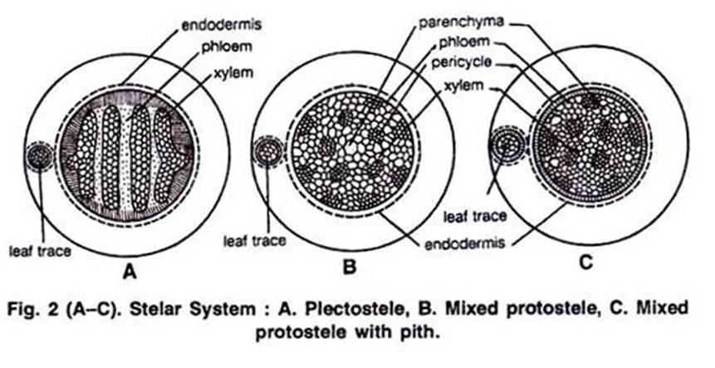
Xylem groups are uniformly scattered in the ground mass of phloem (Fig. 2B) e.g., Lycopodium cernuum.
2. Siphonostele:
A stele with central pith surrounded by vascular tissue is called siphonostele or a medullatedprotostele is called siphonostele.
Siphonostele is of two types:
(a) Ectophloicsiphonostele, and
(b) Amphiphloicsipnonostele.
(a) Ectophloicsiphonostele:
Phloem is present only external to the xylem e.g., Osmunda, Schizaea.
(b) Amphiphloicsiphonostele:
Phloem is present on both external and internal to the xylem e.g., Marsilea rhizome. In it the pith is surrounded by inner endodermis, inner pericycle, inner phloem, xylem, outer phloem, outer pericycle and outer endodermis.
Other Modifications of Siphonostele:
(a) Cladosiphonicsiphonostele:
The siphonostele without leaf gap is known as cladosiphonicsiphonstelee.g., Selaginella.
(b) Phyllosiphonicsiphonostele:
A siphonostele with smaller or larger leaf gaps is called phyllosiphonicsiphonostele e.g., Filicophyta.
(c) Solenostele:
The siphonostele which is perforated by scattered leaf traces is known as slenostele (Gwynne-Vaughan, 1907; Schoulte, 1938).
It may of two types:
(a) Ectophloic, and
(b) Amphiphloic.
(i) Ectophlopicsiphonostele:
Phloem is present only on outer side.
(ii) Amphiphloicsiphonostele:
Phloem is present on both the sides of the xylem.
(d) Dictyostele:
A siphonostele with more overlapping leaf gaps so as to show more than interruption in one transverse section is known as dissected siphonostele or dictyostele. The vascular parts of dictyostele between the neighbouring leaf gaps are known as meristeles.
The meristeles are typically protosteles e.g., Pteris, Ophioglossumlusitanicum, Adiantumcapillaris-veneris, Dryopterischrysocoma etc. (Fig. 5 A,B).

Evolution of Dictyostele from Siphonostele:
Ultimately the siphonostele gives rise to dictyostele. In some of siphonostelic members due to the dwarf axis, the shoot and leaves become over-crowded resulting into the formation of several leaf gaps. The vascular supply given for a leaf from the main stele is called leaf trace.
The parenchymatous region left behind in the main stele after the departure of the leaf trace is called leaf.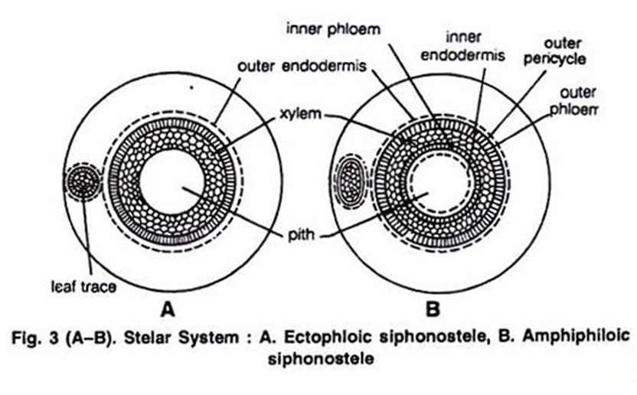
(g) Eustele:
It is characteristic of Gymnosperms and dicots. In this type of stele collateral or bicollateral vascular bundles are present in a ring.
