BIO 1O2 ASSIGNMENT
NAME: Victor-Obi Chiagozie Noble
DEPARTMENT: Medicine $ Surgery
MATRIC NO: 19/MHS01/432
LEVEL: 100
- Importance of fungi to man
i. Fungi causes decay of organic matter.
ii.They prevent the earth from being clogged up by dead organic matter.
iii.Fungi, e.g. yeast are important to food industry.
iv.Production of antibiotics.
v.Cause spoilage of wood, clothes.
2. Cell structure of a unicellular fungus.

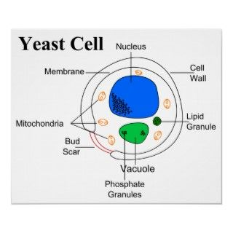

- Sexual reproduction in a filamentous form of fungi (Rhizopus Stonolifer)
i. Two mating types of hyphae grow in the same medium.
ii.They grow perpendicularly in opposite direction.
iii.Nuclei are isolated in gametangium.
iv.The two nuclei fuse in a process called PLASMOGAMY and zygote is formed.
v.They fuse in two undergoing meiosis stages independently.
vi. Zygote germinates under favourable conditions to produce a fruiting which at maturity liberates the haploid spores.

- Adaptation of bryophytes to Land.
i.They have definite structures for water and nutrient absorption.
ii.They possess cuticles which prevent excessive loss of water (desiccation)
iii.They have openings on the aerial part to permit elimination of excess water from plant body and also exchange of gases between internal parts of the plant and the atmosphere.

- A. Eustele: A type of stele in herbaceous dicotyledonous plants in which the vascular bundles are discrete, concentric collateral bundles of xylem and phloem.
B. Atactostele: A type of stele found in monocots which has scattered vascular bundles.
C. Siphonostele: A stele consisting of a core of pith surrounded by concentric layers of xylem and phloem
D. Dictyostele: A type of stele in which the vascular cylinder is broken up into a longitudinal series or network of vascular strands around a pith.
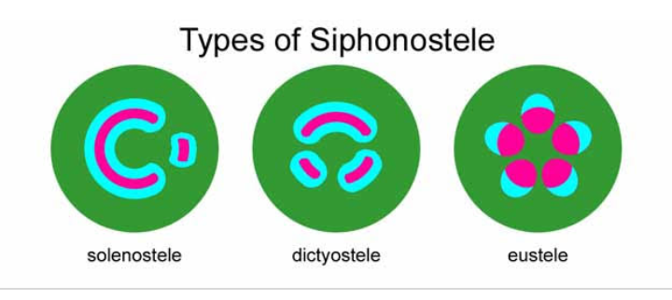

- Life cycle of a primitive vascular (Psilotum)
a. Psilotum plant body is a sporophyte (Diploid 2n)
b. Synangium is the spore bearing structure
c. In synangium, diploid spore mother cells undergo meiosis forming haploid spores (1n)
d. Spores germinate forming gametophyte or prothallus (Monoecious : both antheridia and archegonia are present)
e. Antheridium produce sperms. Sperms are multiflagellate. Archegonium produce egg.
f. Fertilization is oogamous
g. Zygote divides to form embryonic sporophyte later form mature plant body (Diploid Psilotum Sporophyte)

