NAME: Okwumuo Dumebi Kizito
DEPARTMENT: Dentistry
MATRIC NUMBER: 19mhs/01/328
COURSE: BIO 102

ASSIGNMENT:
- Fungi is important to mankind in the following ways;
- Fungi e.g. yeast is important in the food in the food industry for baking.
- Fungi is responsible for the mediation of organic matter.
- Mushrooms serve as food for man.
- Some fungi are parasites to some certain horrible obnoxious pests e.g. houseflies.
- Species e.g. penicillium produces antibiotics.

- A well labeled diagram of a unicellular fungus;
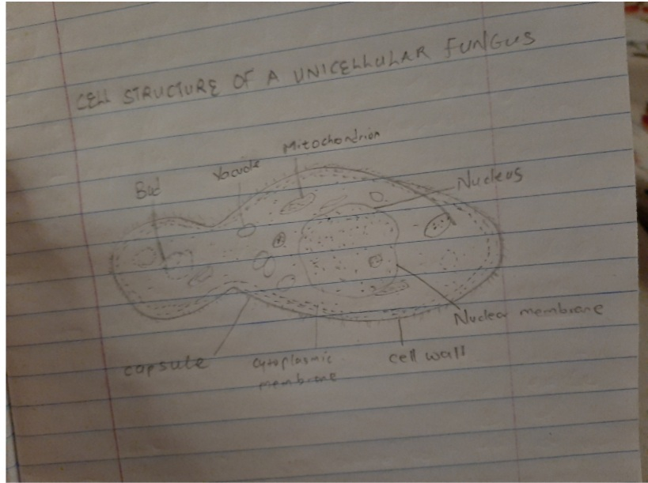
- The sexual reproduction in a typical filamentous form of fungi;
Rhizopus stolonifier: Sexual reproduction occurs when two mating types of hyphae grow in the same medium. Chemical interaction in the two mating types of hyphae in opposite directions. These growths are delimited by a wall such that many nuclei are isolated in what is called gametangium. The two gametangia fuse (plasmogamy) and a zygote is formed which may undergo prolonged dormancy or resting stage. The nuclei in the zygote fuse in twos and undergo meiosis independently. The zygote germinates under favorable conditions to produce haploid spores.
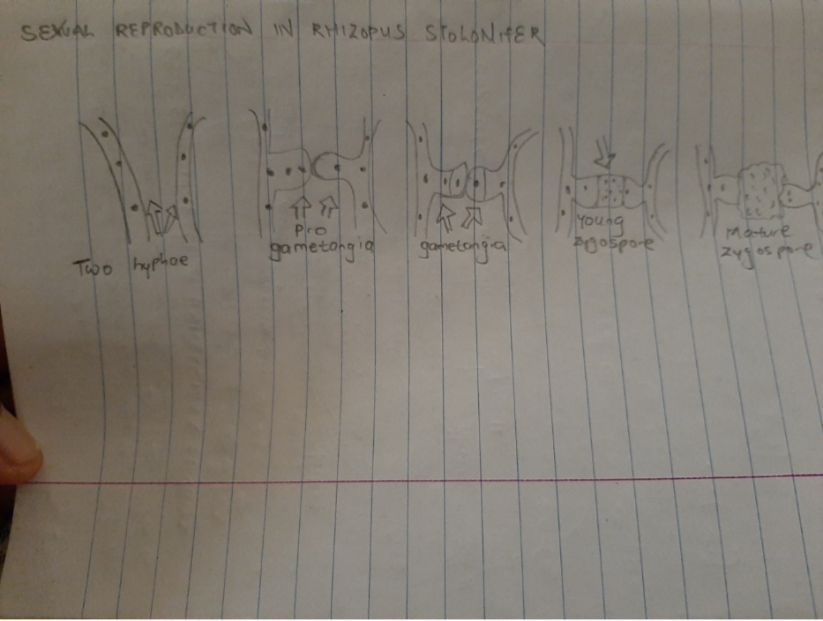
- Bryophytes adapt to their environment in the following ways:
- They have definite structures for water and nutrient absorption from the soil; therefore, the plant body is divided into two portions (an aerial portion and subterranean portion). The subterranean portion is the rhizoid and is not a true root as the case of land plants that are advanced.
- The aerial portion being exposed the atmosphere demands some modifications that prevents excessive loss of water through the body surface (I.e. desiccation).
- Some other modifications that permit elimination of excess water from the plant body and not only exchange of gasses between the plant and atmosphere therefore openings are avaible on the arial parts of plant.

- I. Eusteles: The vascular bundles are discrete, concentric collateral bundles of xylem and phloem.

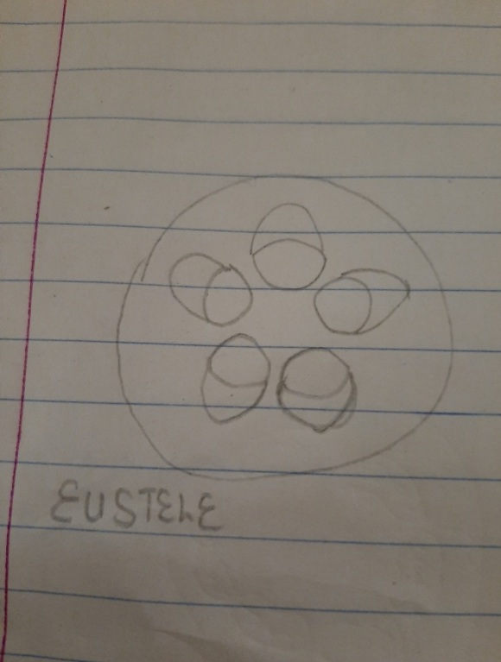
ii. Atactosteles: In grasses and monocotyledonous plants the vascular bundles are scattered.

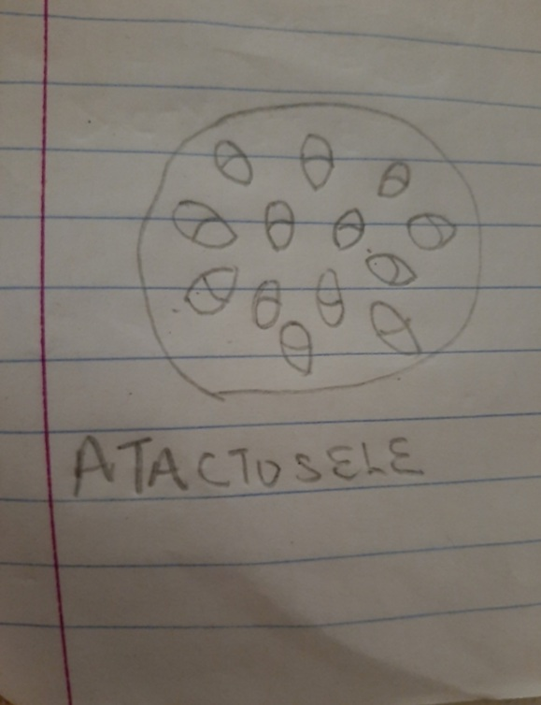
iii. Siphonostele: In more advanced vascular systems e.g. stems of ferns and higher vascular p plants, the stele is a cylinder enclosing a parenchymatous pith.

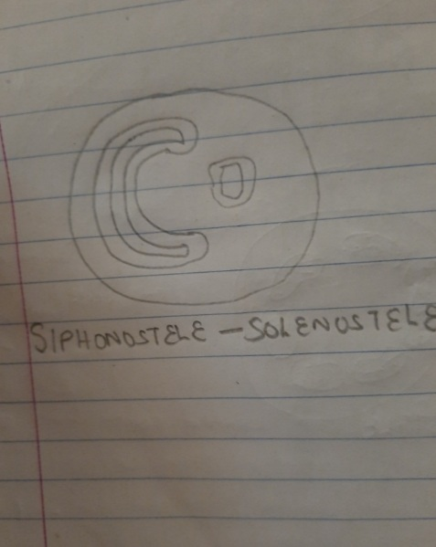
iv. Dictyostele: In siphonosteles, vascular supply to leaves is associated with leaf gaps and the conducing cylinder is a dissected ones.

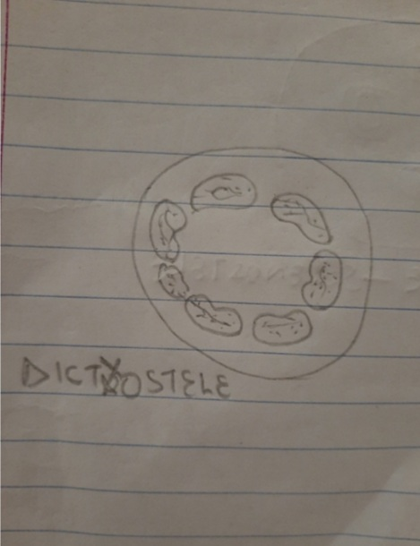

- Life cycle of a primitive vascular plants;
