AMADI CHIBURUOMA YVONNE
19/MHSO1/088
BIOLOGY 102
ASSIGNMENT
- Importance of fungi to mankind
Fungi helps to control the population of damaging pests, hence are used in making biological insecticides
Fungi are essential for the productivity of farm land. For instance in the mycorrhizal relationship between fungi and plant roots.
Yeast which is a fungi has been used for a very long time in making beer, wine and bread.
Fungi not only directly produce substances that humans use as medicine, but they are also versatile tools in the vast field of medical research.
- Illustrate the cell structure of a unicellular fungus with a well labeled diagram
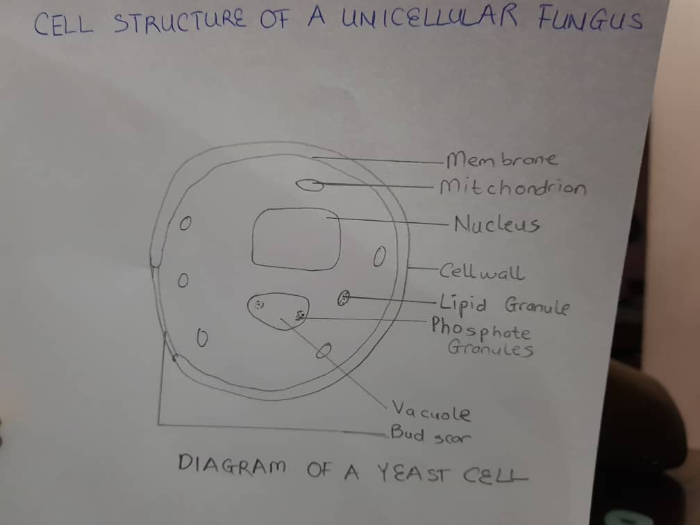

- Outline the sexual reproduction in a typical filamentous form of fungi
Case study: Rhizophus stolonifer
- The process of sexual reproduction involves three phases, Plasmogamy, Karyogamy and meiosis
- In sexual reproduction, spherical spores are formed called zygospores which are thick-walled.
- The zygospores are the only diploid phase of Rhizophus stolonifer. They are composed of two suspensor cells, which are the former gamentangia or hyphae. There is a suspensor cell on each side of a large, rough, dark brown spore.
- The zygospore forms two special haploid hyphae of opposite mating types that touch due to hormones and being in close proximity of each other.
- The two cytoplasm intermingle also known as plasmogamy. As this occurs the nuclei of both parents enter the conjunction causing the resting spore to develop.
- Karyogamy is the term used to describe the fusion of two nuclei. After the zygospore has truly formed, Meiosis occurs and haploid spores are formed and dispersed.
- Meiosis still occurs and a sporangium similar to the asexually produced sporangium is created when the zygospore finally cracks open.

- How do bryophytes adapt to their environment?
Two adaptations made the move from water to land possible for bryophytes: a waxy cuticle and gamentangia.
The waxy cuticle helps to protect the plants tissue from drying out and the gamentangia provided further protection against drying out specifically for the plants gametes.
They possess definite structures for water and nutrient absorption from the soil.

- Describe with illustration the following terminologies.
- Eusteles: A type of stele in which the vascular tissue in the stem forms a central ring of bundles around a pith. The vascular bundles are discrete, concentric, collateral bundles of xylem and phloem.
- Atactostele: A type of stele found in monocots in which the vascular tissue in the stem exists as scattered bundles.
- Siphonostele: A stele in which the vascular tissue is in the form of a cylinder surrounding the pith as in the stem of most ferns and other seedless vascular plants.
- Dictyostele: A type of stele in which the vascular cylinder is broken up into a longitudinal series or network of vascular strands around a pith.
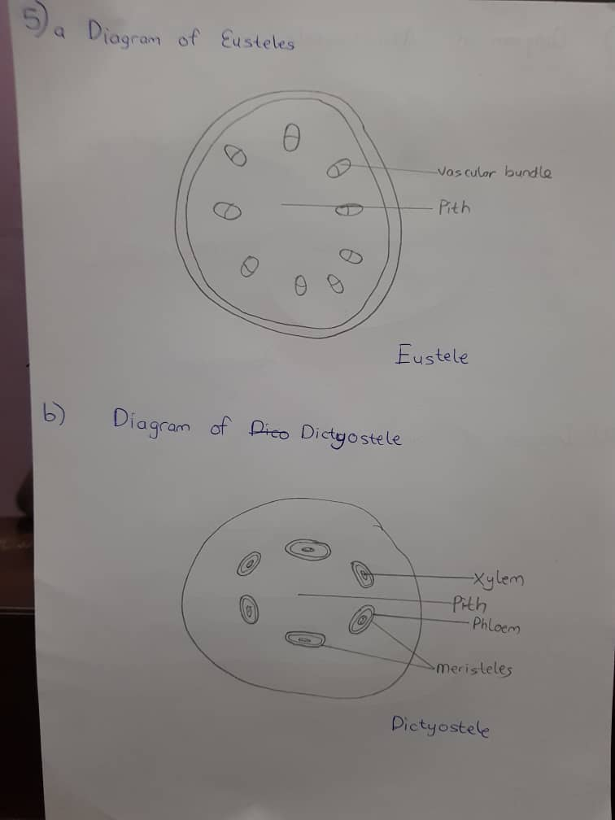
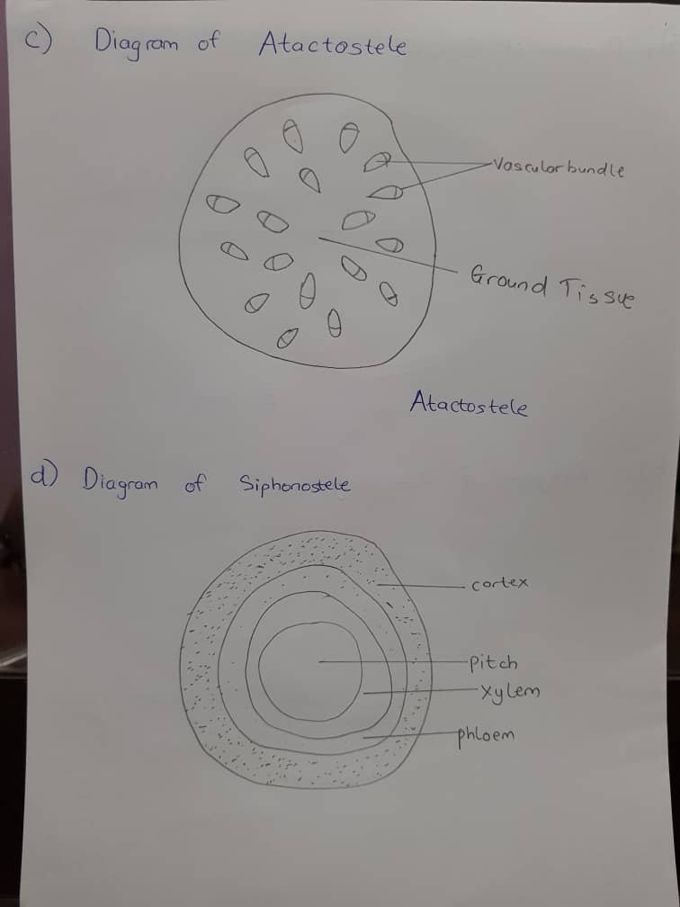
- Illustrate the life cycle of a primitive vascular plant
