Name: Oluwatamilore Fathiat Okeleye
Matric no: 19/MHS01/313
Department: M.B.B.S
Course code: BIO 102
- How are fungi important to mankind?
The majority of grasses and trees require a mycorrhizal relationship with fungi to survive.
Yeasts have been used for thousands of years in the production of beer, wine, and bread.
Fungi not only directly produce substances that humans use as medicine, but they are also versatile tools in the vast field of medical research.
Some fungi attack insects and, therefore, can be used as natural pesticides.
- Illustrate the cell structure of a unicellular fungus with a well labeled diagram.
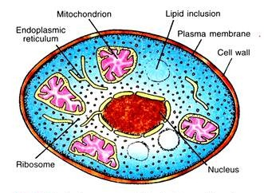

- Outline the sexual reproduction in a typical filamentous form of fungi.
- First two mating types of hyphae grow in the same medium.
- A chemical reaction between them causes a growth that is perpendicular to the hyphae in opposite directions, so they can meet with one another.
- The growths are delimited by a wall just so the nuclei are isolated in differentiated sex organs called gametangia.
- The gametangia fuse in a process called plasmogamy and together they form a zygote which may undergo dormancy for a period.
- The nuclei in the zygote fuse in twos and undergo meiosis independently, it then moves on to germinating under favorable conditions so as to liberate haploid spores at maturity through the production of a fruiting.
- These add up to three stages plasmogamy, karogamy and meiosis.

- How do Bryophytes adapt to their environment?
- A waxy cuticle: the waxy cuticle helped to protect the plants tissue from drying out.
- Bryophytes also show embryonic development which is a significant adaptation that links them to the vascular land plants.
- Gametangia: gametangia provided further protection against drying out specifically for the plants gametes. Bryophytes also show embryonic development which is a significant adaptation that links them to the vascular land plants.
- Eusteles: A type of siphonostele, in which the vascular tissue in the stem forms a central ring of bundles around a pith
Atactostele: A type of eustele, found in monocots, in which the vascular tissue in the stem exists as scattered bundles.
Dictyostele: a stele in which the vascular cylinder is broken up into a longitudinal series or network of vascular strands around a central pith (as in many ferns)

- Illustrate the life cycle of a primitive vascular plant.
