Name: Agun Victor Ayodele
Matric No: 16/SMS03/004
Course Code: BUS 408
Course Title: Human Resource Management

Meaning of Industrial Relations
Industrial relations or employment relations are the multidisciplinary academic field that studies the employment relationship; that is, the complex interrelations between employers and employees, labour/trade unions, employer organizations and the state.
The Industrial Relations or IR encompasses the relationship between the management and workmen and the role of a regulatory body to resolve any industrial dispute.
As the name implies, Industry Relations comprises of two words, Industry, and Relations. Where industry covers the production activity in which the group of workmen is engaged in, while the relations show the relationship between the management and the workers within the industry. IR plays a significant role in today’s working scenario where the harmonious relationship between the employers and employees is needed to have an uninterrupted production. The Industrial Relations mainly cover the following:
Regulatory body to resolve industrial disputes.
Collective Bargaining.
The role of management, unions and government.
Labour Legislation
Worker’s Grievance Redressed system.
Disciplinary policy and practice.
Industrial Relations Training.
The newer name, "employment relations" is increasingly taking precedence because "industrial relations" is often seen to have relatively narrow connotations. Nevertheless, industrial relations have frequently been concerned with employment relationships in the broadest sense, including "non-industrial" employment relationships. This is sometimes seen as paralleling a trend in the separate but related discipline of human resource management.
While some scholars regard or treat industrial/employment relations as synonymous with employee relations and labour relations, this is controversial, because of the narrower focus of employee/labour relations, i.e. on employees or labour, from the perspective of employers, managers and/or officials. In addition, employee relations is often perceived as dealing only with non-unionized workers, whereas labour relations is seen as dealing with organized labour, i.e. unionized workers. Some academics, universities and other institutions regard human resource management as synonymous with one or more of the above disciplines, although this too is controversial.

Parties Involved in Industrial Relations
To understand the concept of industrial relations, we should know that; who all are responsible for developing cordial relationships in the organization?
The different persons holding distinct positions in the organization and the external or internal associations involved in the process of building strong industrial relations can be bifurcated into the following two categories:

Primary Parties
Those persons or associations which are directly associated with or influenced by the functions of industrial relations are as follows:
Employees
The workers who provide their services to the organization are an essential resource and contribute to generating the desired output.
Following are some of the reasons for which employees find maintaining sound industrial relations to be useful for them:
Sharing their views, suggestions and ideas with the management to improve the business operations;
Becoming a part of organizational decision-making and ensuring the betterment of the working conditions;
Speaking out their problems and grievances and seeking for the redressal of the same.
Employers
Employers are responsible for providing a favourable work environment for the employees. They have many rights and powers like laying off inefficient employees, taking strategic decisions such as mergers, acquisition or shutdown of the organization and adapting technological changes in the operations.
Following are the different ways in which managers can benefit from sound industrial relations in the organization:
Motivating the employees to give their best and gaining their trust and commitment;
Improving the overall efficiency and ensuring effective communication among the employees and the management;
Dealing with problems of trade union along with negotiation of employment terms and conditions with such employee representative.
Government
Before the 19th century, the government didn’t use to intervene in the conflicts between the employer and the employee. However, later on, there was a change in the attitude of the government bodies, they started regulating the industrial relations through labour courts and tribunals, for the following reasons:
Safeguarding the interest of both the parties;
Ensuring that both the employer and the employee, abide by the legal terms and conditions.

Other Parties
The parties (especially the internal or external bodies or associations) which impact the industrial relations within an organization are as follows:
Employers’ Association
It is an authoritative body, formed to protect the interest of the industrial owners. It performs the following functions to safeguard the rights of the employers:
Representing the owners in collective bargaining with the employees or government and also in case of national issues;
Creating a proper mechanism to resolve industrial disputes;
Giving an insight into the employee relations in an organization and providing suggestions accordingly.
Trade Unions
When the workers unite together to form an association and elect a representative among themselves; for the protection of their rights and to raise their demands in front of the management; it is named as a trade union. Listed below are the objectives of such associations:
Negotiating collectively with the administration for meeting the individual interest of an employee;
Upgrading the status of the employees in the organization;
Demanding better working conditions and higher job security for the workers;
Safeguarding the interest of the employees by demanding a higher level of democratic control over the decision-making at the organizational, corporate and national levels.
Courts and Tribunals
The judiciary includes the ‘courts’ to resolve the legitimate conflicts and the ‘judicial review’ to administer the justice of the constitution. These courts and tribunals play an essential role in settlement of industrial disputes by eliminating the possibilities of the following:
Judicial flaws;
Conflicting judgment;
Poor evaluation of penalty;
Confusing terms and conditions.
International Labour Organization (ILO)
On the international grounds, an association was formed under the name of International Labour Organization in the year 1919 to set up international norms and standards for dealing with industrial disputes and issues of the workers.
Simultaneously, an International Labour Code (ILC) was set up to establish the recommendations and conventions for minimum international labour standards.
The ILC aimed to look into matters like:
Worker’s compensation, i.e., minimum wages;
Employee’s work duration and number of holidays;
Women employment;
Employee’s safety, security and health in the work environment;
Industrial relations;
Medical facilities and examination along with maternity protection.
Human Resource Function
The human resource department or team acts as a mediator between the organization and its employees for dealing with the personnel issues and conflicts. It is their responsibility to ensure the maintenance of harmonious industrial relations in the company.
Following are the various other functions of the HR professional in the organization:
Addressing the disputes at the initial level;
Acting as a change agent by bringing a mental revolution in case of any conflict between the workers and the management;
Performing the role of an administration expert and a strategic partner by ensuring the implementation of the policy decisions taken at the top level.

Indices of Unemployment in Senegal

Unemployment Rate in Senegal increased to 19 percent in the first quarter of 2019 from 15.10 percent in the fourth quarter of 2018.
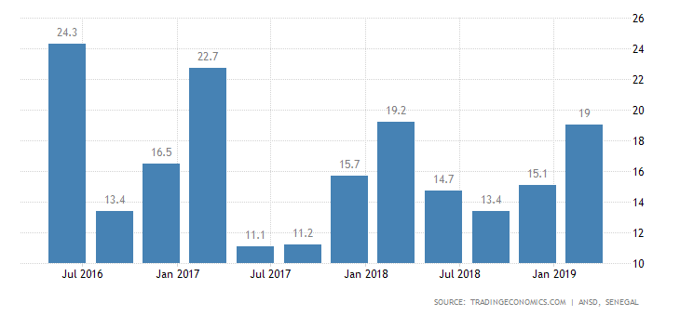

 | Actual | Previous | Highest | Lowest | Dates | Unit | Frequency
 | 19.00 | 15.10 | 25.70 | 5.60 | 1994 - 2019 | percent | Quarterly

Senegal Labour | Last | Previous | Highest | Lowest | Unit
Unemployment Rate | 19.00 | 15.10 | 25.70 | 5.60 | percent | [+]
Population | 16.20 | 15.70 | 16.20 | 3.21 | Million | [+]
Living Wage Family | 211500.00 | 211500.00 | 211500.00 | 211500.00 | XOF/Month | [+]
Living Wage Individual | 89500.00 | 89500.00 | 89500.00 | 89500.00 | XOF/Month | [+]
Wages | 88829.00 | 78909.00 | 186710.00 | 73076.00 | CFA/Month | [+]
Wages High Skilled | 382000.00 | 355200.00 | 382000.00 | 300000.00 | XOF/Month | [+]
Wages Low Skilled | 126400.00 | 123300.00 | 132600.00 | 88800.00 | XOF/Month | [+]

Senegal Unemployment Rate
In Senegal, the unemployment rate measures the number of people actively looking for a job as a percentage of the labour force.
Indices of Unemployment in Nigeria

Youth Unemployment Rate in Nigeria decreased to 36.50 percent in the third quarter of 2018 from 38 percent in the second quarter of 2018.
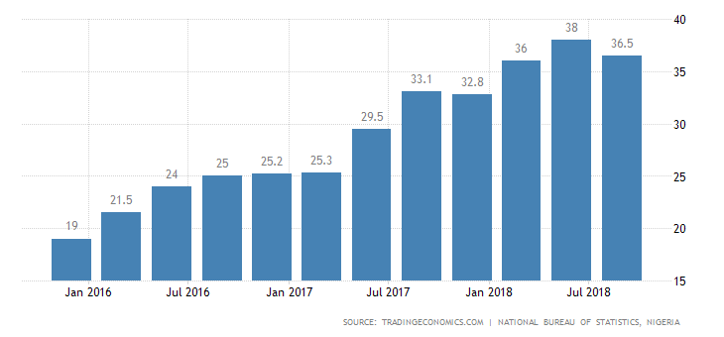

 | Actual | Previous | Highest | Lowest | Dates | Unit | Frequency
 | 36.50 | 38.00 | 38.00 | 11.70 | 2014 - 2018 | percent | Quarterly | NSA

Nigeria Labour | Last | Previous | Highest | Lowest | Unit
Unemployment Rate | 23.10 | 22.70 | 23.10 | 5.10 | percent | [+]
Population | 200.00 | 195.87 | 200.00 | 45.14 | Million | [+]
Unemployed Persons | 20927.60 | 20343.60 | 20927.60 | 4672.00 | Thousand | [+]
Wages High Skilled | 57200.00 | 57200.00 | 57200.00 | 57200.00 | NGN/Month | [+]
Wages Low Skilled | 25500.00 | 25500.00 | 25500.00 | 25500.00 | NGN/Month | [+]
Youth Unemployment Rate | 36.50 | 38.00 | 38.00 | 11.70 | percent | [+]
Living Wage Family | 137600.00 | 135300.00 | 137600.00 | 135300.00 | NGN/Month | [+]
Living Wage Individual | 43200.00 | 41800.00 | 43200.00 | 41800.00 | NGN/Month | [+]
Minimum Wages | 30000.00 | 30000.00 | 30000.00 | 18000.00 | NGN/Month | [+]
Employed Persons | 69542.90 | 69165.60 | 70665.90 | 66951.00 | Thousand | [+]
Employment Rate | 76.90 | 77.30 | 93.60 | 76.90 | percent | [+]

