NAME: EWEIYE RUTH EHINOME
COLLEGE/DEPARTMENT: MHS/MLS
MATRIC NUMBER: 19/MHS06/014
COURSE CODE: BIO 102
      - Importance of fungi to mankind
- Fungi helps in the production of food
- It helps in the preparation of medicine and various acids
- Synthesis of enzymes
- They are responsible for the mediation of the decay of dead organic matter
- It helps produce esters and pigments and also antibiotics
- It also helps in soil fertility

CELL STRUCTURE OF A UNICELLULAR FUNGUS
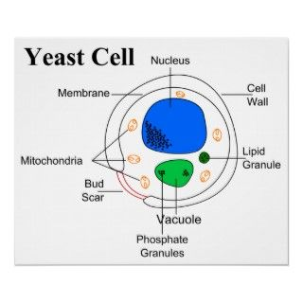

- Sexual reproduction in a filamentous fungi like Rhizopus stolonifer undergoes the following steps;
- First, two mating types of hyphae grow in the same medium.
- A chemical interaction between them causes growth perpendicular to the hyphae in opposite directions, so they can meet with one another.
- The growths are the delimited by a wall just so the nuclei are isolated in differentiated sex organs called gametangia (plural).
- The gametangia fuse in a process called plasmogamy and together they form a zygote which may undergo dormancy for a period.
- The nuclei in the zygote fuse in twos and undergo meiosis independently, it then moves on to germinating under favorable conditions so as to liberate haploid spores at maturity through the production of a fruiting.
- In summary, sexual reproduction in fungi consists of three stages; plasmogamy, karogamy and meiosis.

- Adaptions of bryophytes to their environment
- They possess definite structures for water and nutrient absorption from the soil.
- They also possess a waxy cuticle that keeps them from drying out through the process of desiccation
- They possess gametangia that keep the plants gametes from drying out.

- A. Eusteles - a type of siphonostele in which the vascular tissue in the stem forms a central ring of bundles around a pith. The vascular bundles are discrete, concentric collateral bundles of xylem and phloem.
B. Atactostele - a type of eustele found in monocots, in which the vascular tissue in the stem exists as scattered bundles.
C. Siphonostele – a type of eustele in which the vascular tissue in the stem forms a cylinder surrounding a central pith and possessing leaf gaps.
D. Dictyostele - a type of siphonostele in which the vascular tissue in the stem forms a central cylinder around a pith, but with closely spaced leaf gaps.
Diagrammatic illustrations of the different steles.
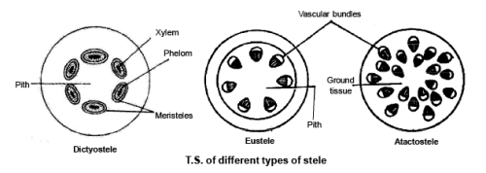

Life cycle of a primitive vascular plant (psilotum)

