NAME: AFOLABI Fope foluwa mayokun
COURSE: BIO 102
DEPARTMENT: MEDICINE AND SURGERY
MATRIC NO: 19/MHS01/046s

1a) Farming
1b) medicine
1c) fermentation
1d) food

2) 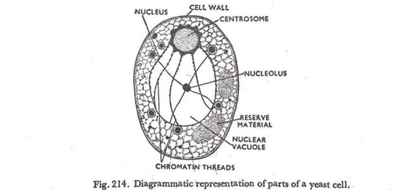

3) Sexual reproduction in a filamentous form of fungi occurs when two mating types of hyphae grow in the same medium. It interact chemically in two mating types of hyphae which induces growth perpendicular to the hyphae in opposite directions and these growth are delimited by the wall such that many nuclei are isolated in what is called gametangium. The two gamentangia fuse(plasmogamy) and a zygote is formed which undergoes a prolonged dormancy or resting stage. The nuclei in the zygotes fuses into twos and undergo meiosis independently

4) Adaptation of bryophytes:
a)They have a waxy cuticle that prevents the body, the zygote, and the embryo from drying out
b) Spores are dispersed by the wind.
c) they have definite structures for water and nutrient absorption from the soil. The plant body is divided into two (an aerial portion and a subterranean portion is the rhizoid and is not a true root as the case of land plants that are advanced.

5) A. Eusteles; a type of stele in which the vascular tissue in the stem forms a central ring of bundles around a pith. The vascular bundles are discrete, concentric collateral bundles of xylem and phloem.
B. Atactostele; a type of stele found in monocots, in which the vascular tissue in the stem exists as scattered bundles.
C. Dictyostele; a type of stele in which the vascular cylinder is broken up into a longitudinal series or network of vascular strands around a pith.
DIAGRAM REPRESENTATION OF THESE
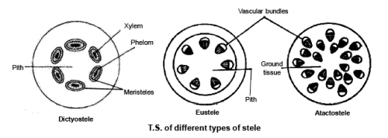

6) LIFECYCLE OF PRIMITIVE VASCULAR PLANT( PSILOTUM)

