NAME: UKWELA JOANNA IBEOJO
COLLEGE: Medicine and Health sciences
DEPARTMENT: MBBS
COURSE: General Biology II BIO 102
MATRIC NO: 19/MHS01/418
ASSIGNMENT
- How are fungi important to mankind?
- They are a major source of citric acid (vitamin C).
- They produce antibiotics such as penicillin, which has saved countless lives.
- They can be genetically engineered to produce insulin and other human hormones.
- Together with bacteria, fungi are responsible for breaking down of organic matter and releasing carbon, oxygen, nitrogen, and phosphorus into the soil and the atmosphere.
- Yeast is used in the baking and brewery industries.

- Illustrate the cell structure of a unicellular fungus with well labelled diagram.

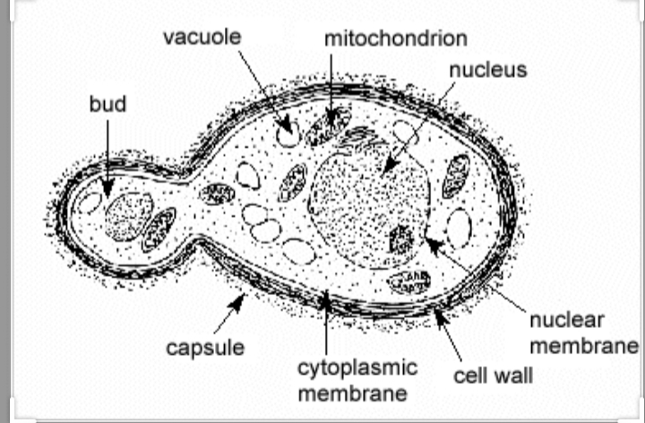

Labelled diagram of the structure of Saccharomyces cerevisiae (yeast), undergoing sexual reproduction.

- ssOutline the sexual reproduction in a typical filamentous fungi.
Sexual reproduction is Rhizopus stolonifera
This happens when two mating types of hyphae grow in the same medium. A Chemical interaction in the two mating types of hyphae induces growths perpendicular to the hyphae in opposite direction. These growths are delimited by a wall such that many nuclei are isolated in what is called a gametangium. The two gametangia fuse (plasmogamy) and a zygote is formed which may undergo prolonged dormancy or resting stage. The nuclei in the zygote fuse in twos and undergo meiosis independently. The zygote germinates under favourable conditions to produce fruiting which at maturity liberates the haploid spores.

- How do bryophytes adapt to their environment ?
Bryophytes have waxy cuticles and gametogania. The waxy cuticle help to protect the plants tissues from drying out and the gametangia provided further protection against drying out specifically for the plants gametes. They have definite structurs for water and nutrient absorption from the soil; the aerial protion and the subterranean portion.

- (a) Eusteles: this is a type of siphonostele, in which vascular tissue in the stem forms a central ring of bundles around a pith.
(b) Atactostele: this is a type of eustele, found in monocots, in which the vascular tissue in the stem exists as scattered bundles.
(c) Siphonostele: this is a stele consisting of a core of pith surrounded by concentric layers of xylem and phloem.
(d) Dictyostele: a stele in which the vascular cylinder is broken up into longitudinal series or a network of vascular strands around a central pith.
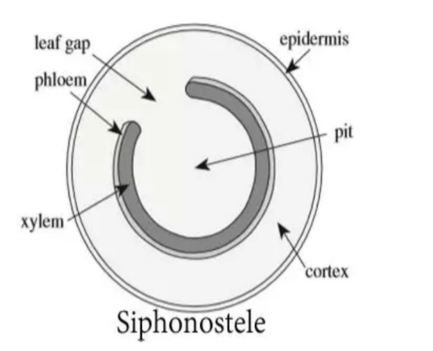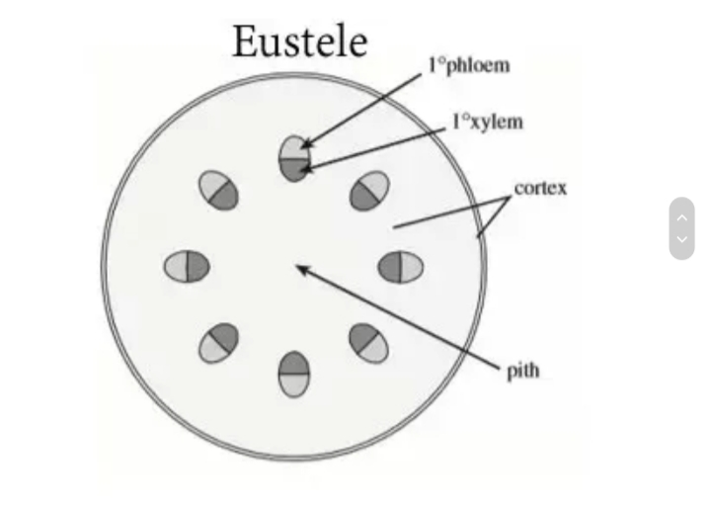

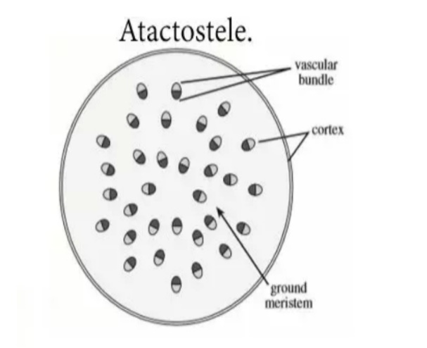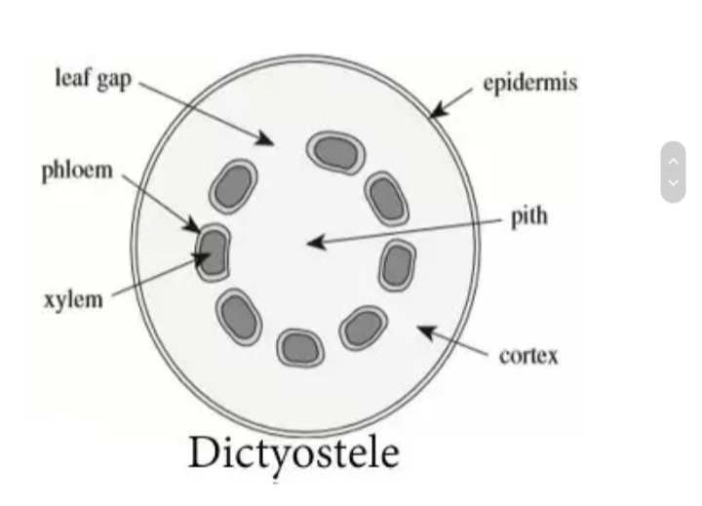

- Illustrate the lifecycle of a primitive vascular plant.
Lifecycle of Psilotum.

