MATRIC NUMBER: 16/MHS06/009
COURSE TITLE: BIOMEDICAL ENGINERRING
COURSE CODE: MLS 410
QUESTION 1: Discuss the physics of the light microscope diagrams and illustrations needed
ANWER 1:
Light microscopes play an important role in many research laboratories, including electron microscopy facilities. They can be used as a primary visualization tool. Light and electron microscopes share many similarities in their optical principles. Understanding how a light microscope works is not only critical for obtaining optimum light images, but also for understanding electron microscopy.
Principle of the light microscopy: In microscopy we take advantage of waveform properties of light. These waves when produced at a particular source vibrate at right angles to the line of propagation. Each wave has a peak and trough. The distance traveled forward by the light ray is one wavelength. Wavelength varies with the color and intensity of the source.
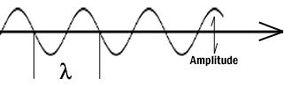
The theoretical resolution of the light microscope was first defined by Abbe in the following equation.
Abbe's equation for theoretical resolution of the light microscope:
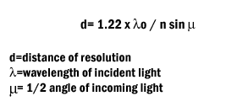
The actual resolution achievable with a light microscope is not as great. The Objective Lens is the first part of the imaging system; the objective lens forms a primary, enlarged image of the object. Very fine details are distinguished with the objective lens. The eyepiece sometimes called the ocular lens, is the second lens, which forms a secondary, further enlarged image. By multiplying the magnifying power of the objective lens and the magnifying power of the ocular the final magnification is found. A Substage Condenser lens is the third optical component. It is placed on a platform beneath the object. Light is directed through the substage condenser and converges to a point at the position of the specimen. The light rays diverge as they pass through the specimen and form an inverted cone, whose base is just large enough to fill the aperture of the objective. The size of the light beam is controlled by a diaphragm beneath the condenser called the aperture diaphragm. Modern light microscopes use several different modes of operation depending on the needs of the investigator. The most common of these being brightfield microscopy in which direct light passes through the objective aperture and illuminates the background against which the image is seen. Since the structural elements being resolved have little variance in refractive index, the image will lack contrast and the details remain invisible. Small structure detail can be revealed by changing the absorption of the object by means of staining. Kohler Illumination is the most common method of illumination. In Kohler illumination the image of the source is projected by the field condenser onto the substage condenser, to the top of the plane of the object. This method assures even illumination.
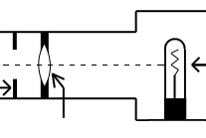
Abbe in order to ease in identification of lens quality devised an equation for numerical aperture. Numerical aperture numbers can assist in comparing angles of dry, water immersion, and oil immersion objectives. Note the similarity to Abbe’s equation for theoretical resolution. This number is found on all objective lenses.
N.A. = n sin u
n = refractive index of medium
u = 1/2 the angle of light rays taken in when focused on the object.
When choosing an objective another consideration is depth of field. Depth of field is the distance from the nearest part of the subject in acceptable focus to the farthest part of the subject in acceptable focus. The efficiency (resolution) of a lens is inversely proportional to the depth of field. Two aberrations within lenses detract from Abbe's equation of theoretical resolution. These aberrations are called spherical aberration and chromatic aberration. Spherical Aberration occurs when outer rays entering a lens are diffracted differently from those entering near the center. A solution for reducing spherical aberration is introducing a diaphragm or aperture.
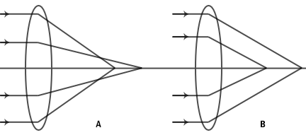
Chromatic Aberration occurs as white light entering a lens is broken into a spectrum from red to violet. Violet rays (more energetic) are refracted more than the red rays (less energetic). Consequently an uncorrected lens will be surrounded by color fringes. The more expensive lenses have a higher degree of correction.
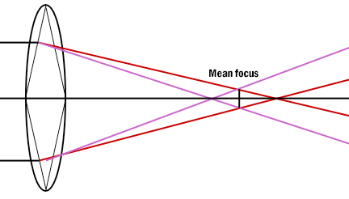
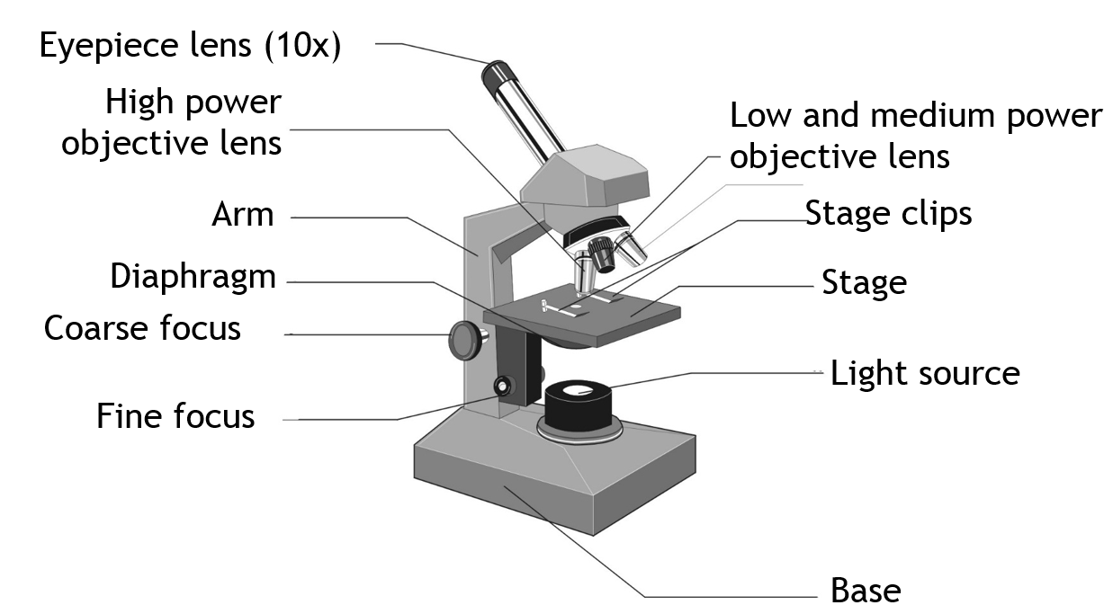
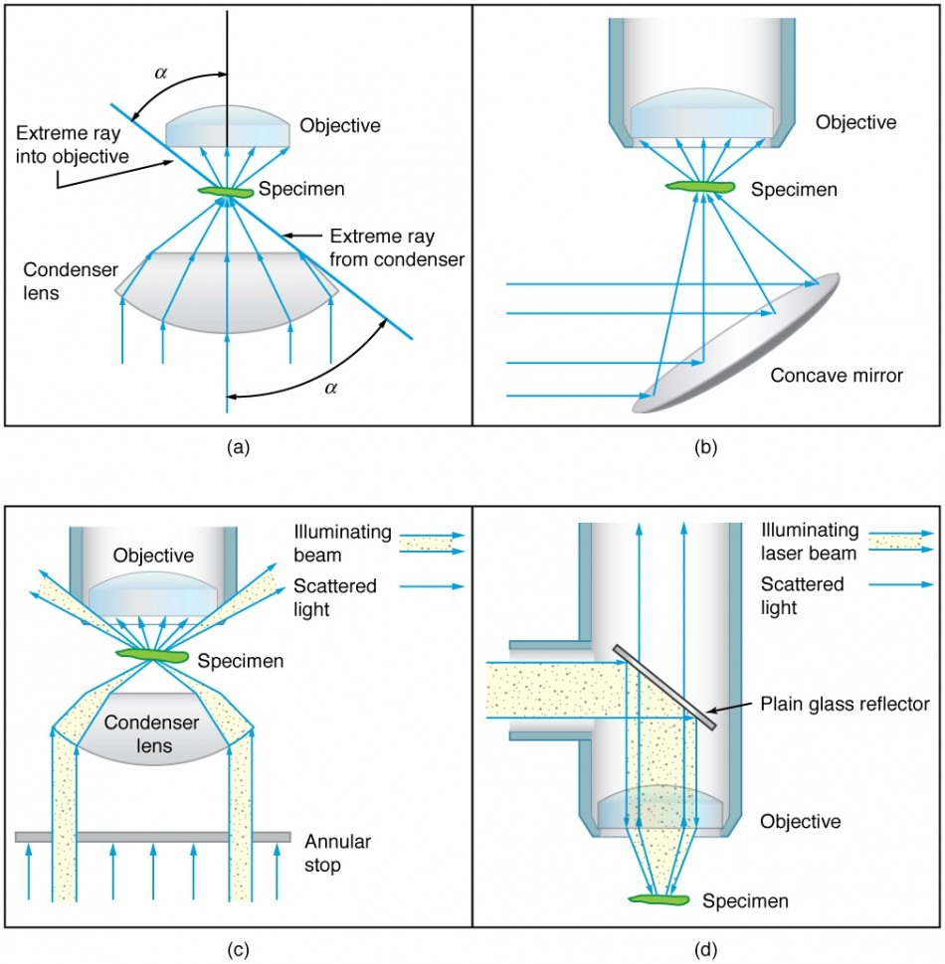

QUESTION 2: Write notes on the following biomedical equipment. Add notes on principle, brand, care and maintenance and cost of
- Centrifuge
- Automatic tissue processor
- Microtome
ANSWER:
Centrifuge; the principle of the centrifuge works on the sedimentation principle, where the centrifugal acceleration causes denser particles and substances to move outward in the radial direction. At the same time objects that are less dense are displaced and move to the center.
- Brands of the centrifuge are;
- General purpose centrifuge
- Bench top centrifuge
- microcentifuges
Care and maintenance of centrifuge:
- Clean the centrifuge daily, or at least weekly.
- Remove the rotor and any sample or container holders.
- Interior cleaning includes the interior bucket, specimen holder, rotor and supports.
- Use a sponge, warm water and a mild detergent such as dishwashing liquid.
- Spills should be wiped up immediately.
- Clean both the exterior and the interior.
- Always place the centrifuge on a flat surface first.
- Always unplug the power cord before cleaning.
Cost of centrifuge; it costs about 120-250 US dollars in naira that’s about 42,000
Automatic Tissue Processor
Principle; the time required for tissue processing may be considerably reduced when tissue suspended in fluid is continuously agitated moved from one reagent to another whenever desired, not restricted by working hours.
Brands;
- Tissue transfer tissue processor
- Fluid transfer tissue processor
Care and maintenance;
- Regular reagent change
- Cleaning of the automatic tissue processor regularly
- Unplug the tissue processor when it’s not in use
- Service the equipment monthly
- Clean the exterior of the machine regularly
Cost; it costs about 1000 US dollars in naira that’s about 350,000
Microtome
Principle; microtome is a sectioning instrument that’s allows the cutting of extremely thin slices of a material known as sections. Microtome are used in microscopy allowing for the preparation of samples for observation under transmitted light or electrons radiation.
Brand;
- Rotary microtome
- Sliding microtome or base ledge microtome
- Cambridge rocking microtome
- Freezing microtome
- Cryostat microtome
- Ultra microtome
Care and maintenance;
- Always change the blades regularly
- Cover up the microtome when it’s not in use
- Clean the exterior of the microtome regularly
- Clean the blade with dry and non-corrosive wipes to avoid damage to the microtome knife
Cost; it costs about 200-500 US dollars in naira that’s about 70,000

