NAME: OLUSEGUN OLAIFA
MATRIC NO: 16/SMS03/020
DEPARTMENT: BUSINESS ADMINISTRATION
COURSE CODE: BUS 408

Questions
1. Explain explicitly what industrial Relation is? who are the parties involved and what are their functions> explain them
2. What is the indices of unemployment in Nigeria. Compare it to any African country of your choice and make your recommendations.

Solution
What is industrial relation?
Industrial relation refers to a relationship between the employers and employees. It also refers to a field of study that examines these types of relationships, especially groups of workers in unions.
The employers are represented by management and employees are represented by unions. There's also a third party involved, the government which acts in the interests of the employees by enacting various legislation.
Parties involved in industrial relation and their functions;
- Trade unions:

Unions Work With Employers to Resolve Labor Issues
One of the most important roles that labor unions perform is that when there is a dispute in the workplace, the union acts as an intermediary between employers and business owners. Labor union leaders are experienced at solving problems through formal arbitration and grievance procedures. Instead of viewing this process as contentious, business owners should welcome the involvement of a union representative, because it can expedite the resolution.

Save Employer Time Through Collective Bargaining
Every labor union in the U.S. operates under what is known as the collective bargaining agreement, which helps secure fair wages, working hours, benefits, and the standards necessary for wage increases. The collective bargaining agreement also protects your employees from being fired without just cause, which protects you from litigation, because you can only terminate a worker if that worker violated your company’s standards and policies.

Help Reduce Turnover Rate
The goal of most labor unions isn’t to create conflict with your business; the goal is to ensure that employees are treated fairly, and that they feel comfortable and secure on the job. When that goal is achieved, employees tend to stick around, instead of trying to find a more favorable situation. Union members earn an estimated 30 percent more in wages than do non-unionized workers, and 92 percent of unionized workers have health insurance, compared to only 68 percent of non-unionized workers.
- The worker/ employee: His role is to kay down his sweat for the job. He must be productive and help maximize profit for the organization. Work to meet the organisation’s objectives and expect salary as at when due.
- The employer or management: To make sure all workers work according to the objective of the organization. To pay the wages and to make sure the workers are motivated to work.
- The government: The government stand as the regulation between the employees and the employer. The government makes policies, rules and regulations which must be obeyed by the parties.
- The community/ society: They are the consumers of the goods and services produced by the workers and management or organization.

2. What is the indices of unemployment in Nigeria. Compare it to any African country of your choice and make your recommendations.

Nigeria: Unemployment rate
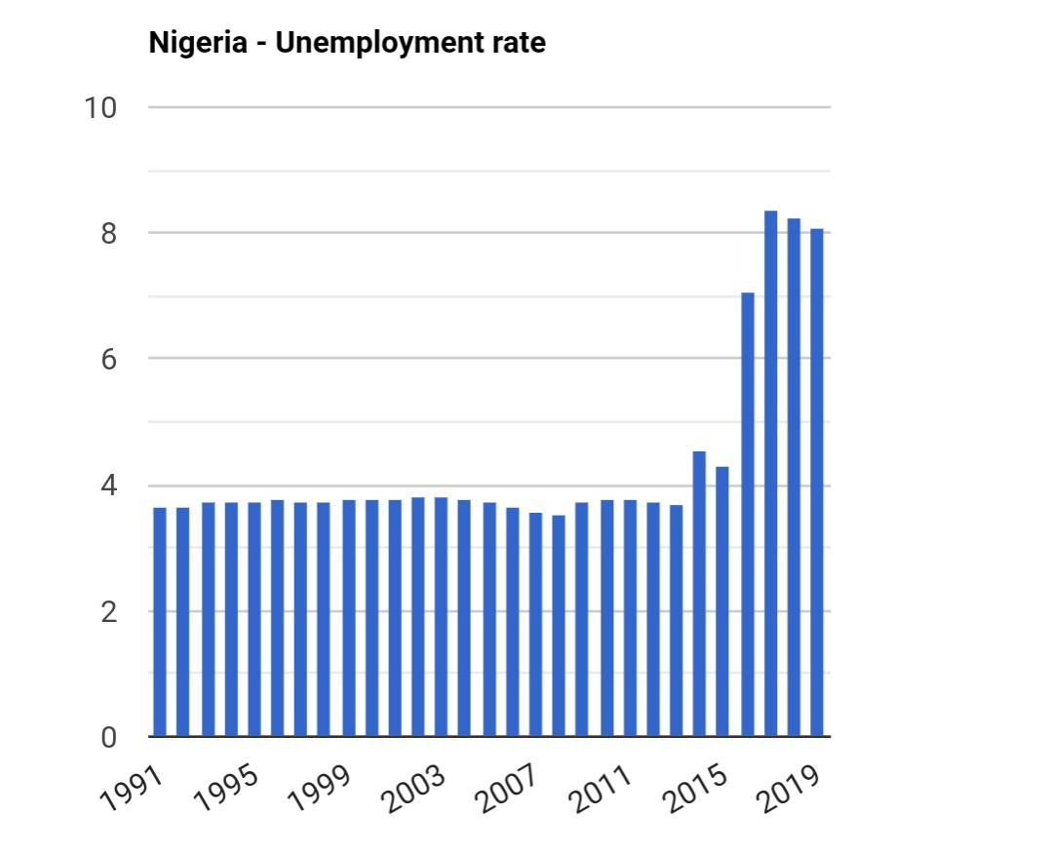
: For that indicator, The World Bank provides data for Nigeria from 1991 to 2019. The average value for Nigeria during that period was 4.36 percent with a minimum of 3.54 percent in 2008 and a maximum of 8.39 percent in 2017. The latest value from 2019 is 8.1 percent. For comparison, the world average in 2019 based on 182 countries is 7.04 percent. See the global rankings for that indicator or use the country comparator to compare trends over time.
The unemployment rate in Nigeria and other countries is defined as the number of unemployed people as percent of the labor force. The labor force includes the people who are either employed or unemployed, i.e. who don't have a job but are actively looking for one. The labor force does not include people who are not looking for work, children, and the retired.
The unemployment rate seldom declines below 4-5 percent even during boom times. There are always people who move between different sectors of the economy or between cities. When the economy goes into recession, then unemployment can reach much higher numbers, sometimes even in the double digits.
Recommendation
Productive work of the government
To overcome the crisis of unemployment in Nigeria, the government must be effective in performing their duties. A socio-economic environment should be created. The government needs to foresee looming crisis and to make all possible actions to prevent it. It is also very important to understand the scope and types of unemployment in Nigeria.
Industrial friendly environment
The government is to consider each sector of the economy and to provide the necessary infrastructure and industrial friendly environment.
Agriculture is one of the major sectors and the government has to do everything possible to attract private investors. Thus, creating new job opportunities.
Improvement of energy supply and transport system will cut the high cost of production. So, there will be no need to cut jobs.
Reformation of educational system
The educational system needs to be reformed in order to produce skilled graduates, innovators, and entrepreneurs. Practice and research should be priority, not just the theoretical learning.
Also, the government needs to create schools, good amenities, infrastructure and job opportunities in rural areas. This will cut the level of migration to cities, thus reducing high population and unemployment in the cities.

Nigerians also have to play their part in reducing the level of unemployment in the country. We need to change our attitude to the future of the country during the election period. We need to understand our responsibility. We should vote for people with credibility, answers and readiness to work. This will determine the conditions of life in the country. Our future is in our hands.

Unemployment rate in Ghana
In 2019, the unemployment rate in Ghana was at approximately 6.78 percent of the total labor force. The unemployment rate is the percentage of a country's labor force that are without jobs but are available to work and actively seeking employment. Ghana’s unemployment rate is above the worldwide unemployment rate, and compared to other Sub-Saharan African countries and other regions, Ghana has a relatively average rate of unemployment.

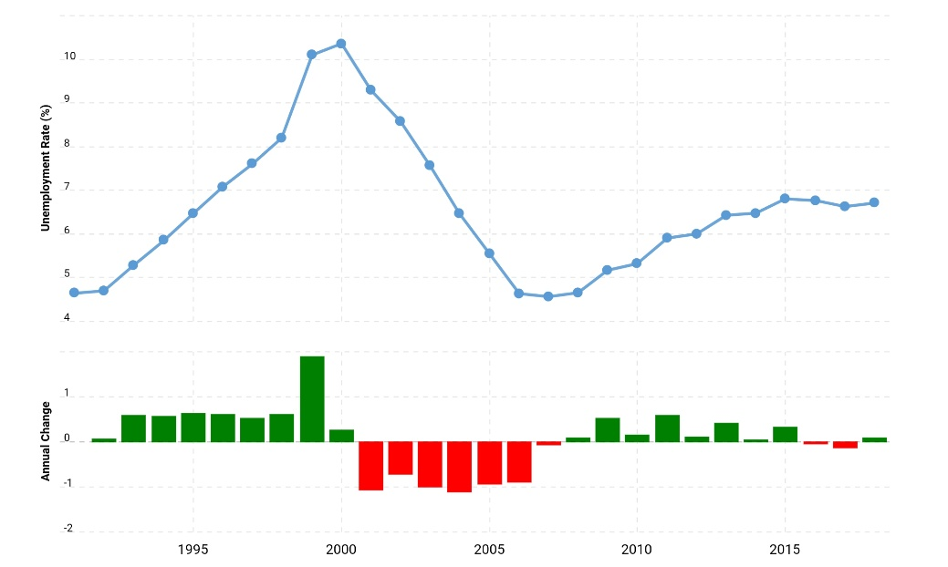
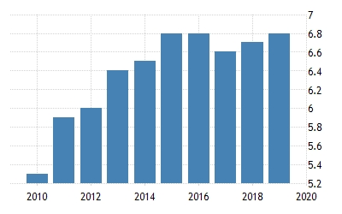
Ghana’s population
Due to the nature of its economy and its population size of over 30 million people, Ghana’s estimated GDP per capita amounts to just over 2,200 U.S. dollars in 2018 and forecast to rise continually over the next few years. Almost half of the country’s population works in the services sector, and around 33 percent work in agriculture. The population is relatively young, with only around 3 percent of the total population aged 65 years or older.
Recommendation
One of the most important economic centers of its region, Ghana’s GDP is at over 65 billion U.S. dollars, and it is projected to grow to over 97 billion U.S. dollars by 2024. Ghana is a country with several valuable natural resources, including gold, petroleum, cocoa, and natural gas. The country’s economy is particularly focused on manufacturing and exporting digital technology goods, and industrial materials. Ghana utilizes these exports domestically as well; its mixed economy is increasingly digital based. A regional leader, it has the goal of being the first African nation to become a developed country in the next decade. There are several positive indications encouraging this possibility, such as that GDP has grown each year, albeit at inconsistent rates.

