NAME: ADAJI ADAKOLE EMMANUEL
MATRIC NUMBER: 18/MHS05/001
DEPARTMENT: PHARMACOLOGY
COURSE CODE: PHS 204

QUESTION
I expect more on the physiology of lactation and details on the physiology of pregnancy in a normal woman

Lactation describes the secretion of milk from the mammary glands and the period of time that a mother lactates to feed her young. The process occurs in all female mammals, although it predates the origin of mammals.
In humans the process of feeding milk is called breastfeeding or nursing.
The chief function of lactation is to provide nutrition and immune protection to the young after birth. In almost all mammals, lactation induces a period of infertility, which serves to provide the optimal birth spacing for survival of the offspring.
In most species, milk comes out of the mother’s nipples; however, the platypus (a non-placental mammal) releases milk through ducts in its abdomen. In only one species of mammal, the dayak fruit bat, is milk production a normal male function.
In some other mammals, the male may produce milk as the result of a hormone imbalance. This phenomenon may also be observed in newborn infants as well (for instance, witch’s milk).
Galactopoiesis is the maintenance of milk production. This stage requires prolactin and oxytocin.

Preparation for Lactation
By the fifth or sixth month of pregnancy, the breasts are ready to produce milk. During the latter part of pregnancy, the woman’s breasts enter into the lactogenesis I stage. This is when the breasts make colostrum, a thick, sometimes yellowish fluid.
At this stage, high levels of progesterone inhibit most milk production. It is not a medical concern if a pregnant woman leaks any colostrum before her baby’s birth, nor is it an indication of future milk production.
At birth, prolactin levels remain high, while the delivery of the placenta results in a sudden drop in progesterone, estrogen, and human placental lactogen levels. This abrupt withdrawal of progesterone in the presence of high prolactin levels stimulates the copious milk production of the lactogenesis II stage.
When the breast is stimulated, prolactin levels in the blood rise and peak in about 45 minutes, then return to the pre-breastfeeding state about three hours later. The release of prolactin triggers the cells in the alveoli to make milk.

Colostrum
Colostrum is the first milk a breastfed baby receives. It contains higher amounts of white blood cells and antibodies than mature milk, and is especially high in immunoglobulin A (IgA), which coats the lining of the baby’s immature intestines, and helps to prevent pathogens from invading the baby’s system. Secretory IgA also helps prevent food allergies. Over the first two weeks after the birth, colostrum production slowly gives way to mature breast milk.

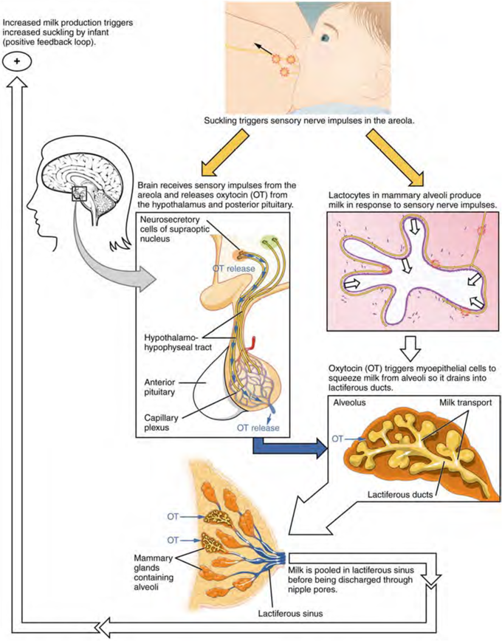

Physiology of pregnancy
Physiology of pregnancy have the potential to increase the risk of marked hyperglycemia and DKA in women with type 1 diabetes. Human placental lactogen, along with growth hormone and prolactin, markedly impairs insulin sensitivity. There is also an accelerated lipolytic rate during normal pregnancy. In addition, the expanding abdominal girth causes rapid shallow breathing and a respiratory alkalosis that leads to a compensatory wasting of bicarbonate in the urine, lowering the patient's buffering capacity. Still, DKA is uncommon in pregnant patients, in part reflecting today's intensive diabetes management in pregnancy. When seen, DKA in a pregnant patient may be the first sign of diabetes or occur because of a broken pump or from an infection. The treatment is similar to that in nonpregnant patients, with mortality rates that are similarly low. On the other hand, older statistics that are still quoted suggest a high fetal loss rate: one review reported 9%.
Pregnancy causes physiologic changes in all maternal organ systems; most return to normal after delivery. In general, the changes are more dramatic in multifetal than in single pregnancies.

Cardiovascular
Cardiac output (CO) increases 30 to 50%, beginning by 6 weeks gestation and peaking between 16 and 28 weeks (usually at about 24 weeks). It remains near peak levels until after 30 weeks. Then, CO becomes sensitive to body position. Positions that cause the enlarging uterus to obstruct the vena cava the most (eg, the recumbent position) cause CO to decrease the most. On average, CO usually decreases slightly from 30 weeks until labor begins. During labor, CO increases another 30%. After delivery, the uterus contracts, and CO drops rapidly to about 15 to 25% above normal, then gradually decreases (mostly over the next 3 to 4 weeks) until it reaches the prepregnancy level at about 6 weeks postpartum.
The increase in CO during pregnancy is due mainly to demands of the uteroplacental circulation; volume of the uteroplacental circulation increases markedly, and circulation within the intervillous space acts partly as an arteriovenous shunt. As the placenta and fetus develop, blood flow to the uterus must increase to about 1 L/min (20% of normal CO) at term. Increased needs of the skin (to regulate temperature) and kidneys (to excrete fetal wastes) account for some of the increased CO.
To increase CO, heart rate increases from the normal 70 to as high as 90 beats/min, and stroke volume increases. During the 2nd trimester, blood pressure (BP) usually drops (and pulse pressure widens), even though CO and renin and angiotensin levels increase, because uteroplacental circulation expands (the placental intervillous space develops) and systemic vascular resistance decreases. Resistance decreases because blood viscosity and sensitivity to angiotensin decrease. During the 3rd trimester, BP may return to normal. With twins, CO increases more and diastolic BP is lower at 20 weeks than with a single fetus.
Exercise increases CO, heart rate, oxygen consumption, and respiratory volume/min more during pregnancy than at other times.
The hyperdynamic circulation of pregnancy increases frequency of functional murmurs and accentuates heart sounds. X-ray or ECG may show the heart displaced into a horizontal position, rotating to the left, with increased transverse diameter. Premature atrial and ventricular beats are common during pregnancy. All these changes are normal and should not be erroneously diagnosed as a heart disorder; they can usually be managed with reassurance alone. However, paroxysms of atrial tachycardia occur more frequently in pregnant women and may require prophylactic digitalization or other antiarrhythmic drugs. Pregnancy does not affect the indications for or safety of cardioversion.

Hematologic
Total blood volume increases proportionally with cardiac output, but the increase in plasma volume is greater (close to 50%, usually by about 1600 mL for a total of 5200 mL) than that in red blood cell (RBC) mass (about 25%); thus, hemoglobin (Hb) is lowered by dilution, from about 13.3 to 12.1 g/dL. This dilutional anemia decreases blood viscosity. With twins, total maternal blood volume increases more (closer to 60%).
WBC count increases slightly to 9,000 to 12,000/mcL. Marked leukocytosis (≥ 20,000/mcL) occurs during labor and the first few days postpartum.
Iron requirements increase by a total of about 1 g during the entire pregnancy and are higher during the 2nd half of pregnancy—6 to 7 mg/day. The fetus and placenta use about 300 mg of iron, and the increased maternal RBC mass requires an additional 500 mg. Excretion accounts for 200 mg. Iron supplements are needed to prevent a further decrease in Hb levels because the amount absorbed from the diet and recruited from iron stores (average total of 300 to 500 mg) is usually insufficient to meet the demands of pregnancy.

Urinary
Changes in renal function roughly parallel those in cardiac function. Glomerular filtration rate (GFR) increases 30 to 50%, peaks between 16 and 24 weeks gestation, and remains at that level until nearly term, when it may decrease slightly because uterine pressure on the vena cava often causes venous stasis in the lower extremities. Renal plasma flow increases in proportion to GFR. As a result, blood urea nitrogen (BUN) decreases, usually to < 10 mg/dL (< 3.6 mmol urea/L), and creatinine levels decrease proportionally to 0.5 to 0.7 mg/dL (44 to 62 micromole/L). Marked dilation of the ureters (hydroureter) is caused by hormonal influences (predominantly progesterone) and by backup due to pressure from the enlarged uterus on the ureters, which can also cause hydronephrosis. Postpartum, the urinary collecting system may take as long as 12 weeks to return to normal.
Postural changes affect renal function more during pregnancy than at other times; ie, the supine position increases renal function more, and upright positions decrease renal function more. Renal function also markedly increases in the lateral position, particularly when lying on the left side; this position relieves the pressure that the enlarged uterus puts on the great vessels when pregnant women are supine. This positional increase in renal function is one reason pregnant women need to urinate frequently when trying to sleep.

Respiratory
Lung function changes partly because progesterone increases and partly because the enlarging uterus interferes with lung expansion. Progesterone signals the brain to lower carbon dioxide (CO2) levels. To lower CO2 levels, tidal and minute volume and respiratory rate increase, thus increasing plasma pH. oxygen consumption increases by about 20% to meet the increased metabolic needs of the fetus, placenta, and several maternal organs. Inspiratory and expiratory reserve, residual volume and capacity, and plasma PCO2 decrease. Vital capacity and plasma PCO2 do not change. Thoracic circumference increases by about 10 cm.
Considerable hyperemia and edema of the respiratory tract occur. Occasionally, symptomatic nasopharyngeal obstruction and nasal stuffiness occur, eustachian tubes are transiently blocked, and tone and quality of voice change.
Mild dyspnea during exertion is common, and deep respirations are more frequent.

Gastrointestinal (GI) and hepatobiliary
As pregnancy progresses, pressure from the enlarging uterus on the rectum and lower portion of the colon may cause constipation. GI motility decreases because elevated progesterone levels relax smooth muscle. Heartburn and belching are common, possibly resulting from delayed gastric emptying and gastroesophageal reflux due to relaxation of the lower esophageal sphincter and diaphragmatic hiatus. Hydrochloric acid production decreases; thus, peptic ulcer disease is uncommon during pregnancy, and preexisting ulcers often become less severe.
Incidence of gallbladder disorders increases somewhat. Pregnancy subtly affects hepatic function, especially bile transport. Routine liver function test values are normal, except for alkaline phosphatase levels, which increase progressively during the 3rd trimester and may be 2 to 3 times normal at term; the increase is due to placental production of this enzyme rather than hepatic dysfunction.

Endocrine
Pregnancy alters the function of most endocrine glands, partly because the placenta produces hormones and partly because most hormones circulate in protein-bound forms and protein binding increases during pregnancy.
The placenta produces the beta subunit of human chorionic gonadotropin (beta-hCG), a trophic hormone that, like follicle-stimulating and luteinizing hormones, maintains the corpus luteum and thereby prevents ovulation. Levels of estrogen and progesterone increase early during pregnancy because beta-hCG stimulates the ovaries to continuously produce them. After 9 to 10 weeks of pregnancy, the placenta itself produces large amounts of estrogen and progesterone to help maintain the pregnancy.
The placenta produces a hormone (similar to thyroid-stimulating hormone) that stimulates the thyroid, causing hyperplasia, increased vascularity, and moderate enlargement. Estrogen stimulates hepatocytes, causing increased thyroid-binding globulin levels; thus, although total thyroxine levels may increase, levels of free thyroid hormones remain normal. Effects of thyroid hormone tend to increase and may resemble hyperthyroidism, with tachycardia, palpitations, excessive perspiration, and emotional instability. However, true hyperthyroidism occurs in only 0.08% of pregnancies.
The placenta produces corticotropin-releasing hormone (CRH), which stimulates maternal adrenocorticotropic hormone (ACTH) production. Increased ACTH levels increase levels of adrenal hormones, especially aldosterone and cortisol, and thus contribute to edema.
Increased production of corticosteroids and increased placental production of progesterone lead to insulin resistance and an increased need for insulin, as does the stress of pregnancy and possibly the increased level of human placental lactogen. Insulinase, produced by the placenta, may also increase insulin requirements, so that many women with gestational diabetes develop more overt forms of diabetes.
The placenta produces melanocyte-stimulating hormone (MSH), which increases skin pigmentation late in pregnancy.
The pituitary gland enlarges by about 135% during pregnancy. The maternal plasma prolactin level increases by 10-fold. Increased prolactin is related to an increase in thyrotropin-releasing hormone production, stimulated by estrogen. The primary function of increased prolactin is to ensure lactation. The level returns to normal postpartum, even in women who breastfeed.

Dermatologic
Increased levels of estrogens, progesterone, and MSH contribute to pigmentary changes, although exact pathogenesis is unknown. These changes include
- Melasma (mask of pregnancy), which is a blotchy, brownish

