NAME: ALIYU MARIAM OMOTAYO
COURSE: BIO 102
DEPARTMENT: MBBS MEDICINE AND SURGERY
MATRIC NUMBER: 19/MHS01/085
- Fungi are important to man for the following reasons;
- They serve as agents of fermentation in the production of bread, alcoholic beverages, etc.
- Yeast is important in food industries like bakeries and yogurt making factories.
- It serves as food for man in the form of mushroom.
- They play an important role in medicine yielding antibiotics.
- They are major source of citric acid.
- Yeasts are unicellular fungus, very polymorphic and are capable of assuming different forms depending on the medium in which they grow and their age. Individually, yeast cells are hyaline but in colonies appear white, cream-coloured or slightly brownish. Cells may remain attached in short chains forming a pseudomycelium, but they do not produce true mycelium. The cells are variable in shape being globose, oval, elongated, or rectangular.
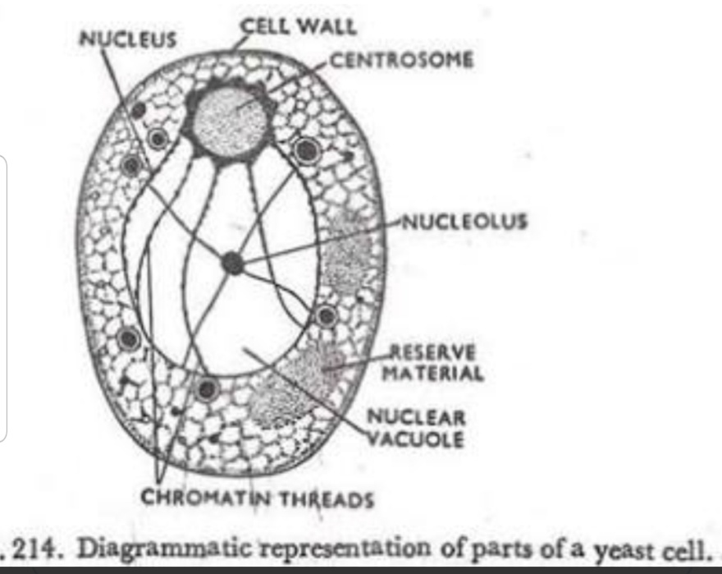
- Sexual reproduction in a filamentous fungi like Rhizopus stolonifer undergoes the following steps;
- First, two mating types of hyphae grow in the same medium.
- A chemical interaction between them causes growth perpendicular to the hyphae in opposite directions, so they can meet with one another.
- The growths are the delimited by a wall just so the nuclei are isolated in differentiated sex organs called gametangia (plural).
- The gametangia fuse in a process called plasmogamy and together they form a zygote which may undergo dormancy for a period.
- The nuclei in the zygote fuse in twos and undergo meiosis independently, it then moves on to germinating under favorable conditions so as to liberate haploid spores at maturity through the production of a fruiting.
- In summary, sexual reproduction in fungi consists of three stages; plasmogamy, karogamy and meiosis.
- Bryophytes are able to survive in their habitat via they following;
- They possess definite structures for water and nutrient absorption from the soil.
- They also possess a waxy cuticle that keeps them from drying out through the process of desiccation
- The possession of gametangia that keep the plants gametes from drying out.
- A. Eusteles: a type of stele typical of dicotyledonous plants in which the vascular tissue in the stem forms a central ring of bundles around a pith. The vascular bundles are discrete, concentric collateral bundles of xylem and phloem.
B. Atactostele: a type of stele found in monocots, in which the vascular tissue in the stem exists as scattered bundles.
C. Siphonostele: A stele consisting of a core of pith surrounded by concentric layers of xylem and phloem.
D. Dictyostele: a type of stele in which the vascular cylinder is broken up into a longitudinal series or network of vascular strands around a pith.
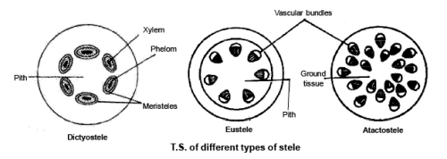
Diagrammatic illustrations of the different steles.

- The lifecycle of primitive vascular plant is an alternation of generations, where the diploid sporophyte alternates with the haploid gametophyte phase. The diploid sporophyte is the dominant phase of the lifecycle, while the gametophyte is an inconspicuous, but still-independent organism.

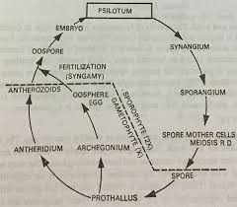
Life cycle of a primitive vascular plant (psilotum)

