NAME: AFUWAPE OLAMIDE MARY
MATRIC NO: 19/MHS01/049
DEPARTMENT: MEDICINE AND SURGERY
- Fungi are responsible for the mediation of decay of organic matter. Without fungi, the surface of the earth would have been clogged up with dead matters with all the various elements locked up in them instead of returning into various cycles. Fungi e.g. yeast are important in food industry. Mushrooms are eaten by many human societies e.g. Penicillium notatum which produce important antibiotics. Many fungi species mediate the spoilage of wood, food, clothes and paper. Many are plants pathogens causing blights and smuts in cereals (Helminthosporium maydis and Ustilago zeac respiration). Some fungi are parasites to some certain horrible obnoxious offensive pests e.g. houseflies and therefore constitute important biological control agents in regard to such pests.

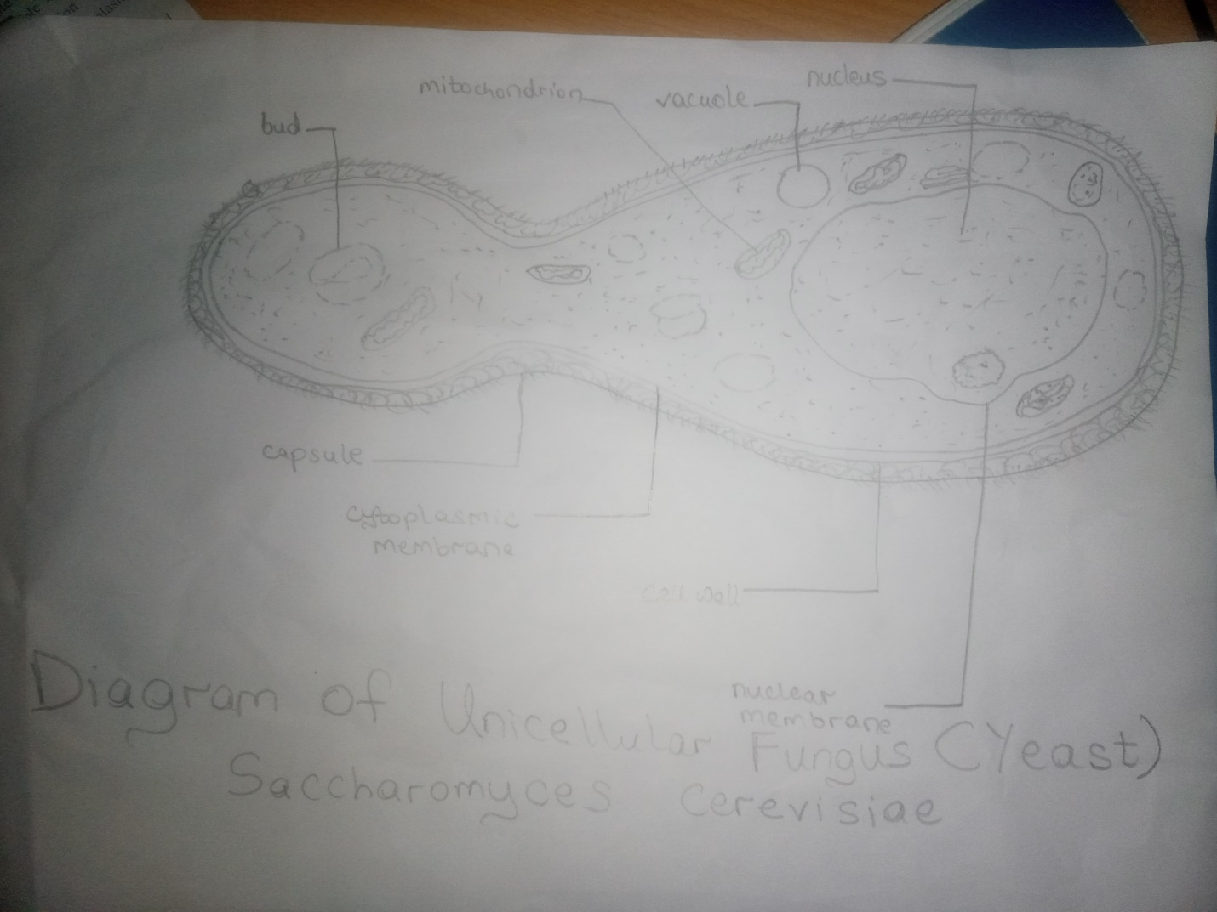

- Sexual reproduction in filamentous form of fungi – Rhizopus stolonifer
This occurs when two mating types of hyphae grow in the same medium. Chemical interaction in the two mating types of hyphae induces growths perpendicular to the hyphae in opposite directions. These growths are delimited by a wall such that many nuclei are isolated in what is called a gametangium. The two gametangia fuse (plasmogamy) and a zygote is formed which may undergo prolonged dormancy or resting stage. The nuclei in the zygotes fuse in twos and undergo meiosis independently. The zygote germinates under favorable conditions to produce a fruiting which at maturity liberates the haploid spores.
Relatives of Rhizopus in similar circumstances are many. Mucor spp are a group which lack rhizoids. The genus Pilobolus is usually found growing on cow/ horse dung. Species called black mould belong to Aspergillus; the spores are many in the air and germinate readily on exposed food and fruits; while some species of Aspergillus e.g. A. niger and A. fumigatus cause certain lung diseases (aspergilloses) in man and other animals, some are used in food processing. The hyphae are coenocytic and the nuclei are haploid. A multinucleate foot cell is delimited on the coenocytic horizontal hypha in favorable environments. A vertical hypha (conidiophere) with a modified tip carrying bottle-shaped sterigma (pl. sterigmata) produces haploid spores called conidia (sing: conidium) is produced by the foot cell which is easily dispersed by air.
- Ways in which Bryophytes adapt to environment
  - They have definite structures for water and nutrients absorption from the soil; therefore the plant body is divided into two (an aerial portion and a subterranean portion). The subterranean portion is the rhizoid and is not a true root as the case of land plants that are advanced.
  - The aerial portion being exposed to the atmosphere demands some modifications that prevent excessive loss of water through the body surface (i.e. desiccation).
  - Some other modifications that permit elimination of excess water from the plant body and not only exchange of gases between the internal parts of the plant and the atmosphere therefore openings are available on the aerial parts of the plant.
Bryophytes are similar to higher plants in that the fertilized egg develops into an embryo, a cell mass dependent on the gametophyte (the sexual plant). Their embryos however, develop into sporophytes (asexual plants) which unlike those of higher plants remain almost entirely dependent on the gametophytes and have no true leaves, stems or roots.
- (a) Eustele: this is one of the kinds of vascular organization encountered in flowering plants. It is found in herbaceous dicotyledonous plants in which the vascular bundles are discrete and concentric collateral bundles of xylem and phloem.
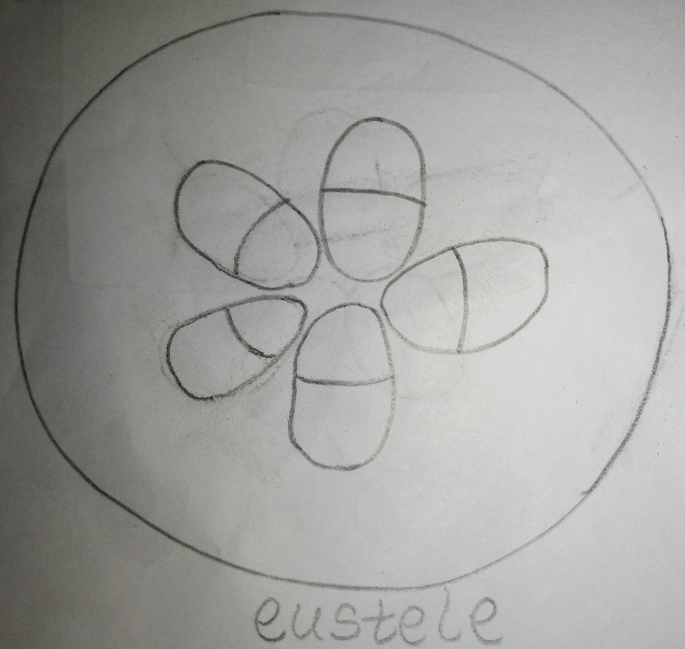
(b) Atactostele: this is one of the kinds of vascular organization encountered in flowering plants. In grasses and many monocotyledonous plants, the vascular bundles are scattered.
(c) Siphonostele: In this, vascular supply to leaves is associated with leaf gaps. The nature of the vascular supply to leaves is also noteworthy element of the vascular system. Vascular supply to leaves is absent in protosteles e.g. Psilotum where the vascular supply is associated with a leaf gap.
(d) Dictyostele: This is the conducting cylinder of vascular supplies associated to leaf gaps or not and it is dissected.
- Life cycle of a primitive vascular plant – Psilotum
