Stephen Helen Ebiaredo
19/MHS02/112
Nursing
BIO 102 ASSIGNMENT
- How is fungi important to mankind?
Fungi is responsible for the mediation of decay organic matter.fungi e.g yeast are important in food industry. Mushrooms are eaten by many human society or species e.g penicillium notatum for example produce important antibiotics.while some fungi are parasites to some certain horrible obnoxious pest e.g houseflies therefore constitute important biological control agent in regard to such pests
- Illustrate the cell structure of a unicellular fungus with a well labeled diagram.
CELL STRUCTURE OF A UNICELLULAR FUNGUS
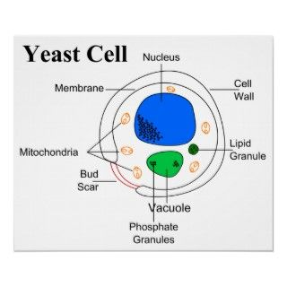
- Outline the sexual reproduction in a typical filamentous form of fungi
Sexual reproduction in a filamentous fungi like Rhizopus stolonifer undergoes the following steps;
- First, two mating types of hyphae grow in the same medium.
- A chemical interaction between them causes growth perpendicular to the hyphae in opposite directions, so they can meet with one another.
- The growths are the delimited by a wall just so the nuclei are isolated in differentiated sex organs called gametangia (plural).
- The gametangia fuse in a process called plasmogamy and together they form a zygote which may undergo dormancy for a period.
- The nuclei in the zygote fuse in twos and undergo meiosis independently, it then moves on to germinating under favorable conditions so as to liberate haploid spores at maturity through the production of a fruiting.
- In summary, sexual reproduction in fungi consists of three stages; plasmogamy, karogamy and meiosis.
- How do Bryophytes adapt to their environment.
Bryophytes are able to survive in their habitat via they following;
- They possess definite structures for water and nutrient absorption from the soil, therefore the plants body is divided into two(an aerial portion and a subterranean portion).
- They also possess a waxy cuticle that keeps them from drying out through the process of desiccation
- They possess gametangia that keep the plants gametes from drying out.
- Describe with illustration the following terminologies
A. Eusteles; a type of stele in which the vascular tissue in the stem forms a central ring of bundles around a pith. The vascular bundles are discrete, concentric collateral bundles of xylem and phloem.
B. Atactostele; a type of stele found in monocots, in which the vascular tissue in the stem exists as scattered bundles.
C. Dictyostele; a type of stele in which the vascular cylinder is broken up into a longitudinal series or network of vascular strands around a pith.
Diagrammatic illustrations of the different steles.
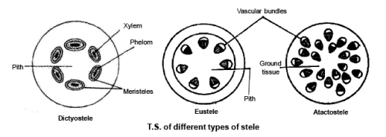
- Illustrate the life cycle of a primitive vascular plant.

Life cycle of a primitive vascular plant (psilotum)

