NAME: ADEGUNJU AYOMIDE MERCY
DEPARTMENT: MBBS
COURSE CODE: BIO102
MAT NO: 19/MHS01/026

- How are fungi important to mankind?
Fungi is responsible for the mediation of decay of organic matter. Fungi e.g. yeast, are important in food industry. Mushrooms are eaten by many human societies, species e.g. Penicillium notatum produce important antibiotics. Some fungi are parasites to some certain horrible obnoxious pests e.g. houseflies therefore constitute important biological control agents in regard to such pests.
- Illustrate the cell structure of a unicellular fungus with a well labeled diagram
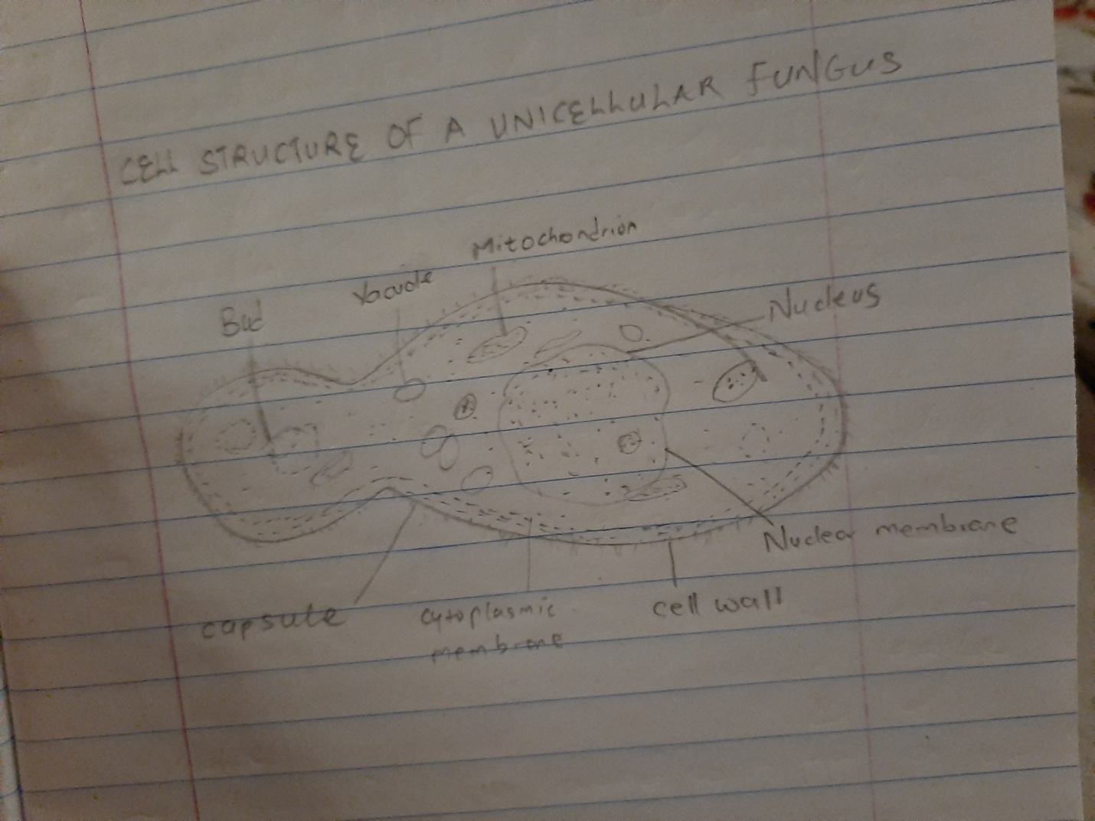
- Outline the sexual reproduction in a typical filamentous form of fungi
Rhizopus stolonifer : sexual reproduction occurs when two mating types of hyphae grow in the same medium. Chemical interaction in the two mating types of hyphae induces growths perpendicular to the hyphae in opposite directions. These growths are delimited by a wall such that many nuclei are isolated in what is called gametangium. The two gametangia fuse (plasmogamy) and a zygote is formed which may undergo prolonged dormancy or resting stage. The nuclei in the zygote fuse in twos and undergo meiosis independently. The zygote germinates under favourable conditions to produce a fruiting which at maturity liberates the haploid spores.
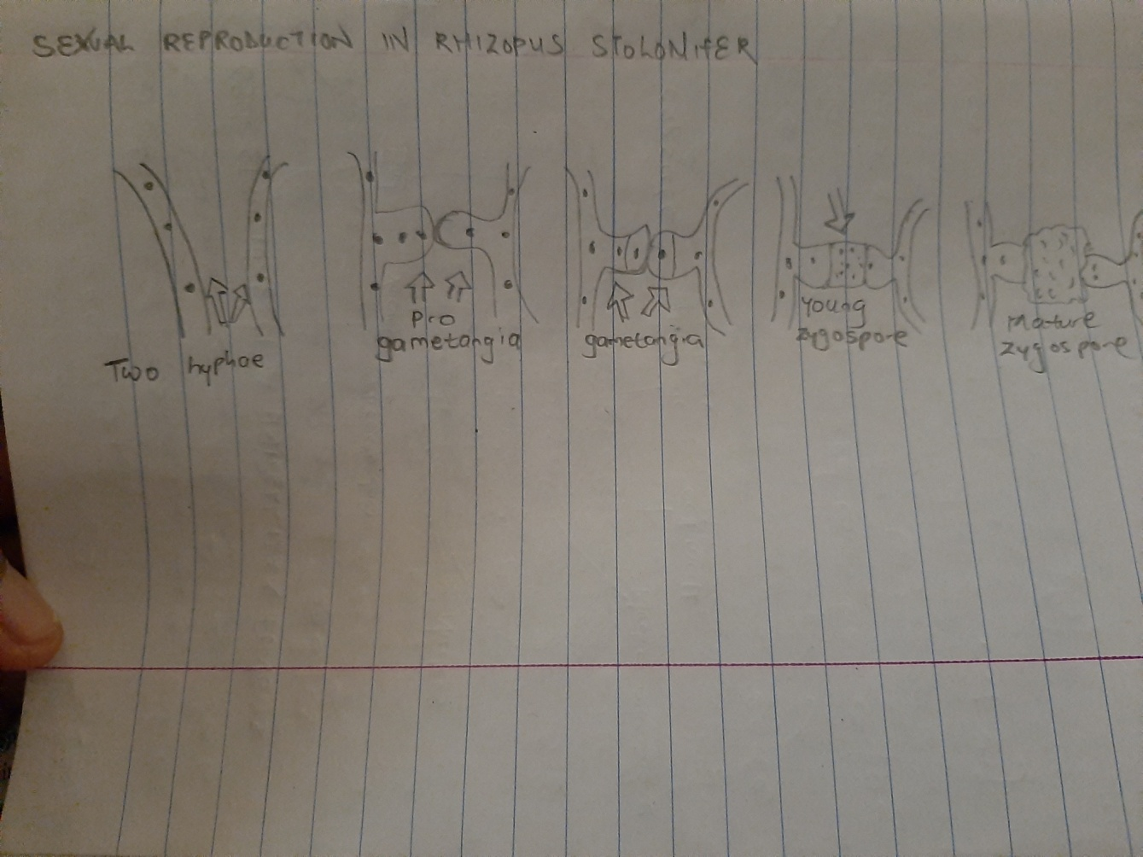
- How do Bryophytes adapt to their environment
- They have definite structures for water and nutrient absorption from the soil; therfore the plant body is divided into two (an aerial portion and a subterranean portion). The subterranean portion is the rhizoid and is not a true root as the case of land plants that are advanced.
- The aerial portion being exposed to the atmosphere demands some modifications that prevents excessive loss of water through the body surface (i.e desiccation
- Some other modifications that permit elimination of excess water from the plant body and not only exchange of gasses between the internal parts of the plant and the atmosphere therefore openings are available on the aerial parts of the plant.
- Describe with illustrations the following terminologies
- Eusteles: The vascular bundles are discrete, concentric collateral bundles of xylem and phloem.

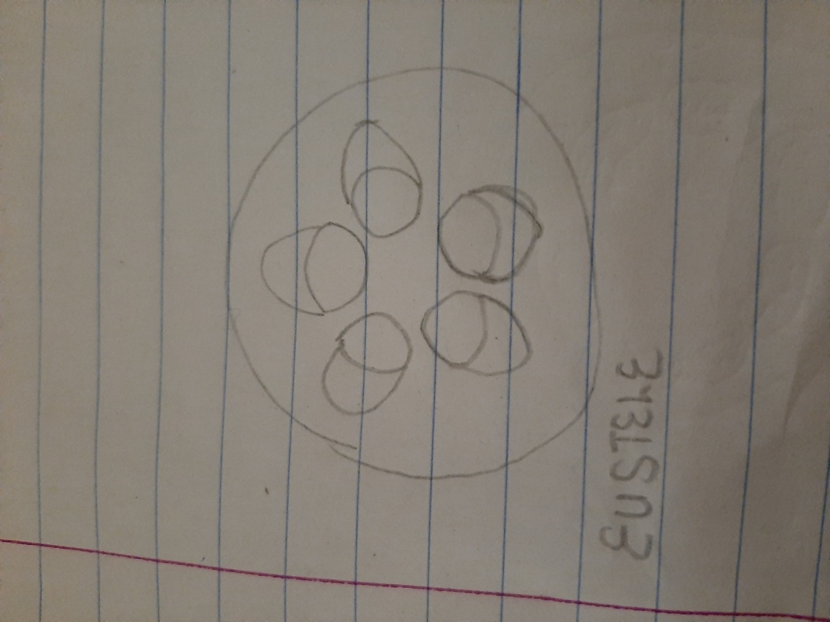
- Atactostele : In grasses and monocotyledonous plants the vasacular bundles are scattered.
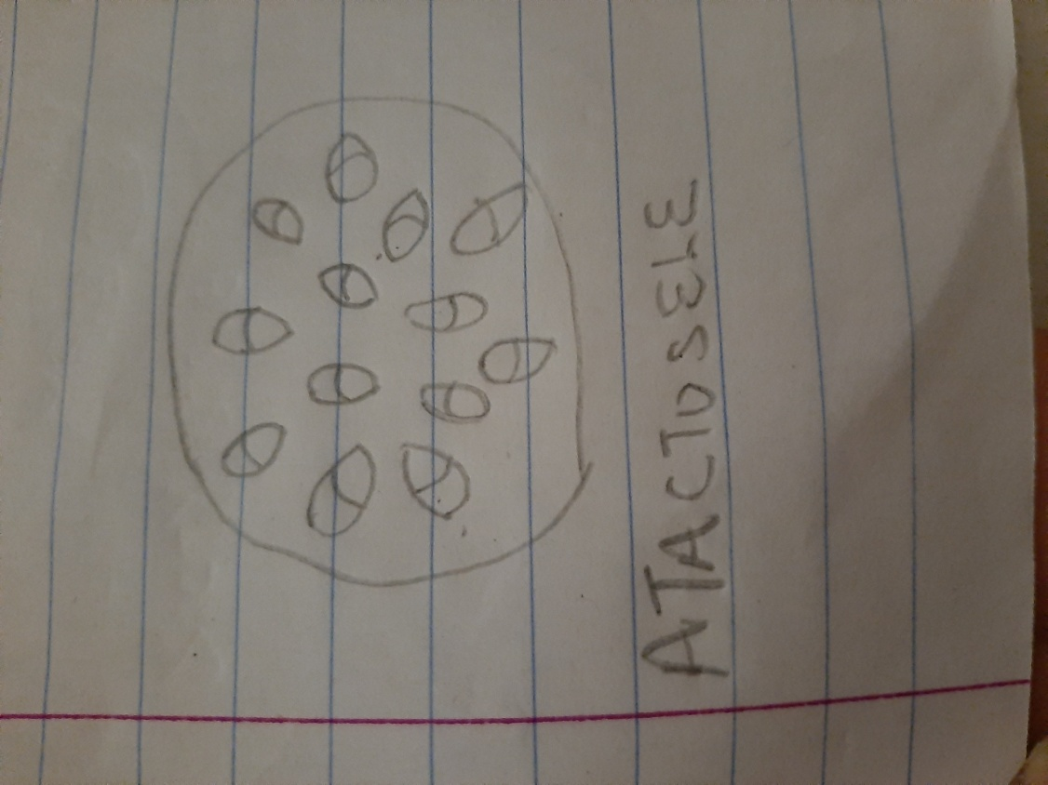
- Siphonostele: In more advanced vascular systems e.g stems of ferns and higher vascular plants, the stele is a cylinder enclosing a parenchymatous pith.
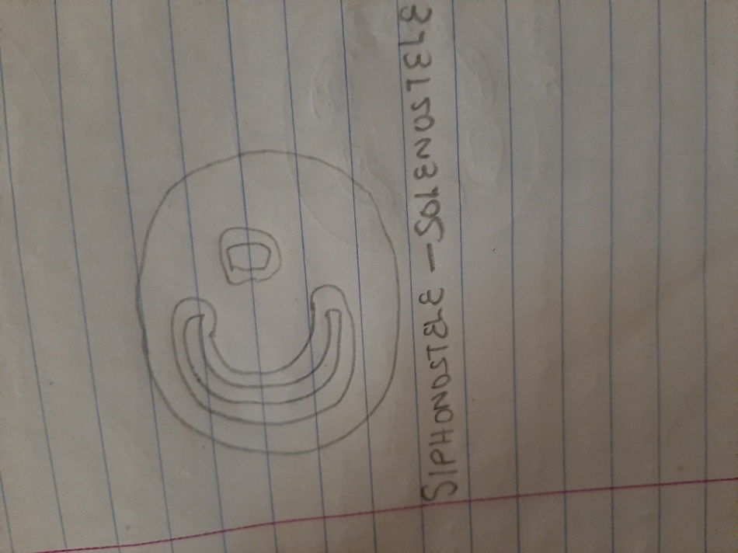
- Dictyostele: In siphonosteles, vascular supply to leaves is associated with leaf gaps and the conducting cylinder is a dissected one.
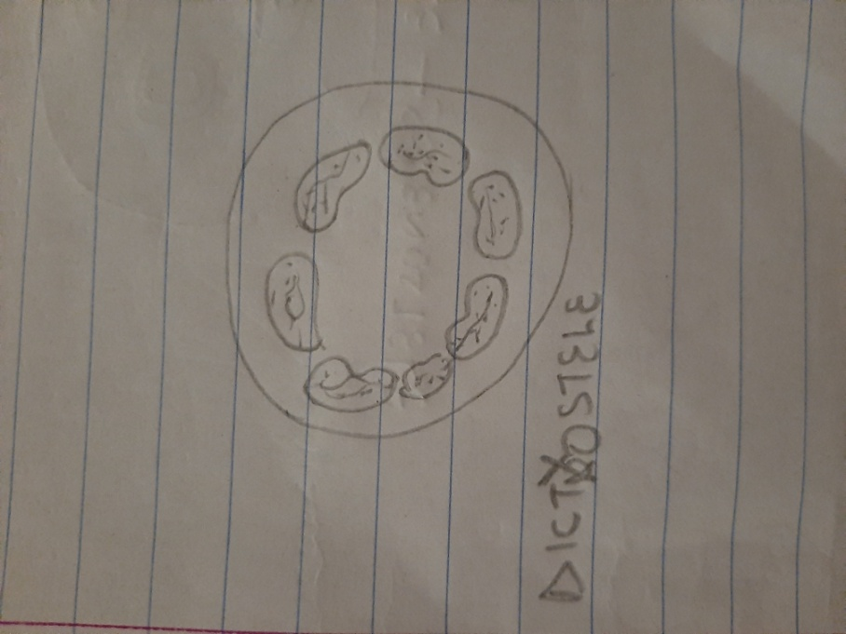
- Illustrate the life cycle of a primitive vascular plant.
