NAME: JWAN SEKYEEN BLESSING.
COLLEGE: MHS.
DEPARTMENT: MBBS.
MATRIC NUMBER: 19/MHS01/224.

- (i) As animal pathogens, fungi help to control the population of damaging pests.
(ii) Farming: The mycorrhizal relationship between fungi and play roots is essential for the productivity of farmland.
(iii) Medicine: Many secondary metabolites of fungi are of great commercial importance. Fungi naturally produce antibiotics to kill or inhibit the growth if bacteria, limiting their competition in the natural environment.
(iv) Food: Fungi, as food, play a role in human nutrition in the form of mushrooms and also as agents of fermentation in the production of bread, cheese and other alcoholic beverages.
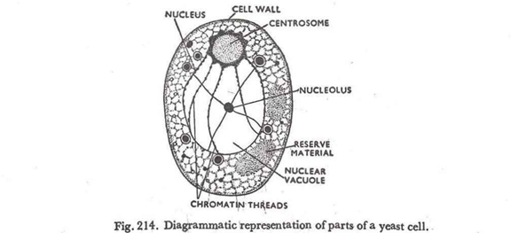

- Sexual Reproduction of yeast:
The sexual reproduction takes place very rarely in some of the species of yeasts. This takes place by conjugation. Two individuals come close to each other and the beak-like outgrowths are given out from them. These outgrowths fuse with each other. The nuclei of both individuals come in these beaks, the wall of contact dissolves and ultimately the nuclei fuse with each other giving rise to a zygote, which soon converts into an ascus. The diploid nucleus (2n) of asucs divides thrice producing eight nuclei. The first division is reductional to bring haploid (n) condition again.
Around each nucleus the cytoplasm is deposited, they become walled and called the ascospores. On bursting the wall of ascus the ascospores are liberated. On getting suitable conditions they germinate and the new individuals are produced by budding.

- (i) Mosses have developed leaf-, stem-, and root-like structures, apart from the thallus of algae. They develop specialized structures for a particular function. Generally, leaves are specialized for photosynthesis; stems are specialized for support as well as transport; roots are specialized for support and absorption of water.

(ii) Each cell of the moss is surrounded by a thick cell wall, providing support to the plant as in higher plants.

(iii). Mosses have chlorophyll for photosynthesis. Hence, they produce their own food.

(iv) .Mosses asexually reproduce through spores. A spore consists of a single reproductive cell covered by a protective, hard, and watertight covering. It is transmitted through the air. The production of this type of spores by mosses is an adaptation for the life on land.

- (i) Siphonostele: This is the modification of protostele. A stele in which the protostele is medullated is known as siphonostele. Such stele contains a tubular vascular region and a parenchymatous central region. Jeffrey (1898) interpreted that the vascular portion of siphonostele possesses a parenchymatous area known as a gap immediately above the branch traces only or immediately above leaf and branch traces.
On the basis of these branch and leaf gaps Jeffrey (1910), distinguished two types of siphonosteles. In one type, however, the leaf gaps are not found and they are known as cladosiphonic siphonosteles. In the other type both leaf and branch gaps are present and they are known as phyllosiphonic siphonosteles.

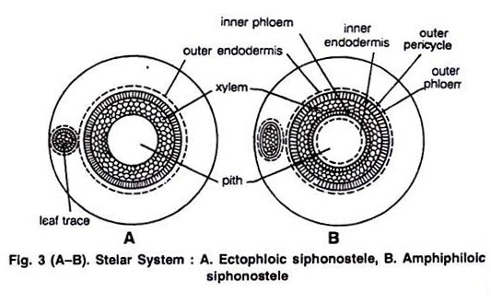
(ii) Eustele: Eustele can be defined as a type of ectophloic siphonostele with overlapping leaf gaps. The leaf gaps occur parallel to each other and are not distantly spaced. The upper part of a gap overlaps the basal part of the upper adjacent gap. When viewed as three-dimensional object the vascular strands form an interconnected network. The vascular strands are separate as seen in cross- section. Each vascular strand, also called vascular bundle, is conjoint and collateral.

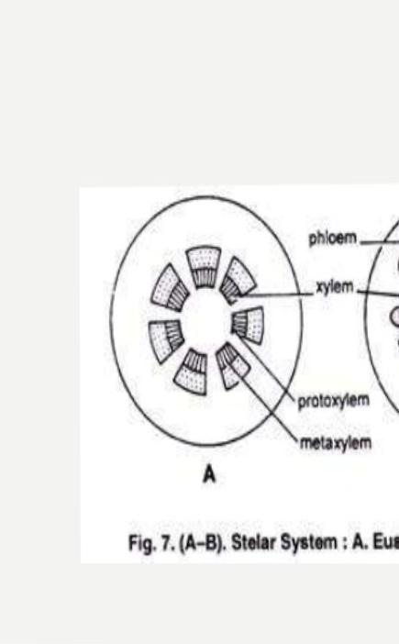
Parenchyma occurs at interfascicular region. All vascular bundles are arranged in a ring like manner. Pericycle surrounds the vascular bundles on the peripheral side, the whole being bounded by a continuous endodermis. Eustele is the characteristic of gymnosperm and dicotyledonous stem. Ex. Helianthus, Xanthium etc. Eustele with bicollateral vascular bundle is observed in the families Cucurbitaceae, Solanaceae etc.

(iii) . Atactostele: Atactostele can be defined as a type of eustele where collateral vascular bundles are arranged in an irregular manner (Fig. 15.2). It is the characteristic of monocotyledonous stem where there is no distinction between pith and cortex.

Parenchyma bounded by epidermis is designated as ground tissue in monocotyledons. The vascular bundles are scattered on the ground tissue as seen in cross-section of stem. The vascular strands form an interconnected network when viewed as three-dimensional object. Ex. Stem of Zea mays, Asparagus (Fig. 15.3E) etc.

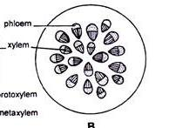

DIAGRAM OF AN ATACTOSTELE.

ii. Dictyostele:

Dictyostele can be defined as a type of amphiphloic siphonostele with overlapping leaf gaps. The upper part of a leaf gap overlaps the lower part of the upper adjacent leaf gap. The gaps are not distantly spaced from each other and occur in parallel manner. As a result a longitudinal cylindrical network of interconnected vascular strands (Fig. 15.1C) is formed when viewed as three- dimensional object.

The vascular strand is perforated as seen in cross-section. The vascular strands are arranged in a ring-like manner and parenchyma occurs in between the vascular strands. Each vascular strand is composed of xylem surrounded by phloem.

This amphicribral vascular strand is surrounded by a pericycle and the whole being bounded on the outside by a continuous endodermis. Ex. Mohria, Polypodium falcatum, Ophioglossum, Dryopteris etc. Each vascular strand of dictyostele is referred to as meristele.

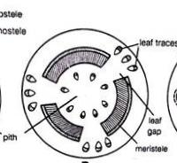
DIAGRAM OF A DICTYOSTELE.
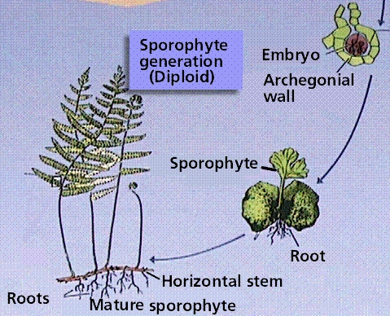

DIAGRAM OF THE LIFE CYCLE OF A PRIMITIVE VASCULAR PLANT.

