16/MHS06/052
TOBORE OLOKOR
MLS 406

Coronaviruses belong to the Coronaviridae family in the Nidovirales order. Corona represents crown-like spikes on the outer surface of the virus; thus, it was named as a coronavirus. Coronaviruses are minute in size (65–125 nm in diameter) and contain a single-stranded RNA as a nucleic material, size ranging from 26 to 32kbs in length (Fig. 1). The subgroups of coronaviruses family are alpha (α), beta (β), gamma (γ) and delta (δ) coronavirus. The severe acute respiratory syndrome coronavirus (SARS-CoV), H5N1 influenza A, H1N1 2009 and Middle East respiratory syndrome coronavirus (MERS-CoV) cause acute lung injury (ALI) and acute respiratory distress syndrome (ARDS) which leads to pulmonary failure and result in fatality. These viruses were thought to infect only animals until the world witnessed a severe acute respiratory syndrome (SARS) outbreak caused by SARS-CoV, 2002 in Guangdong, China [1]. Only a decade later, another pathogenic coronavirus, known as Middle East respiratory syndrome coronavirus (MERS-CoV) caused an endemic in Middle Eastern countries [2].

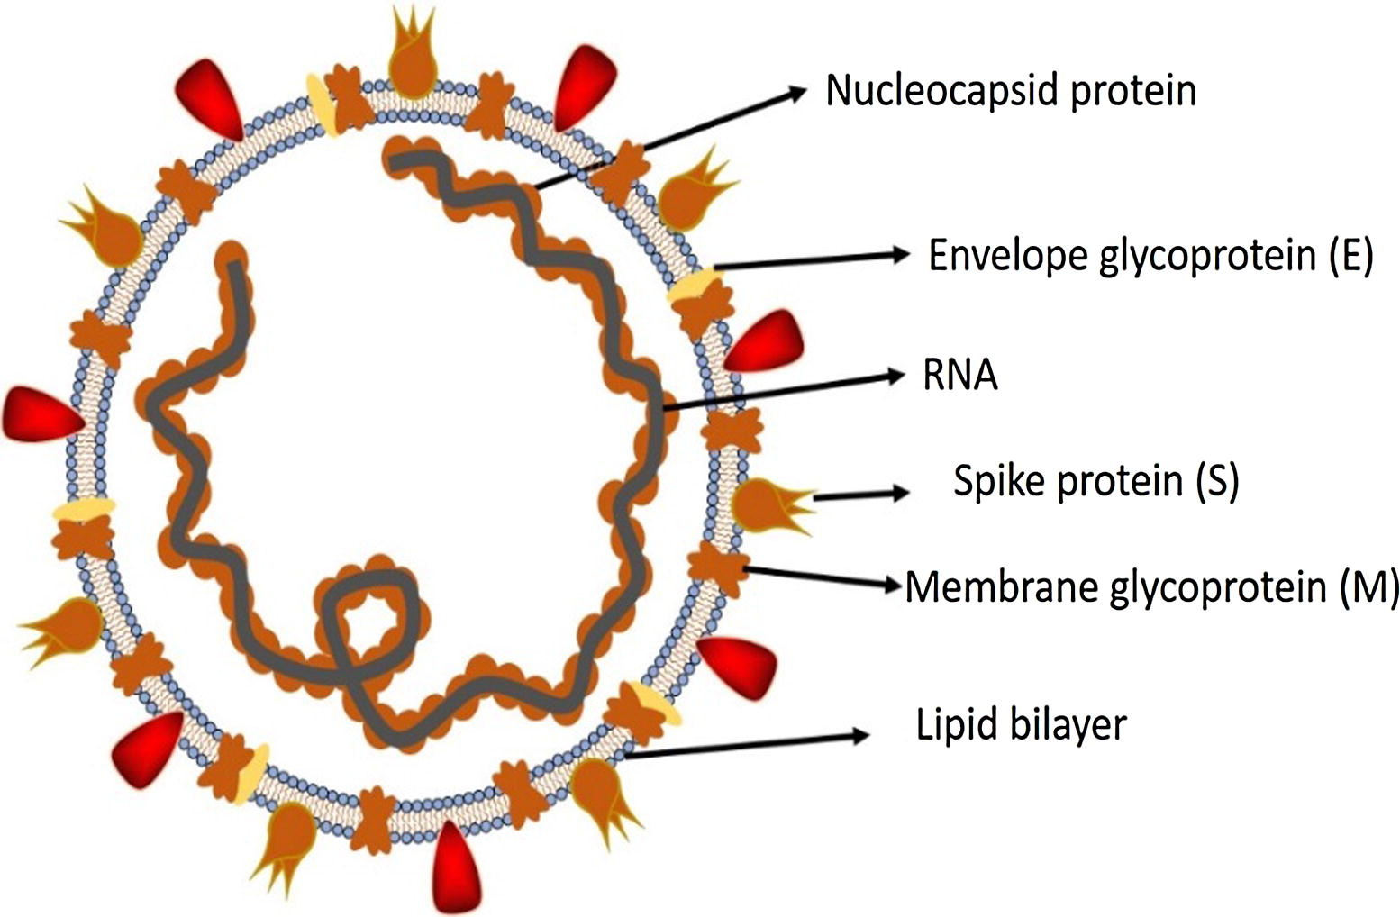

Recently at the end of 2019, Wuhan an emerging business hub of China experienced an outbreak of a novel coronavirus that killed more than eighteen hundred and infected over seventy thousand individuals within the first fifty days of the epidemic. This virus was reported to be a member of the β group of coronaviruses. The novel virus was named as Wuhan coronavirus or 2019 novel coronavirus (2019-nCov) by the Chinese researchers. The International Committee on Taxonomy of Viruses (ICTV) named the virus as SARS-CoV-2 and the disease as COVID-19 [3], [4], [5]. In the history, SRAS-CoV (2003) infected 8098 individuals with mortality rate of 9%, across 26 contries in the world, on the other hand, novel corona virus (2019) infected 120,000 induviduals with mortality rate of 2.9%, across 109 countries, till date of this writing. It shows that the transmission rate of SARS-CoV-2 is higher than SRAS-CoV and the reason could be genetic recombination event at S protein in the RBD region of SARS-CoV-2 may have enhanced its transmission ability. In this review article, we discuss the origination of human coronaviruses briefly. We further discuss the associated infectiousness and biological features of SARS and MERS with a special focus on COVID-19.

Comparative analysis of emergence and spreading of coronaviruses
In 2003, the Chinese population was infected with a virus causing Severe Acute Respiratory Syndrome (SARS) in Guangdong province. The virus was confirmed as a member of the Beta-coronavirus subgroup and was named SARS-CoV [6], [7]. The infected patients exhibited pneumonia symptoms with a diffused alveolar injury which lead to acute respiratory distress syndrome (ARDS). SARS initially emerged in Guangdong, China and then spread rapidly around the globe with more than 8000 infected persons and 776 deceases. A decade later in 2012, a couple of Saudi Arabian nationals were diagnosed to be infected with another coronavirus. The detected virus was confirmed as a member of coronaviruses and named as the Middle East Respiratory Syndrome Coronavirus (MERS-CoV). The World health organization reported that MERS-coronavirus infected more than 2428 individuals and 838 deaths [8]. MERS-CoV is a member beta-coronavirus subgroup and phylogenetically diverse from other human-CoV. The infection of MERS-CoV initiates from a mild upper respiratory injury while progression leads to severe respiratory disease. Similar to SARS-coronavirus, patients infected with MERS-coronavirus suffer pneumonia, followed by ARDS and renal failure [9].

Recently, by the end of 2019, WHO was informed by the Chinese government about several cases of pneumonia with unfamiliar etiology. The outbreak was initiated from the Hunan seafood market in Wuhan city of China and rapidly infected more than 50 peoples. The live animals are frequently sold at the Hunan seafood market such as bats, frogs, snakes, birds, marmots and rabbits [10]. On 12 January 2020, the National Health Commission of China released further details about the epidemic, suggested viral pneumonia [10]. From the sequence-based analysis of isolates from the patients, the virus was identified as a novel coronavirus. Moreover, the genetic sequence was also provided for the diagnosis of viral infection. Initially, it was suggested that the patients infected with Wuhan coronavirus induced pneumonia in China may have visited the seafood market where live animals were sold or may have used infected animals or birds as a source of food. However, further investigations revealed that some individuals contracted the infection even with no record of visiting the seafood market. These observations indicated a human to the human spreading capability of this virus, which was subsequently reported in more than 100 countries in the world. The human to the human spreading of the virus occurs due to close contact with an infected person, exposed to coughing, sneezing, respiratory droplets or aerosols. These aerosols can penetrate the human body (lungs) via inhalation through the nose or mouth (Fig. 2) [11], [12], [13], [14].

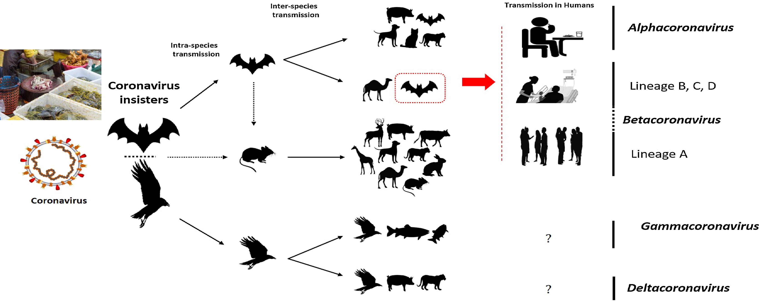
Fig. 2. The key reservoirs and mode of transmission of coronaviruses (suspected reservoirs of SARS-CoV-2 are red encircled); only α and β coronaviruses have the ability to infect humans, the consumption of infected animal as a source of food is the major cause of animal to human transmission of the virus and due to close contact with an infected person, the virus is further transmitted to healthy persons. Dotted black arrow shows the possibility of viral transfer from bat whereas the solid black arrow represent the confirmed transfer. (For interpretation of the references to colour in this figure legend, the reader is referred to the web version of this article.)

Primary reservoirs and hosts of coronaviruses
The source of origination and transmission are important to be determined in order to develop preventive strategies to contain the infection. In the case of SARS-CoV, the researchers initially focused on raccoon dogs and palm civets as a key reservoir of infection. However, only the samples isolated from the civets at the food market showed positive results for viral RNA detection, suggesting that the civet palm might be secondary hosts [15]. In 2001 the samples were isolated from the healthy persons of Hongkong and the molecular assessment showed 2.5% frequency rate of anti-bodies against SARS-coronavirus. These indications suggested that SARS-coronavirus may be circulating in humans before causing the outbreak in 2003 [16]. Later on, Rhinolophus bats were also found to have anti-SARS-CoV antibodies suggesting the bats as a source of viral replication [17]. The Middle East respiratory syndrome (MERS) coronavirus first emerged in 2012 in Saudi Arabia [9]. MERS-coronavirus also pertains to beta-coronavirus and having camels as a zoonotic source or primary host [18]. In a recent study, MERS-coronavirus was also detected in Pipistrellus and Perimyotis bats [19], proffering that bats are the key host and transmitting medium of the virus [20], [21]. Initially, a group of researchers suggested snakes be the possible host, however, after genomic similarity findings of novel coronavirus with SARS-like bat viruses supported the statement that not snakes but only bats could be the key reservoirs (Table 1) [22], [23]. Further analysis of homologous recombination revealed that receptor binding spike glycoprotein of novel coronavirus is developed from a SARS-CoV (CoVZXC21 or CoVZC45) and a yet unknown Beta-CoV [24]. Nonetheless, to eradicate the virus, more work is required to be done in the aspects of the identification of the intermediate zoonotic source that caused the transmission of the virus to humans

. Key features and entry mechanism of human coronaviruses
All coronaviruses contain specific genes in ORF1 downstream regions that encode proteins for viral replication, nucleocapsid and spikes formation [25]. The glycoprotein spikes on the outer surface of coronaviruses are responsible for the attachment and entry of the virus to host cells (Fig. 1). The receptor-binding domain (RBD) is loosely attached among virus, therefore, the virus may infect multiple hosts [26], [27]. Other coronaviruses mostly recognize aminopeptidases or carbohydrates as a key receptor for entry to human cells while SARS-CoV and MERS-CoV recognize exopeptidases [2]. The entry mechanism of a coronavirus depends upon cellular proteases which include, human airway trypsin-like protease (HAT), cathepsins and transmembrane protease serine 2 (TMPRSS2) that split the spike protein and establish further penetration changes [28], [29]. MERS-coronavirus employs dipeptidyl peptidase 4 (DPP4), while HCoV-NL63 and SARS-coronavirus require angiotensin-converting enzyme 2 (ACE2) as a key receptor [2], [26].

SARS-CoV-2 possesses the typical coronavirus structure with spike protein and also expressed other polyproteins, nucleoproteins, and membrane proteins, such as RNA polymerase, 3-chymotrypsin-like protease, papain-like protease, helicase, glycoprotein, and accessory proteins [30], [31]. The spike protein of SARS-CoV-2 contains a 3-D structure in the RBD region to maintain the van der Waals forces [32]. The 394 glutamine residue in the RBD region of SARS-CoV-2 is recognized by the critical lysine 31 residue on the human ACE2 receptor [33]. The entire mechanism of pathogenicity of SARS-CoV-2, from attachment to replication is well mentioned in Fig. 3.

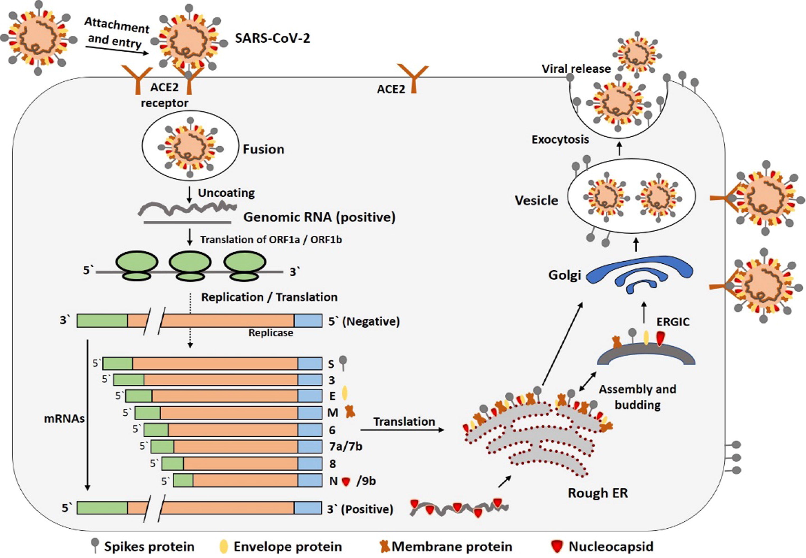
Fig. 3. The life cycle of SARS-CoV-2 in host cells; begins its life cycle when S protein binds to the cellular receptor ACE2. After receptor binding, the conformation change in the S protein facilitates viral envelope fusion with the cell membrane through the endosomal pathway. Then SARS-CoV-2 releases RNA into the host cell. Genome RNA is translated into viral replicase polyproteins pp1a and 1ab, which are then cleaved into small products by viral proteinases. The polymerase produces a series of subgenomic mRNAs by discontinuous transcription and finally translated into relevant viral proteins. Viral proteins and genome RNA are subsequently assembled into virions in the ER and Golgi and then transported via vesicles and released out of the cell. ACE2, angiotensin-converting enzyme 2; ER, endoplasmic reticulum; ERGIC, ER–Golgi intermediate compartment.

