QUESTION
- Discuss the physics of the light microscope (diagrams and illustrations needed).
A microscope is a multiple-element system having more than a single lens or mirror. A microscope can be made from two convex lenses. The image formed by the first element becomes the object for the second element. The second element forms its own image, which is the object for the third element, and so on. Ray tracing helps to visualize the image formed. If the device is composed of thin lenses and mirrors that obey the thin lens equations, then it is not difficult to describe their behavior numerically. The first lens is called the objective lens, and has typical magnification values from 5× to 100×. In standard microscopes, the objectives are mounted such that when you switch between objectives, the sample remains in focus. Objectives arranged in this way are described as par focal. The second, the eyepiece, also referred to as the ocular, has several lenses which slide inside a cylindrical barrel. The focusing ability is provided by the movement of both the objective lens and the eyepiece. The purpose of a microscope is to magnify small objects, and both lenses contribute to the final magnification. Additionally, the final enlarged image is produced in a location far enough from the observer to be easily viewed, since the eye cannot focus on objects or images that are too close.
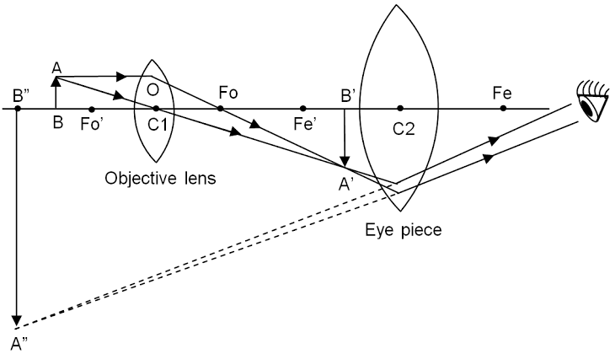A ray diagram from left to right shows a virtual inverted enlarged final image of the object, a small object in upright position, a convex objective lens, inverted smaller image of the object, a large convex eye-piece and an eye on an optical axis. The object h’ is placed just outside F subscript O two, the principal focus of the objective lens. Rays from the object are passing through the objective lens, converging and forming an inverted magnified image h subscript I, which acts as an object for the eyepiece and passing at the eye. Dotted lines are joined backward from the rays entering the eyepiece at the tip of the virtual, magnified, inverted and final image of the object given as h subscript i. Distance of the object for the objective lens and distance of the image from it is given as d subscript o and d subscript I respectively.
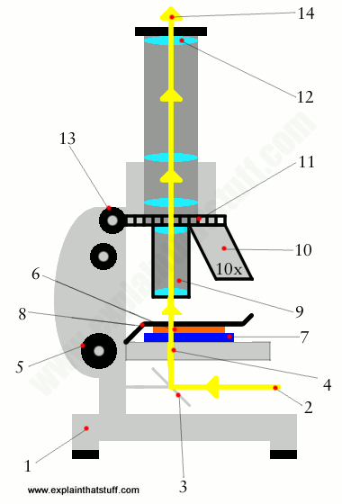Figure 2. A compound microscope composed of two lenses, an objective and an eyepiece. The objective forms a case 1 image that is larger than the object. This first image is the object for the eyepiece. The eyepiece forms a case 2 final image that is further magnified. To see how the microscope in Figure 2 forms an image, we consider its two lenses in succession. The object is slightly farther away from the objective lens than its focal length (fo) producing a case 1 image that is larger than the object. This first image is the object for the second lens, or eyepiece. The eyepiece is intentionally located so it can further magnify the image. The eyepiece is placed so that the first image is closer to it than its focal length (fe). Thus the eyepiece acts as a magnifying glass, and the final image is made even larger. The final image remains inverted, but it is farther from the observer, making it easy to view (the eye is most relaxed when viewing distant objects and normally cannot focus closer than 25 cm). Since each lens produces a magnification that multiplies the height of the image, it is apparent that the overall magnification (m) is the product of the individual magnifications: m = mome, where mo is the magnification of the objective and me is the magnification of the eyepiece. This equation can be generalized for any combination of thin lenses and mirrors that obey the thin lens equations.

- Write notes on the following biomedical equipment, add notes on principle, brand, care and maintenance and cost
- Centrifuge
- Automatic tissue processor
- Microtome
ANSWER
CENTRIFUGE
- Principle of Centrifugation
Centrifugation is a technique of separating substances which involves the application of centrifugal force. The particles are separated from a solution according to their size, shape, density, the viscosity of the medium and rotor speed. In a solution, particles whose density is higher than that of the solvent sink (sediment), and particles that are lighter than it floats to the top. The greater the difference in density, the faster they move. If there is no difference in density (isopyhlic conditions), the particles stay steady. To take advantage of even tiny differences in density to separate various particles in a solution, gravity can be replaced with the much more powerful “centrifugal force” provided by a centrifuge. A centrifuge is a piece of equipment that puts an object in rotation around a fixed axis (spins it in a circle), applying a potentially strong force perpendicular to the axis of spin (outward).
- Types of Centrifuge
LOW-SPEED CENTRIFUGE
Most laboratories have a standard low-speed centrifuge used for routine sedimentation of heavy particles. The low-speed centrifuge has a maximum speed of 4000-5000rpmThese instruments usually operate at room temperatures with no means of temperature control. Two types of rotors are used in it, fixed angle and Swinging bucket. It is used for sedimentation of red blood cells until the particles are tightly packed into a pellet and supernatant is separated by decantation.
HIGH-SPEED CENTRIFUGES
High-speed centrifuges are used in more sophisticated biochemical applications, higher speeds and temperature control of the rotor chamber are essential. The high-speed centrifuge has a maximum speed of 15,000 – 20,000 RPM.
ULTRACENTRIFUGES
It is the most sophisticated instrument. Ultracentrifuge has a maximum speed of 65,000 RPM (100,000’s x g).Intense heat is generated due to high speed thus the spinning chambers must be refrigerated and kept at a high vacuum. It is used for both preparative work and analytical work.
- CARE AND MAINTENANCE OF THE CENTRIFUGE
Improper centrifuge care can lead to damage of critical centrifuge parts, resulting in the malfunction of the centrifuge. Aggressive chemicals can lead to corrosive spots on the rotors and rotor-buckets, which can in turn lead to holes forming in the rotor. Improper cleaning can also damage coatings and lead to corrosion. Sensors, gaskets, seals, and wiring can become damaged if flood with water.
There are several important cleaning and safety procedures that should be used to ensure a centrifuge works properly. First, you should clean your centrifuge daily. This includes cleaning both the exterior and the interior of the centrifuge. A sponge, warm water, and a mild detergent can be used to clean the centrifuge. Do not use caustic detergents or a product that contains chlorine ions. A plastic scrub brush should be used to avoid damaging the coatings. When you are finished cleaning the centrifuge you should use a centrifuge lubricant to lubricate the bucket grooves and rubber seals. You should also use approved disinfectants and/or “spill” kits to disinfect the centrifuge on a regular basis. In addition to cleaning the centrifuge, you should also check for residue and corrosion on the rotors on a weekly or monthly basis.
Scheduling regular preventive maintenance with a trained technician for your centrifuge is vital because it increases the durability and functionality of the centrifuge. Regular preventive maintenance also ensures accurate results and reliable performance, which will benefit your research.
- BRAND AND COST OF CENTRIFUGES
- Super Deal PRO Desktop Electric Lab Laboratory Centrifuge Machine Lab Medical Practice w/Timer and Speed Control - Low Speed - 4000 RPM - Capacity 20 ml x 6-110v
- COST----$60
- Microyn Digital Bench-top Centrifuge, 100-5000rpm (Max. 3074xg), 6x15ml ,by Labnique
- COST---$300

Benchmark Scientific C2000 PlateFuge Micro centrifuge with Swing-Out Rotor, 115V by benchmark scientific

COST -----$590

MICROTOME
- MAINTENANCE AND CARE OF YOUR MICROTOME KNIFE
BEFORE USING YOUR MICROTOME KNIFE
A. Your microtome knife has been coated with an oil mixture to prevent rust and corrosion when not in use.
B. Before using your knife, take a lint-free facial tissue saturated in either xylene, benzene or acetone to remove the protective oil coating on the knife.
C. Use a dry, lint-free, facial tissue to wipe your knife clean. DO NOT USE GAUZE or any other coarse material; it will destroy the edge of your knife.
D. Your knife has already been stropped and is now ready for immediate use.

- CARING FOR YOUR MICROTOME KNIFE

Keep the edge of your knife clean at all times. Spray or brush any household oil on your knife to prevent rust when not in use. Store your knife in its case to prevent oxidation from occurring.
- PRINCIPLE OF MICROTOMY
Microtome is a sectioning instrument that allows the cutting of thin slices of a material known as a section. Microtomes are used in microscopy to allow for the preparation of sample for observation under transmitted light or electron radiation.
- BRAND AND COST OF MICROTOMES
- My-b120 rotary microtome
- COST---$4050
- Biobase CE fast freezing prix rotary cryostat microtome
- COST---$10000
- SY-B120 FREEZING ROTARY MICROTOME
- COST----$5600

AUTOMATIC TISSUE PROCCESING MACHINE
- PRINCIPLE OF THE AUTOMATIC TISSUE PROCESSOR
- Tissue processing is concerned with the diffusion of various substances into and out of porous tissues. Diffusion results from the tendency of processing reagents to equalize concentrations both inside and outside blocks of tissue. The reagent molecules diffuse down a concentration gradient and move from where they are at a high concentration to where they are at a lower concentration. This movement requires no energy since it always progresses down the concentration gradient.
- BRAND AND COST OF THE AUTOMATIC TISSUE PROCESSING MACHINE
- 2016 sakura Tissue tek xpress 120 rapid tissue processor
- COST---$25,000
- THERMO SCIENTIFIC Shandon TissueWave Tissue Processor
COST---$6,800

- CARE AND MAINTENANCE OF THE AUTOMATIC TISSUE PROCESSOR
One of the most important steps to ensuring consistent and trouble-free tissue processing is reagent maintenance. Keeping reagents fresh is critical to proper tissue processing and overall quality control (QC). Since over-used reagents lead to problems that are difficult to diagnose. Another important QC check is the paraffin temperature. As mentioned earlier in this course, melted paraffin must be kept at 2-4° C above the melting point of paraffin. The paraffin chambers on the processor must maintain the proper temperature and this temperature should be checked daily. Paraffin may also be melted and stored in special paraffin pots so that melted paraffin is always available for filling the embedding center or the processor. The paraffin pots must be temperature controlled and monitored daily for the proper temperature. If the paraffin is cooked at high temperatures it will breakdown and cause microtomy problems.

