NAM: OWOSHO BASHIRAT BOLAJOKO
DEPARTMENT: MEDICINE AND SURGERY
MATRIC NO: 19/MHS01/371
BIO 102 ASSIGNMENTS
QUESTION 1. HOW ARE FUNGI IMPORTANT TO MAN?
Fungi are important to everyday human life
- IN THE ECOSYSTEM: are responsible for the mediation of decay of organic matter in the ecosystem, because of their saprophytic nature they are important decomposers in most ecosystem
- FOR FOOD: play an important role in the food industry i.e Yeast( Saccharomcyes cerevisiae), Mushrooms are edible and used by man for food. Mushrooms, morels, chanterelles and truffles are considered as delicacies. Fungi are also agents of fermentation in the production of bread, cheeses, alcoholic beverages, and numerous other food preparations.
- ECONOMIC IMPORTANCE: Fungi species mediate the spoilage of wood, food, clothes and papers
- AS ANIMAL PATHOGENS: fungi help to control the population of damaging pests, in which they specifically attack only insects, leaving plants and man
- IN THE HEALTH SYSTEM: Secondary metabolites of fungi are used as medicines, such as antibiotics and anticoagulants.
- FOR STUDY: Fungi are model organisms for the study of eukaryotic genetics and metabolism

QUESTION2. ILLUSTRATE THE CELL STRUCTURE OF A UNICELLULAR FUNGUS WITH A WELL LABELED DIAGRAM.
Fungus in discussion: BREWER’S YEAST
Brewer’s yeast is a well-known example of unicellular forms in fungi.
It has a simple cell structure even with its advancement in fungal forms from the point of view of its spore-producing structures. Yeast cells are found on exposed sugary fluids foe example; Palm wine, and sugary fruits where fermentation process is mediated.
Cells exists in diploid/haploid states. Under favourable environmental conditions, in both states, they multiply rapidly by simple mitotic cell divisions; budding involving nuclear division and division of the cytoplasm in such a way thta one segment of the constricted cytoplasm is smaller than the others.
Diploid cell arise from haploid cells by processes of plasmogamy and karyyogamy(a kind of fertilization)
A diploid cell may undergo meiosis under certain conditions to produces four(4) haploid spores-ascospores.

QUESTION3: OUTLINE SEXUAL REPRODUCTION IN A TYPICAL FI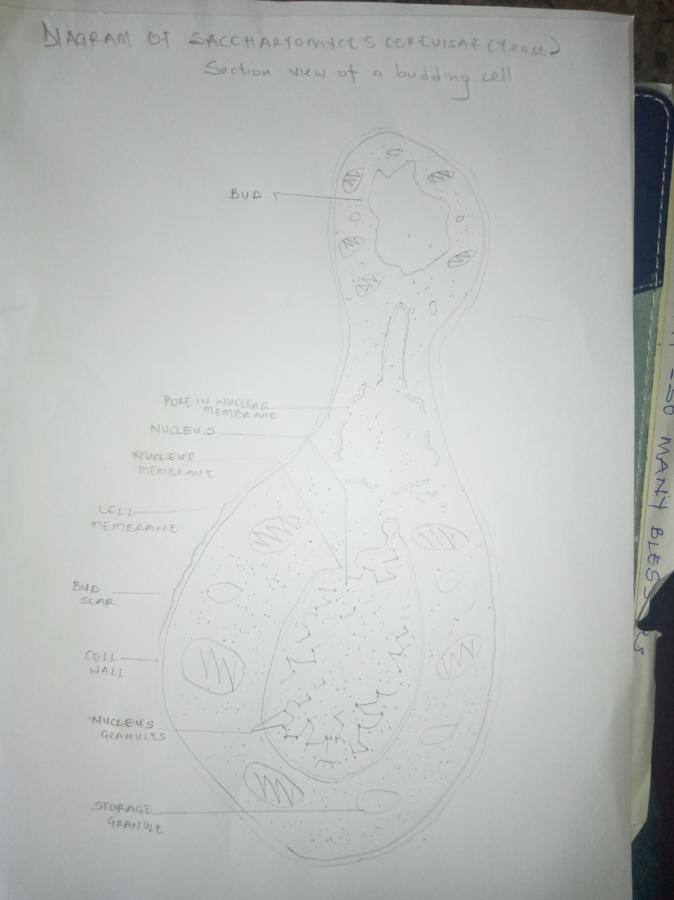LAMENTOUS FUNGUS
Fungus in discussion: Rhizopus stolonifer
Sexual reproduction occurs when two mating types of hyphae grow in the same medium. Chemical interaction in the two mating types of hyphae induces growths perpendicular to the hyphae in opposite directions. These growths are delimited by a wall such that many nuclei are isolated in what is called gametangium.
The two gametanagia fuse (plasmogamy) and a zygote is formed which may undergo prolonged dormancy or resting stage. The nuclei in the zygote fuse in twos and undergo meiosis independently.
The zygote germinates under favourable conditions to produce a fruiting which at maturity liberates haploid spores
QUESTION4: HOW DO BRYOPHYTES ADAPT TO THEIR ENVIRONMENT
Bryophytes, collective term applied to approximately 22,000 species of small plants that are usually in moist areas on soil, tree trunks, and rocks. Below is how bryophytes adapt to land habitat;
- BRYOPHYTES have definite structures for water absorption from the soil; therefore the plant body is divided into two (an aerial portion and a subterranean portion). The subterranean portion is the rhizoid and is not a true root as the case of land plants that are advanced.
- The aerial portion of BRYOPHYTES being exposed to the atmosphere demands some modifications that prevents excessive loss of water through the body surface
- In BRYOPHTES there are some other modifications that permit elimination of excess water from the plant body and not only exchange of gasses between the internal parts of the plant and the atmosphere therefore openings are available on the aerial parts of the plant.

QUESTION5: DESCRIBE WITH ILLUSTRATION THE FOLLOWING TERMINOLOGIES
- Eusteles
- Atactostele
- Siphonostele
- Dictyostele
- EUSTELES: A stele typical old dicotyledonous plants that consists of vascular bundles of xylem and phloem strands with parenchyma cells between the bundles
- ATACTOSTELES: A type of eustele, found in monocots, in which the vascular tissue in the stem exists as scattered bundles.
- SIPHONOSTELE: A stele in which the vascular tissue is in the form of a cylinder surrounding the pith, as in the stems of most ferns and other seedless vascular plants.
- DICTYOSTELE: A stele in which the vascular cylinder is broken up into a longitudinal series or network of vascular strands around a central path
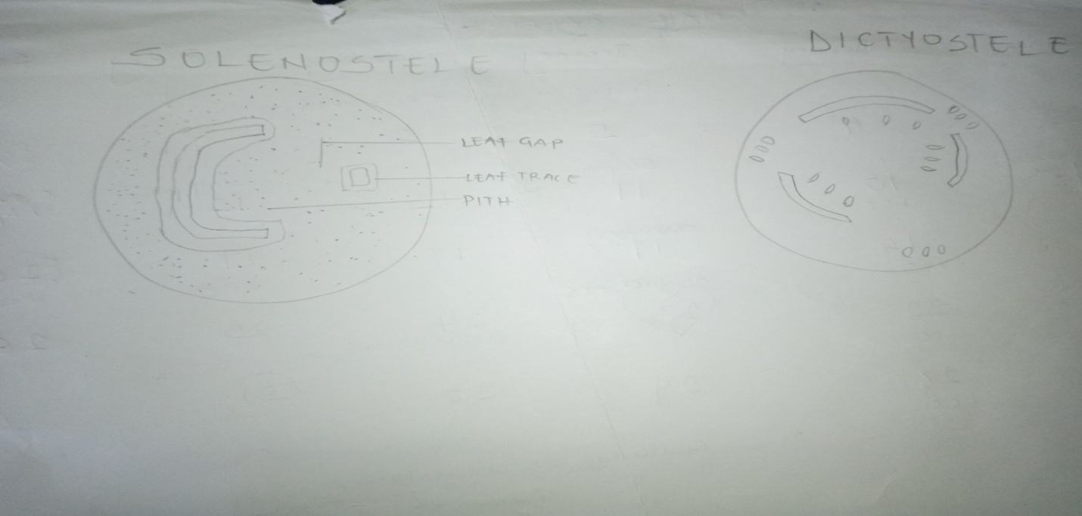

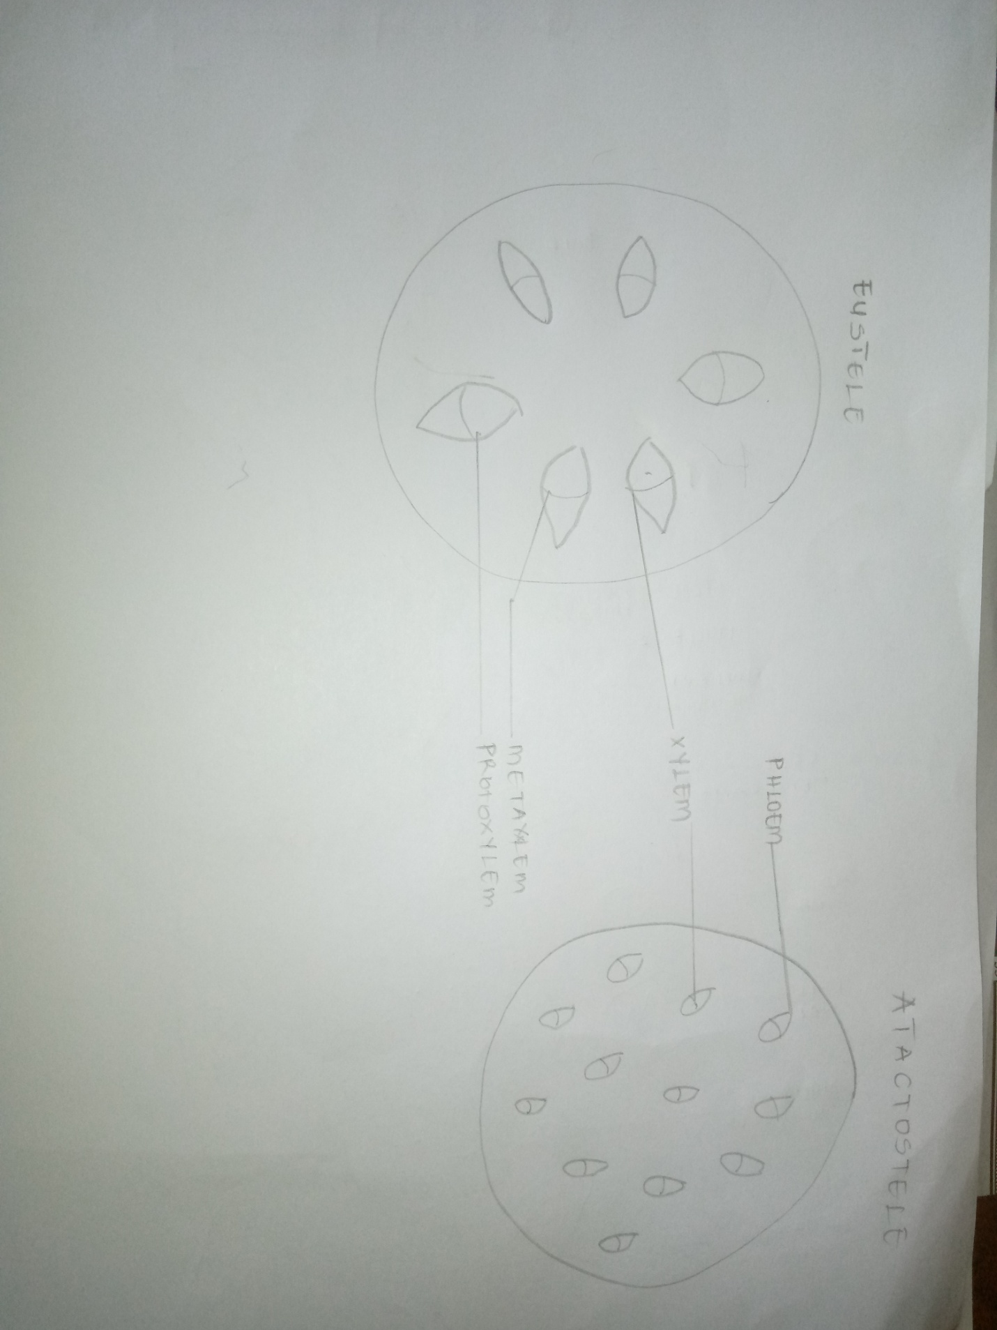

QUESTION6: ILLUSTRATE THE LIFE CYCLE OF A PRIMITIVE VASCULAR PLANT
Vascular plant in discussion- Psilotum
Psilotum is a very primitive vascular plant; the species represent some of the most primitive vascular plants
LIFE CYCLE OF A PRIMITIVE VASCULAR PLANTS(Psilotum)
