NAME: FRANCIS NMESOMACHI ESTHER
COLLEGE: MEDICINE AND HEALTH SCIENCES
DEPARTMENT: MEDICINE AND SURGERY
MATRIC NO.: 19/MHS01/175
DATE: 05-05-2020
BIO 102 ASSIGNMENTS
- IMPORTANCE OF FUNGI TO MANKIND
- Mushrooms are eaten by humans and it therefore provides antibiotics for the body
- Fungi e.g. yeast is important in the food industry
- Many fungi species mediate the spoilage of wood, food, clothes and paper
- Some fungi species acts as parasites to some horrible pests such as housefly and grasshopper.

- DIAGRAM OF A UNICELLULAR FUNGUS- YEAST ( Saccharomyces cerevisiae)
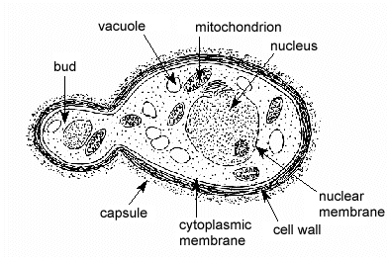

- SEXUAL REPRODUCTION IN A TYPICAL FILAMENTOUS FORM OF FUNGI.
Sexual reproduction occurs when two mating types of hyphae grow in the same medium. Chemical interaction in the two mating types of hyphae induces growth perpendicular to the hyphae in opposite directions. These growths are delimited by a wall such that many nuclei are isolated in what is called a gamentangium.
The two gamentangia fuse (plasmogamy) and a zygote is formed which may undergo prolonged dormancy or resting stage. The nuclei in the zygote fuse in twos and undergo meiosis independently.
The zygote germinates under favorable conditions to produce a fruiting which at maturity liberates the haploid spores.

- ADAPTATION OF BRYOPHYTES TO THEIR ENVIRONMENT
- They have definite structures for water and nutrient absorption from the soil; therefore the plant body is divided into two (an aerial portion and a subterranean portion). The subterranean portion is the rhizoid and it is not a true root as the case of land plants that are advanced.
- The aerial portion being exposed to the atmosphere demands some modifications that prevents loss of water through the body surface (i.e. desiccation)
- Some other modifications that permit removal of excess water from plant body and not only exchange of gases between the internal part of the plants and the atmosphere therefore openings are available on the aerial part of the plants.

- a. eusteles: in herbaceous dicotyledonous plants; the vascular bundles are discrete, concentric collateral bundles of xylem and phloem.
b. atactostele: in grasses and many monocotyledonous plants; the vascular bundles are scattered.
c. siphonostele: in more advanced vascular systems e.g. stems of ferns and higher vascular plants, the stele is a cylinder enclosing a parenchymatous pith.
d. dictyostele: in siphonosteles, vascular supply to leaves is associated with leaf gaps and the conducting cylinder is a dissected one, it is known as dictyostele.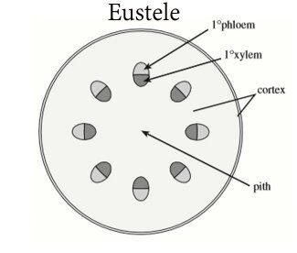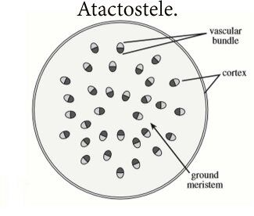 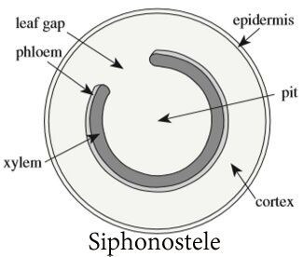 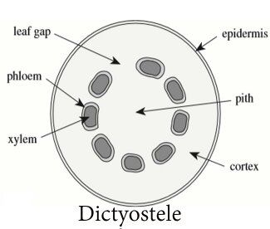

- LIFE CYCLE OF A PRIMITIVE VASCULAR PLANT-PSILOTUM
