ASSIGNMENT
NAME: AFOLABI NAFEESAH OLASUMBO
MATRIC NO:17/MHS01/027

CAVERNOUS SINUS

The cavernous sinus within the human head is one of the dural venous sinuses creating a cavity called the lateral sellar compartment bordered by the temporal bone of the skull and the sphenoid bone, lateral to the sella turcica.
Cavernous sinus
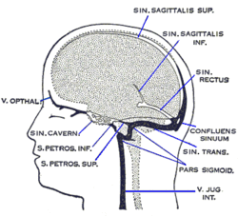
Cavernous sinus (center, labeled "SIN. CAVERN.")
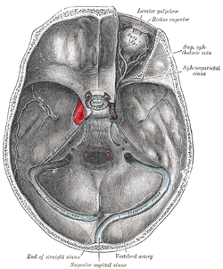
The sinuses at the base of the skull. Cavernous sinus labeled in red

Structure
The cavernous sinus is one of the dural venous sinuses of the head. It is a network of veins that sit in a cavity, approximately 1 x 2 cm in size in an adult. The carotid siphon of the internal carotid artery, and cranial nerves III, IV, V (branches V₁ and V₂) and VI all pass through this blood-filled space.

Nearby structures
- Above: optic tract, optic chiasma, internal carotid artery.
- Inferiorly: Foramen lacerum and the junction of the body and greater wing of sphenoid bone.
- Medially: Hypophysis cerebri or (pituitary gland) and sphenoidal air sinus.
- Laterally: temporal lobe with uncus.
- Anteriorly: superior orbital fissure and the apex of the orbit .
- Posteriorly: apex of the petrous temporal bone.

Venous connections
- Superior and inferior ophthalmic veins
- Sphenoparietal sinus
- Superficial middle cerebral veins
- Inferior cerebral veins
Blood leaves the sinus via superior and inferior petrosal sinuses as well as via the emissary veins through the foramina of the skull (mostly through foramen ovale). There are also connections with the pterygoid plexus of veins via inferior ophthalmic vein, deep facial vein and emissary veins

Contents
Apart from the blood which passes through a venous sinus, several anatomical structures, including some cranial nerves and their branches, also pass through the sinus.
Structures within the outer (lateral) wall of the compartment from superior to inferior:
- Oculomotor nerve
- Trochlear nerve
- Ophthalmic and maxillary branches of the trigeminal nerve
Structures passing through the midline (medial) wall:
- Abducens nerve
- Internal carotid artery accompanied by the Internal carotid plexus
These nerves, with the exception of CN V₂, pass through the cavernous sinus to enter the orbital apex through the superior orbital fissure. The maxillary nerve, division V₂ of the trigeminal nerve travels through the lower portion of the sinus and exits via the foramen rotundum. The maxillary branch passes external to, but immediately adjacent to, the lateral wall of the sinus)
The optic nerve lies just above and outside the cavernous sinus, superior and lateral to the pituitary gland on each side, and enters the orbital apex via the optic canal.

Function

Venous drainage
As a venous sinus, the cavernous sinus receives blood from the superior and inferior ophthalmic veins and from superficial cortical veins, and is connected to the basilar plexus of veins posteriorly. The cavernous sinus drains by two larger channels, the superior and inferior petrosal sinuses, ultimately into the internal jugular vein via the sigmoid sinus, also draining with emissary vein to pterygoid plexus.

Clinical significance
It is the only anatomic location in the body in which an artery travels completely through a venous structure. If the internal carotid artery ruptures within the cavernous sinus, an arteriovenous fistula is created (more specifically, a carotid-cavernous fistula). Lesions affecting the cavernous sinus may affect isolated nerves or all the nerves traversing through it.
The pituitary gland lies between the two paired cavernous sinuses. An abnormally growing pituitary adenoma, sitting on the bony sella turcica, will expand in the direction of least resistance and eventually compress the cavernous sinus. Cavernous sinus syndrome may result from mass effect of these tumors and cause ophthalmoplegia (from compression of the oculomotor nerve, trochlear nerve, and abducens nerve), ophthalmic sensory loss (from compression of the ophthalmic nerve), and maxillary sensory loss (from compression of the maxillary nerve). A complete lesion of the cavernous sinus disrupts CN III, IV, and VI, causing total ophthalmoplegia, usually accompanied by a fixed, dilated pupil. Involvement of CN V (V₁ and variable involvement of V₂) causes sensory loss in these divisions of the trigeminal nerve. Horner's syndrome can also occur due to involvement of the carotid ocular sympathetics, but may be difficult to appreciate in the setting of a complete third nerve injury.
Because of its connections with the facial vein via the superior ophthalmic vein, it is possible to get infections in the cavernous sinus from an external facial injury within the danger area of the face. In patients with thrombophlebitis of the facial vein, pieces of the clot may break off and enter the cavernous sinus, forming a cavernous sinus thrombosis. From there the infection may spread to the dural venous sinuses. Infections may also be introduced by facial lacerations and by bursting pimples in the areas drained by the facial vein.
Potential causes of cavernous sinus syndrome include metastatic tumors, direct extension of nasopharyngeal tumours, meningioma, pituitary tumors or pituitary apoplexy, aneurysms of the intracavernous carotid artery, carotid-cavernous fistula, bacterial infection causing cavernous sinus thrombosis, aseptic cavernous sinus thrombosis, idiopathic granulomatous disease (Tolosa–Hunt syndrome), and fungal infections. Cavernous sinus syndrome is a medical emergency, requiring prompt medical attention, diagnosis, and treatment

2.The human nose is the most protruding part of the face. It bears the nostrils and is the first organ of the respiratory system. The nose is an olfactory and respiratory organ. It consists of nasal skeleton, which houses the nasal cavity. The nasal cavity has four functions:
-Warms and humidifies the inspired air.
-Removes and traps pathogens and particulate matter from the inspired air.
-Responsible for sense of smell.
-Drains and clears the paranasal sinuses and lacrimal ducts.
Divisions
The nasal cavity is the most superior part of the respiratory tract. It extends from the vestibule of the nose to the nasopharynx, and has three divisions:
Vestibule – the area surrounding the anterior external opening to the nasal cavity.
Respiratory region – lined by a ciliated psudeostratified epithelium, interspersed with mucus-secreting goblet cells.
Olfactory region – located at the apex of the nasal cavity. It is lined by olfactory cells with olfactory receptors.
Projecting out of the lateral walls of the nasal cavity are curved shelves of bone. They are called conchae (or turbinates). The are three conchae – inferior, middle and superior.
They project into the nasal cavity, creating four pathways for the air to flow. These pathways are called meatuses:
Inferior meatus – between the inferior concha and floor of the nasal cavity.
Middle meatus – between the inferior and middle concha.
Superior meatus – between the middle and superior concha.
Spheno-ethmoidal recess – superiorly and posteriorly to the superior concha.
The function of the conchae is to increase the surface area of the nasal cavity – this increases the amount of inspired air that can come into contact with the cavity walls. They also disrupt the fast, laminar flow of the air, making it slow and turbulent. The air spends longer in the nasal cavity, so that it can be humidified.

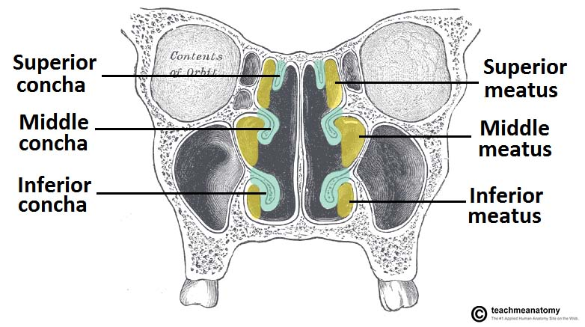

Openings into the Nasal Cavity
One of the functions of the nose is to drain a variety of structures. Thus, there are many openings into the nasal cavity, by which drainage occurs.
The paranasal sinuses drain into the nasal cavity. The frontal, maxillary and anterior ethmoidal sinuses open into the middle meatus. The location of this opening is marked by the semilunar hiatus, a crescent-shaped groove on the lateral walls of the nasal cavity.
The middle ethmoidal sinuses empty out onto a structure called the ethmoidal bulla. This is a bulge in the lateral wall formed by the middle ethmoidal sinus itself. The posterior ethmoidal sinuses open out at the level of the superior meatus.
The only structure not to empty out onto the lateral walls of the nasal cavity is the sphenoid sinus. It drains onto the posterior roof.
In addition to the paranasal sinuses, other structures open into the nasal cavity:
Nasolacrimal duct – acts to drain tears from the eye. It opens into the inferior meatus.
Auditory (Eustachian) tube – opens into the nasopharynx at the level of the inferior meatus. It allows the middle ear to equalise with the atmospheric air pressure.

Clinical Relevance: Spread of Infection
As the auditory tube connects the middle ear and upper respiratory tract, it is a path by which infection can spread from the upper respiratory tract to the ear. Infection of the auditory tube causes swelling of the mucous linings, and the tube becomes blocked. This results in diminished hearing.
Gateways to the Nasal Cavity
As well as openings for the drainage of structures, nerves, vasculature and lymphatics need to be able to access the nasal cavity.
The cribriform plate is part of the ethmoid bone. It forms a portion of the roof of the nasal cavity. It contains very small perforations, allowing fibres of the olfactory nerve to enter and exit,
At the level of the superior meatus, the sphenopalatine foramen is located. This hole allows communication between the nasal cavity and the pterygopalatine fossa. The sphenopalatine artery, nasopalatine and superior nasal nerves pass through here.
The incisive canal is a pathway between the nasal cavity and the incisive fossa of the oral cavity. It transmits the nasopalatine nerve and greater palatine artery.
Vasculature
The nose has a very rich vascular supply – this allows it to effectively change humidity and temperature of inspired air. The nose receives blood from both the internal and external carotid arteries:
Internal carotid branches:
-Anterior ethmoidal artery
-Posterior ethmoidal artery
The ethmoidal arteries are branch of the ophthalmic artery. They descend into the nasal cavity through the cribriform plate
External carotid branches:
-Sphenopalatine artery
-Greater palatine artery
-Superior labial artery
-Lateral nasal arteries
In addition to the rich blood supply, these arteries form anastomoses with each other. This is particularly prevalent in the anterior portion of the nose .
The veins of the nose tend to follow the arteries. They drain into the pterygoid plexus, facial vein or cavernous sinus.
In some individuals, a few nasal veins join with the sagittal sinus (a dural venous sinus). This represents a potential pathway by which infection can spread from the nose into the cranial cavity.
Adapted from work by FirstAdmiral [CC BY-SA 3.0], via Wikimedia Commons
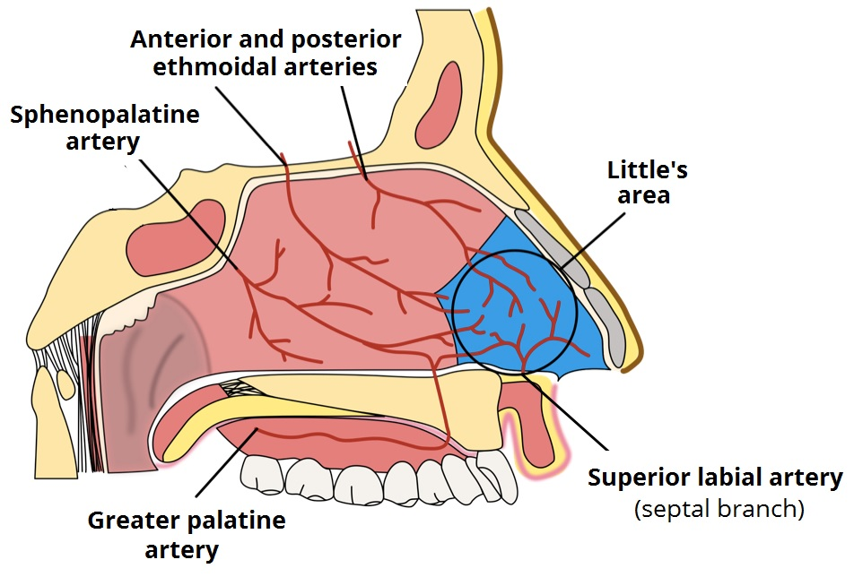
Fig 4 – Little’s area and the arterial supply to the nose.
Clinical Relevance: Epistaxis
Epistaxis is the medical term for a nosebleed. Due to the rich blood supply of the nose, this is a common occurrence. It is most likely to occur in the anterior third of the nasal cavity – this area is known as the Kiesselbach area.
The cause can be local (such as trauma), or systemic (such as hypertension).
Innervation
The innervation of the nose can be functionally divided into special and general innervation.
Special sensory innervation refers to the ability of the nose to smell. This is carried out by the olfactory nerves. The olfactory bulb, part of the brain, lies on the superior surface of the cribriform plate, above the nasal cavity. Branches of the olfactory nerve run through the cribriform plate to provide special sensory innervation to the nose.
General sensory innervation to the septum and lateral walls is delivered by the nasopalatine nerve (branch of maxillary nerve) and the nasociliary nerve (branch of the ophthalmic nerve). Innervation to the external skin of the nose is supplied by the trigeminal nerve.
By TeachMeSeries Ltd (2020)
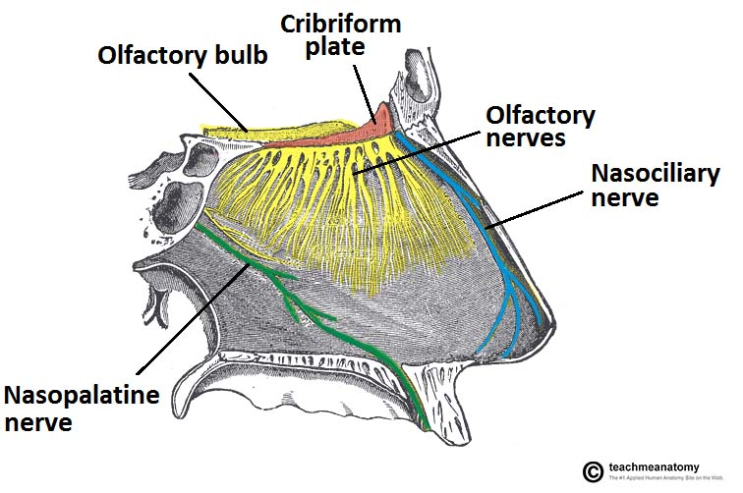

Clinical Relevance: Cribriform Plate Fracture
A fracture of the cribriform plate can occur as a result of nose trauma. It is either fractured directly by the trauma, or by fragments of the ethmoid bone.
A fractured cribriform plate can penetrate the meningeal linings of the brain, causing leakage of cerebro-spinal fluid. Exposing the brain to the outside environment like this increases the risks of meningitis, encephalitis and cerebral abscesses.
The olfactory bulb lies on the cribriform plate and can be damaged irreversibly by the fracture. In this case, the patient may present with anosmia (loss of smell).
his Article

