NAME: ADENIYI SAMUEL ADEBIYI
MATRIC NO: 19/MHS01/035
DEPARTMENT: MBBS
COURSE: BIO102

- Importance of fungi to mankind;
- They are responsible for the mediation of decay of organic matter.
- They are used in the process of fermentation
- Fungi are eaten by many human societies.
- Some are parasites to certain obnoxious pests of man.

- CELL STRUCTURE OF UNICELLULAR FUNGUS

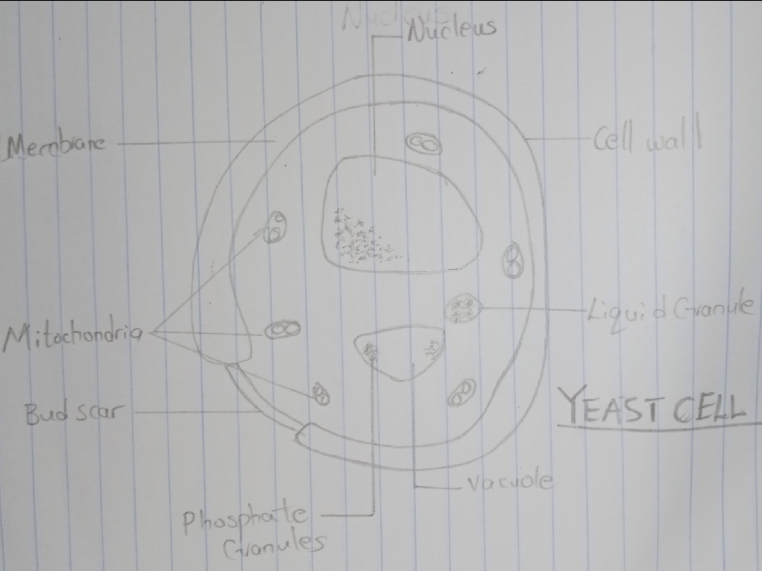

- Sexual reproduction in a filamentous fungus like Rhizopus stolonifer undergoes the following steps;
- First, two mating types of hyphae grow in the same medium.
- A chemical interaction between them causes growth perpendicular to the hyphae in opposite directions, so they can meet with one another.
- The growths are the delimited by a wall just so the nuclei are isolated in differentiated sex organs called gametangia (plural).
- The gametangia fuse in a process called plasmogamy and together they form a zygote which may undergo dormancy for a period.
- The nuclei in the zygote fuse in twos and undergo meiosis independently, it then moves on to germinating under favorable conditions so as to liberate haploid spores at maturity through the production of a fruiting.
- In summary, sexual reproduction in fungi consists of three stages; plasmogamy, karyogamy and meiosis.

- Bryophytes are able to adapt to their environment via the following;
- They possess definite structures for water and nutrient absorption from the soil.
- They possess gametangia that keep the plants gametes from drying out.
- They also possess a waxy cuticle that keeps them from drying out through the process of desiccation.

- Eusteles; a type of stele in which the vascular tissue in the stem forms a central ring of bundles around a pith. The vascular bundles are discrete, concentric collateral bundles of xylem and phloem.
- Atactostele: a type of stele found in monocots, in which the vascular tissue in the stem exists as scattered bundles.
- Dictyostele: a type of stele in which the vascular cylinder is broken up into a longitudinal series or network of vascular strands around a pith.

DIAGRAMMATIC ILLUSTRATION OF DIFFERENT STELES
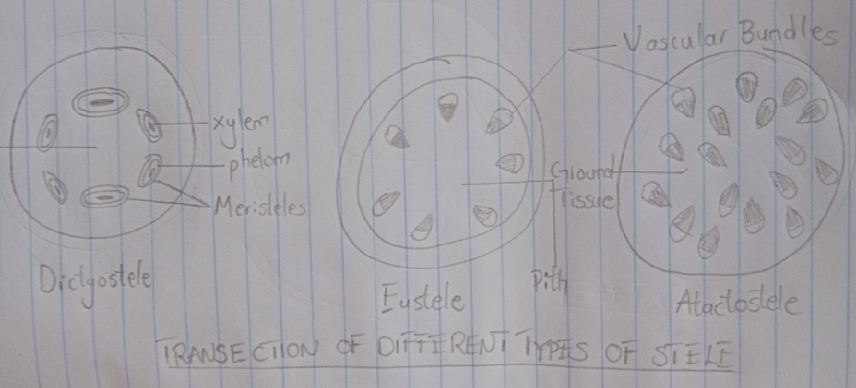

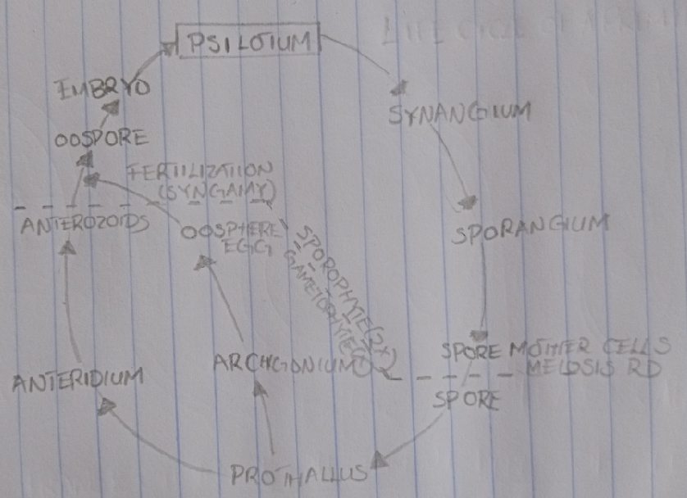
- LIFECYCLE OF A PRIMITIVE VASCULAR PLANT

