Name: Torisheju S. Tosan
Course:Csc306
Matric number:17/sci01/079

Characteristics of a good Database

- Should be able to store all kinds of data that exists in this real world. Since we need to work with all kinds of data and requirements, database should be strong enough to store all kinds of data that is present around us.
- Should be able to relate the entities / tables in the database by means of a relation. i.e.; any two tables should be related. Let us say, an employee works for a department. This implies that Employee is related to a particular department. We should be able to define such a relationship between any two entities in the database. There should not be any table lying without any mapping.
- Data and application should be isolated. Because database is a system which gives the platform to store the data, and the data is the one which allows the database to work. Hence there should be clear differentiation between them.
- Multiple users should be able to access the same database, without affecting the other user. i.e.; if teachers want to update a student’s marks in Results table at the same time, then they should be allowed to update the marks for their subjects, without modifying other subject marks. A good database should support this feature.
- Database should also provide security, i.e.; when there are multiple users are accessing the database, each user will have their own levels of rights to see the database. Some of them will be allowed to see whole database, and some will have only partial rights. For example, instructor who is teaching Physics will have access to see and update marks of his subject. He will not have access for other subjects. But the HOD will have full access on all the subjects.

Optional Relationship

An optional relationship between two entities indicates that it is not necessary for every entity occurrence to participate in the relationship. In other words, for both entities the minimum number of instances in which each participates, in each instance of the relationship is zero

Partial Participation in a relationship

Partial Participation- It specifies that each entity in the entity set may or may not participate in the relationship instance in that relationship set. That is why, it is also called as optional participation. Partial participation is represented using a single line between the entity set and relationship set.

Differences between DML & DDL

DDL | DML
It stands for Data Definition Language. | It stands for Data Manipulation Language.
It is used to create database schema and can be used to define some constraints as well. | It is used to add, retrieve or update the data.
It basically defines the column (Attributes) of the table. | It add or update the row of the table. These rows are called as tuple.
It doesn’t have any further classification. | It is further classified into Procedural and Non-Procedural DML.
Basic command present in DDL are CREATE, DROP, RENAME, ALTER etc. | BASIC command present in DML are UPDATE, INSERT, MERGE etc.

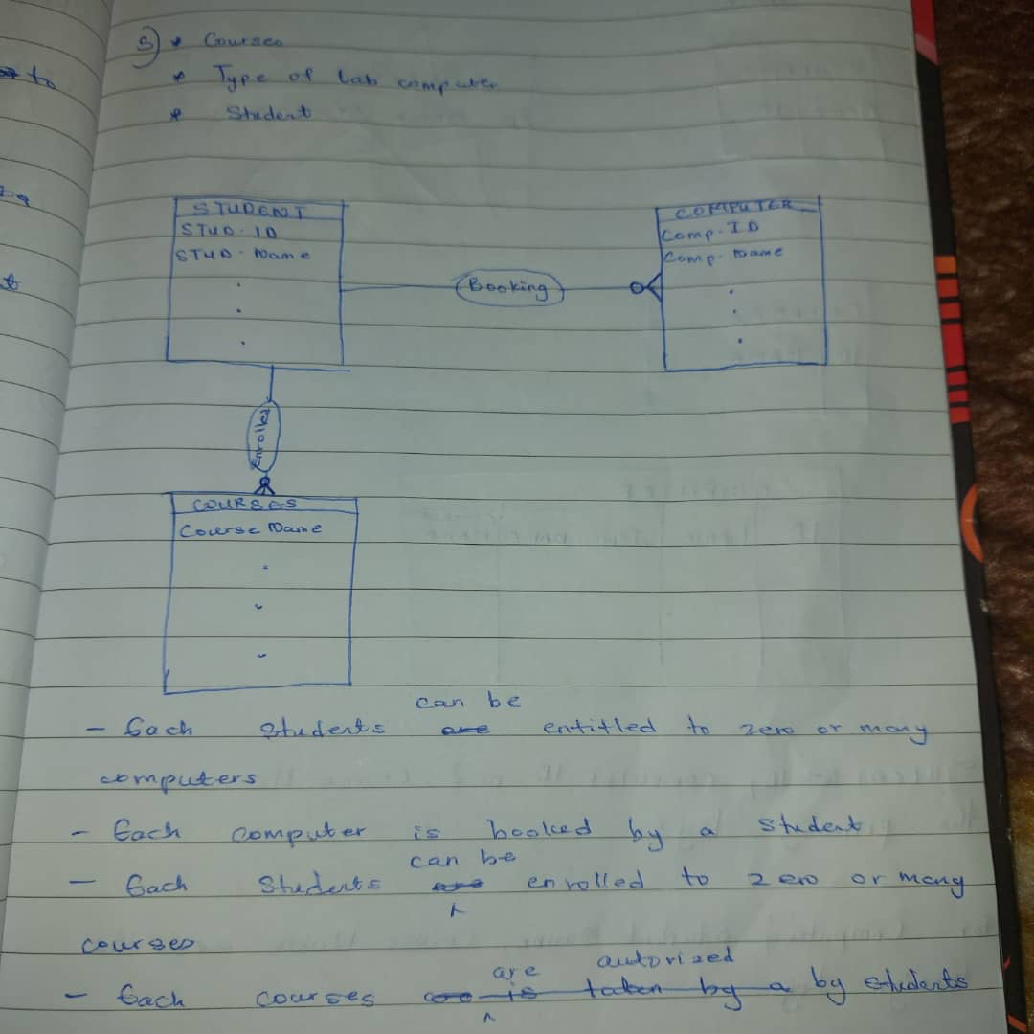

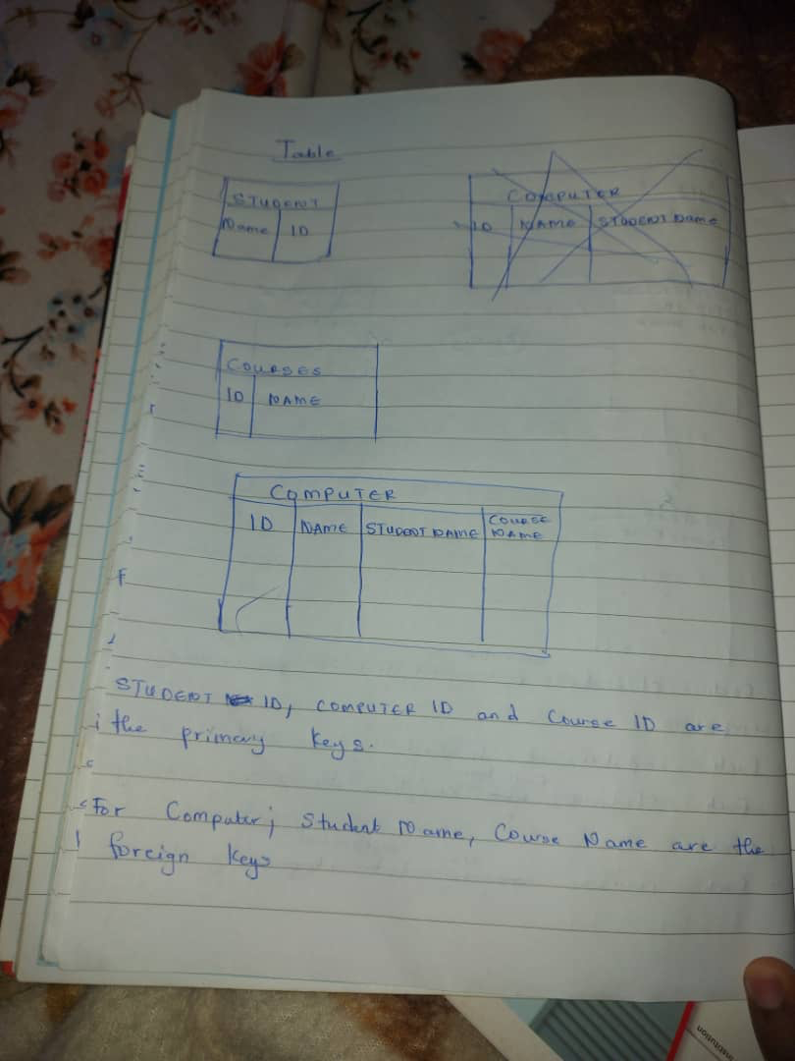
5.

