NAME: ODOK-OGAR DIVINE ONYODUMA
MATRIC NO: 18/MHS05 /009
DEPARTMENT: PHYSIOLOGY

QUESTIONS:
- Development of the lungs.
- Rotation of the stomach and formation of the omental bursa.
- Development of the esophagus..

ANSWERS:
DEVELOPMENT OF THE LUNGS:
It begins approximately after 4 weeks of development of embryo worth the formation of respiratory diverticulum(lungs bud) which appears as an outgrowth from the ventral foregut. Retinoids acid from surrounding mesoderm is the initiating factor.

The epithelium of the lungs is derived from foregut, connective tissue, muscle and cartilage are from splanchnic mesoderm. Parietal pleura is from somatic mesoderm.

•As development continues, the diverticulum expands caudally and 2 longitudinal ridges, the tracheoesophageal ridges, separate it from the foregut
•These ridges are called tracheosophageal ridges
•Subsequently, these ridges fuse to form the tracheoesophageal septum
•This tracheoesophageal septum divides the foregut into
•a dorsal portion called the esophagus,
• a ventral portion called the trachea and lung buds.

The long bus forms the bronchial buds which form into the right and left main bronchi. Growth is caudal and lateral to fill the pericardioperitoneal canals. There are 10 tertiary bronchi developed in the right, and 8 on the left. These correspond to the bronchopulmonary segments in the adult lung. Terminal bronchioles divide to form respiratory bronchioles and these alveolar ducts.
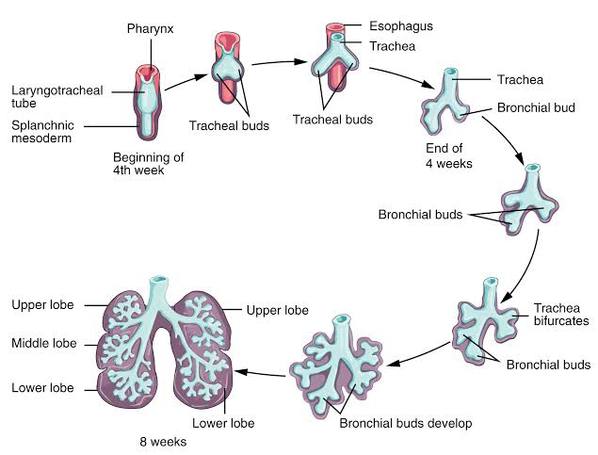
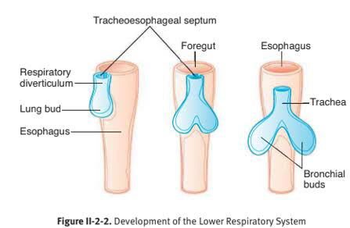

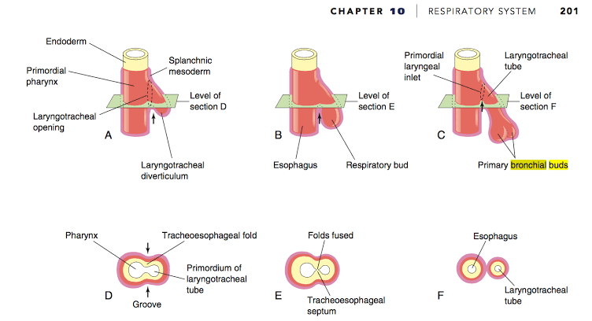

ROTATION OF THE STOMACH AND FORMATION OF THE OMENTAL BURSA.
Rotation along its longitudinal axis and AP axis
•As stomach enlarges, it slowly rotates 90 degrees, clockwise around its longitudinal axis
•As a result of this, the:
•The ventral border moves to the right and the dorsal border to the left
•The original left side becomes the ventral surface and the original right side becomes the dorsal surface
•the left vagus nerve, initially innervating the left side of the stomach now innervates the anterior wall
• similarly, the right vagus nerve innervates the posterior wall
•Before rotation, the cranial and caudal ends of the stomach are in the median plane
During rotation and growth of the stomach, the cephalic or cardiac portion moves to the left and slightly downward
•the caudal or pyloric part moves to the right and upward
•After rotation, stomach assumes its final position with its long axis almost transverse to the long axis of the body.
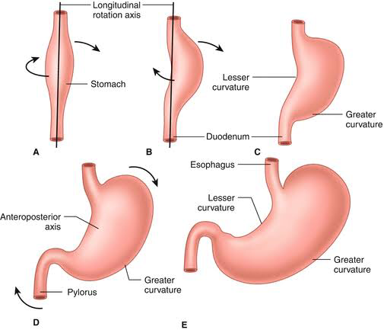
FORMATION OF THE OMENTAL BURSA
Isolated clefts (small cavities) develop in the mesenchyme forming in the thick dorsal mesogastrium
• The clefts soon coalesce to form a single cavity, the omental bursa or lesser peritoneal sac
• as a result of the rotation of the stomach, the dorsal mesogastrium is pulled to the left, thereby enlarging the bursa, to form a large recess of the peritoneal cavity
•As a result of the development of the diaphragm, the cranial part of the large bursa/large recess is cut off (limited by the diaphragm) to form a closed space called the infracardiac bursa
•The remaining inferior portion of the superior part of the omental bursa persists as the superior recess of the omental bursa
•inferiorly, the dorsal mesogastrium elongates and to form a fold called the greater omentum
• inside this fold is a space called inferior recess of the omental bursa.

This greater omentum overhangs the developing intestines
•as soon as the layers of the greater omentum fuse, the inferior recess disappears
• The omental bursa communicates with the main part of the peritoneal cavity/greater peritoneal sac through an opening called the omental foramen/ epiploic foramen or foramen of Winslow
• In the adult, this foramen is located posterior to the free edge of the lesser omentum.

DEVELOPMENT OF THE ESOPHAGUS.
•When the embryo is approximately 4 weeks old, the respiratory diverticulum appears at the ventral wall of the foregut at the border with the pharyngeal gut
• The tracheoesophageal septum gradually partitions this diverticulum from the dorsal part of the foregut
• In this manner, the foregut divides into;
•a ventral portion called the respiratory primordium
•a dorsal portion called the esophagus
•At first the esophagus is short but as the heart and lungs descend, it lengthens rapidly.
◦ The upper 2/3 of the esophagus has a muscular coat which is made up of striated muscles (derived from the mesenchyme in the caudal pharyngeal aches) and it is innervated by the vagus nerve
• the lower 1/3 muscular coat is smooth (formed from surrounding splanchnic mesenchyme) and is innervated by the splanchnic plexus.
• The epithelial cells proliferate and obliterate the lumen (partly or completely) but this obliteration is temporary
•Recanalization normally occurs by the end of the embryonic period
•Failure of proper recanalization leads to narrowing of the lumen (stenosis).

●note
•Epithelium & glands:
◦Derived from endoderm
•Striated muscles (mainly in the superior third):
◦Derived from the mesenchyme in the caudal pharyngeal aches
•Smooth muscles (mainly in the inferior third):
◦Derived from the surrounding splanchnic mesoderm

