NAME: OKE-OWO TIMOTHY
DEPT: MMECHANICAL ENGINEERING
MAT NO: 19\ENG06\045
COURSE CODE: CHM 102

ASSINGMENT
1. Name the functional group present in each of the following molecules.
i. CH₂=C(OH)HCHO: Hydroxyl group or alkanol (OH) and aldehyde , alkanal (CHO) and alkene(double bond)
ii. C₆H₅CH(NH₂)COCH₃: Amine(NH₂) and ketones(c=o)
iii.CH₃C=CHCH(OH)CHO: Hydroxyl group or alkanol (OH), aldehyde or alkanal (CHO) and alkene(double bond)

2.A O.856g sample of pure (2R,3R) – tartaric acid was diluted to 10cm3 with water and placed in a 1.0 dm polarimetre tube the observed rotation at 20⁰C was +1.0⁰ calculate the specific rotation of (2R,3R) tartaric acid.

i. Specific rotation is given by[ α] in g⁻¹ cm³ dm⁻¹

ii. α= observed rotation in degree

iii .c=concentration of optically active solute in gcm⁻³

iv. L=path length in dm
Recall that,
$\left[ α\right]= α$\CL
C=O.0856g\cm³ ,
L=1.0 dm,
α=1.0⁰,
T=20⁰c , wavelength=589nm
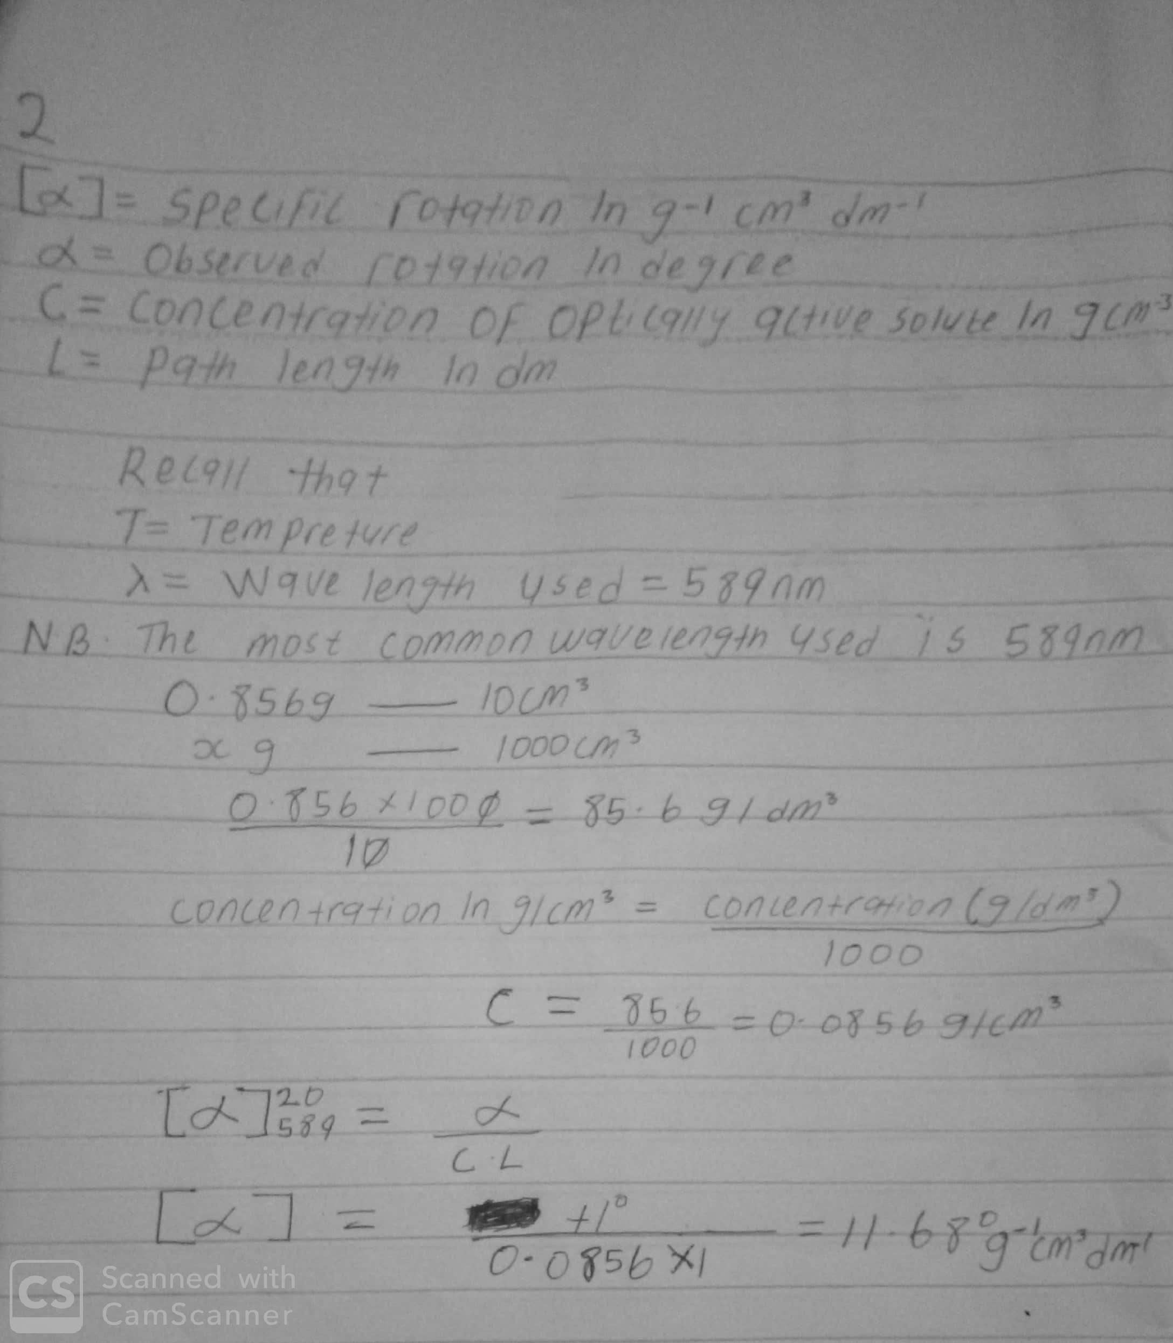

3.draw the possible geometric isomers (where possible) for each of the following compounds
i. Hexa-2,4 diene
ii.2,3 di methyl but 2-ene
