NAME: KEHINDE JESUYANMIFE JESULAYOMI
MATRIC NUMBER: 19/MHS01/228
COURSE CODE: BIO102
LEVEL: 100
COLLEGE/DEPARTMENT: MHS/MBBS

- HOW ARE FUNGI IMPORTANT TO MANKIND?

ANSWER:
- RECYCLING: Fungi (together with bacteria) are responsible for most of the recycling which returns dead material to the soil in a form in which it can be reused. Without fungi, these recycling activities would be seriously reduced. We would effectively be lost under piles many meters thick, of dead plants and animals remains.
- MYCORRHIZAE AND PLANT GROWTH: Fungi are vital for growth of most plants, including crops through the development of mycorrihazal associations. As plants are at the base of most food chains, if their growth was limited, all animal life, including human, would be seriously reduced through starvation.
- FOOD: Fungi are also important directly as food for humans. Many mushrooms are edible and different species are cultivated for sale worldwide. Fungi are also widely used in the production of food and drinks. These includes cheeses, beer and wine, bread, some cake and soya bean production.
- MEDICINES: Penicillin, perhaps the most famous of all antibiotic drugs, is derived from a common fungus called Penicillium. Many other fungi also produce antibiotic substances, which are widely used to control diseases in human and animal populations. The discovery of antibiotics revolutionized healthcare worldwide.

- ILLUSTRATE THE CELL STRUCTURE OF A UNICELLULAR FUNGUS WITH A WELL LABELED DIAGRAM.

ANSWER:
The structure of the cell wall is unicellular fungus (yeast) is similar to plant but chemically the fungi cell wall are composed of chitin. The cell membrane of a fungus has a unique sterol and ergo sterol. Most true fungi have a cell wall consisting largely of chitin and other polysaccharides. True fungi do not have cellulose in their cell walls.
DIAGRAM:

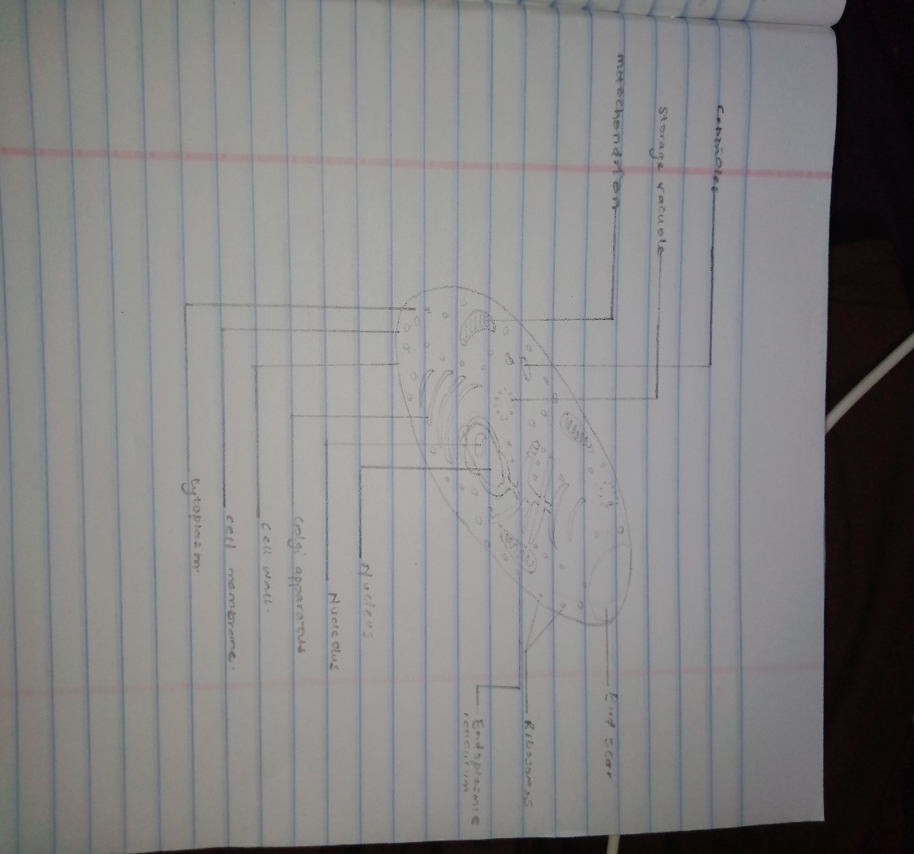

- OUTLINE THE SEXUAL REPRODUCTION IN A TYPICAL FILAMENTOUS FORM OF FUNGI

ANSWER:
Sexual reproduction in the fungi consists of three sequential stages; plasmogamy, karyogamy and meiosis.
- The diploid chromosomes are pulled apart into two daughter cells, each containing a single set of chromosomes (a haploid state)
- Plasmogamy is the first phase of sexual reproduction in fungi
- It is the fusion of protoplasts of two compatible gametes or sex cells or hyphae
- As a result of plasmogamy, two compatible nuclei are come close to each other.
Karyogamy is the fusion of two nuclei to form a diploid nucleus.
- In some fungi (phycomycetes) karyogamy occurs immediately after plasmogamy
- In some other fungi (ascomycetes and bascidiomycetes) karyogamy is much delayed.
- In the latter case (delayed karyogamy) two opposite strains of nucleoli get themselves arranged in pairs (dikaryon) in a single cell.
- This dikaryon divide mitotically as usual along with the simultaneous division of cytoplasm
- This results in the establishment of a separate karyotic phase in the life cycle of fungi
- This phase of life cycle is called dikaryotic phase
- After the establishment of dikaryotic phase, the two nuclei of a dikaryon fuse to form the diploid zygote
- Zygote is the only diploid phase in the life cycle o fungi
- Meiosis: zygote immediately undergo reduction division (meiosis) to produce meiospores
- After karyogamy reduction division takes places in the diploid nucleus and thus haploid stage is established
- In sexual reproduction of fungi, the two compatible nuclei (male and female) are brought together by the following processes
Planogametic copulation, gametangial contact, gametangial copulation, spermatization, somatogamy.

- HOW DO BRYOPHYTES ADAPT TO THEIR ENVIRONMENT?

ANSWER:
ADAPTATIONS OF BRYOPHYTES
- They have a waxy cuticle that prevents the body, the zygote, and the embryo from drying out.
- Spores are dispersed by the wind.
- The gametangia provides further protection against drying out specifically for the plants gametes.
- Lack of lignin prevents them from reaching a significant height. The Artic is characterized by a simple vegetation structure: there are no trees, shrubs are small, and other vascular plants such as herbs and grasses usually have a scattered distribution with low cover. As a result, competition for light becomes less restricting for small plants with very limited ability to grow high, such as bryophytes.

- DESCRIBE WITH ILLUSTRATION THE FOLLOWING TERMINOLOGIES: (a) EUSTELES (B) ACTACTOSTELE (C) SIPHONOSTELE (d) DICTYOSTELE

ANSWER:
- Eusteles is a type of siphonostele, in which the vascular tissue in the stem forms a central ring of bundles around a pith.
- Actactostele is a type of eustele, found in monocots, in which the vascular tissue in the stem exists as scattered bundles.
- Siphonostele is a stele consisting of a core of pith surrounded by concentric layers of xylem and phloem
- Dictyostele is a stele in which the vascular cylinder is broken up into a longitudinal series or network of vascular strands around a central pith (as in many ferns).
DIAGRAM:
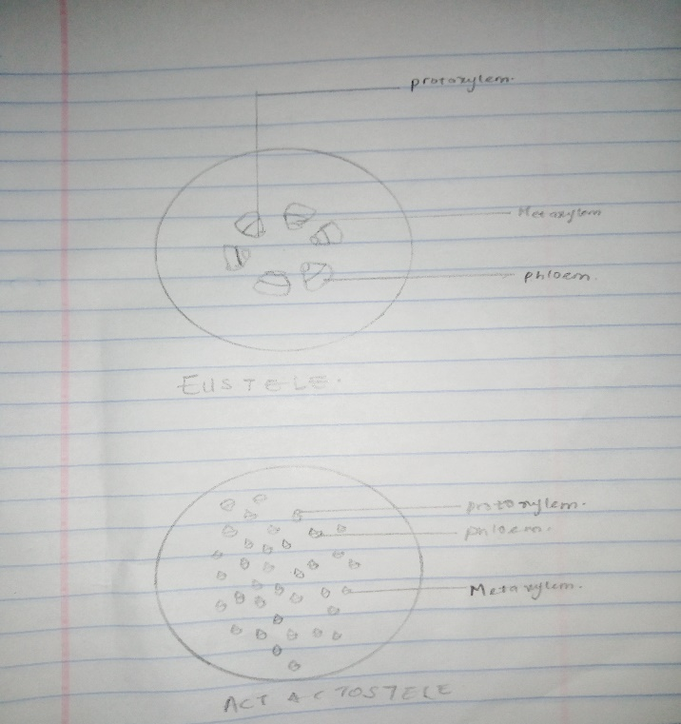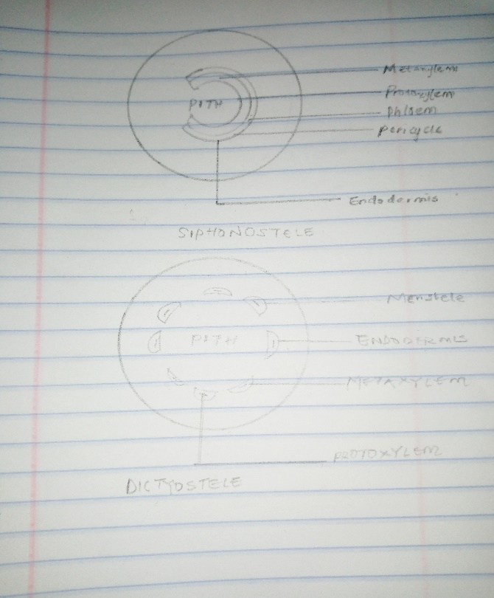
- ILLUSTRATE THE LIFE CYCLE OF A PRIMITIVE VASCULAR PLANT
The life cycle of primitive vascular plants is an alternation of generations, where the diploid sporophyte alternates with the haploid gametophyte phase. The diploid sporophyte is the dominant phase of the life cycle, while the gametophyte is an inconspicuous, but still independent organism.

