MATRIC NUMBER: 15/MHS/034
COURSE CODE: MLS 410
QUESTIONS:
- Discuss the phyics of the light microsope diagrams and illustrations needed
- Write notes on the ff biomedical equipment. Add notes on principle, brand, maintenance and cost
- Centrifuge
- Automatic Tissues processor
- Microtome
ANSWERS:
- A microscope can be made from two convex lenses. The image formed by the first element becomes the object for the second element. The second element forms its own image, which is the object for the third element, and so on. Ray tracing helps to visualize the image formed. If the device is composed of thin lenses and mirrors that obey the thin lens equations, then it is not difficult to describe their behavior numerically. Microscopes were first developed in the early 1600s by eyeglass makers in The Netherlands and Denmark. The first lens is called the objective lens, and has typical magnification values from 5× to 100×. In standard microscopes, the objectives are mounted such that when you switch between objectives, the sample remains in focus. Objectives arranged in this way are described as parfocal. The second, the eyepiece, also referred to as the ocular, has several lenses which slide inside a cylindrical barrel. The focusing ability is provided by the movement of both the objective lens and the eyepiece. The purpose of a microscope is to magnify small objects, and both lenses contribute to the final magnification. Additionally, the final enlarged image is produced in a location far enough from the observer to be easily viewed, since the eye cannot focus on objects or images that are too close.
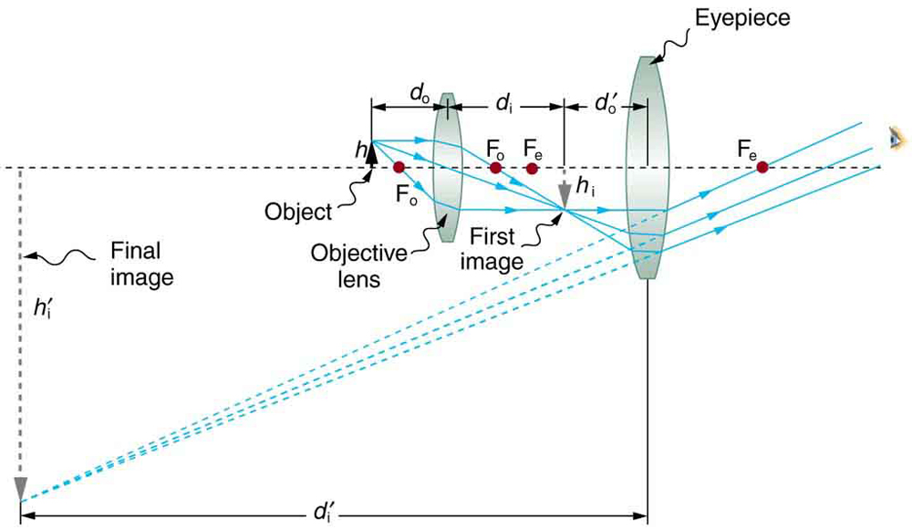
A compound microscope composed of two lenses, an objective and an eyepiece. The objective forms a case 1 image that is larger than the object. This first image is the object for the eyepiece. The eyepiece forms a case 2 final image that is further magnified.
Principles of Light, Electrons, & Microscopy
In microscopy we take advantage of waveform properties of light. These waves when produced at a particular source vibrate at right angles to the line of propagation. Each wave has a peak and trough. The distance traveled forward by the light ray is one wavelength (lambda). Wavelength varies with the color and intensity of the source.
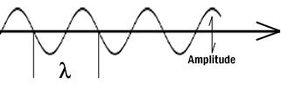
Figure 1: Schematic diagram of a wave.
How the image is formed
The structures the light microscope is called upon to resolve exert only a small influence on the light they transmit. What is changed is the phase of momentary vibration. Conventional brightfield illumination will lack contrast and the details of the sample remain invisible. When the emerging waves have acquired a larger phase difference due to changes in refractive index, greater contrast is produced. This manifests itself by an edge effect (diffraction, refraction, and reflection). Sample details may be resolved in a number of ways. When a light passes through stained structures intensity is reduced selectively depending on the color and density of the sample as the light is absorbed. Selective absorption of wavelengths of white light produces colored light. Refraction changes the direction of a light ray as it passes from one medium to another. The shorter the wavelength, the greater the refractive angle. Diffraction is the bending of light rays around objects with sharp edges. A new wave front is created at this edge. Diffraction can be useful, but can also reduce resolution. When light is dispersed it is separated into its constituent wavelengths as a result of refraction on entering a transparent medium. Contrast can be defined as a steep slope between bright and dark image points. Adequate contrast MUST be achieved before the specimen can be resolved.
Two terms that are often confused, but are central to microscopy are magnification and resolution. Magnification is the degree by which dimensions in an image are, or appear to be, enlarged with respect to the corresponding dimensions in the object. Resolution is the act or result of displaying fine detail in an image. Magnification without resolution would be meaningless.
The theoretical resolution of the light microscope was first defined by Abbe in the following equation.
Abbe's equation for theoretical resolution of the light microscope:
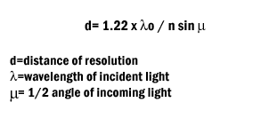
The actual resolution achievable with a light microscope is not as great. We will discuss the reasons for this later.
It is important to understand and to recognize the various components of the light microscope. The first and perhaps the most important element are the lenses.
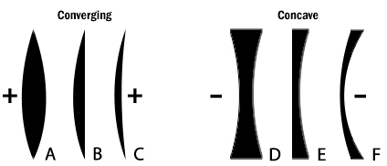
Figure 2: The six simple lenses. A, B, & C are converging or positive lenses. D, E, & F are concave or negative lenses.
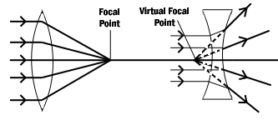
Figure 3: Converging and diverging lenses. Parallel rays enter a convex lens converge and meet at the principle focus. The distance between the center of the lens and the principal focus is the focal length. Parallel rays entering a concave lens diverge and never meet.
The Objective Lens is the first part of the imaging system; the objective lens forms a primary, enlarged image of the object. Very fine details are distinguished with the objective lens. The eyepiece sometimes called the ocular lens, is the second lens, which forms a secondary, further enlarged image. By multiplying the magnifying power of the objective lens and the magnifying power of the ocular the final magnification is found. A Substage Condenser lens is the third optical component. It is placed on a platform beneath the object. Light is directed through the substage condenser and converges to a point at the position of the specimen. The light rays diverge as they pass through the specimen and form an inverted cone, whose base is just large enough to fill the aperture of the objective. The size of the light beam is controlled by a diaphragm beneath the condenser called the aperture diaphragm.
The light source should contain both a lens to project an image of the lamp filament called a field condenser and a diaphragm to control the size of the illuminated field called a field diaphragm.
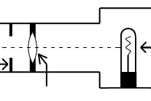
Figure 4: Typical lamp for light microscope.
Kohler Illumination is the most common method of illumination. In Kohler illumination the image of the source is projected by the field condenser onto the substage condenser, to the top of the plane of the object. This method assures even illumination.
Modern light microscopes use several different modes of operation depending on the needs of the investigator. The most common of these being brightfield microscopy in which direct light passes through the objective aperture and illuminates the background against which the image is seen. Since the structural elements being resolved have little variance in refractive index, the image will lack contrast and the details remain invisible. Small structure detail can be revealed by changing the absorption of the object by means of staining.
Many microscopes have special lenses that allow an investigator to image using phase-contrast. This method reveals details in specimens possessing very slight differences in optical path or refractive index in the surrounding media. Phase contrast requires no staining and can be used with living tissue. Contrast is produced in this method by phase differences in the light leaving the object to amplitude differences in the image. A phase plate alters the optical path length traveled by diffracted light from that traveled by direct light.
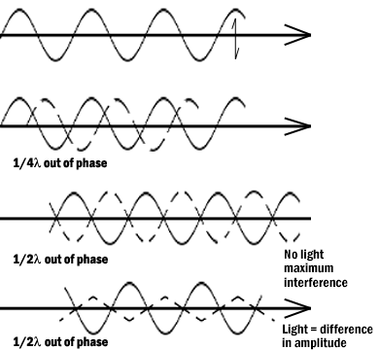
Figure 5: Light waves in brightfield and phase contrast after passing through an object. Pathway A represents the lightwave before encountering the object. Wave B represents the wave phase after passage in brightfield (unstained mode). C compares the wave phase of an object veiwed with phase contrast.
Differential interference contrast (DIC) differs from phase contrast in that the image has a strong relief and three-dimensional appearance. It must be remembered that the impression of surface details are the results of the optics and not the specimen for most biological samples. The optics for DIC consist of a polarizer at the light source and Wollaston prisms in the condenser and above the objectives. The beam passes through the polarizer, enters the first prism where it is split in two. One beam vibration is parallel to the prism and one is perpendicular. Both beams pass through the specimen in parallel in close proximity and are recombined in the second prism.
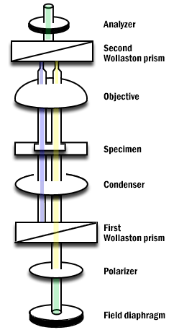
Figure 6: Differential Interference Contrast Schematic.
Darkfield microscopy is a mode in which direct light is prevented from passing through the objective aperture, but a hollow cone of light forms an apex in the plane of the specimen. The image is formed by light scattering from features of the object. Details appear bright white against a dark background. Darkfield can also be used for living bacteria, algae and plankton.
Some materials produce light when excited by short wavelengths of radiation. This effect is called fluorescence or auto-fluorescence. Specimens that do not fluoresce by themselves may be treated with fluorochromes which produce a secondary florescence. By illuminating with a high intensity mercury or xenon source and filtering out all but the desired excitation wave length to contact the specimen, the resulting longer (less energetic) wavelengths of emission from the specimen its self veiwed. Fluorescence microscopy can be used to enhance particular organelles, immunocytochemistry, in-situ hybridization, enzyme cytochemistry and elemental localization.
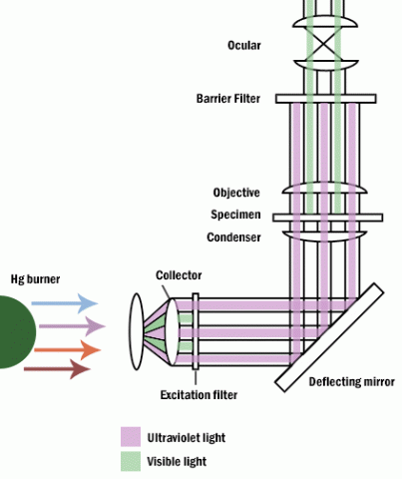
Figure 7: Fluoresence microscope.
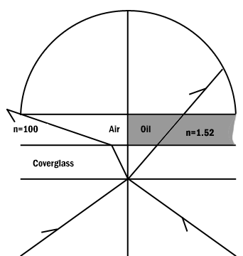
Figure 8: Comparison of a dry and an oil immersion objective.
Abbe in order to ease in identification of lens quality devised an equation for numerical aperture. Numerical aperture numbers can assist in comparing angles of dry, water immersion, and oil immersion objectives. Note the similarity to Abbe’s equation for theoretical resolution. This number is found on all objective lenses.
N.A. = n sin u
n = refractive index of medium
u = 1/2 the angle of light rays taken in when focused on the object.
When choosing an objective another consideration is depth of field. Depth of field is the distance from the nearest part of the subject in acceptable focus to the farthest part of the subject in acceptable focus. The efficiency (resolution) of a lens is inversely proportional to the depth of field (Table 1).
N.A. | .25 .30 .50 .65 .85 .95
Depth (in microns) | 8.0 5.5 2.0 1.0 .25 .10
Table 1: Variation in Depth of Field with Change in N.A.
Two aberrations within lenses detract from Abbe's equation of theoretical resolution. These aberrations are called spherical aberration and chromatic aberration. Spherical Aberration occurs when outer rays entering a lens are diffracted differently from those entering near the center. A solution for reducing spherical aberration is introducing a diaphragm or aperture.
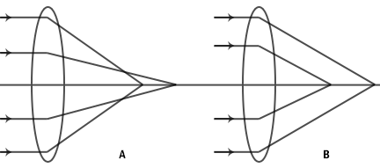
Figure 9: Spherical aberration of a simple lens. A. Under correction. B. Over correction.
The thickness of the cover glass should be chosen according to specifications of a particular objective. Deviation from the required thickness results in over correction or under correction of spherical aberration.
Chromatic Aberration occurs as white light entering a lens is broken into a spectrum from red to violet. Violet rays (more energetic) are refracted more than the red rays (less energetic). Consequently an uncorrected lens will be surrounded by color fringes. The more expensive lenses have a higher degree of correction.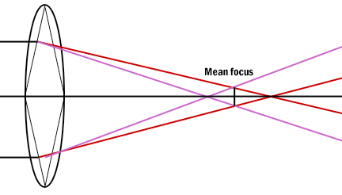
- CENTRIFUGE:
The Centrifuge is a ubiquitous instrument in biomedical laboratories and a basic knowledge of the theory of centrifugation is more than useful. Centrifuge performance can be classiﬁed as low-speed, high-speed and ultra-speed. Usual applications include the separation of serum or plasma from red blood cells, the separation of precipitated solids from the liquid phase of a mixture, or the separation of liquids of varying density.

PRINCIPLES OF CENTRIFUGATION
Particles suspended in a ﬂuid move, under the inﬂuence of gravity, towards the bottom of a vessel at a rate that depends, in general, on their size and density. Centrifugation is a technique designed to utilise centrifugal forces, which are greater than the force of gravity, to speed up the sedimentation rate of particles. This is achieved by spinning the vessel containing the ﬂuid and particles about an axis of rotation so that the particles experience a force acting away from the axis. The force is measured in multiples of the Earth’s gravitational force and is known as the relative centrifugal ﬁeld (RCF) or, more commonly, the ‘g’ force.
TYPES OF CENTRIFUGES
- Low-Speed Instruments: Low-speed centrifuges have maximum rotor speeds of less than 10,000 rpm, which do not require the rotors to be run in a vacuum, and there are instruments with a temperature control facility. Most instruments now include a sensor that will detect any imbalance when the rotor is running and cut oﬁfpower to the drive mechanism if imbalance is present. Low-speed instruments are used to separate serum or plasma from red blood cells, and to harvest and purify chemical precipitates, intact cells, nuclei, large mitochondria and large plasma-membrane fragments.
- High-Speed Instruments: In general, high-speed centrifuges are capable of rotor speeds up to 21,000 rpm, although the new generation of super-speed instruments are capable of rotor speeds of 30,000 rpm, in which RCFs of 120,000 xg are possible. These instruments require refrigeration systems to overcome the heat generated by the friction of the spinning rotor, and the higher-speed machines must incorporate vacuum systems. High-speed centrifuges are used in the separation of a number of cell constituents and in the isolation and puriﬁcation of viruses.
- Ultracentrifuges: Ultracentrifuges are capable of speeds in excess of 30,000 rpm and RCFs of over 600,000 xg.They can be used in the isolation and puriﬁcation of membrane components such as the endoplasmic reticulum and Golgi membrane, endosomes, ribosomes, DNA and RNA. Once again, refrigeration and vacuum systems are necessary.
CENTRIFUGE USE
There are a few important guidelines for operating a centrifuge, even a small one. Following them can prevent damage to the centrifuge and possible serious injury to you and others.
- The work surface must be level and firm: Do not use the centrifuge on an uneven or slanted work surface.
- Balance the tubes in the rotor: If you want to run a tube with 10 mL of liquid, put another tube with 10 mL of water in the opposing hole on the rotor. If the liquid has a higher or lower density than water, you must balance the tubes by mass, not volume.
- Do not open the lid while the rotor is moving: Even though many centrifuges have a "safety shutoff" if the lid is opened, the only thing this does is stop powering the rotor. The rotor will still spin due to its own inertia for a while until friction slows and eventually stops it.
- If you see it wobbling or shaking, turn it off or pull the plug: A little vibration is normal, but excessive amounts can mean danger. FIRST, double check that you correctly balanced the tubes. If the answer is yes and the wobbling still happens, contact the manufacturer or dealer and get the unit serviced. Do NOT continue to run a centrifuge that wobbles visibly when the rotor is spinning.
- Do not bump, jar, or move the centrifuge while the rotor is spinning: Make sure you don't have the cord dangling from a table edge where someone could catch their foot in it and pull down the centrifuge.

PREVENTIVE MAINTENANCE
- If the bearings on the upper and lower ends of the motor shaft are not of the sealed type then they should be lubricated as per the manufacturer’s instructions.
- Brushes should be removed regularly and checked for wear; they should be replaced if they are worn to more than one-half of their original length. When reinserting used brushes, replace them in the same orientation. New brushes should be broken in by slowly accelerating the unloaded unit to mid-speed and then allowing it to run for a period of time.
- The rotor, buckets and shields or carriers should be examined for signs of mechanical stress (eg cracks, corrosion).
- Some manufacturers etch the expiry date on the rotor and this should be checked periodically.
- Regularly lubricate the contact areas between the centrifuge buckets and Ihe pins.
- Regularly check the condition of the O-ring on the tie-down nut on top of the rotor, and replace it if worn or damaged.
- Always follow a manufacturer's specific instuctions.
AUTOMATIC TISSUE PROCESSOR:
A tissue processor is a device that prepares tissue samples for sectioning and microscopic examination in the diagnostic laboratory. Microscopic analysis of cells and tissues requires the preparation of very thin, high quality sections (slices) mounted on glass slides and appropriately stained to demonstrate normal and abnormal structures.
The ATP machine plays a big role in the preparation of the tissue by passing them through various chemicals; a major process called TISSUE PROCESSING
WORKING PRINCIPLE OF AUTOMATIC TISSUE PROCESSOR MACHINE – TP 1050 Leica processor model
Most ATPMs are easy-to-program interface. The Leica processor model has ten 1.8L (60.9oz.) reagent beakers and two 1.8L (60.9oz.) wax baths. The tissue basket oscillates up and down in each station at three-second intervals to ensure thorough and even mixing of the reagents and optimum tissue infiltration. Infiltration time is separately programmable for each station. Up to nine programs may be run with immediate or delayed starting times. When it’s time for tissue to be transferred to the next beaker or jar, the cover of the machine is raised up, and the lifting mechanism carefully removes the tissue basket and gently transfers it to the next beaker. When the infiltration time for any particular station is exceeded, a warning message will display, indicating the station number and excess time. Controls are arranged by functionality with an LCD to indicate operational parameters. Reagent container lids have seals to minimize operator exposure to hazardous fumes. Tissue basket immediately immerses in a station in the event of power loss to protect samples from drying out. When power is restored, program will resume. In the event of long-term power failure, wax is liquified. Capacity of tissue basket is 80 cassettes. Vacuum configurations hasten infiltration, allowing pressure to be applied to any station in either manual or automatic operation. Fume control configurations extract fumes with a fan and pass them through an internal carbon filter. For added efficiency, these models feature a two-part containment shield surrounding the reagent container platform.
Maintenance and care of automated tissue processor
- Any spillage or overflow should be cleaned immediately
- Accumulation of wax on any surface should be removed
- The temperature of the paraffin wax bath should be set to 3oc above the melting point of wax
- Timings should be checked when placing the cassettes in the processor
MICROTOME:
Microtome is an instrument with the help of which sections of tissues are cut and the process of cutting thin sections is known as Microtomy. The thickness of sections produced during microtomy may be between fractions of 50-100 nm, in ultramicrotomy, to several 100 microns. The common range is between 5-10m but both the maximum and minimum thickness is limited by the consistency of relation of the thickness of sections to the nature of tissues. These sections are stained using suitable staining techniques followed by observing them under the microscope.
TYPES OF MICROTOMES –
1.) Rotary microtome
The Rotary microtome is so-called because of a Rotary action of the handwheel responsible for the cutting moment. The block holder is mounted on a steel carriage, which makes up and down in groves this type of instrument is the most ideal for routine and research work it is excellent for cutting serial sections.
Advantages of the Rotary microtome
- Heavy and stable.
- Ideal for serial sections in large numbers.
- Paraffin-embedded tissues are cut by a rotary microtome.
- The knife holder is movable.
- The sections are cut are flat.
- It is useful for routine and research papers.
2.) Sliding or Base Sledge Microtome
This is a large heavy instrument with a fixed knife beneath which the object moves mounted on a heavy sliding base containing the feed mechanism used primarily for cutting the sections of cellulose nitrate embedded tissues with an obliquely set knife.
Advantages of Base-sledge microtome
- It is useful for cutting extremely hard blocks and large sections.
- The microtome is heavy and stable.
- The knife used is sledge shaped which requires less honing.
4) Cambridge rocking microtome
The instrument is so named because the arm has to move in a rocking motion while cutting the sections. The instrument was invented by Sir Horace Darwin in 1881 was developed by Cambridge company hence it is called the Cambridge rocking microtome. It is a simple machine in which the knife is held by means of microtome thread. The rocking microtome was designed primarily for cutting paraffin wax sections but in an emergency use frozen section by inserting a wooden block in which the tissue is frozen.
Advantages of Cambridge rocking microtomes
- The cost of a knife and microtome is low.
- Celloidin embedded tissues can be sectioned easily.
5.) Freezing microtomes
This type has been designed for the production or preparation of frozen sections of fluid and non-fluid tissues usually without preliminary embedding. The object stage is connected to the cylinder of compressed carbon dioxide for the rapid cooling of the tissues and provisions are also made for the cooling of the knife.
Advantages of Freezing microtome
- It is used for sections required for Rapid diagnosis
- It cuts non-dehydrated fresh tissue in a frozen state.
- The method is useful for Rapid histopathological diagnosis during operation
- This type of microtome is also used when lipids, enzymes, and neurological structures are to be demonstrated.
WORKING PRINCIPLE OF ROTARY MICROTOME –
- It is used for slicing paraffin tissue sections of uniform thickness.
- This method is designed to cut 1-60 micron thick sections.
- A knob on the device (typically at the backside) is used to modify the thickness of the sections.
- A knife is constant inside the knife holder and clamped tightly.
- The tissue block is drawn throughout the knife-edge and it is mechanically advanced. The top and bottom of the block have to be parallel and horizontal and as a minimum 1mm of paraffin has to be present in all aspects beyond the tissue.
- The trimming of the edges of the block is usually completed with a single-sided razor blade and the block face is trimmed with the microtome knife.
- The technician decides the type of section to be made in line with the nature of tissue and instructions received from the pathologist.
- At some stage in section slicing, as the wheel of the microtome turns, sections are cut and slide on the knife. A ribbon of sections is produced.
- The ribbon of sections is transferred to warm water inside the tissue floatation bath to put off any wrinkles present in the section.
- The best quality section that is free from any scratches and cracks can be decided on from the tissue ribbons. The tissue ribbons are then taken on smooth glass slides with a respective identification number.
- The slides are pulled from the water and the preferred sections are positioned flat on the surface of glass slides. The slides with the sections are positioned on a rack in a hot air oven to dry.
Daily Care Routine daily care consists of removing sectioning debris from the working area, brushing debris from the knife and cleaning as appropriate:
- first remove the microtome knife/blade holder and clean it.
- remove the debris trays and clean
- wipe covers and remove excess debris as required
- wipe visor if required Note that the microtome requires no other routine maintenance.
Microtome Knives and Blades Great care must be exercised when handling knives and or disposable blades.
- knives/blades must be stored in their boxes when not in use
- knives /blades fitted to the microtome must be properly guarded
- particular care must be taken during cleaning and knife sharpening

