16/MHS06/040
MLS 410 ASSIGNMENT

LIGHT MICROSCOPE

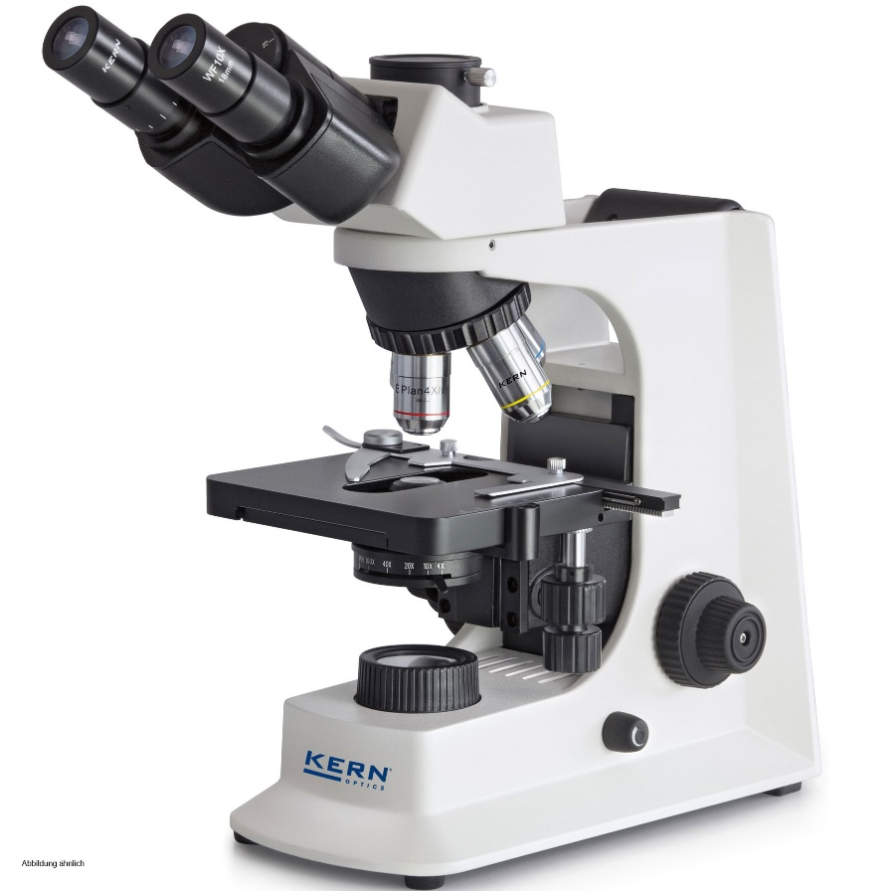

Physics of light microscope
A microscope is an important device that enables us visualizes minute objects either animate or inanimate that cannot be seen using the naked eyes
Working principle
The image of the specimen is first produced by a lens close to the specimen called the objective lens. The objective collects light from the specimen and forms the primary image
A second lens near the eyes called the eye piece enlarges the primary images converting it into one that can enter the pupil of the eye
The magnification of the objective multiplied by that of the eyepiece gives the total magnification of the image seen in the microscope.
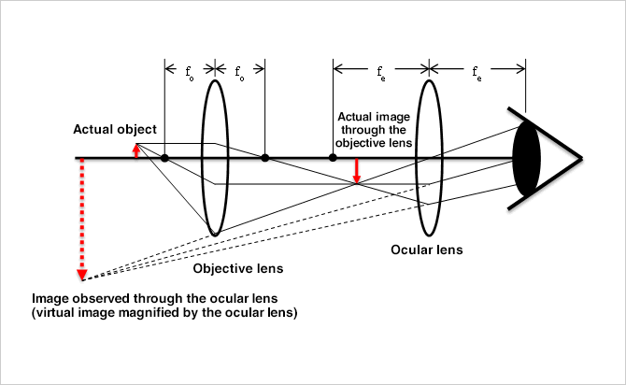

The methodology of the light microscope
The specimen to be examined is usually mounted on a transparent glass slide to allow easy transfer of light and is positioned on the specimen stage between the condenser lens and objective lens
The beam of visible light from the base is then focused by a condenser lens onto the specimen, the objective lens then picks up the light transmitted by the specimen and creates a magnified image of the specimen called the primary image. This image is again magnified by the ocular lens.
To see how the microscope forms an image, we consider its two lenses in succession. The object is slightly farther away from the objective lens than its focal length $f_{o}$, producing a case 1 image that is larger than the object. This first image is the object for the second lens, or eyepiece. The eyepiece is intentionally located so it can further magnify the image. The eyepiece is placed so that the first image is closer to it than its focal length $f_{e}$. Thus, the eyepiece acts as a magnifying glass, and the final image is made even larger. The final image remains inverted, but it is farther from the observer, making it easy to view (the eye is most relaxed when viewing distant objects and normally cannot focus closer than 25 cm). Since each lens produces a magnification that multiplies the height of the image, it is apparent that the overall magnification is the product of the individual magnifications:
$$M=m_{o}m_{e}$$
where
$m_{o}$ is the magnification of the objective and $m_{e}$ is the magnification of the eyepiece. This equation can be generalized for any combination of thin lenses and mirrors that obey the thin lens equations.
The magnification of the microscope
$$M=D/{f_{o}}×L/{f_{e}}$$
Where D = the least distance of distinct vision(25cm)
L= the length of the microscope tube
$f_{o}$= the focal length of the objective lens
$f_{e}$= the focal length of the eye-piece lens

CENTRIFUGE
A centrifuge is a piece of equipment that puts an object in rotation around a fixed axis, spins it in a circular motion applying a potentially strong force perpendicular to the axis of the spin
The centrifuge works using the sedimentation principle, where the centripetal acceleration causes denser substances or particles to move outward in a radial direction or to settle to the bottom of the tube while substances with lower densities are displaced and moved to the center or rise to the top.
Brands
Some brands of centrifuge are Super Deal, Labnique, Vision scientific, F2C, Wechef, FOUR E’s SCIENTIFIC, Unico, Yescom, Beckman- coulter
Types
- Low speed centrifuge
Used for routine sedimentation of heavy particles, packing them into pellets and supernatant of which the supernatant is gotten from decantation. This type of centrifuge has a maximum speed of 4000- 5000 rpm, they usually operate at room temperature.
There are 2 types of rotors used: fixed angle rotor and swinging bucket rotors.

- High speed centrifuge
Used in more sophisticated biochemical applications, higher speeds and temperature control of the rotor chamber is essential. This centrifuge has a maximum speed of 15,000-20,000 rpm, the operator can carefully control speed and temperature which is required by different sensitive biological samples
There are 3 types of rotors used: fixed angle, swinging bucket and vertical rotors.
- Ultracentrifuge
A very sophisticated instrument used for both preparative and analytical works. This centrifuge has a maximum speed of 65,000 rpm.
Intense heat is generated due to the very high speed thus the spinning chamber must be refrigerated and kept at a high vacuum while in use.
Care and maintenance
- Avoiding Rotor Failures
The centrifugal field which accelerates the separation process also exerts large forces on the rotor material. If a rotor fails, the centrifuge is severely damaged. Rotors are designed to be run up to their maximum speed with a load of a specific weight. One should never attempt to run a rotor at a speed higher than the one designated by its manufacturer. Also, if high density solutions (greater than 1.2 g/mL, for instance) are used, the run speed must be reduced to prevent undue stress on the rotor. Consult the instruction manual for exact directions.
- Tube Breakage
Glass tubes can break during centrifugation, due to improper loading or inherent defects. every glass fragment must be removed from the buckets, adapters, rubber liners, and rotor chamber before the next run is made. If gray dust is found, which results from sandblasting of the rotor chamber by glass particles, it must be cleaned up too. Several dry runs should be made without samples and clean the chamber between each run to be sure this dust is eliminated from the centrifuge.
- Chemical Resistance
If uncommon solvents or solutions are to be centrifuged, consult the manual to be sure they are compatible with the various plastics and metals comprising the centrifuge, the rotor, the tubes, and other accessories.
- Aerosol Generation
If any liquid is spilled on a rotor, it will be dispersed as a particulate mist when the centrifuge is run. Part of this mist will be fine enough to form a relatively stable aerosol which will tend to be dispersed throughout the laboratory. Such spills should be thoroughly cleaned up before running the centrifuge.
- Handling Human Samples
Human blood or blood components can transmit an infectious disease or virus if the patient or donor carries these. Blood should be handled with respect for this possibility during all laboratory manipulations.

- When in doubt, refer to the instruction manual
From time to time, questions about the actual operation and maintenance of the centrifuge may pop up. The instruction manual provided with the instrument is designed to answer these questions. It should be read before making the first run and kept handy for future reference.
Cost
Prices of centrifuge vary with brands and types
Basic laboratory centrifuge is relatively inexpensive ranging from as low as 30usd to as high as 1000usd with exceptions to few that can be as expensive as 2000usd and counting.

AUTOMATIC TISSUE PROCESSOR
Tissue processing is concerned with the diffusion of various substances into and out of porous tissues. Diffusion results from the tendency of processing reagents to equalize concentrations both inside and outside blocks of tissue. The reagent molecules diffuse down a concentration gradient and move from where they are at a high concentration to where they are at a lower concentration. This movement requires no energy since it always progresses down the concentration gradient.
This whole process can be done using an automatic tissue processor.
Brands
Brands of the automatic tissue processor are BETCO, ESROSE, MKLB LAB, Radical, Safire, Weswox, Rescholar etc.
Care and maintenance
Drain the solution tanks, rinse them with warm water and allow to dry before filling with new solutions
Clean processing racks from the processor.
Always switch off the processor after use.
Cost
Prices of automatic tissue processors vary with brands and modifications
But in the general laboratory setting, automatic tissue processors are relatively expensive ranging from 1000usd to as high as 14,000usd
MICROTOME
microtome is a sectioning instrument that allows the cutting of extremely thin slices of a material known as section. Microtome is used in microscopy, allowing for the preparation of sample for observation under transmitted light or electrons radiation. It is a method for the preparation of thin section for materials such as bones, minerals, and teeth. Microtome is a common instrument; it operates with a staged rotary action such that the cutting is part of the rotary motion.
The flywheel in many microtomes can be operated by hands. This has the advantage of clean cuts been made, as the relatively large mass of the fly wheel prevents the sample from being stopped during the sample cut. It cuts thickness between 1- and 60-micron meter. For hard material, it cuts a semi thin section with a thickness of as low as .5-micron meter.

Brands
Some brands of microtomes are Leica, Weswox, Jung Bio cut, Thermo Scientific, MICROM, SHURCUT etc.
Types
- Rotary microtome
The Rotary microtome is called so because of a Rotary action of the handwheel responsible for the cutting moment. The block holder is mounted on a steel carriage, which moves up and down in groves, this type of instrument is the most ideal for routine and research work, it is excellent for cutting serial sections. The feed mechanism is activated by turning a wheel on one side of the machine. The knife is fixed with its edge fixed upwards and the object is moved against the knife rising and falling vertically.
One rotation of the operating wheel produces a complete cycle downwards cutting stroke and an upward return stroke and activation of the advanced mechanism. It is often modified to cut ultrathin sections between 50Å – 200Å. The wheel may be electrically operated or manually.
Parts of the rotary microtomes are
Block holder, Knife clamp screw, Knife clamps, Block adjustment, Thickness gauge, The angle of tilt adjustment and Operating handle.
Advantages of the Rotary microtome
Heavy and stable.
Ideal for serial sections in large numbers.
Paraffin-embedded tissues are cut by a rotary microtome.
The knife holder is movable.
The sections are cut are flat.
It is useful for routine and research papers.

- Sliding or Base Sledge Microtome
This is a large heavy instrument with a fixed knife beneath which the object moves mounted on a heavy sliding base containing the feed mechanism. Used primarily for cutting the sections of cellulose nitrate embedded tissues with an obliquely set knife. The blocks holder is mounted on a steel carriage which slides backward and forwards on groves against a fixed horizontal knife. The block is raised towards the knife at a predetermined thickness. This type of microtome is designed for cutting sections of very large blocks of tissues for example whole brain.
Parts of Base-sledge microtome
Angular tilt adjustment, Knife clamps, Block holder, Coarse feed adjustment, Operating handle, Thickness gauge, Adjustment locking nut, Block adjustment screw, and Split nut clasp.
Advantages of Base-sledge microtome
It is useful for cutting extremely hard blocks and large sections.
The microtome is heavy and stable.
The knife used is sledge shaped which requires less honing.

- Cambridge rocking microtome
The instrument is named because the arm has to move in a rocking motion while cutting the sections. It is a simple machine in which the knife is held by means of microtome thread. The rocking microtome was designed primarily for cutting paraffin wax sections but in an emergency use frozen section by inserting a wooden block in which the tissue is frozen. It cuts the sections between 1 to 20 microns. The knife is fixed with the edge, while the object is moved against this knife circularly, producing a sharply curved surface to the block, with each stroke the tissue holder automatically moves vertically towards the knife. Cutting stroke is Spring operated and is easy to handle. The microtome must be placed on a solid non-slippery surface to allow a better hold.
Parts of the rocking microtomes
Knife holder, Block holder or chuck, Upper arm, Screw, Lever, Pawl, Ratchet wheel, Mil head microtome screw, Sleeve, Lower Arm and Scale.
Advantages of Cambridge rocking microtomes
The cost of a knife and microtome is low.
Celloidin embedded tissues can be sectioned easily.

- Freezing microtomes
This type has been designed for the production or preparation of frozen sections of fluid and non-fluid tissues usually without preliminary embedding. The object stage is connected to the cylinder of compressed carbon dioxide for the rapid cooling of the tissues and provisions are also made for the cooling of the knife. The movement of the knife takes place horizontally across the surface of the tissues. Ribbon sections cannot be prepared using this microtome. All freezing microtomes have the feature of employing a non-movable tissue block and cooling system.
Part of freezing type microtome
Knife clamps, Operating handle, Thickness gauge, Stage, Stage valve and Coarse adjustment.
Advantages of Freezing microtome
It is used for sections required for Rapid diagnosis
It cuts non-dehydrated fresh tissue in a frozen state.
The method is useful for Rapid histopathological diagnosis during operation
This type of microtome is also used when lipids, enzymes, and neurological structures are to be demonstrated.

Care and maintenance
Always lock the blade when not in use or remove blade after use
Use the brush provided to dust out all section particles from the stage , section holder and base
Remove the base to properly dust off any extra section particles
Take away the microtome bi and discard all section not used
Close the microtome with the cover after cleaning
Cost
Microtome prices vary with brands and types
But in the general laboratory setting, microtomes are relatively expensive ranging from 1500usd to as high as 12,000usd

