MATRIC NUMBER : 16/MHS06/010

MLS 408 ASSIGNMENT

In a tabular form only, compare and contrast sections of the Gastrointestinal tract.
SIMILARITIES BETWEEN ALL THE SECTIONS
OF THE GASTROINTESTINAL TRACT
They all aid in the :
- Digestion of food
- Secretion of digestive juices
- Absorption of water, salts, vitamins and end products of food digestion
- Excretion of waste products
- Lined by a mucous membrane

DIFFERENCES :

S/N | SECTIONS OF THE  GIT | GENERAL  FUNCTIONS | EPITHELIAL  LINING | STRUCTURE | DISEASES
1. | Oral  Cavity | Food particles are mixed with saliva, which lubricates them and initiates their digestion. | Mucous membrane (the oral mucosa) consisting of a stratified squamous epithelium, which may or may not be keratinized, and an underlying connective tissue layer, the lamina propria. | 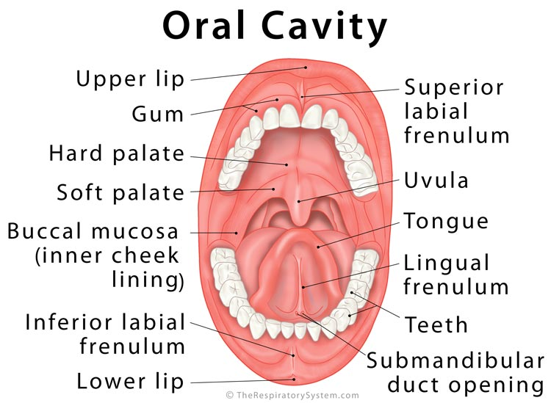 | - Tooth decay  - Oral cancer  - Gum disease
2. | Esophagus | Transports food from the pharynx to the stomach. | Stratified squamous epithelium and has a prominent muscularis mucosa and thick muscularis externa. The muscularis externa of the esophagus is unique in that it transitions from striated to smooth muscle over the length of the tube. | 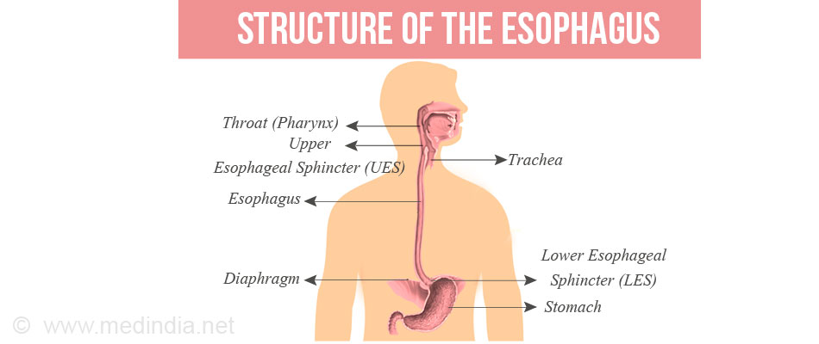 | - GERD (gastroesophageal reflux disease).  - heartburn,  - Esophageal cancer, and  - Eosinophilic esophagitis
3. | Stomach | The site where food is mixed with gastric juice and reduced to a fluid mass called chime. | The inner surface of the stomach is lined by a mucous membrane known as the gastric mucosa which contains the glands and the gastric pits.. Simple columnar epithelium, lamina propria, and the muscularis mucosa. | 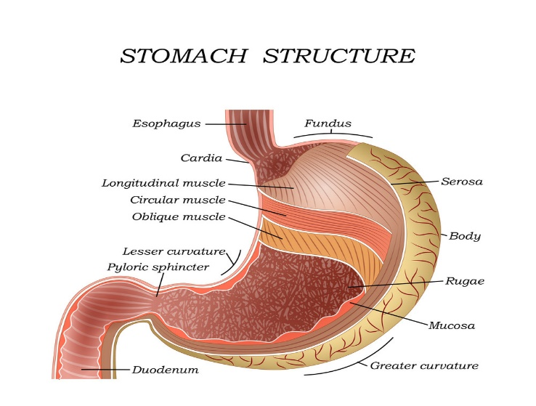 | - Gallstones  - Celiac Disease  - Crohn's Disease  - Ulcerative Colitis  - Irritable Bowel Syndrome  - Hemorrhoids  - Diverticulitis
4. | Small Intestine | Responsible for the continued digestion and absorption of the GI tract contents. | Simple columnar epithelium which consists primarily of absorptive cells (enterocytes), with scattered goblet cells and occasional enteroendocrine cells. | 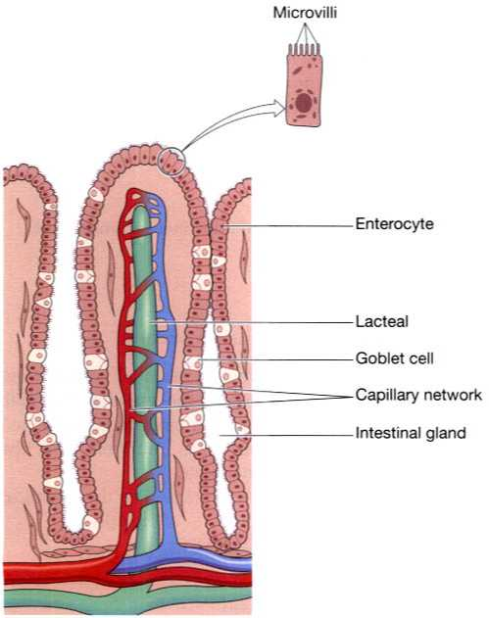 | - Bleeding.  - Celiac disease.  - Crohn's disease.  - Infections.  - Intestinal cancer.  - Intestinal obstruction.  - Irritable bowel syndrome.  - Ulcers, such as peptic ulcer.
5. | Large Intestine | Absorbs water and concentrates waste material that is formed into feces. | Simple columnar epithelium. Instead of having the evaginations of the small intestine (villi), the large intestine has invaginations (the intestinal glands). | 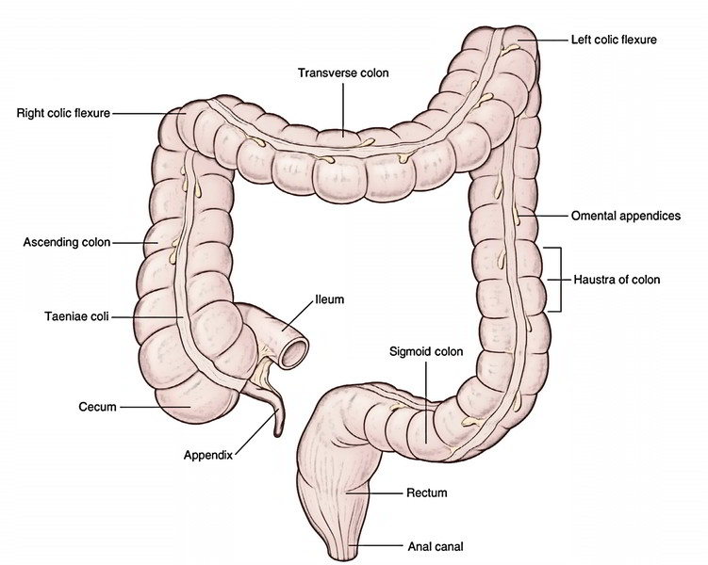 | - Hirschsprung's disease  - Constipation  - Diarrhea
6. | Rectum | Stores the feces. | The mucosa has the typical intestinal epithelium with simple columnar enterocytes and numerous goblet cells.  At the anal transitional zone the columnar epithelium flattens more and more and eventually becomes stratified squamous non-keratinized epithelium. | 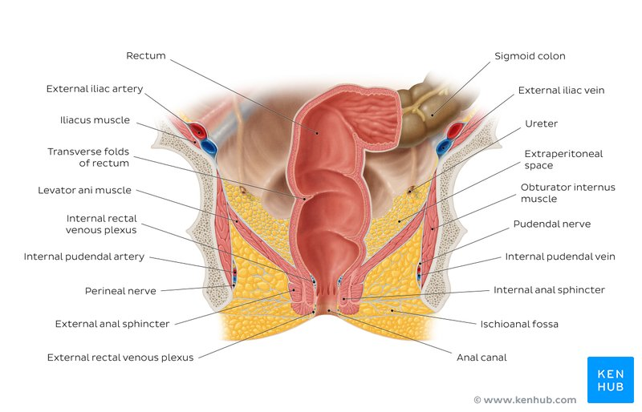 | - Irritable bowel syndrome,  - Constipation,  - Hemorrhoids,  - Anal fissures,  - Abscess,  - Colitis,  - Polyps and  - Colon cancer.
7. | Anal canal | Feces pass out of the rectum, through the anus, and out of the body | The anal canal is mainly lined by stratified squamous epithelium.  At its upper end, the anal canal is lined by columnar epithelium identical to that of the rectum.  This changes to a non-keratinizing stratified squamous type at the level of the pectinate (or dentate) line. | 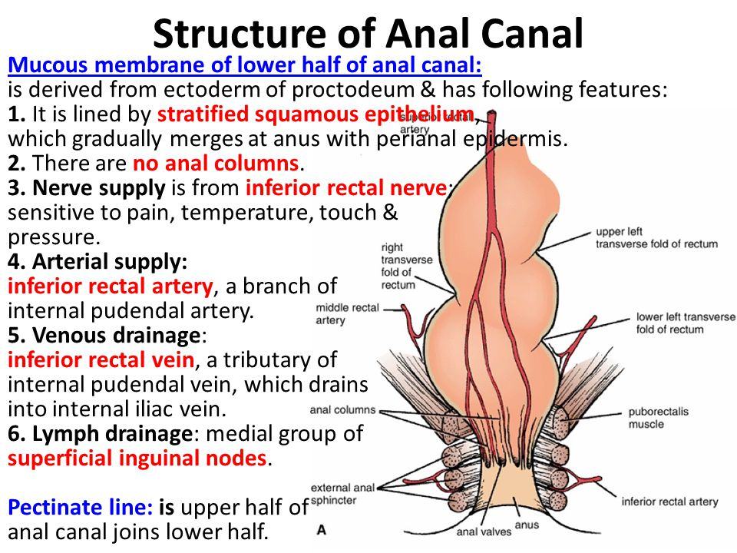 | - Anal fissure  - Peri-anal abscess  - Acutely prolapsed thrombosed piles  - Peri-anal haematoma.

