1) It is the precursor of all cell hormones eg oesterogens, androgens, etc.
It is the main component of most animal tissues.
It is also the main component of animal cell membrane.
It is the main component in the metabolism of vitamin D (cholecalciferol)
2) Globosides are phosphoglycerides that contain two or more sugar residues. They are found in red blood cells and are used in the determination of the ABO system while gangliosides are complex phosphoglycerides obtained from glucocerebrosides and contain oligosaccharide and 1 or more sialic acid.
3) phosphatidyl choline
4) the 1st ring (ring A)
5) 1) phosphoglycerides contain glycerol as their backbone
2) Phosphoglycerides are amphiphilic in nature
3) They contain 1 phosphate group

Triacylglycerol | phosphoglycerides
They are esters of glycerol with 3 fatty acid molecules | They contain glycerol backbone with 1 phosphate group
Fat cells store triglycerides | they help break down fats in the body.
Dioleopalmitin | Phosphatidyl choline
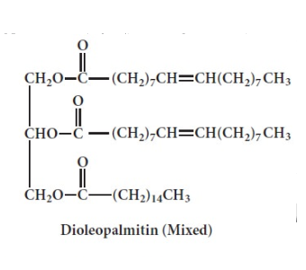 | 