MADUBUKO KEREN-HAPPUCH AMARACHI
19/MHS09/014
DENTISTRY
BIOLOGY
- (i) They are part of the nutrient cycle in the ecosystem.
(ii) Yeasts are used for production of beer, wine and bread.
(iii) They produce substances that human use as medicine.
(iv) They can be used as natural pesticide.
(v) They are available for as soil additives
2. 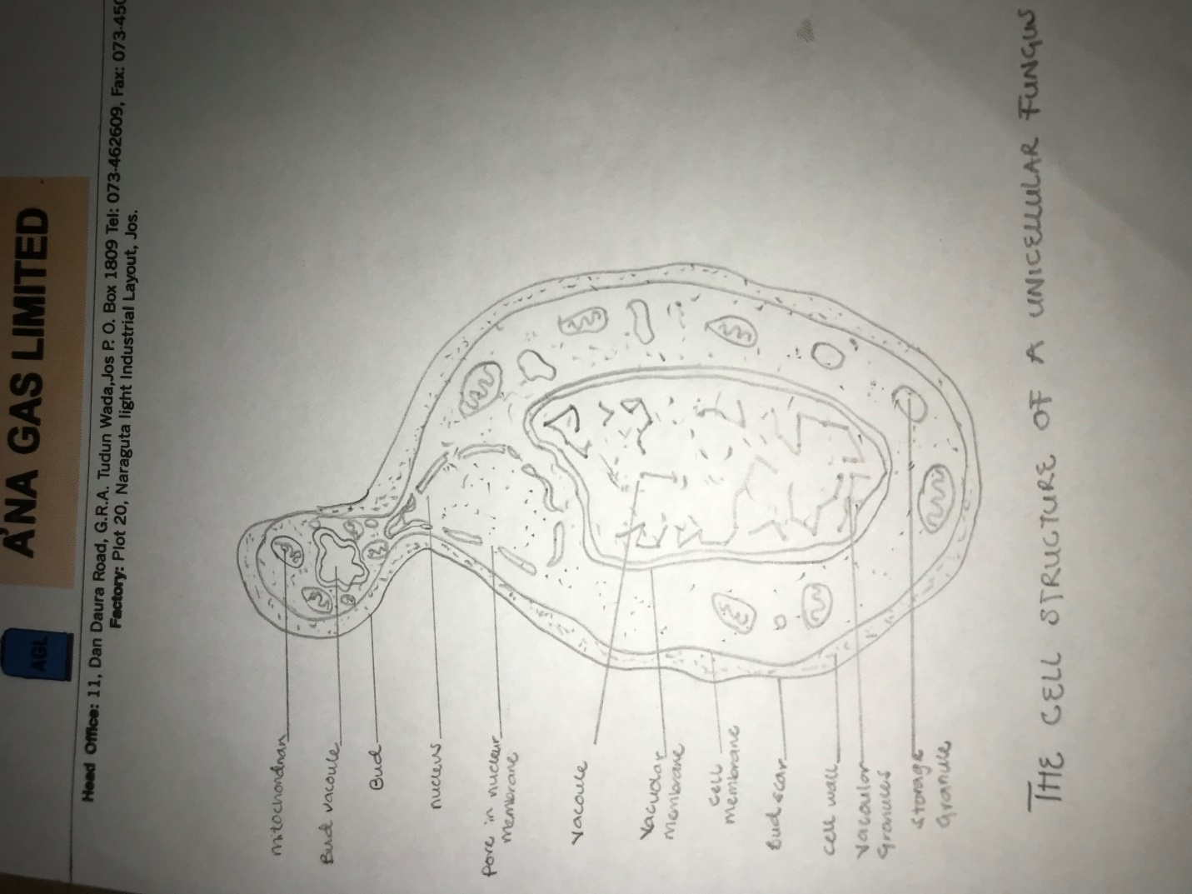
3. Sexual reproduction allows the fungus to adapt to new environment. The nuclear membrane remains intact throughout the process. The nucleus of the fungus becomes pinched at its midpoint, and the diploid chromosomes are pulled apart by spindle fibers formed within the intact nucleus. The nucleolus is usually retained and divided between the daughter cells. It consists of plasmogamy, karyogamy and meiosis stages. The diploid chromosomes are pulled apart into two daughter cells, each containing a single set of chromosomes. Plasogamy brings together two compatible haploid nuclei. Karyogamy results in the fusion of these haploid nuclei and the formation of a diploid nucleus. The formed by this is called by the zygote. Once karyogamy has occurred, meiosis follows and restores the haploid phase. The haploid nuclei that results from meiosis are generally incorporated in spores called meiospores.
.4. They lack lignin which makes their competition for light less restricting.
(ii) The permafrost bellow prevents water from draining away and keeps it available to plants.
(iii) They have a unique ability to recover from long-lasting extreme environmental conditions.
(iv)They show a high degree of phenotypic plasticity.
(v) They photosynthesize whenever conditions are unfavorable which enables them to survive in cold region.
(vi) they survive droughts, shutting down all metabolic processes, and reviving under favorable conditions with a minimum of destruction.
5.a. eustele is a stele typical of a dicotyledonous plants that consists of vascular bundles of xylem and phloem strands with parenchymal cells between the bundles.
b. Atactostele is a type of monocotyledonous siponostele in which the vascular bundles are dispersed irregularly throughout the center of the stem.
c. siphonostele is a stele in which the vascular tissue is in form of a cylinder surrounding the pith.
d. dicotyostele is b

