NAME: IBEKU CHIBUZOR GRACE
COLLEGE: MEDICINE AND HEALTH SCIENCES
DEPARTMENT: MEDICINE AND SURGERY
COURSE CODE: BIO 102
ASSIGNMENT
1a). They are responsible for the mediation of decay of organic matter
b). They are very important to the entire terrestrial ecosystem in material cycling and to man
c). They are important in food industry
d). Fungi e.g. mushroom serves as food
e). Some fungi constitute important biological control agents in regard to pests
2). CELL STRUCTURE OF A UNICELLULAR FUNGUS

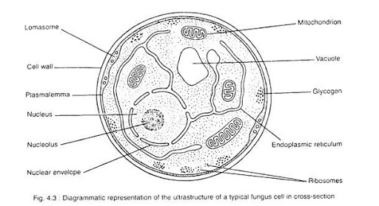

3). Rhizoporous stolonifera
a). First, two mating types of hyphae grow in the same medium
b). A chemical interaction between them causes growth perpendicular to the hyphae in opposite directions, so they can meet with one another
c). The growths are the delimited by a wall just so the nuclei are isolated in differentiated sex organs called gametangia (plural).
d). The gametangia fuse in a process called plasmogamy and together they form a zygote which may undergo dormancy for a period.
e). The nuclei in the zygote fuse in two and undergo meiosis independently, it then moves on to germinating under favorable conditions so as to liberate haploid spores at maturity through the production of a fruiting.
f). In summary, sexual reproduction in fungi consists of three stages; plasmogamy, karogamy and meiosis
4a). They have definite structures for water and nutrient absorption from the soil; therefore, the plant body is divided into two (an aerial portion and a subterranean portion)
b). The aerial portion being exposed to the atmosphere demands some modifications that prevents excessive loss of water through the body surface i.e. desiccation and some other modifications that permits climination of excess water from the plant body and not only exchange of gases between the internal parts of the plant and the atmosphere therefore openings are available on the aerial parts of the plant.
5a). Eusteles: A type of stele in which the vascular tissue in the stem forms a central ring in bundles around a pith. The vascular bundles are discrete, collateral bundles of xylem and phloem.
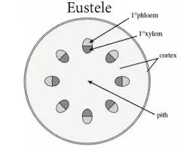

b). Atactostele: A type of stele found in monocots, in which the vascular tissue in the stem exists as scattered bundles.
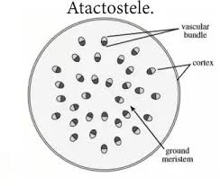
c). Siphonostele: A type of stele consisting of a core of pith surrounded by concentric layers of xylem and phloem.
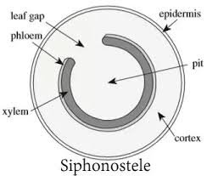
d). Dictyostele: A type of stele in which the vascular cylinder is broken up into a longitudinal series or network of vascular strands around a pith.
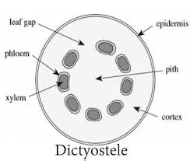
6). LIFE CYCLE OF A PRIMITIVE VASCULAR PLANT
