NAME: NTAMU PRECIOUS TIMOTHY
DEPARTMENT: MBBS
COURSE CODE: BIO102
MATRIC NUMBER: 19/MHS01/261
1a. Fungi e.g. yeast are important in the food industry
b. Fungi are responsible for the mediation of decay of organic matter
c. Without fungi and other microbes, the surface of the earth would have been clogged up with dead matters with all the various elements locked up in them instead of returning into various cycle
2. 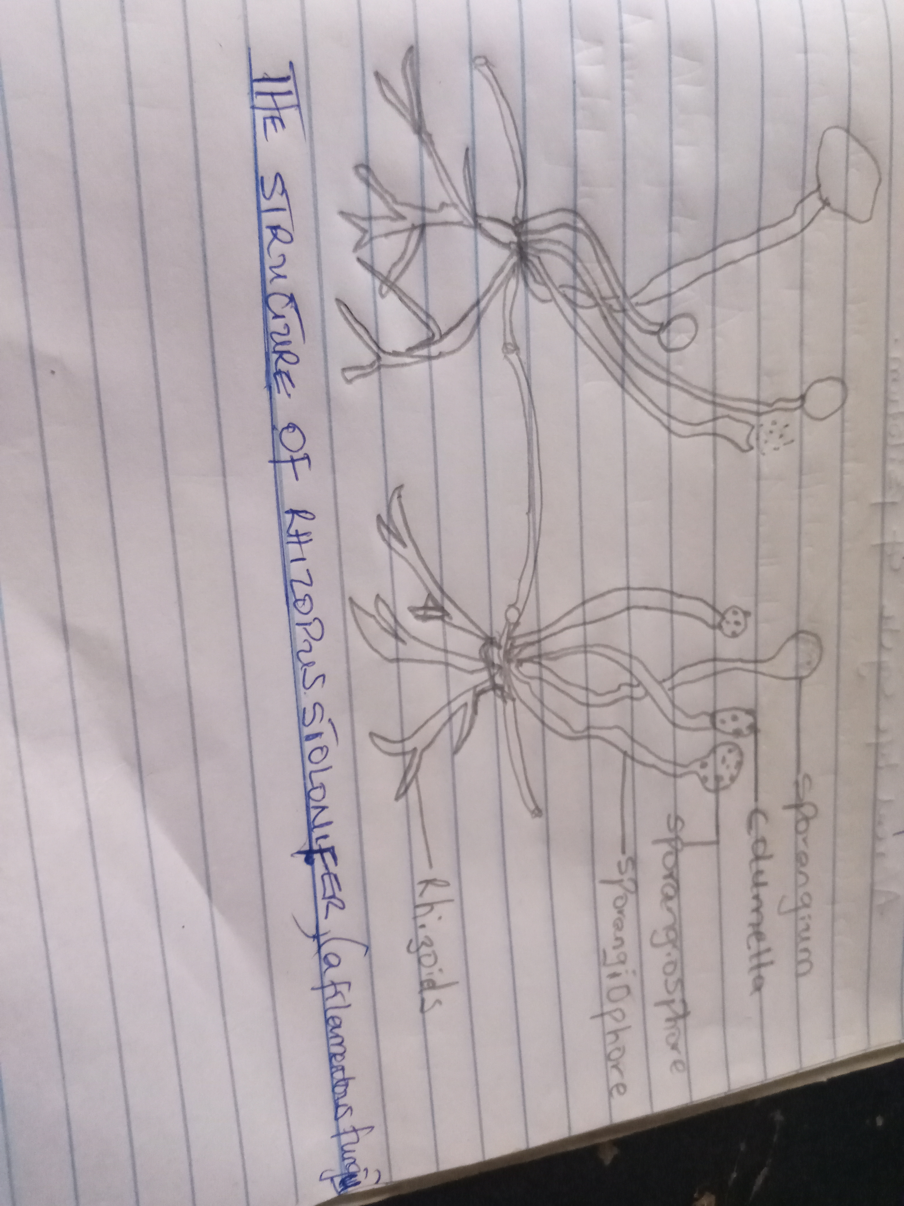

3. Sexual reproduction occurs when two mating types of hyphae grow in the same medium. Chemical interaction in the two mating types of hyphae induces growths perpendicular to the hyphae in opposite directions. These growths are delimited by a wall such that many nuclei are isolated in what is called a gametangium.
The two gametangia fuse (plasmogamy)and a zygote is formed which may undergo prolonged dormancy or resting stage. The nuclei in the zygote fuse into twos and undergo meiosis independently.
The zygote germinates under favorable conditions to produce a fruiting which at maturity liberates the haploid spores.
4a. They have definite structure for water and nutrient absorption form the soil; therefore, the plant body is divided into two (an aerial portion and a subterranean portion). The subterranean portion is the rhizoid and is not a true root as the case of land plants that are advanced.
b. The aerial portion being exposed to the atmosphere demands some modifications that prevents excessive loss of water through the body surface (i.e. desiccation)
c. Some other modifications that permit elimination of excess water from the plant body and not just exchange of gasses between the internal parts of the plant and the atmosphere the openings are available on the aerial part of the plant.
5a. Eusteles: In herbaceous dicotyledonous plants, eustele in which the vascular bundles are discrete, concentric collateral bundles of xylem and phloem.
b. Atactostele: In grasses and many monocotyledonous plants. Atactostele i.e. the vascular bundles are scattered. The nature of the vascular supply to leaves is also noteworthy element of the vascular system
c. Siphonosteles: the vascular supply to leaves is associated with leaves gap and the conducting cylinder is a dissected one.
d. Dictylostele: In vascular plants, the saprophyte is the dominant generation unlike in the bryophyte where gametophyte is the dominant generation. The sporophyte in vascular plants shows a progressive increase in size and complexity along the evolutionary ladder.
6. 