NAME: SADIKU DAVID JESUFERANMI
MATRIC NO: 18/SCI01/082
Assignment on loop
- Write a program that count from 100 to 1 varying the control variable in the steps of 3 and printing its square for each count. Using do statement and While statement.
Solution
#include<stdio.h>

int main(){

int i= 100;
int square=1000;

do {
printf(" \n%d= %d\n ", i,square);
i = i - 3;
square= i*i;
}while( i <= 100 && i>=0 );

return 0;
}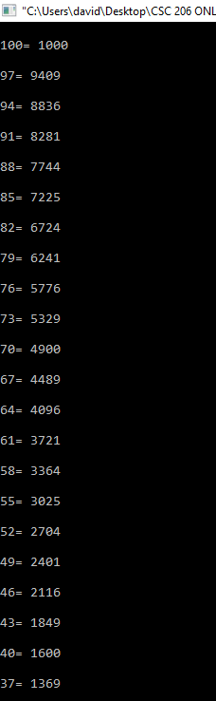

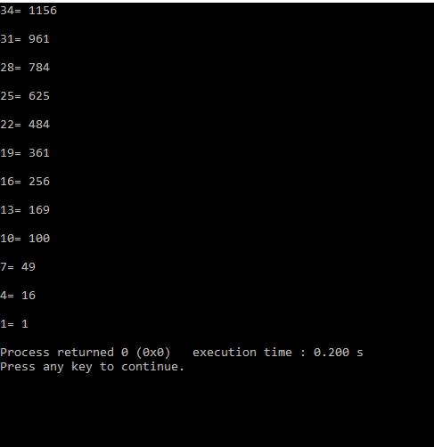

- Write a C program to display 80 bottles. But, if the input exceed 59, exit the loop and end the program. (Hint: using break statement)
Solution
#include <stdio.h>
int main () {
int bottles = 1;
int limit=59;
while( bottles < 81 ) {
printf(" %d\n", bottles);
bottles=bottles+1;
if( bottles >= limit) {
break;
}
}
return 0;
}

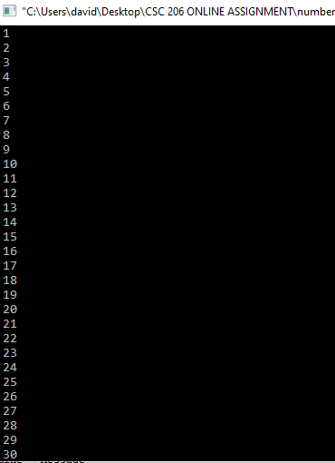

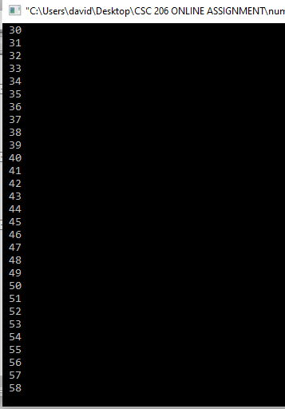

- Write a program that reads an integer and displays a message to indicate whether it is a prime number or not. It is reminded that a prime number is any integer greater than 1 with no divisor other than 1 and itself.
Solution
#include <stdio.h>
int main() {
int n, i, prime = 0;
printf("Enter a positive integer: ");
scanf("%d", &n);
for (i = 2; i <= n / 2; ++i) {
if (n % i == 0) {
prime = 1;
break; }
}
if (n == 1) {
printf("1 is neither prime nor composite."); }
else {
if (prime == 0)
printf("%d is a prime number.", n);
else
printf("%d is not a prime number.", n);
printf(" \n\nA prime number is any integer greater than 1 with no divisor other than 1 and itself. "); }
return 0;
}
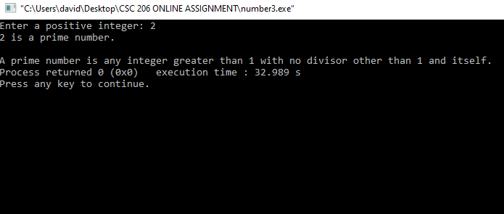

- Write a c program to find factorial of a natural number
Solution
#include <stdio.h>

int main()
{
int i, Number;
long Factorial= 1;

printf("\n Please Enter any number to Find Factorial\n");
scanf("%d", &Number);

for (i = 1; i <= Number; i++)
{
Factorial = Factorial * i;
}

printf("\nFactorial of %d = %d\n", Number, Factorial);

return 0;
}
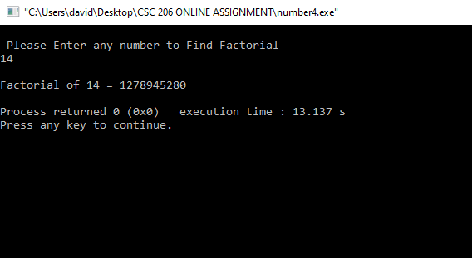

- Write a program in C that count from 50 to 1000 varying the control variable in steps of 7 using do While statement.
Solution
#include <stdio.h>

int main () {

int num = 50;
do {
printf(" %d\n", num);
num = num + 7;
}while( num <= 1000 );

return 0;
}
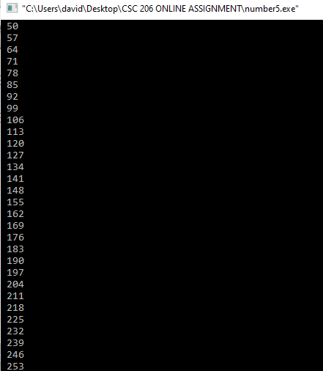

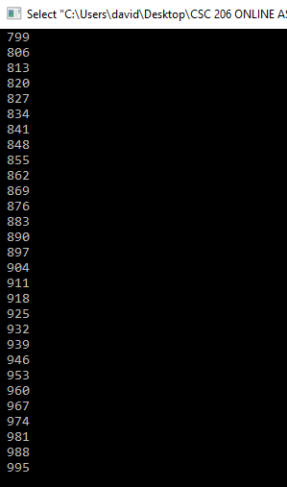

- Using conditional operator, write a program in C programming Language to find if a given character is a consonant or a vowel.
Solution
#include <stdio.h>

int main()
{
char ch;

printf("Input a character\n");
scanf("%c", &ch);

switch(ch)
{
case 'a':
case 'A':
case 'e':
case 'E':
case 'i':
case 'I':
case 'o':
case 'O':
case 'u':
case 'U':
printf("%c is a vowel.\n", ch);
break;
default:
printf("%c is a consonant.\n", ch);
}

return 0;
}
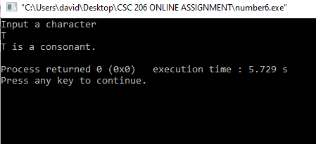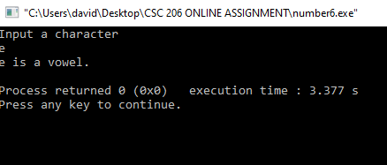

- Write a program (using FOR statement) that reads an integer and displays its multiplication table. The program should force the user to enter an integer within [1, 10].
Solution
#include <stdio.h>
int main() {
int n, i;
printf("Enter an integer: ");
scanf("%d", &n);

for (i = 1; i <= 10; ++i) {
printf("%d * %d = %d \n", n, i, n * i);
}
return 0;
}
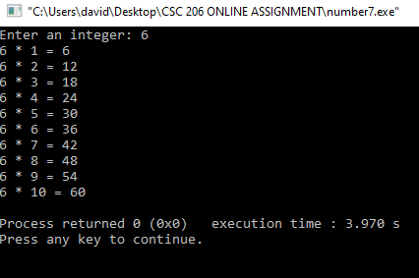

- A test consists of 10 multiple choice questions, each of which has three possible answers. The first answer gets three points, the second one point, and the third two points. Write a program that uses the switch statement to read the test taker’s 10 answers and display the final score.
Solution

#include <stdio.h>

int main()
{
int test;

printf("Input answer of question 1\n");
scanf("%d", &test);
printf("Input answer of question 2\n");
scanf("%d", &test);
printf("Input answer of question 3\n");
scanf("%d", &test);
printf("Input answer of question 4\n");
scanf("%d", &test);
printf("Input answer of question 5\n");
scanf("%d", &test);
printf("Input answer of question 6\n");
scanf("%d", &test);
printf("Input answer of question 7\n");
scanf("%d", &test);
printf("Input answer of question 8\n");
scanf("%d", &test);
printf("Input answer of question 9\n");
scanf("%d", &test);
printf("Input answer of question 10\n");
scanf("%d", &test);

switch(test)
{
case 1:
printf("you have 3 points");
break;
case 2:
printf("you have 2 points");
break;
case 3:
printf("you have 1 point");
break;

}

return 0;
}
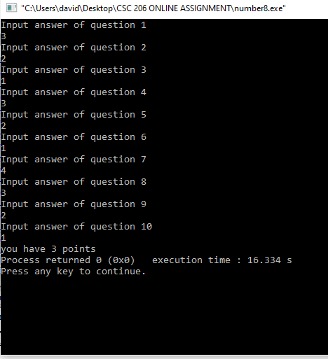

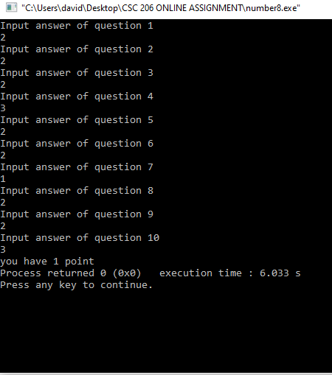

- Write a C program to find the product of 8 integers entered by a user. If user enters 0 skip it. (Hint: using continue statement).
Solution

#include <stdio.h>

int main()
{
int n;
int number,pro;

printf("\nEnter an integer number :");
scanf("%d",&n);

pro=1;

while(n>0)
{
number=n%10;
pro*=number;
n=n/10;
}

printf("\nPRODUCT of all digits: %d",pro);

return 0;
}
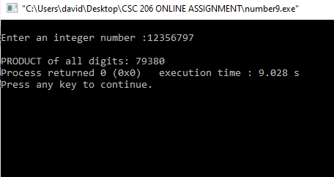

- Write a program that reads the initial population of a country and its annual population growth (as a percentage). Then, the program should read the number of years and display the new population for each year.
Solution

#include<stdio.h>
int main()
{
int count=1,year_num;
float Rate;
long currentyear;
long NextYr;

while (count<=1)
{
printf("Enter the initial population: ");
scanf("%d",&currentyear);
printf("Enter the rate: ");
scanf("%f",&Rate);

printf("Year Population\n");
printf("---- ----------\n");

if ((currentyear>0 && currentyear<100000000) && (Rate>0 && Rate<10))
{
NextYr = currentyear;
for(year_num=0;year_num<=25;year_num++)
{
NextYr = Rate * NextYr * (1-NextYr/100000000);
printf("%10d%12d\n",year_num,NextYr);

}
break;
}

else if ((currentyear < 0 || currentyear > 100000000) || (Rate<0 || Rate>10))
{
printf("Invalid Input!");
printf("Enter the initial egret population: ");
scanf("%d",&currentyear);
printf("Enter the rate: ");
scanf("%f",&Rate);
if ((currentyear>0 && currentyear<100000000) && (Rate>0 && Rate<10))
{
NextYr = currentyear;

for(year_num=0;year_num<=25;year_num++)
{
printf("%10d%12d\n",year_num,NextYr);
NextYr = Rate * NextYr * (1-NextYr/100000000);

}
break;

}
else
{
printf("No more chance ! Bye ! ");
}
}
return 0;
}
}
