MATRIC NUMBER: 16/MHS06/073
COURSE TITLE: Biomedical Engineering
COURSE CODE: MLS412
QUESTION
- Discuss the physics of the light microscope diagrams and illustrations needed.
- Write notes on the biomedical equipment. Add notes on principle, brand, care and maintenance and cost of
- Centrifuge
- Automatic Tissue Processor
- Microtome

ANSWERS

1. A light microscopes is an equipment that helps to visualize an image by using a glass lens and magnification is determined by, the lens’s ability to bend light and focus it on the specimen, which forms an image. Light microscopes send light through a path that first focuses the light into a tight beam and then passes that light through a sample, which creates an image. That image then passes through one or more lenses to magnify it until it reaches the user's eye or a camera. Because light needs to pass through the sample, it must be either very small or very thin. Most cells (bacterial or otherwise) are both small and transparent, and so light can easily pass through them. Light microscopes can come in several forms. Simple light microscopes use a single lens to magnify an object and cannot reach high magnification. Compound light microscopes use two sets of lenses - an objective lens and an eyepiece - to produce images. Monocular microscopes have one eyepiece, while binocular microscopes have two eyepieces and reduce eyestrain.
The simple light microscope diagram consists of various parts, which includes;
Eyepiece, lens tube, objective revolver, objective lens, stage, condenser, fine focus, coarse focus, luminous-field diaphragm, light source, base.

The Physics and illustration of the Eyepiece:
An eyepiece is that part of an optical system, which is directed to the viewer. It is a construction of at least one or more lenses. The function of the eyepiece in a microscope is to convert the real- enlarged-intermediate-image from the objective into an enlarged-virtual-image.
The size of the outpassing cone of light is adjusted to the size of the human eye. In an ideal case, the exit pupil is not larger, so that the complete pencil of rays can enter the eye.
It is essentially a combination of lenses used as a magnifier, the latter being a positive lens of short focal length that forms a magnified virtual image of the object placed at a distance from the lens less than its focal length. The eyepiece is commonly made of two lenses or lens combinations, of which the one closer to the eye is termed the eye lens while the other, closer to the primary image formed by the objective, is termed the field lens.
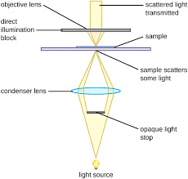
The Physics and Illustration of an Objective lens:
An objective (lens) is that part of an optical system, which is directed to the object. It´s task is to collect the light rays, that are reflected from the observed item. The objective generates a real-optical image. At the lower end of a typical compound optical microscope, there are one or more objective lens that collect light from the sample. The objective is usually in a cylinder housing containing a glass single or multi-element compound lens. Typically, there will be around three objective lenses screwed into a circular nose piece which may be rotated to select the required objective lens. These arrangements are designed to be , which means that when one changes from one lens to another on a microscope, the sample stays in focus. Microscope objectives are characterized by two parameters, namely, magnification and numerical aperture. The former typically ranges from 5× to 100× while the latter ranges from 0.14 to 0.7, corresponding to focal lengths of about 40 to 2 mm, respectively.
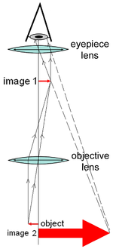
The physics of Objective revolver:
Objective revolvers are used in microscopes with multiple objective lenses, that have different magnification factors.
By spinning the revolver, one can chose the lens with the desired enlargement level.

The physics and Illustration of stage:
The stage is a platform below the objective lens which supports the specimen being viewed. In the center of the stage is a hole through which light passes to illuminate the specimen. The stage usually has arms to hold slides (rectangular glass plates with typical dimensions of 25×75 mm, on which the specimen is mounted).
At magnifications higher than 100× moving a slide by hand is not practical. A mechanical stage, typical of medium and higher priced microscopes, allows tiny movements of the slide via control knobs that

The physics and illustration of the Condenser:
The condenser bundles the rays from the light source, so they are projected equally on the object. Thus, every part of the object is illuminated on the same brightness level.
Condensers normally consist of one or two lenses. These lenses fractionize the light and all the rays leave as parallel beams. An aspherical lens makes sure, that no aberrations occur. This guarantees a better image quality. Their production costs are higher than those of normal lenses. They can be another criteria that differentiates high-performance microscopes from cheap microscopes.
The physics and illustration of fine/coarse focus:
With the fine focus one can regulate the distance between object and objective, to achieve the necessary sharpness. The fine focus moves the stage only minimally – like the name already says.
Like the fine focus, the coarse focus also moves the stage to regulate the difference between object and objective. His task is, to catch the right distance roughly and quickly. The optimal sharpness can be adjusted with the fine coarse afterwards.
The physics and illustration of luminous- field diaphragm:
The luminous-field diaphragm can adjust the diameter of the light ray from the light source. This can prevent the object from being outshined.

The physics and illustration of light source:
The early microscopes used concave mirrors to reflect light on the objects. Many sources of light can be used. At its simplest, daylight is directed via a mirror. Most microscopes, however, have their own adjustable and controllable light source – often a halogen lamp, although illumination using LEDs and lasers are becoming a more common provision. Köhler illumination is often provided on more expensive instruments.

The physics and illustration of the base:

The base guarantees the necessary stability to the microscope.
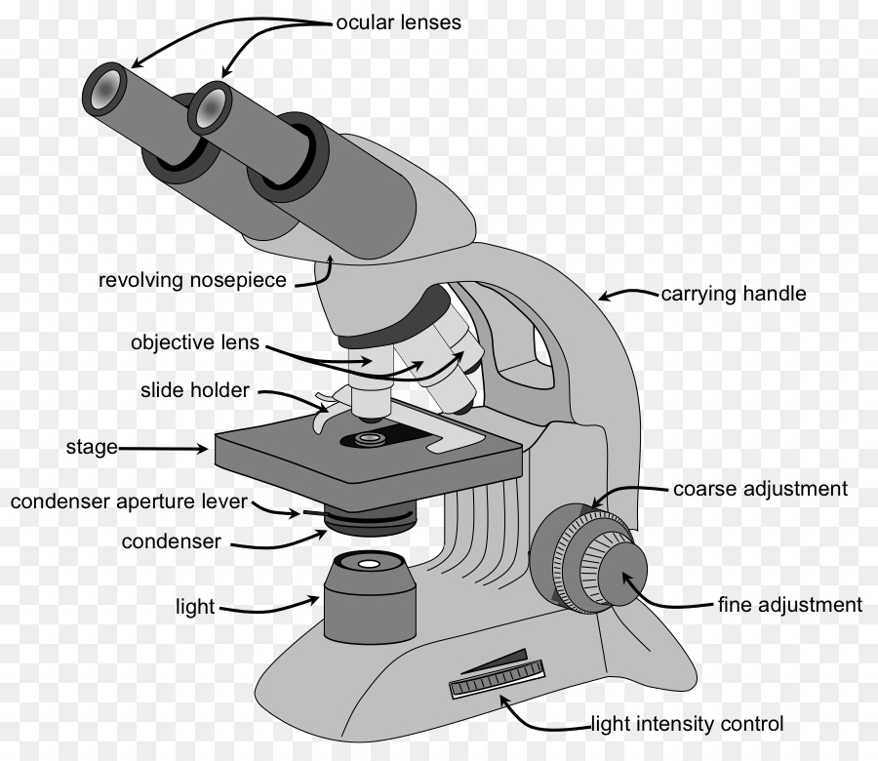

2. Biomedical equipment are equipment used for system usage, maintenance responsibilities, and ways to obtain data on an extensive range of monitoring, diagnostic, therapeutic, and surgical instrumentation. Solutions to issues encountered while interacting with doctors, nurses, and other technicians who use biomedical instrumentation are often studied and realized by those in the profession.
A biomedical equipment technologist must study electronics, electronics management, medical physiology, and computer applications. After graduating, he or she may opt to specialize in particular types of equipment used, generally in nuclear medicine, surgery, radiology, clinical laboratory, dialysis, or intensive care.
Some biomedical equipment includes:
- Anesthesia
- Aspiration pump
- Centrifuge
- Coagulation analyser
- Sterilizer
- Computer equipment
- Endoscopy system
- Incubator
- Lab microscope
- Lab refrigerator, etc
THE PRINCIPLE OF CENTRIFUGE:
The centrifuge involves principle of centrifugation where the acceleration at the centripetal force causes denser substances to separate out along the radial direction at the bottom.
In a solution, particles whose density is higher than that of the solvent sink and particles that are lighter than it float to the top.
The greater the difference in density, the faster they move.

THE BRAND: LABNET CENTRIFUGE

Labnet Centrifuges are an Ideal Solution for Most Labs. Labnet International is a leading worldwide supplier in a number of core product areas: centrifugation, liquid handling, shakers and rockers, constant temperature equipment, and laboratory plastics.
CARE AND MAINTENANCE OF THE CENTRIFUGE
- Always place the centrifuge on a flat surface first.
- Always unplug the power cord before cleaning.
- Emergency phone numbers and procedures should be posted and kept up to date.
- Wear disposable gloves.
- Follow your facility’s safety procedures when cleaning and disinfecting the centrifuge.
- Before moving the centrifuge to a new location, the exterior and interior surfaces should be cleaned and disinfected.
- Plug in centrifuge only when completely dry.
THE PRINCIPLE OF AUTOMATIC TISSUE PROCESSOR :
The tissue basket oscillates up and down in each station at three-second intervals to ensure thorough and even mixing of the reagents and optimum tissue infiltration.
Infiltration time is separately programmable for each station. Up to nine programs may be run with immediate or delayed starting times.
When it is time for tissue to be transferred to the next beaker or jar, the cover of the machine is raised up, and the lifting mechanism carefully removes the tissue basket and gently transfers it to the next beaker.
When the infiltration time for any particular station is exceeded, a warning message will display, indicating the station number and excess time. Controls are arranged by functionality with an LCD to indicate operational parameters. Reagent container lids have seals to minimize operator exposure to hazardous fumes.
Tissue basket immediately immerses in a station in the event of power loss to protect samples from drying out. When power is restored, program will resume.

THE BRAND: KEDEE AUTOMATIC TISSUE PROCESSOR

This processor is used to process animal and human tissues automatically. It is accurate and easy to use and maintain. It is an excellent choice for histology and pathology labs of hospitals and research institutions.

THE CARE AND MAINTENANCE OF AUTOMATIC TISSUE PROCESSOR:

- Any spillage or overflow should be cleaned immediately
- Accumulation of wax on any surface should be removed
- The temperature of the paraffin wax bath should be set to 30degrees above melting point of wax.
- Timing should be checked when placing the cassettes in the processor.

THE PRINCIPLE OF MICROTOME:
Microtome is a sectioning instrument that allows the cutting of extremely thin slices of a material known as section. Microtomes are used in microscopy, allowing for the preparation of sample for observation under transmitted light or electrons radiation.
THE BRAND:
The pfm Rotary 3006 EM is a modern, newly designed fully electronic rotary microtome for all applications in routine use, research and industry. Benefits excellent section quality.

THE CARE AND MAINTENANCE OF MICROTOME:
The microtome knife has been coated with an oil mixture to prevent rust and corrosion when not in use. Use a dry, lint-free, facial tissue to wipe your knife clean. DO NOT USE GAUZE or any other coarse material; it will destroy the edge of your knife.

