16/MHS06/065
MLS 410 ASSIGNMENT
BIOMEDICAL ENGINEERING

QUESTIONS
1.Discuss the physics of the light microscope diagrams and illustrations needed
2. Write notes on the following biomedical equipment. Add notes on principle, brand, care and maintenance and cost
a) Centrifuge b) Automatic Tissues Processor c) Microtome

ANSWER
- The compound binocular light microscope is an indispensable piece of apparatus in all medical laboratories.
The light microscope also referred to as optical microscope, is a type of microscope that commonly uses visible light and a system of lenses to generate magnified images of small objects. The physics of a light microscope basically talks about the mechanics involved in magnification of small objects.
Before dealing with the physics, some terms have to be explained:
- Refraction;
Refraction is the change in direction of light passing obliquely from one medium to another of different optical density.
Illustration;
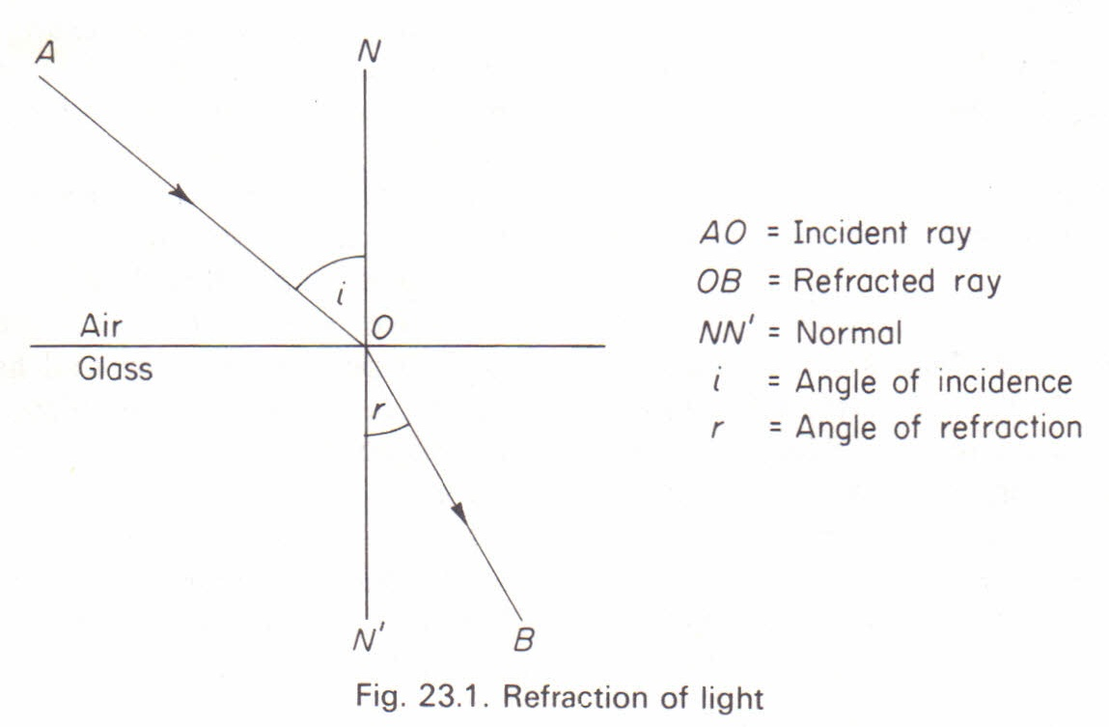
This diagram shows the path of a ray of light passing from air into glass plate. At point O, is the point of entry into the glass and line NN’ called the ‘normal’ is perpendicular to the surface of separation of the media. The ray of A is refracted towards the normal along the B in the glass. In conclusion, a ray of light passing from a rarer to a denser medium is refracted towards the normal but when passing from a denser to a rarer medium is refracted away from the normal.
Refractive index
The angle (AON) i, is termed as angle of incidence and angle r is the angle of refraction. The sine of the angle of incidence divided by the angel of refraction is a constant quantity for any given media and is called the Refractive Index (RI)
RI =sin I
sin R

Principal Focus of a converging lens
A biconvex lens has two spherical surfaces which curve outwards. It is called a converging lens as rays of light passing through the lens converge to a focal point. The center of the lens surfaces is called the center of curvature. A straight line between these two centers is the principal axis. A line, drawn at right angles to this axis, which passes through the center of the lens is termed the principal plane. The diameter or width of the lens is called its aperture.

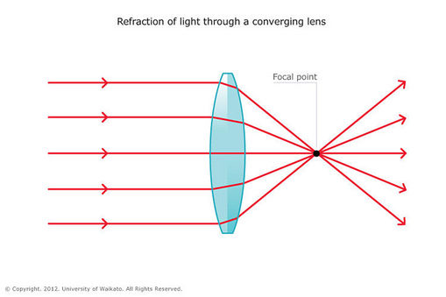
Rays of light entering a converging lens parallel to the principal axis are refracted towards and across this axis. The point at which they cross are called the principal focus. A biconvex lens has two principal foci, one on either side.

OPTICAL SYSTEM OF A LIGHT MICROSCOPE
The first lens is called the objective lens, and has typical magnification values from 5×5× to 100×100×. In standard microscopes, the objectives are mounted such that when you switch between objectives, the sample remains in focus. Objectives arranged in this way are described as parfocal.
The second, the eyepiece, also referred to as the ocular, has several lenses which slide inside a cylindrical barrel. The focusing ability is provided by the movement of both the objective lens and the eyepiece. The purpose of a microscope is to magnify small objects, and both lenses contribute to the final magnification. Additionally, the final enlarged image is produced in a location far enough from the observer to be easily viewed, since the eye cannot focus on objects or images that are too close.

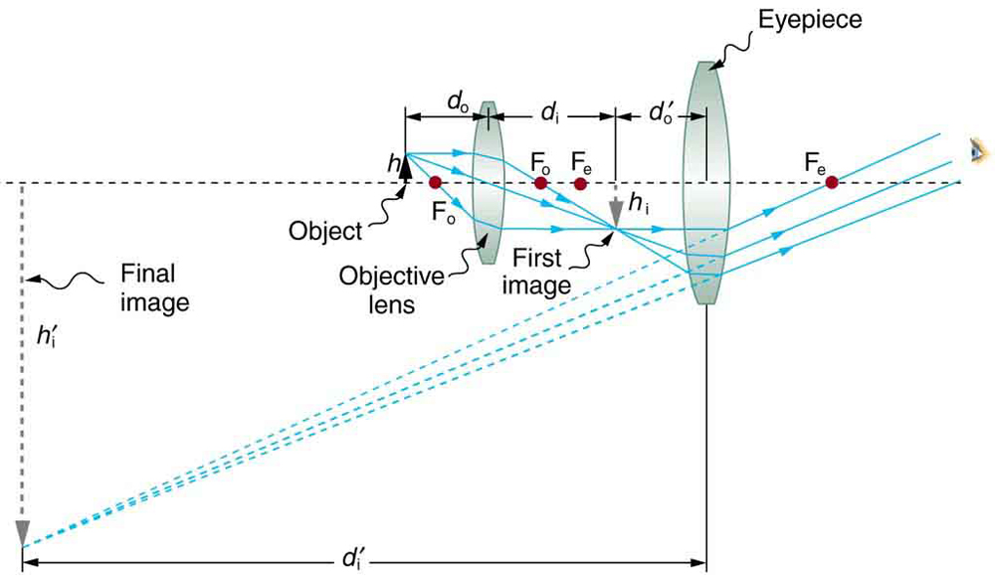

To see how the microscope in the above figure forms an image, we consider its two lenses in succession. The object is slightly farther away from the objective lens than its focal length fofo size 12{f rSub {size 8{o}, producing a case 1 image that is larger than the object. This first image is the object for the second lens, or eyepiece. The eyepiece is intentionally located so it can further magnify the image. The eyepiece is placed so that the first image is closer to it than its focal length fefe size 12{f rSub { size 8{e}. Thus the eyepiece acts as a magnifying glass, and the final image is made even larger. The final image remains inverted, but it is farther from the observer, making it easy to view (the eye is most relaxed when viewing distant objects and normally cannot focus closer than 25 cm). Since each lens produces a magnification that multiplies the height of the image, it is apparent that the overall magnification mm size 12{m} {} is the product of the individual magnifications:
m=mome,m=mome, size 12{m=m rSub { size 8{o} } m rSub { size 8{e} } } {}
26.12
where momo; is the magnification of the objective
meme; is the magnification of the eyepiece.
This equation can be generalized for any combination of thin lenses and mirrors that obey the thin lens equations.

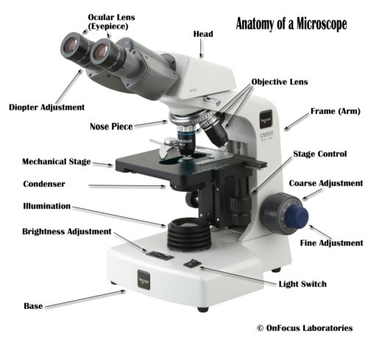
The lenses
A compound microscope has two or more lenses. The eyepiece or ocular lens sits atop the body tube. Many microscopes are binocular and have two ocular lenses.

Additionally, a binocular head will have a prism, either in the head or the body tube, to split the image and direct it to both oculars. The oculars have different available magnifications, but usually less than the power of the objective lenses. The objective lenses are at the bottom of the microscope tube nearest the specimen; they gather and focus the light transmitted from the specimen.
Usually three or four objectives of different strengths will reside in a revolving turret, and magnification may be changed by turning the turret to line up a different lens with the body tube. Objective magnification strengths usually range from 10X to 100X. Fine and coarse focusing adjustments are accomplished with focusing knobs located on the body of the microscope.

The stage
The specimen sits directly below the objectives on the microscope’s stage. A mechanical stage allows precise movement of the specimen along the X and Y coordinates and graduated markers allow the viewer to note the location of features on the slide. A hole or aperture in the stage allows light to illuminate the specimen.

The light
Below the stage, a diaphragm, condenser, and light source control light emission and distribution to the specimen. At the bottom of the optical train is the illumination source.
In a simple microscope, the light source may be ambient light collected and reflected upwards into the aperture by a small mirror.
The type of illumination source will increase in sophistication as a microscope’s complexity increases. Tungsten-halogen, mercury arc, and metal halide lamps, as well as LED illumination provide different types of light to meet certain viewing requirements.
How Does a Microscope Work?
Magnification
The power to enlarge the image of the specimen when viewed through a microscope is known as the magnification and is dependent upon how much the lenses bend the light waves.
Magnification is expressed in numeric multiples of how much enlargement occurs with a lens. If the magnification of a lens is 2X then it roughly doubles the size of the image of the object.
With a compound microscope, the total magnification can be determined by multiplying the magnifications of the objective and ocular lenses. Consequently, an ocular lens of 10X coupled with a 40X objective yields a total magnification of 400X.
However, the higher the magnification the closer the lens must be to the specimen. Since a higher magnification lens bends light more severely, the specimen is brought into focus a shorter distance from the lens and this is known as the focal length.

- A) CENTRIFUGE
A centrifuge is a laboratory device that is used for the separation of fluids, gas or liquid, based on density. Separation is achieved by spinning a vessel containing material at high speed; the centrifugal force pushes heavier materials to the outside of the vessel. A centrifuge is also a piece of equipment that puts an object in rotation around a fixed axis (spins it in a circle), applying a force perpendicular to the axis of spin (outward) that can be very strong.
The main function of centrifuge is to separate the liquid and solid particles in the suspension, or to separate the two kind of different liquid with different density which cannot dissolve in each other in the emulsion.

PARTS OF A CENTRIFUGE
A centrifuge has three basic parts, namely rotor, drive shaft and motor.
Rotors can be mounted on the drive shaft, which connects it to the motor. The motor provides the power to turn the rotor. Usually, a secure cabinet surrounds and supports these parts. The sample is placed in a reinforced plastic tube which is then held in a rotor which rotates around a spindle.
Rotors are usually made from robust material, like aluminum alloy or stainless steel. For the minimizing of vibration and strain on the shaft and bearings, a loaded rotor should be well balanced, i.e., its total mass should be distributed about the axis of rotation such that the resultant of all elemental forces is zero.
The types of rotors include;
Fixed-angle rotors:
The sample tubes are placed in a machined hole in the metal rotor which is at a fixed angle (generally 45⁰), relative to the vertical axis of rotation. This angle remains constant during the centrifugation process and the pellet is obtained against the side-wall of the tube.
Swinging-bucket rotor:
The sample tubes are placed in a holder which is suspended from the rotor. When the centripetal force is applied, the holder swings out to become horizontal with the horizontal axis of the rotor and the pellet is obtained at the bottom of the tube

TYPES OF CENTRIFUGE
- LOW-SPEED CENTRIFUGE
Most laboratories have a standard low-speed centrifuge used for routine sedimentation of heavy particles. The low-speed centrifuge has a maximum speed of 4000-5000rpm
These instruments usually operate at room temperatures with no means of temperature control. Two types of rotors are used in it, fixed angle and swinging bucket.
It is used for sedimentation of red blood cells until the particles are tightly packed into a pellet and supernatant is separated by decantation.
- HIGH-SPEED CENTRIFUGES
High-speed centrifuges are used in more sophisticated biochemical applications, higher speeds and temperature control of the rotor chamber are essential. The high-speed centrifuge has a maximum speed of 15,000 – 20,000 RPM.
The operator of this instrument can carefully control speed and temperature which is required for sensitive biological samples.
Three types of rotors are available for high-speed centrifugation-
Fixed angle, swinging bucket, vertical rotors.

- ULTRACENTRIFUGES
It is the most sophisticated instrument. Ultracentrifuge has a maximum speed of 65,000 RPM (100,000’s x g). Intense heat is generated due to high speed thus the spinning chambers must be refrigerated and kept at a high vacuum.
It is used for both preparative work and analytical work

PRINCIPLE
The centrifuge mainly works on the principle of sedimentation, where the acceleration at centripetal force causes denser substances to separate out along the radial direction at the bottom of the tube.
It is basically the apparent force that draws a rotating body away from the center of rotation which is caused by the inertia of the body as the body’s path is continually redirected. The acceleration achieved by centrifugation is expressed as a multiple of the earth’s gravitational force (g). Based on the acceleration values they can reach, centrifuges are categorized into bench top (up to 15000 g), high speed refrigerated centrifuges (50000 g) and ultracentrifuges (500000 g). As ultracentrifuges can operate under cold conditions and in the vacuum, they are ideal for separating macromolecules like proteins, nucleic acids and carbohydrates. The radial force produced by the spinning rotor can also be expressed relative to g, as Relative centrifugal force (RCF) or g-force.
In a solution, particles whose density is higher than that of the solvent sink (sediment), and particles that are lighter than it floats to the top.
•The greater the difference in density, the faster they move. If there is no difference in density (isopycnic conditions), the particles stay steady.
•To take advantage of even tiny differences in density to separate various particles in a solution, gravity can be replaced with the much more powerful “centrifugal force” provided by a centrifuge.
•A centrifuge is a piece of equipment that puts an object in rotation around a fixed axis (spins it in a circle), applying a potentially strong force perpendicular to the axis of spin (outward).
•The centrifuge works using the sedimentation principle, where the centripetal acceleration causes denser substances and particles to move outward in the radial direction.
At the same time, objects that are less dense are displaced and move to the center.
•In a laboratory centrifuge that uses sample tubes, the radial acceleration causes denser particles to settle to the bottom of the tube, while low- density substances rise to the top.

CARE AND MAINTANANCE OF CENTRIFUGE
Switch off the device and disconnect it from the power supply before starting any cleaning or disinfection.
•The outside of the centrifuge and the rotor chamber should be cleaned regularly with neutral detergents. This is for hygienic purposes as well as to prevent contamination caused by residual contamination.
•Only neutral agents may be used for cleaning and disinfection (e.g. diluted neutral alcohol-based disinfectant or 70% isopropanol mixture).
•Residue from detergents should be removed. Also remove condensation and clean the condensation tray. Leave the centrifuge lid open.
•The rotor chamber and the rotor shaft should simply be wiped with a moist cloth. Please clean your rotor using a neutral cleaning liquid. This will protect the rotor and prolong its service life.
Do not use acetone, caustic detergents, or detergents that contain chlorite ions. Corrosion is most frequently caused by using chlorite ion solutions, such as sodium hypochlorite (household bleach).
Do not use steel wool, wire brushes, abrasives, or sandpaper, since they may damage the rotor coating (anodized coating) and thus increase the risk of corrosion.

BRAND AND COST
- Eppendorf 5424 Centrifuge Microfuge +24 place rotor
$695 #250,200
- Electric Centrifuge lower-speed desktop laboratory Machine 4000rpm
$153.67 which is about #56,000
- CE PRP Beauty Centrifuge CGF PRF Blood Centrifuge Serum fat separator
$403.88 which is about #150,000
- Kenley Desktop electric lab centrifuge

AUTOMATIC TISSUE PROCESSOR
The aim of tissue processing is to embed the tissue in a solid medium firm enough to support the tissue and give it sufficient rigidity to enable thin sections to be cut, and yet soft enough not to damage the knife or tissue

There are significant variables which need to be considered when processing tissue and these include the operating conditions (such as temperature), the concentration of the reagents and the properties of the tissue. In the histology laboratory, conventional tissue processing describes the stages required to take fixed tissue samples through dehydration and clearing to the state where it is completely infiltrated and embedded with a suitable medium (normally paraffin wax) in readiness for cutting sections on a microtome (microtomy). For routine purposes, tissues are most conveniently processed through dehydration, clearing and infiltration stages automatically. There are two broad types of automatic tissue processors available - tissue transfer and fluid transfer types;

Tissue transfer processors
These processors are characterized by the transfer of tissues, contained within a basket, through a series of stationary reagents arranged in-line or in a circular carousel plan. The rotary or carousel is the most common model of automatic tissue processor, and is provided with 9-10 reagent and 2-3 wax positions, with a capacity of 30-110 cassettes depending upon the model. Fluid agitation is achieved by vertical oscillation or rotary motion of the tissue basket. Processing schedules are card-notched, pin or touch pad programmed. These processors allow maximum flexibility in the choice of reagents and schedules that can be run on them. These machines have a rapid turn-around time for day or night processing. In more recent models the tissue basket is enclosed within an integrated fume hood during agitation and transfer cycles thus overcoming the disadvantages of earlier styles.

Fluid transfer processors
In fluid-transfer units, processing fluids are pumped to and from a retort in which the tissues remain stationary. There are 10-12 reagent stations with temperatures adjustable between 30-45°C, 3-4 paraffin wax stations with variable temperature settings between 48-68°C, and vacuum-pressure options for each station. Depending upon the model these machines can process 100-300 cassettes at any one time. Agitation is achieved by tidal action. Schedules are microprocessor programmed and controlled and can be viewed on a screen (see image below). Vacuum-pressure cycles coupled with heated reagents allow effective reductions in processing times and improved infiltration of dense tissues. Fluid-transfer processors overcome the main drawbacks of the tissue-transfer machines. Tissues are unable to dry out within the sealed retort and reagent vapors are vented through filters or retained in a closed-loop system. Processors are provided with alert systems and diagnostic programmes for troubleshooting and maintenance.

PRINCIPLE OF TISSUE PROCESSOR
The principle of tissue processing is designed to remove all extractable water from the tissue, replacing it with a support medium that provides sufficient rigidity to enable sectioning of the tissue without damage or distortion. The principle is based on the use of chemicals dehydrate and clear the tissue so that it can be embedded into molten paraffin wax which stands as a support medium for the tissue in order to easy sectioning
1. DEHYDRATION
The first stage in tissue processing is dehydration (the removal of water). In tissues, water is present in both free and bound forms and needs to be removed before processing can continue. Dehydration is usually carried out using alcohols (such as ethanol) but these can dissolve certain cellular components such as lipids. Although dehydration can also cause tissue shrinkage, the stage is necessary in all infiltration methods, except where tissues are supported by an aqueous embedding medium (such as water-soluble waxes).

2. CLEARING
Clearing is the transition step between dehydration and infiltration with the embedding medium. Although tissues are water-free following dehydration, infiltration with wax cannot be carried out because wax and ethanol are largely immiscible. Many dehydrants are immiscible with paraffin wax and a solvent (clearing agent or ante medium) miscible with both the dehydrating agent and the embedding medium is used to assist the transition between these steps. The term clearing arises because some solvents have a high refractive index. When dehydrated tissues are placed into these reagents, they are rendered transparent. This property is used to determine the endpoint and duration of the clearing step since the presence of opaque areas indicates incomplete dehydration. Clearing agents are fat solvents and therefore remove fat from the tissue. It must be noted that shrinkage occurs when tissues are transferred from the dehydrating agent to the clearing agent and from the clearing agent to wax. In the final stage shrinkage may result from the extraction of fat by the clearing agent. Xylene is the most popular clearing agent and several changes of it are required to completely displace the ethanol. The choice of a clearing agent depends upon the type of tissue processor used, the processing conditions such as temperature, safety factors and cost.

3. INFILTRATION AND EMBEDDING
Infiltration
This is the saturation of tissue cavities and cells by a supporting substance which is generally the medium in which they are finally embedded. The most common agent of choice is paraffin wax which is molten when hot and solid when cold. An infiltrating and embedding medium should ideally be molten between 30°C and 60°C and suitable for sectioning. Additionally, the properties of the medium should be similar to those of the tissues to be sectioned with regard to density and elasticity. Various substances have been used to infiltrate and embed tissues in readiness for eventual section cutting or microtomy.
The use of vacuum infiltration is often used to help complete impregnation of tissues with wax. This is carried using a molten wax or other medium under reduced pressure. Vacuum assistance helps to not only reduce the time tissues are subjected to heat but it also assists in the complete removal of any remaining solvent. Modern tissue processors are equipped to deliver vacuum and pressure during tissue processing.

Embedding
Paraffin embedding is the standard method used in histology laboratories to produce blocks of tissue for section cutting (microtomy). This process is usually carried out using an embedding center and involves surrounding the tissues by a medium such as paraffin wax which when cooled and solidified will provide sufficient support for section cutting or microtomy (see stages below). The production of properly oriented and accurately labelled blocks is one of the essential skills of trained histologists and includes knowledge and understanding in areas such as tissue sampling, identification and human anatomy.

CARE AND MAINTAINANCE
- Reagent maintenance:
One of the most important steps to ensuring consistent and trouble-free tissue processing is reagent maintenance. Keeping reagents fresh is critical to proper tissue processing and overall quality control (QC).
Since over-used reagents lead to problems that are difficult to diagnose, most laboratories keep a maintenance log to keep track of how often reagents are changed and rotated. Determining how often each reagent is changed is as individual as the processing protocol for every laboratory.
Some laboratories implement reagent changes based on how often each reagent is used. Other laboratories change reagents based on the number of cassettes or the amount of tissue processed, rather than a rigid calendar schedule. Once determined, reagent maintenance schedules should be adhered and charts should be utilized for tracking purposes, in order to retain consistent quality of processed tissue.
- Temperature checks;
Melted paraffin must be kept at 2-4° C above the melting point of paraffin. The paraffin chambers on the processor must maintain the proper temperature and this temperature should be checked daily. Paraffin may also be melted and stored in special paraffin pots so that melted paraffin is always available for filling the embedding center or the processor. The paraffin pots must be temperature controlled and monitored daily for the proper temperature. If the paraffin is cooked at high temperatures it will breakdown and cause microtomy problems. Since there are dozens of paraffin’s available on the market, technical support from the processor manufacturer is recommended. Not all paraffin’s are made for all processors or all applications.
- Always switch off the processor immediately after use
- Regular servicing of the machine is required.

BRAND AND COST
- Lipshaw Circular Tissue Processor
$550.00 which is about #200,000
- 2016 Sakura Tissue-Tek® Xpress® X120 Rapid Tissue Processor
$25,000 which is about #9 million
- Leica TP1020 Automatic Tissue Processor, fully conditioned
$11,950 which is about #4 300 000.

MICROTOME
A microtome is a tool used to cut extremely thin slices or sections of tissue for light microscopy studies. The most commonly used microtomes in the histology laboratory are the rotary and sledge varieties (see images below). Microtomes use steel, glass, or diamond blades depending upon the specimen and thickness of the section required. Nowadays, disposable steel blades are generally used to prepare paraffin sections of tissues for light microscopy histology.
In the rotary microtome, the device operates with a staged rotary action such that the actual cutting is part of the rotary motion. In a rotary microtome, the knife is typically fixed in a horizontal position and the principle of section cutting is shown in the image above. Although the flywheel in many microtomes can be operated manually, they are generally automated or semi-automated. Typically, sections are cut between 3 and 5 µm using paraffin wax for diagnostic histology although thinner sections can be attained if samples are embedded in synthetic resin.

PRINCIPLE OF A ROTARY MICROTOME
It is used for slicing paraffin tissue sections of uniform thickness.
This method is designed to cut 1-60 micron thick sections.
A knob on the device (typically at the backside) is used to modify the thickness of the sections.
A knife is constant inside the knife holder and clamped tightly.
The tissue block is drawn throughout the knife-edge and it is mechanically advanced. The top and bottom of the block have to be parallel and horizontal and as a minimum 1mm of paraffin has to be present in all aspects beyond the tissue.
The trimming of the edges of the block is usually completed with a single-sided razor blade and the block face is trimmed with the microtome knife.
The technician decides the type of section to be made in line with the nature of tissue and instructions received from the pathologist.
At some stage in section slicing, as the wheel of the microtome turns, sections are cut and slide on the knife. A ribbon of sections is produced.
The ribbon of sections is transferred to warm water inside the tissue floatation bath to put off any wrinkles present in the section.
The best quality section that is free from any scratches and cracks can be decided on from the tissue ribbons. The tissue ribbons are then taken on smooth glass slides with a respective identification number.
The slides are pulled from the water and the preferred sections are positioned flat on the surface of glass slides. The slides with the sections are positioned on a rack in a hot air oven to dry.

PARTS OF A ROTARY MICROTOME
•Block holder
•Knife clamp screw
•Knife clamps
•Block adjustment
•Thickness gauge
•The angle of tilt adjustment
•Operating handle

CARE AND MAINTAINACE
the blade guard must be used whenever a blade is present on the holder and when the microtome is not in active use.
The arm (wheel) lock must be engaged whenever the rotary arm is not in active use.
The blade should be installed and removed with the aid of a clamping tool such as a pair of hemostats.
When placing or retrieving materials near the blade, use appropriate tools (such as forceps or fine-tipped paint brush) so that hands remain in the clear of the blade.
Always ensure that the microtome is cleaned immediately after use.

BRAND AND COST
- Leica® RM2165 Rotary microtome
$2,750 which is about 990,000
- Thermos® HM 325 Rotary microtome
$8,500 which is about #3 million.

