Name: Olusegun Olamide Elizabeth
Matric number: 16/MHS06/056
Assignment title: Biomedical Engineering
Course code: MLS/410

- Discuss the physics of the light microscope using diagrams and illustrations needed and write notes on the following biomedical equipment stating its principal, brand, care and maintainace and cost (a) Centrifuge (b) Automatic Tissues Processor (c) Microtome
The light microscope is an instrument for visualizing fine detail of an object. It does this by creating a magnified image through the use of a series of glass lenses which first focus a beam of light onto or through an object, and convex objective lenses to enlarge the image formed. In the majority of light microscopes, the image is viewed directly through binocular eye-pieces that act as a secondary lens in the form of a magnifying glass to observe the projected image. Such instruments are termed‘compound microscopes,’and the total magnification is the sum of the objective magnification and the eyepiece magnification. The magnification range extends from 10 to 1000, with a resolving power of the order of 0.2mm, depending on the type and numerical aperture (area available for passage of light) of the objective lenses. Optical microscopes can magnify up to 1500× with a theoretical resolution of −0.2 μm. The lenses can be quite complicated and are composed of multiple elements to reduce aberrations. Microscope objective lenses are particularly important as they primarily gather light from the specimen. Three parameters describe microscope objectives: the numerical aperture (NA), the magnification (m), and the working distance. The NA is related to the light gathering ability of a lens and is obtained using the angle of acceptance θ formed by the maximum cone of rays focusing on the specimen (see Figure 3a) and is given by NA = n sin α, where n is the refractive index of the medium between the lens and the specimen and α=θ2. As the angle of acceptance given by θ increases, NA becomes larger and more light is gathered from a smaller focal region giving higher resolution. A 0.75 NA objective gives more detail than a 0.10 NA objective. While the numerical aperture can be used to compare resolutions of various objectives, it does not indicate how far the lens could be from the specimen. This is specified by the “working distance,” which is the distance (in mm usually) from the front lens element of the objective to the specimen, or cover glass. The higher the NA the closer the lens will be to the specimen and the more chances there are of breaking the cover slip and damaging both the specimen and the lens. The focal length of an objective lens is different than the working distance. This is because objective lenses are made of a combination of lenses and the focal length is measured from inside the barrel. The working distance is a parameter that microscopists can use more readily as it is measured from the outermost lens. The working distance decreases as the NA and magnification both increase.

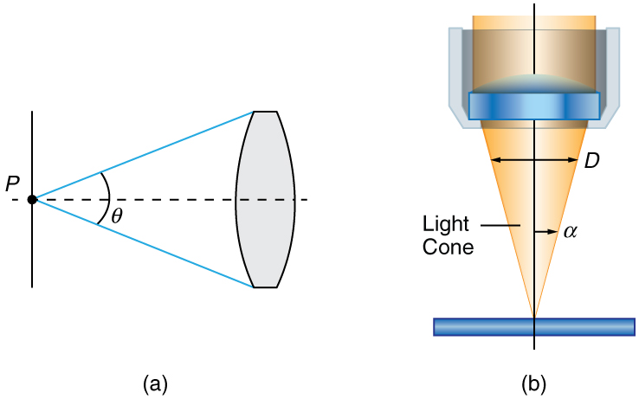
Figure 3. (a) The numerical aperture of a microscope objective lens refers to the light-gathering ability of the lens and is calculated using half the angle of acceptance. (b) Here, is half the acceptance angle for light rays from a specimen entering a camera lens, and is the diameter of the aperture that controls the light entering the lens.

The term f/# in general is called the f-number and is used to denote the light per unit area reaching the image plane. In photography, an image of an object at infinity is formed at the focal point and the f-number is given by the ratio of the focal length f of the lens and the diameter D of the aperture controlling the light into the lens (see Figure 3b). If the acceptance angle is small the NA of the lens can also be used as given as f/#=fD≈12NA. As the f-number decreases, the camera is able to gather light from a larger angle, giving wide-angle photography. As usual there is a trade-off. A greater f/# means less light reaches the image plane. A setting of f/16 usually allows one to take pictures in bright sunlight as the aperture diameter is small. In optical fibers, light needs to be focused into the fiber. Figure 4 shows the angle used in calculating the NA of an optical fiber.
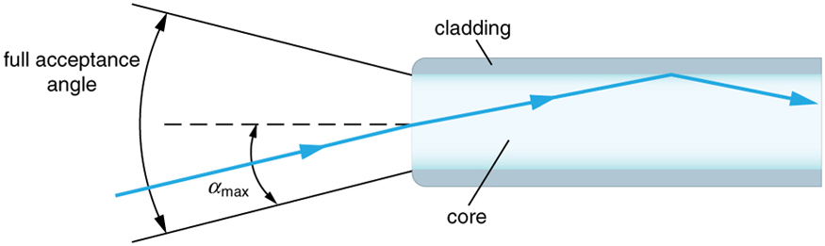
Figure 4. Light rays enter an optical fiber. The numerical aperture of the optical fiber can be determined by using the angle αmax.
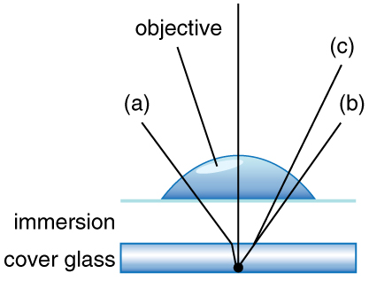
Figure 5. Light rays from a specimen entering the objective. Paths for immersion medium of air (a), water (b) (n = 1.33), and oil (c) (n = 1.51) are shown. The water and oil immersions allow more rays to enter the objective, increasing the resolution.
Can the NA be larger than 1.00? The answer is ‘yes’ if we use immersion lenses in which a medium such as oil, glycerin or water is placed between the objective and the microscope cover slip. This minimizes the mismatch in refractive indices as light rays go through different media, generally providing a greater light-gathering ability and an increase in resolution. Figure 5 shows light rays when using air and immersion lenses.
When using a microscope, we do not see the entire extent of the sample. Depending on the eyepiece and objective lens we see a restricted region which we say is the field of view. The objective is then manipulated in two-dimensions above the sample to view other regions of the sample. Electronic scanning of either the objective or the sample is used in scanning microscopy. The image formed at each point during the scanning is combined using a computer to generate an image of a larger region of the sample at a selected magnification.
When using a microscope, we rely on gathering light to form an image. Hence most specimens need to be illuminated, particularly at higher magnifications, when observing details that are so small that they reflect only small amounts of light. To make such objects easily visible, the intensity of light falling on them needs to be increased. Special illuminating systems called condensers are used for this purpose. The type of condenser that is suitable for an application depends on how the specimen is examined, whether by transmission, scattering or reflecting. See Figure 6 for an example of each. White light sources are common and lasers are often used. Laser light illumination tends to be quite intense and it is important to ensure that the light does not result in the degradation of the specimen.

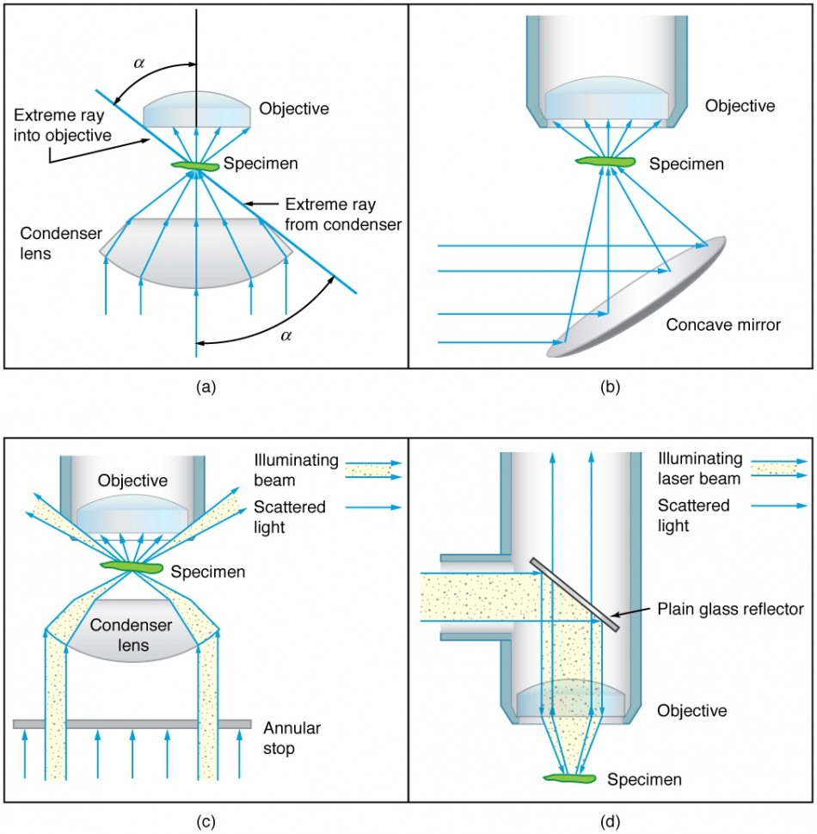

Figure 6. Illumination of a specimen in a microscope. (a) Transmitted light from a condenser lens. (b) Transmitted light from a mirror condenser. (c) Dark field illumination by scattering (the illuminating beam misses the objective lens). (d) High magnification illumination with reflected light – normally laser light.

2. CENTRIFUGE; A centrifuge is a piece of equipment that puts an object in rotation around a fixed axis (spins it in a circle), applying a force perpendicular to the axis of spin (outward) that can be very strong. The centrifuge works using the sedimentation principle, where the centrifugal acceleration causes denser substances and particles to move outward in the radial direction. At the same time, objects that are less dense are displaced and move to the center. In a laboratory centrifuge that uses sample tubes, the radial acceleration causes denser particles to settle to the bottom of the tube, while low-density substances rise to the top.
- Laboratory centrifuges, are general-purpose instruments of several types with distinct, but overlapping, capabilities. These include clinical centrifuges, superspeed centrifuges and preparative ultracentrifuges.
- Analytical ultracentrifuges are designed to perform sedimentation analysis of macromolecules using the principles devised by Theodor Svedberg.
- Haematocrit centrifuges are used to measure the volume percentage of red blood cells in whole blood.
- Gas centrifuges, including Zippe-type centrifuges, for isotopic separations in the gas phase.
Industrial centrifuges may otherwise be classified according to the type of separation of the high-density fraction from the low density one.
Generally, there are two types of centrifuges: the filtration and sedimentation centrifuges. For the filtration or the so-called screen centrifuge the drum is perforated and is inserted with a filter, for example a filter cloth, wire mesh or lot screen. The suspension flows through the filter and the drum with the perforated wall from the inside to the outside. In this way the solid material is restrained and can be removed. The kind of removing depends on the type of centrifuge, for example manually or periodically. Common types are:
- Screen/scroll centrifuges (Screen centrifuges, where the centrifugal acceleration allows the liquid to pass through a screen of some sort, through which the solids cannot go (due to granulometry larger than the screen gap or due to agglomeration))
- Pusher centrifuges
- Peeler centrifuges
- Inverting filter centrifuges
- Sliding discharge centrifuges
- Pendulum centrifuges
- Sedimentation centrifuges
In the centrifuges the drum is a solid wall (not perforated). This type of centrifuge is used for the purification of a suspension. For the acceleration of the natural deposition process of suspension the centrifuges use centrifugal force. With so-called overflow centrifuges the suspension is drained off and the liquid is added constantly. Common types are:
- Separator centrifuges (Continuous liquid); common types are:
  - Solid bowl centrifuges
  - Conical plate centrifuges
- Tubular centrifuges
- Decanter centrifuges, in which there is no physical separation between the solid and liquid phase, rather an accelerated settling due to centrifugal acceleration.
Though most modern centrifuges are electrically powered, a hand-powered variant inspired by the whirligig has been developed for medical applications in developing countries.
Many designs have been shared for free and open-source centrifuges that can be digitally manufactured. The open-source hardware designs for hand-powered centrifuge for larger volumes of fluids with a radial velocity of over 1750 rpm and over 50 N of relative centrifugal force can be completely 3-D printed for about $25. Other open hardware designs use custom 3-D printed fixtures with inexpensive electric motors to make low-cost centrifuges (e.g. the Dremelfuge that uses a Dremel power tool).

Maintance of a Centrifuge
- Always place the centrifuge on a flat surface first.
- Always unplug the power cord before cleaning.
- Emergency phone numbers and procedures should be posted and kept up to date.
- Wear disposable gloves.
- Follow your facility’s safety procedures when cleaning and disinfecting the centrifuge.
- Before moving the centrifuge to a new location, the exterior and interior surfaces should be cleaned and disinfected.
- Plug in centrifuge only when completely dry.

Cleaning
Centrifuge interiors are made from a range of materials—plastic, ceramic, aluminum and stainless steel—that manufacturers use in the search for performance in a high-stress environment. Manufacturers’ recommendations on the cleaners and scrubbers to use and method and frequency of application take this into account and will get the best results.
- Clean the centrifuge daily, or at least weekly.
- Remove the rotor and any sample or container holders.
- Interior cleaning includes the interior bucket, specimen holder, rotor and supports.
- Use a sponge, warm water and a mild detergent such as dishwashing liquid.
- Do not use caustic detergents or any product containing chlorine ions. (Diluted bleach is sometimes used as a disinfectant, but at full strength can attack stainless steel and discolor or damage the bowl (see below). A plastic scrub pad can be used, but products such as steel wool, wire brushes and other abrasives can damage coatings and lead to corrosion.
- Spills should be wiped up immediately.
- Clean both the exterior and the interior.
- Do not pour water directly into the chamber or flood the inside of the centrifuge with cleaner. Sensors, gaskets, seals, wiring and other parts that may be present can be easily damaged. Motors, vacuum pumps, condensers and other expensive parts can also be damaged by exposure to water and cleaning products.
- Scrub tube cavities with a test tube brush with nonmetallic tip. Dry each part with an absorbent towel.

Disinfecting and Decontamination
Disinfect on a regular basis. Approved disinfectants and/or “spill kits” should be used. A 10% bleach solution (one-part bleach to nine parts water) can be used with some materials: consult manual. After cleaning with a bleach dilution, dispose of any remaining mix.
Many rotors have sealed compartments that provide aerosol containment and confine spills of toxic, pathogenic, infectious or radioactive materials. If breakage occurs, it may be that only the sealed containers require decontamination. It will be necessary to decontaminate the chamber if a sample-holder in an unsealed carrier breaks or if any occurrence allows the sample out of the sealed compartment. Allow sufficient time for the disinfectant to work. If a spill occurs outside a containment device, follow facility rules on procedures and reporting. The protocols for spills outside of containment devices, including centrifuges, almost always differ from those for contained spills, and users of equipment should be aware of the appropriate steps to promote worker and environmental safety. Spill clean-up requires proper personal protective equipment (PPE), including a lab coat or gown, and gloves. A face shield, shoe covers or respirator may be needed as well.
Spills of radioactive substances can often be addressed with a decontamination solution of 70% ethanol and 10% sodium dodecyl sulfate in water. Parts will need to be rinsed with ethanol first, and the following decontamination, with deionized water. Appropriate protective gear should be worn and properly disposed of after use.
Cost; US$45.00 - US$160.00

AUTOMATIC TISSUE PROCESSOR is a device that prepares tissue samples for sectioning and microscopic examination in the diagnostic laboratory. Microscopic analysis of cells and tissues requires the preparation of very thin, high quality sections (slices) mounted on glass slides and appropriately stained to demonstrate normal and abnormal structures.
The ATP machine plays a big role in the preparation of the tissue by passing them through various chemicals; a major process called TISSUE PROCESSING
The ATPM works by following through an already established processing steps.
Tissues to be processed are cut into small pieces to ensure the tissue fits into the tissue cassettes Smaller tissues (2-4 um) will be processed faster than the whole tissue or organ.
These tissue cassettes are packed into the oscillating tissue basket to tissue prior to fixation.
(i) FIXATION – this is the process of preserving or fixing tissues by passing them through chemicals called fixatives. The fixatives will help protect the tissue from decay and autolysis. Routine fixative of use is 10% formalin
(ii) DEHYDRATION – this is the process of removing water molecules from the tissue by passing the tissue through ascending grades of alcohol. E.g methanol, acetone, 70-100% alcohol
(iii) CLEARING – this is the process of removing alcohol from the tissue by passing it through chemicals that will remove the alcohol molecules. These agents are called clearing agents. Xylene is mostly used for clearing.
(iv) INFILTRATION – this is the process of filling intracellular spaces left in the tissue by paraffin wax. This will help confer a bit of rigidity to the processed tissue.
(v) EMBEDDING- this last step is manually done. This has to do with immersing the processed tissue into a mould containing liquid paraffin wax. This is for external support so that the tissue won’t crumble during microtomy
There are two main types of processors, the tissue-transfer (or “dip and dunk”) machines where specimens are transferred from container to container to be processed, or the fluid-transfer (or “enclosed”) types where specimens are held in a single process chamber or retort and fluids are pumped in and out as required. Most modern fluid-transfer processors employ raised temperatures, effective fluid circulation and incorporate vacuum/pressure cycles to enhance processing and reduce processing times.
Costing; Automatic Tissue Processor Price: $12,800

A MICROTOME is a tool used to cut extremely thin slices or sections of tissue for light microscopy studies. The most commonly used microtomes in the histology laboratory are the rotary and sledge varieties (see images below). Microtomes use steel, glass, or diamond blades depending upon the specimen and thickness of the section required. In the rotary microtome, the device operates with a staged rotary action such that the actual cutting is part of the rotary motion. In a rotary microtome, the knife is typically fixed in a horizontal position and the principle of section cutting is shown in the image above. Although the flywheel in many microtomes can be operated manually, they are generally automated or semi-automated. Typically, sections are cut between 3 and 5 µm using paraffin wax for diagnostic histology although thinner sections can be attained if samples are embedded in synthetic resin.
Types
A sledge microtome is a device where the sample is placed into a fixed holder (shuttle), which then moves backwards and forwards across a knife. Modern sled microtomes have the sled placed upon a linear bearing, a design that allows the microtome to readily cut many coarse sections. By adjusting the angles between the sample and the microtome knife, the pressure applied to the sample during the cut can be reduced. Typical applications for this design of microtome are of the preparation of large samples, such as those embedded in paraffin for biological preparations. Typical cut thickness achievable on a sledge microtome is between 1 and 60 μm.
This instrument is a common microtome design. This device operates with a staged rotary action such that the actual cutting is part of the rotary motion. In a rotary microtome, the knife is typically fixed in a horizontal position. In the figure to the left, the principle of the cut is explained. Through the motion of the sample holder, the sample is cut by the knife position 1 to position 2, at which point the fresh section remains on the knife. At the highest point of the rotary motion, the sample holder is advanced by the same thickness as the section that is to be made, allowing the next section to be made.
The flywheel in many microtomes can be operated by hand. This has the advantage that a clean cut can be made, as the relatively large mass of the flywheel prevents the sample from being stopped during the sample cut. The flywheel in newer models is often integrated inside the microtome casing. The typical cut thickness for a rotary microtome is between 1 and 60 μm. For hard materials, such as a sample embedded in a synthetic resin, this design of microtome can allow good "semi-thin" sections with a thickness of as low as 0.5 μm.

Cryomicrotome; For the cutting of frozen samples, many rotary microtomes can be adapted to cut in a liquid-nitrogen chamber, in a so-called cryomicrotome setup. The reduced temperature allows the hardness of the sample to be increased, such as by undergoing a glass transition, which allows the preparation of semi-thin samples. However the sample temperature and the knife temperature must be controlled in order to optimise the resultant sample thickness.

Ultramicrotome; A ribbon of ultrathin sections prepared by room-temperature ultramicrotomy, floating on water in the boat of a diamond knife used to cut the sections. The knife blade is the edge at the upper end of the trough of water. An ultramicrotome is a main tool of ultramicrotomy. It allows the preparation of extremely thin sections, with the device functioning in the same manner as a rotational microtome, but with very tight tolerances on the mechanical construction. As a result of the careful mechanical construction, the linear thermal expansion of the mounting is used to provide very fine control of the thickness. These extremely thin cuts are important for use with transmission electron microscope (TEM) and serial block-face scanning electron microscopy (SBFSEM), and are sometimes also important for light-optical microscopy. The typical thickness of these cuts is between 40 and 100 nm for transmission electron microscopy and often between 30 and 50 nm for SBFSEM. Thicker sections up to 500 nm thick are also taken for specialized TEM applications or for light-microscopy survey sections to select an area for the final thin sections. Diamond knives (preferably) and glass knives are used with ultramicrotomes. To collect the sections, they are floated on top of a liquid as they are cut and are carefully picked up onto grids suitable for TEM specimen viewing. The thickness of the section can be estimated by the thin-film interference colors of reflected light that are seen as a result of the extremely low sample thickness.

Vibrating; The vibrating microtome operates by cutting using a vibrating blade, allowing the resultant cut to be made with less pressure than would be required for a stationary blade. The vibrating microtome is usually used for difficult biological samples. The cut thickness is usually around 30–500 μm for live tissue and 10–500 μm for fixed tissue. A variation on the vibrating microtome is the Compresstome microtome, The Compresstome uses a specimen syringe or "lipstick-like" tube to hold the tissue. The tissue specimen is completely embedded in agarose (a polysaccharide), and the tissue is slowly and gently pressed out of the tube for the vibrating blade to cut. The device operates in the following way: the end of the specimen tube where the tissue emerges is slightly narrower than the loading end, which allows gentle "compression" of the tissue as it comes out of the tube. The slight compression prevents shearing, uneven cutting, and vibration artifacts from forming. Note that the compression technology does not damage or affect the tissue being sectioned.
There are several advantages of the Compress tome microtome: 1) the agarose embedding provides stability to the entire specimen on all sides, which prevents uneven slicing or shearing of tissue; 2) the compression technology gently compresses tissue for even cutting, so that the blade doesn't push against the tissue; 3) faster sectioning than most vibrating microtomes; and 4) it cuts tissue from older or more mature animals well to provide healthier tissues.

Saw; The saw microtome is especially for hard materials such as teeth or bones. The microtome of this type has a recessed rotating saw, which slices through the sample. The minimal cut thickness is approximately 30 μm and can be made for comparatively large samples.

Laser; The laser microtome is an instrument for contact-free slicing.^{[19]} Prior preparation of the sample through embedding, freezing or chemical fixation is not required, thereby minimizing the artifacts from preparation methods. Alternately this design of microtome can also be used for very hard materials, such as bones or teeth, as well as some ceramics. Dependent upon the properties of the sample material, the thickness achievable is between 10 and 100 μm.
The device operates using a cutting action of an infrared laser. As the laser emits a radiation in the near infrared, in this wavelength regime the laser can interact with biological materials. Through sharp focusing of the probe within the sample, a focal point of very high intensity, up to TW/cm², can be achieved. Through the non-linear interaction of the optical penetration in the focal region a material separation in a process known as photo-disruption is introduced. By limiting the laser pulse durations to the femtoseconds range, the energy expended at the target region is precisely controlled, thereby limiting the interaction zone of the cut to under a micrometre. External to this zone the ultra-short beam application time introduces minimal to no thermal damage to the remainder of the sample.
The laser radiation is directed onto a fast scanning mirror-based optical system, which allows three-dimensional positioning of the beam crossover, whilst allowing beam traversal to the desired region of interest. The combination of high power with a high raster rate allows the scanner to cut large areas of sample in a short time. In the laser microtome the laser-microdissection of internal areas in tissues, cellular structures, and other types of small features is also possible.
Maintenance
Routine daily care consists of removing sectioning debris from the working area, brushing debris from the knife and cleaning as appropriate.
- first remove the microtome knife/blade holder and clean it
- remove the debris trays and clean
- wipe covers and remove excess debris as required
- wipe visor if required
- Great care must be exercised when handling knives and or disposable blades.
- knives/blades must be stored in their boxes when not in use
- knives /blades fitted to the microtome must be properly guarded
- particular care must be taken during cleaning and knife sharpening
cost
Note that the microtome requires no other routine maintenance.
Costing; US $ 3000-6500

