BCH 202 assignment
18/SCI/03/008
- Importance of cholesterol
- It serves as the precursor for a variety of important product, for example; bile acids, hormones and vitamin D.
- It is a major structural constituent of cell membranes and plasma lipoproteins.
- It aids in the protection, insulation of nerve fibers, and also ensures more efficient conduction of nerve impulses.
- Cell membrane permeability: It is essential for determining the molecules that can pass in and out of the cell.
- Differences between globosides and gangliosides
S/N | GLOBOSIDES | GANGLIOSIDES
1 | They lack sialic acid (N-acetyl neuraminic acid) | They possess sialic acid (N-acetyl neuraminic acid)
2 | They are not derived from glucocerebrosides. | They are derived from glucocerebrosides

- Phosphatidyl choline.
- Ring B.
- A. they are amphiphatic i.e, they are hydrophilic and hydrophobic.
B. they are amphoteric i.e, they have polar and non Polar Regions.
C. they are glycerol based phospholipids that contain 2 molecules of fatty acids, a phosphate group and an alcohol.
6. Differences between triacylglycerides and phosphoglycerides.
S/N | TRIACYLGLYCERIDES | PHOSPHOGLYCERIDES
1. | They contain 3 fatty acid molecules. | They contain 2 fatty acid molecules.
2. | They lack an alcohol group. | They possess an alcohol group.
3. | They lack a phosphate group. | They possess a phosphate group.
4. | Examples are a triacylglycerol containing lauric acid, palmitic acid, and lignoceric acid. And a triacylglycerol containing oleic acid, cerstic acid and arachidic acid. | Examples are cephalin (phosphatidylethanolamine) and lechitin (phosphatidylcholine)
5. | 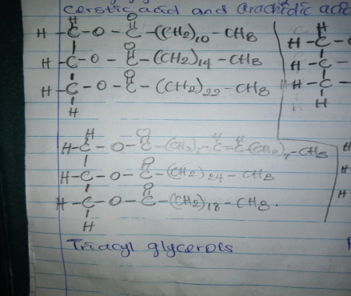 | 