16/MHS06/053
COURSE TITLE: BIOMEDICAL ENGINEERING
COURSE CODE: MLS 410
ASSIGNMENT TILE: BIOMEDICAL EQUIPMENTS
QUESTION
1. Discuss the physics of the light microscope, diagrams and illustrations needed.
2. Write notes on the following biomedical equipment. Add notes on the principle, brand, care and maintenance and cost.
a) Centrifuge
b) Automatic tissue processor
c) Microtome
ANSWER
1. Physics of a light microscope
The compound binocular light microscope is an indispensable piece of apparatus in all medical laboratories.
The light microscope also referred to as optical microscope, is a type of microscope that commonly uses visible light and a system of lenses to generate magnified images of small objects. The physics of a light microscope basically talks about the mechanics involved in magnification of small objects.
Before dealing with the physics, some terms have to be explained:
- Refraction;
Refraction is the change in direction of light passing obliquely from one medium to another of different optical density.
Illustration;
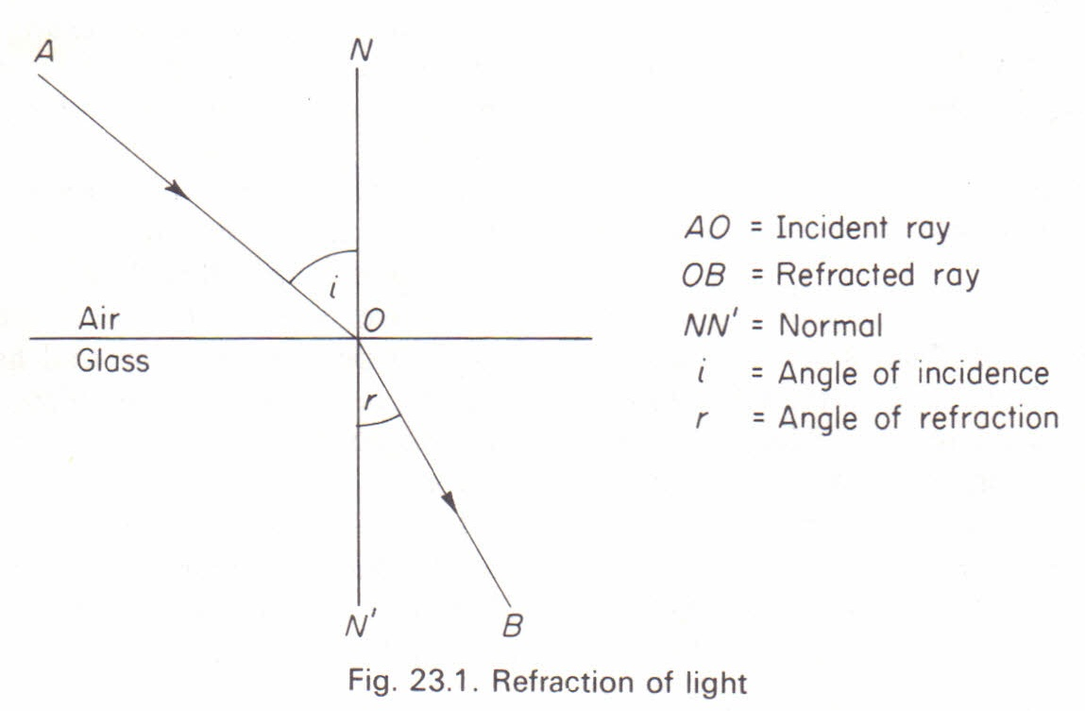
This diagram shows the path of a ray of light passing from air into glass plate. At point O, is the point of entry into the glass and line NN’ called the ‘normal’ is perpendicular to the surface of separation of the media. The ray of A is refracted towards the normal along the B in the glass. In conclusion, a ray of light passing from a rarer to a denser medium is refracted towards the normal but when passing from a denser to a rarer medium is refracted away from the normal.
Refractive index
The angle (AON) i, is termed as angle of incidence and angle r is the angle of refraction. The sine of the angle of incidence divided by the angel of refraction is a constant quantity for any given media and is called the Refractive Index (RI)
R.I =$\frac{\sin{i}}{\sin{r}}$

Numerical aperture
The numerical aperture is defined as the product of the refractive index of the medium outside the lens and the sine of half the angle of the cone of light absorbed by the front lens of the objective. The numerical aperture is in many ways more important than the magnification. This is because an increase in NA results in an increase in resolution.

Principal Focus of a converging lens
A biconvex lens has two spherical surfaces which curve outwards. It is called a converging lens as rays of light passing through the lens converge to a focal point. The center of the lens surfaces is called the center of curvature. A straight line between these two centers is the principal axis. A line, drawn at right angles to this axis, which passes through the center of the lens is termed the principal plane. The diameter or width of the lens is called its aperture.

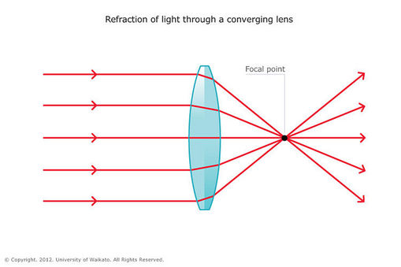
Rays of light entering a converging lens parallel to the principal axis are refracted towards and across this axis. The point at which they cross are called the principal focus. A biconvex lens has two principal foci, one on either side.

OPTICAL SYSTEM OF A LIGHT MICROSCOPE
The first lens is called the objective lens, and has typical magnification values from 5×5× to 100×100×. In standard microscopes, the objectives are mounted such that when you switch between objectives, the sample remains in focus. Objectives arranged in this way are described as parfocal.
The second, the eyepiece, also referred to as the ocular, has several lenses which slide inside a cylindrical barrel. The focusing ability is provided by the movement of both the objective lens and the eyepiece. The purpose of a microscope is to magnify small objects, and both lenses contribute to the final magnification. Additionally, the final enlarged image is produced in a location far enough from the observer to be easily viewed, since the eye cannot focus on objects or images that are too close.

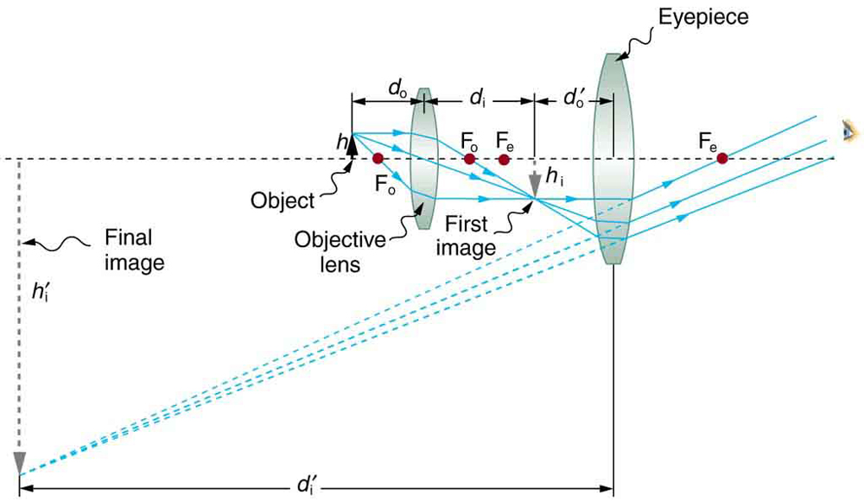

To see how the microscope in the above figure forms an image, we consider its two lenses in succession. The object is slightly farther away from the objective lens than its focal length f_{o}, producing a case 1 image that is larger than the object. This first image is the object for the second lens, or eyepiece. The eyepiece is intentionally located so it can further magnify the image. The eyepiece is placed so that the first image is closer to it than its focal length f_{e}. Thus the eyepiece acts as a magnifying glass, and the final image is made even larger. The final image remains inverted, but it is farther from the observer, making it easy to view (the eye is most relaxed when viewing distant objects and normally cannot focus closer than 25 cm). Since each lens produces a magnification that multiplies the height of the image, it is apparent that the overall magnification m is the product of the individual magnifications:
m=m_{o}m_{e},
where m_{o}; is the magnification of the objective
m_{e}; is the magnification of the eyepiece.
This equation can be generalized for any combination of thin lenses and mirrors that obey the thin lens equations.

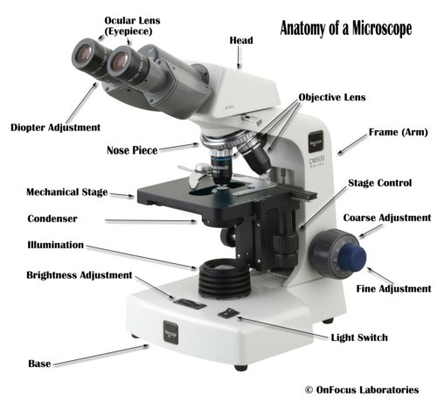
The lenses
A compound microscope has two or more lenses. The eyepiece or ocular lens sits atop the body tube. Many microscopes are binocular and have two ocular lenses.

Additionally, a binocular head will have a prism, either in the head or the body tube, to split the image and direct it to both oculars. The oculars have different available magnifications, but usually less than the power of the objective lenses. The objective lenses are at the bottom of the microscope tube nearest the specimen; they gather and focus the light transmitted from the specimen.
Usually three or four objectives of different strengths will reside in a revolving turret, and magnification may be changed by turning the turret to line up a different lens with the body tube. Objective magnification strengths usually range from 10X to 100X. Fine and coarse focusing adjustments are accomplished with focusing knobs located on the body of the microscope.

How Does a Microscope Work?
Magnification
The power to enlarge the image of the specimen when viewed through a microscope is known as the magnification and is dependent upon how much the lenses bend the light waves.
Magnification is expressed in numeric multiples of how much enlargement occurs with a lens. If the magnification of a lens is 2X then it roughly doubles the size of the image of the object.
With a compound microscope, the total magnification can be determined by multiplying the magnifications of the objective and ocular lenses. Consequently, an ocular lens of 10X coupled with a 40X objective yields a total magnification of 400X.
However, the higher the magnification the closer the lens must be to the specimen. Since a higher magnification lens bends light more severely, the specimen is brought into focus a shorter distance from the lens and this is known as the focal length.
WORKING PRINCIPLE OF A MIGHT MICROSCOPE
The magnification of the object is produced by the combined action of two lenses, the objective lens and the eye piece lens. The specimen to be viewed with the light microscope has to be sufficiently thin so that light can pass through it. Some light is absorbed while passing through the specimen, and a contrast may be produced due to differences in light absorption by different parts of the specimen. However, the optical system of the bright light microscope does not reveal much contrast in the unstained preparation. Therefore, the contrast needs to be enhanced with staining

2a) Centrifuge
A centrifuge is a laboratory device that is used for separation of fluids (gas or liquid) based on their density. Separation is achieved by spinning a vessel containing material at high speed, the centrifugal force pushes the heavier materials to the outside of the vessel. There are various types of centrifuge used in the medical laboratory and they all follow the same basic principle. Some types of centrifuge include; small bench centrifuge, fixed angle rotors, vertical tube rotors, ultracentrifuge, high speed refrigerated centrifuge amongst others.
Principle; The principle of a centrifuge states that at a high speed, fluid components separate to their various constituents based on their densities. The centrifuge mainly works on the principle of sedimentation, where the acceleration at centripetal force causes denser substances to separate out along the radial direction at the bottom of the tube.
It is basically the apparent force that draws a rotating body away from the center of rotation which is caused by the inertia of the body as the body’s path is continually redirected. The acceleration achieved by centrifugation is expressed as a multiple of the earth’s gravitational force (g). Based on the acceleration values they can reach, centrifuges are categorized into bench top (up to 15000 g), high speed refrigerated centrifuges (50000 g) and ultracentrifuges (500000 g). As ultracentrifuges can operate under cold conditions and in the vacuum, they are ideal for separating macromolecules like proteins, nucleic acids and carbohydrates. The radial force produced by the spinning rotor can also be expressed relative to g, as Relative centrifugal force (RCF) or g-force.
Brands and costs
There are many brands of centrifuge that are available and that are used in different laboratories.
- Eppendorf 5424 Centrifuge Microfuge +24 place rotor
$695 #250,200
- Electric Centrifuge lower-speed desktop laboratory Machine 4000rpm
$153.67 which is about #56,000
- CE PRP Beauty Centrifuge CGF PRF Blood Centrifuge Serum fat separator
$403.88 which is about #150,000
- Kenley Desktop electric lab centrifuge

Care and maintenance of centrifuge
- Clean both the exterior and the interior of the centrifuge.
- Use a sponge, warm water and a mild detergent such as dishwashing fluid.
- Clean the centrifuge daily, or at least weekly.
- Do not use any caustic detergents or any products containing chlorine ions in the cleaning of the centrifuge.
- Spills should be wiped up immediately.
- Do not pour water directly into the chamber or flood the inside of the centrifuge with a cleaner.
- Plug in centrifuge only when completely dry.
- Scrub tube cavities with a test tube brush with nonmetallic tip. Dry each part with an absorbent towel.
- Switch off the device and disconnect it from the power supply before starting any cleaning or disinfection.
- The outside of the centrifuge and the rotor chamber should be cleaned regularly with neutral detergents. This is for hygienic purposes as well as to prevent contamination caused by residual contamination.
- Only neutral agents may be used for cleaning and disinfection (e.g. diluted neutral alcohol-based disinfectant or 70% isopropanol mixture).
- Residue from detergents should be removed. Also remove condensation and clean the condensation tray. Leave the centrifuge lid open.
- The rotor chamber and the rotor shaft should simply be wiped with a moist cloth. Please clean your rotor using a neutral cleaning liquid. This will protect the rotor and prolong its service life.
- Do not use steel wool, wire brushes, abrasives, or sandpaper, since they may damage the rotor coating (anodized coating) and thus increase the risk of corrosion.

Automatic tissue processor
An automatic tissue processor is a device which passes a tissue through all the tissue processing processes for histological evaluation. Tissue processing is explained as a process and steps required to take a tissue from fixation to a state where it is completely infiltrated with a suitable histological embedding medium, and can be embedded ready for section cutting on the microtome. The steps in tissue processing include; dehydration, clearing, infiltration, and embedding. The major function of the automatic tissue processor are to perform the processing steps listed above automatically, which would require little to minimal human labor and is faster.
Principle; Tissue processing occurs due to the diffusion of various substances/fluids in and out of stabilized porous tissues. The diffusion process results from the thermodynamic tendency of processing reagents to equalize concentrations inside and outside the bits of tissue, which is in accordance to that of Fick’s law. Time required for tissue processing may be considerably reduced when the tissue is suspended in fluid, continuously agitated and moved from one reagent to another when desired, not restricted by working hours.
Brands and cost
- Lipshaw Circular Tissue Processor
$550.00 which is about #200,000
- 2016 Sakura Tissue-Tek® Xpress® X120 Rapid Tissue Processor
$25,000 which is about #9 million
- Leica TP1020 Automatic Tissue Processor, fully conditioned
$11,950 which is about #4 300 000.

Care and maintenance of an automatic tissue processor
The common and general care and maintenance automatic tissue processor are stated below;
- For cleaning, only mild detergents should be used.
- The processor should only be turned on we in use.
- The processor should not be overloaded with tissue samples.
- While the instrument is in use, no liquid may enter the instrument to avoid damage.
- For the purpose of maintenance and repair, the maintenance team from the company that developed the machine should only open the instrument.
- Spilled reagents have to be wiped away immediately. In the case of long term exposure, the instrument surface are only conditionally resistant to solvents.
- The heated wax bath may only be used with paraffin. Under no circumstances may they be filled with solvents. When solvents heat, highly explosive mixtures build up which may cause harm and as well damage the instrument.
- Xylene and acetone should be avoided because the control panel and the lacquered surfaces are not resistant to them.
- Reagent maintenance:
One of the most important steps to ensuring consistent and trouble-free tissue processing is reagent maintenance. Keeping reagents fresh is critical to proper tissue processing and overall quality control (QC).
Since over-used reagents lead to problems that are difficult to diagnose, most laboratories keep a maintenance log to keep track of how often reagents are changed and rotated. Determining how often each reagent is changed is as individual as the processing protocol for every laboratory.
Some laboratories implement reagent changes based on how often each reagent is used. Other laboratories change reagents based on the number of cassettes or the amount of tissue processed, rather than a rigid calendar schedule. Once determined, reagent maintenance schedules should be adhered and charts should be utilized for tracking purposes, in order to retain consistent quality of processed tissue.
- Temperature checks;
Melted paraffin must be kept at 2-4° C above the melting point of paraffin. The paraffin chambers on the processor must maintain the proper temperature and this temperature should be checked daily. Paraffin may also be melted and stored in special paraffin pots so that melted paraffin is always available for filling the embedding center or the processor. The paraffin pots must be temperature controlled and monitored daily for the proper temperature. If the paraffin is cooked at high temperatures it will breakdown and cause microtomy problems. Since there are dozens of paraffin’s available on the market, technical support from the processor manufacturer is recommended. Not all paraffin’s are made for all processors or all applications.
- Always switch off the processor immediately after use
- Regular servicing of the machine is required.

Microtome
A microtome is an instrument used exclusively in the histopathology department of the laboratory. The process of cutting tissues into thin sections with the aid of a microtome is called microtomy, This equipment is used to cut thin sections of tissue that allows for easy identification of the tissue specimens under the microscope. There are different types of microtome which includes; Rotary microtome, base sledge microtome, cryostat, ultra-microtome. Sliding microtome, freezing microtome, Cambridge rocking microtome. There are different factors that are considered before a type of microtome is used in cutting a section and they include
The type of embedding medium used
The type of work
Nature of the tissue preparation
Principle of rotary microtome; It id worked by rotating a wheel fitted with a handle. The razor is placed in front of the microtome in a razor holder, which is movable. The material, embedded in a paraffin block is fixed on the block holder, which can be fixed to an adjustable socket.
Brand and cost of microtome
- Leica® RM2165 Rotary microtome
$2,750 which is about 990,000
- Thermos® HM 325 Rotary microtome
$8,500 which is about #3 million.
Care and maintenance of a microtome
- Store knife in its case to prevent oxidation
- Keep the knife edge clean at all times
- Daily cleaning of paraffin debris will help keep a microtome cutting optimally for many years.
- The microtome knife should be coated with an oil mixture to prevent rust and corrosion when not in use
- The blade guard must be used whenever a blade is present on the holder and when the microtome is not in active use.
- The arm (wheel) lock must be engaged whenever the rotary arm is not in active use.
- The blade should be installed and removed with the aid of a clamping tool such as a pair of hemostats.
- When placing or retrieving materials near the blade, use appropriate tools (such as forceps or fine-tipped paint brush) so that hands remain in the clear of the blade.
- Always ensure that the microtome is cleaned immediately after use.

