16/MHS06/015
MLS 410
QUESTIONS
- Discuss the physics of the light microscope. Diagrams and illustrations needed.
- Write notes on the following biomedical equipment. Add notes on principle, brand, care, maintenance and cost.
- Centrifuge B) Automatic tissue processor C) Microtome
ANSWERS.
- Light Microscope also referred as Optical Microscope; there are two basic types, which are known as Simple Microscope and Compound Microscope. A light microscope (LM) is an instrument that uses visible light and magnifying lenses to examine small objects not visible to the naked eye, or in finer detail than the naked eye allow. The light microscope is an instrument for visualizing fine detail of an object. It does this by creating a magnified image through the use of a series of glass lenses, which first focus a beam of light onto or through an object, and convex objective lenses to enlarge the image formed. 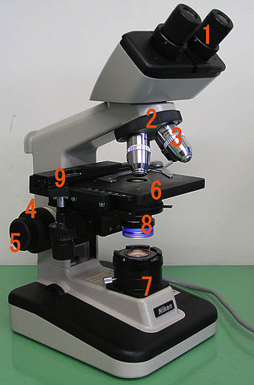
Diagram of a light microscope
1. Eye piece 2&3. Objective lens 4. Focus knob 5. Coarse adjustment knob 6. Fine adjustment 7. Stage 8. Light source 9. Diaphragm

PHYSICS OF A LIGHT MICROSCOPE
In the illustration below, it explains that the object is slightly farther away from the objective lens than its focal length f_{o}, producing a case 1 image that is larger than the object. This first image is the object for the second lens, or eyepiece. The eyepiece is intentionally located so it can further magnify the image. The eyepiece is placed so that the first image is closer to it than its focal length f_{e}. Thus the eyepiece acts as a magnifying glass, and the final image is made even larger. The final image remains inverted, but it is farther from the observer, making it easy to view (the eye is most relaxed when viewing distant objects and normally cannot focus closer than 25 cm). Since each lens produces a magnification that multiplies the height of the image, it is apparent that the overall magnification m is the product of the individual magnifications: m = m_{o}m_{e}, where m_{o} is the magnification of the objective and m_{e} is the magnification of the eyepiece. This equation can be generalized for any combination of thin lenses and mirrors that obey the thin lens equations.

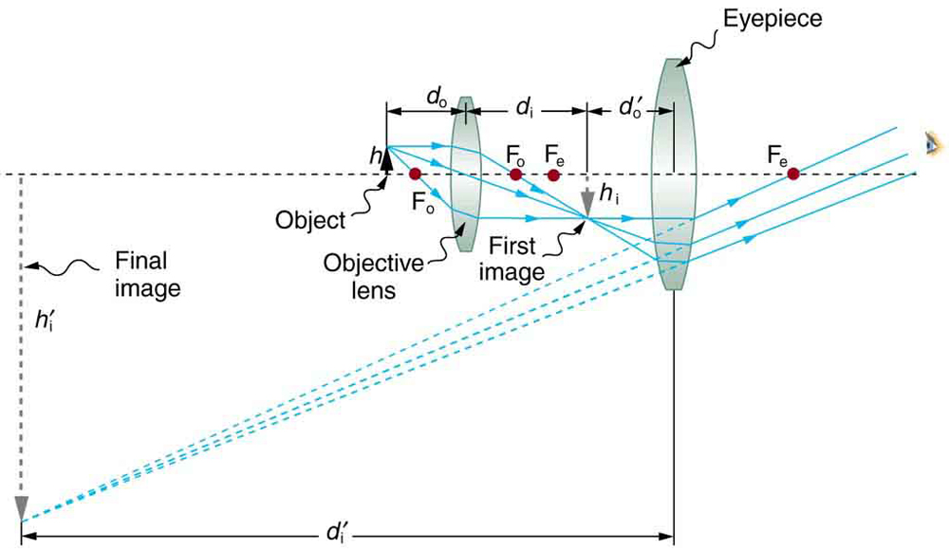
A compound microscope is composed of two lenses, an objective eyepiece. The objective forms a case 1 image that is usually larger than that of the object. The first image is the object for the eyepiece and it forms a case 2 final image, which is further magnified.

Compound microscope: a microscope constructed from two convex lenses, the first serving as the ocular lens (close to the eye) and the second serving as the objective lens
Objective lens: the lens nearest to the object being examined
Eyepiece: the lens or combination of lenses in an optical instrument nearest to the eye of the observer
Numerical aperture: a number or measure that expresses the ability of a lens to resolve fine detail in an object being observed. Derived by mathematical formula NA = n sin α, where n is the refractive index of the medium between the lens and the specimen and α=θ2α=θ2
- Centrifuge, Automatic tissue processor, Microtome.
- CENTRIFUGE
A centrifuge is a laboratory device that is used for the separation of fluids, gas or liquid, based on density. Separation is achieved by spinning a vessel containing material at high speed; the centrifugal force pushes heavier materials to the outside of the vessel.
PRINCIPLE: the principle of a centrifuge states that at a high centrifugal speed, blood components separate into their various constituents.
TYPES OF CENTRIFUGE
- Small Bench Centrifuges
- Large Capacity Refrigerated Centrifuges
- High Speed Refrigerated Centrifuges
- Ultra Centrifuges
- Fixed Angle Rotors
- Vertical Tube Rotors
- Zonal Rotors
- Elutriator Rotors
BRANDS OF CENTRIFUGE
There are various brands of centrifuges that are used in the laboratory to spin samples. The following are few of the best centrifuges used in the laboratory.
- Eppendorf 5424 Micro centrifuge for 24-Place 1.5/2.0mL Micro centrifuge Tubes: this centrifuge has the large capacity that accommodates up to 20 samples of 1.5-2ml, which is great, plus if you work in a big lab. This centrifuge offers you a shorter time for the sediment to be created to save your time.
- ELMI CM-7S Clinical PRP Bench top Centrifuge with 6-Place Swing-Out Rotor for 50 mL: Using this centrifuge, one would have the possibility to set the exact time the samples need, at the optimum parameters which is thanks to the user-friendly controls. The rotational speed can also adjusted in an interval between 100-3500 revolutions per minutes. The centrifuge is more suitable for small labs as it has a small capacity of only 6 test tubes.
- Scilogex 91302341 Model DM0412 Clinical Centrifuge with A12-10P Fixed-Angle Rotor and Adapters, 4,500 rpm, 110/240v: this centrifuge doesn’t occupy much space and it is a silent device that lets you focus on other tasks while the test tubes are centrifuged automatically.
- Globe Scientific 6261 Polypropylene Centrifuge Tube

Unico C806 Power Spin Model FX Centrifuge

CARE AND MAINTAINANCE OF A CENTRIFUGE
- Clean the centrifuge daily, or at least weekly.
- Remove the rotor and any sample or container holders.
- Interior cleaning includes the interior bucket, specimen holder, rotor and supports.
- Use a sponge, warm water and a mild detergent such as dishwashing liquid.
- Do not use caustic detergents or any product containing chlorine ions. (Diluted bleach is sometimes used as a disinfectant, but at full strength can attack stainless steel and discolor or damage the bowl (see below). A plastic scrub pad can be used, but products such as steel wool, wire brushes and other abrasives can damage coatings and lead to corrosion.
- Spills should be wiped up immediately.
- Clean both the exterior and the interior.
- Do not pour water directly into the chamber or flood the inside of the centrifuge with cleaner. Sensors, gaskets, seals, wiring and other parts that may be present can be easily damaged. Motors, vacuum pumps, condensers and other expensive parts can also be damaged by exposure to water and cleaning products.
- Scrub tube cavities with a test tube brush with nonmetallic tip. Dry each part with an absorbent towel.
- Plug in centrifuge only when completely dry.
COST OF A CENTRIFUGE
In the purchase of any equipment, the cost is one of the most important things to put into considerations. If the cost is way out of ones budget such equipment cannot be purchased. There are various costs of a centrifuge, which varies from brand to brand and also varies on the ability as well as the size of the centrifuge. Due to some researches, it says that centrifuges costs can be in a range of $1,000-$5,000= 390,110.00-1,950,550.00 naira.

- AUTOMATIC TISSUE PROCESSOR
In order to know what a tissue processor does, one needs to understand tissue processing. Tissue processing is explained as a process and steps required to take animal or human tissue from fixation to the state where it is completely infiltrated with a suitable histological wax and can be embedded ready for section cutting on the microtome. The steps in tissue processing includes; fixation, dehydration, clearing, infiltration, embedding. After the embedding the block is cut into sections on the microtome.
The major function of an automatic tissue processor is the do the steps listed above automatically which is faster and requires very little to minimal manual labor.

PRINCIPLE
- Tissue processing occurs due to diffusion of various substances/fluids in and out of stabilized porous tissues. The diffusion process results from the thermodynamic tendency of processing reagents to equalize concentrations inside and outside the bits of tissue, which is in accordance to that of FICK’S LAW.
- Time required for tissue processing may be considerably reduced when tissue is suspended in fluid, continuously agitated and moved from one reagent to another when desired, not restricted by working hours.

BRAND AND COST
There are a lot of brands with good automated tissue processor, a few have been listed below
- KD-TS6A –automatic tissue processor. Cost =$12,800=4,623,616.00 naira.
- ASP6025 – Automated vacuum tissue processor. Cost =
- YR433-Automated tissue processor
- KD-TS3D1-Automatic tissue processor. Cost=$9,800=3,539,956.00 naira
- Leica TP1020-Automated tissue processor. Cost=$24,750.00=8,940,195.00

CARE AND MAINTANANCE OF AN AUTOMATED TISSUE PROCESSOR.
To each automatic tissue processor is its own safety and maintenance methods, the common and general care and maintenance methods are written down below.
- The processor should only be turned on when in use
- The processor should not be overloaded with tissue samples
- Spilled reagents have to be wiped away immediately. In the case of long-term exposure the instrument surface are only conditionally resistant to solvents.
- While the instrument is in use, no liquid may enter the instrument to avoid damage.
- The heated wax bath may only be used with paraffin. Under no circumstances may they be filled with solvents. When solvents heat, highly explosive mixtures build up which may cause harm and as well damage the instrument.
- For the purpose of maintenance and repair, the maintenance team from the company that developed the machine should only open the instrument.
- For cleaning, only mild household detergents should be used
- Xylene and acetone should be avoided because the control panel and the lacquered surfaces are not resistant to them.

- MICROTOME
A microtome is an instrument used exclusively in the histopathology department of the laboratory. The process of cutting tissues into thin sections with the aid of a microtome is called MICROTOMY. This equipment is used to cut thin sections of tissue that allows for easy identification of the tissue specimens under the microscope. There are different types of microtome which includes; Rotary microtome, Sliding microtome, Cambridge rocking microtome, Freezing microtome.
PRINCIPLE OF A ROTARY MICROTOME: is worked by rotating a wheel fitted with a handle. The razor is placed in front of the microtome in a razor-holder, which is movable. The material, embedded in a paraffin block is fixed on the block-holder, which can be fixed to an adjustable socket

BRAND AND COST OF A MICROTOME
- CUT 5062-Rotary microtome/ semi- automatic
- CUT 6062 –Rotary microtome/ automated
- ARM 3750-Rotary microtome/automated
- HEAVY SLEDGE –XL –Sliding microtome/ automated: has the following features which includes Section thickness ranging from 1 to 1,000 μm, adjustable in 1 μm intervals
Sectioning speed ranging from 1 to 125 mm/s, continuously adjustable
Vertical knife stroke distance: 70 mm
Knife retraction: freely adjustable from 100 – 2000 µm. Knife clearance angle adjustment freely configurable from 0° to -25°
Knife declination freely configurable in both ways from 90° to 135°
Freely configurable collision protection level
Trimming function for fast trimming of samples with free configurable trim values
Individual sectioning window with freely programmable front and rear starting and finishing points

- ROTO-CUT 400 – Rotary microtome/ automated: they assure the highest precision and section quality. Adjustable sample-holder on two axis with a 360° rotation. The blade-holder cutting angle can be adjusted according to operator’s needs. All SCILAB microtome versions are equipped with sample retraction during vertical stroke.
All operations are driven through intuitive and friendly buttons; changing from the trimming to sectioning is quick and easy; the blade-holder is equipped with a mechanical system that ensures the whole surface exhaustion of blade edge.
The blade-holder is equipped with a protection system against accidental shoves avoiding any risks for the operator. The system is enabling also during the section setting: a friendly blade-removal system allows removing safely the blade. The blade-holder can be easily blocked in high position allowing the sample introduction or its easy and safe removal.
- ROTO-CUT 200- Rotary microtome/ semi-automatic
- MRP2015-Rotary microtome/ manual
- HM 325 – Rotary microtome/ manual: can cut high-quality paraffin sections without a power supply with the robust Thermo Scientific™ HM 325 Rotary Microtome. The HM 325 features retraction at the return travel to protect the specimen and manual coarse advance for fast working.

- AMR 400- Rotary microtome/manual: this microtome has the following features:
● Spacious magnetized section waste tray
● Ergo-hand wheel handle
● Convenient storage area on top of instrument
● Disposable blade holder with integrated safety finger protection guard
● Two hand wheel locks : hand wheel can be locked at any position
● Distortion-resistant base plate ensures optimum overall stability
● Both low & high profile disposable blade are usable

The costs of various microtomes depend on the size and the efficiency of the microtome in question.
- The average cost for a rotary microtome is $6900=2,687,550.00 naira.
- The cost of a cryostat microtome is $5000-8000=1,947,500.00- 3,116,000.00 naira.
NOTE: THESE PRICES ARE BASED ON THE DATA I GOT FROM MY RESEARCH.

CARE AND MAINTENCE OF MICROTOME
- The microtome knife has been coated with an oil mixture to prevent rust and corrosion when not in use.
- Before using your knife, take a lint-free facial tissue saturated when not in use in either xylene, benzene or acetone to remove the protective oil coating on the knife.
- Store your knife in its case to prevent oxidation.
- Keep the edge of your knife clean at all times.
- Daily cleaning of paraffin debris will help to keep a microtome cutting optimally for many years

REFERENCES
courses.lumenlearning.com
en.wikipedia.org.com
http://stmichaelshospitalresearch.ca/
www.medicalexpo.com
www.scribd.com
www.futurity.org

