Matric no : 16/MHS01/142
Dept MLS
Course code : MLS410
Course title: Biomedical Engineering
Q1 Discuss the physics of the light microscope diagrams and illustration needed.
Q2 write notes on the following biomedical equipment. Add notes on principle, brand, care and maintenance and cost, A) centrifuge B) Automatic tissue processor C) Microtome
ANSWERS
A light microscope is a laboratory instrument or tool, that uses visible light to detect and magnify very small objects, and enlarging them.
Principle of light microscopes
light microscopes visualize an image by using a glass lens and magnification is determined by, the lens’s ability to bend light and focus it on the specimen, which forms an image. When a ray of light passes through one medium into another, the ray bends at the interface causing refraction. The bending of light is determined by the refractive index, which is a measure of how great a substance slows the speed of light. The direction and magnitude of the bending of the light are determined by the refractive indexes of the two mediums that form the interface.A medium with a lower refractive index such as glass to air, it normally speeds up the light penetration and making light bend away from the normal and when light is passed through a medium with a greater refractive index such as air to glass, it normally slows down and bends towards the normal, perpendicularly to the surface.If an object is put between these two mediums i.e between water and air, in this case, a prism, the prism will bend the light at an angle. This is how the microscopic lenses work, they bend the light at an angle. The lens (convex) on receiving the light rays, it focuses the rays at a specific point known as the focal point (F-point). The measure of distance from the center of the lens and the focal point is known as the focal length.A microscope uses lenses whose strength is predetermined, in that, the strength of a lens is directly related to the focal length i.e short focal length magnifies objects more than lenses with a long focal length. Microscopy works strictly with a factor of resolution whereby resolution being the ability of a lens to be able to differentiate small objects that are closely packed together. The resolution of a light microscope is determined by a numerical aperture of its lens system and by the wavelength of the light it employs; a numerical aperture a definition of the light wavelengths produced when the specimen is illuminated. A minimum distance (d) between two objects that distinguishes then to be two separate entities, determined by the wavelengths of the light can be calculated by an Abbe equation using the wavelength of the light that illuminated the specimen (Lambda, λ) and the numerical aperture (NA, n sin Ɵ) i.e. d=0.5 λ/n sin Ɵ

Types of light microscopes
1 Bright field Light Microscope
2 Phase Contrast Light Microscope
3 Dark-Field Light Microscope
4 Fluorescence Light Microscope

Brightfield Light Microscope (Compound light microscope
This is the most basic optical Microscope used in microbiology laboratories which produces a dark image against a bright background. Made up of two lenses, it is widely used to view plant and animal cell organelles including some parasites such as Paramecium after staining with basic stains. Its functionality is based on being able to provide a high-resolution image, which highly depends on the proper use of the microscope. This means that an adequate amount of light will enable sufficient focusing of the image, to produce a quality image. It is also known as a compound light microscope.
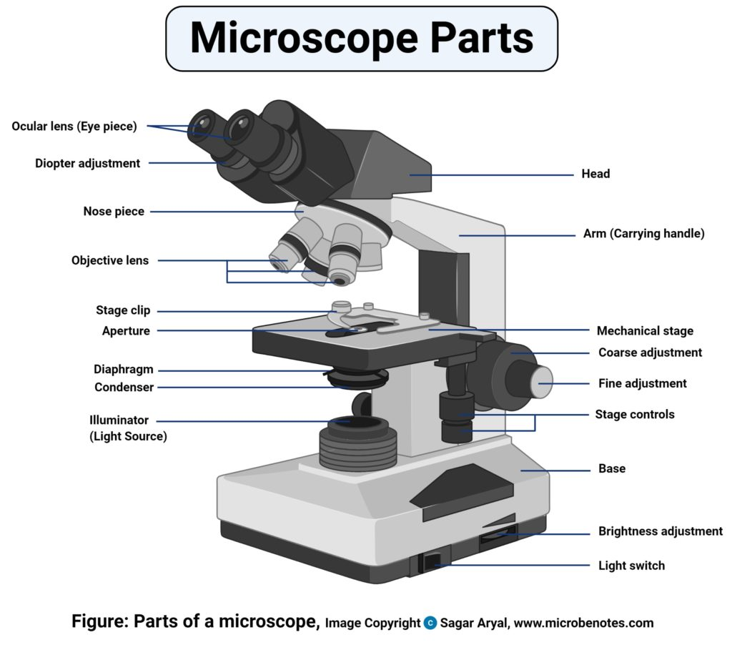
It is composed of:
. Two lenses which include the objective lens and the eyepiece or ocular lens. .Objective lens is made up of six or more glasses, which make the image clear from the object
The condenser is mounted below the stage which focuses a beam of light onto the specimen. It can be fixed or movable, to adjust the quality of light, but this entirely depends on the microscope.
They are held together by a sturdy metallic curved back used as an arm and a stand at the bottom, known as the base, of the microscope. The arm and the base hold all the parts of the microscope.
The stage where the specimen is placed, allowing movement of the specimen around for better viewing with the flexible knobs and it is where the light is focused on.
Two focusing knobs i.e the fine adjustment knob and the coarse adjustment knob, found on the microscopes’ arm, which can move the stage or the nosepiece to focus on the image. the sharpen the image clarity.
It has a light illuminator or a mirror found at the base or on the microbes of the nosepiece.
The nosepiece has about three to five objective lenses with different magnifying power. It can move round to any position depending on the objective lens to focus on the image.
An aperture diaphragm also is known as the contrast, which controls the diameter of the beam of light that passes through the condenser, in that, when the condenser is almost closed, the light comes through to the center of the condenser creating high contrast. But when the condenser is widely open, the image is very bright with very low contrast.

Magnification by Bright field Microscope (Compound light microscope)

During visualization, the objective lens remains parfocal which means, when the objective lens is changed, the image still remains in focus. The objective lens plays a major role in focusing the image on the condenser forming an enlarged clear image within the microscope, which is then further magnified by the eyepiece to a primary image.

What is seen in the microscope as an enlarged clear image of the specimen is known as the virtual image. To calculate the magnification, multiply the objective and eyepiece objective magnification together. The magnification is standard, i.e not too high nor too low, and therefore depending on the magnification power of the lenses, it will range between 40X and 100oX.

Calculation of magnification = Magnification of objective lens/magnification of the eyepiece lens

The objective lens plays a vital role in not only enlarging the image but also making it clear for viewing, a feature known as resolution. Resolution according to Prescott, is the ability of a lens to separate or distinguish between small objects closely linked together.

Whereas the eyepiece magnifies the image at the end of the viewing, its magnification range is lower than that of the objective lens at 8X-12X (10X standard) and that of the objective lens at 40X-100X, magnification, and resolution of the microscope is highly dependant on the objective lens.
Applications of the Bright Field Light Microscope (Compound light microscope)

Vastly used in Microbiology, this microscope is used to view fixed and live specimens, that have been stained with basic stains. This gives contrast for easy visibility under the microscope. Therefore it can be used to identify basic bacteria cells and parasitic protozoans such as Paramecium.
Phase Contrast Microscope
This is a type of optical microscope whereby small light deviations know as phase shifts occur during light penetration into the unstained specimen. These phase shifts are converted into the image to mean, when light passes through the opaque specimen, the phase shifts brighten the specimen forming an illuminated (bright) image in the background.
The phase-contrast microscope produces high contrast images when using a transparent specimen more so those of microbial cultures, thin tissue fragments, cell tissues, and subcellular particles.
The principle behind the working of the phase-contrast microscope is the use of an optical method to transform a specimen into an amplitude image, that’s viewed by the eyepiece of the microscope.
The PCM can be used to view unstained cells also known as the phase objects, which means that the morphology of the cell is maintained and the cells can be observed in their natural state, in high contrast and efficient clarity. This is because if the specimens are stained and fixed, they kill most cells, a characteristic that is uniquely undone by the brightfield light microscope.
The shifts that occur during light penetration, become converted to changes in amplitude which causes the image contrast.
Coupled with contrast-enhancing elements such as fluorescence, they produce better visuals of the specimens’ image.
Parts of the Phase Contrast Microscope
The instrumentation of the Phase Contrast Microscope is based on its light pathways from receiving the source of light to the visualization of the image.
Therefore its sequentially made up of:
Light source (Mercury arc lamp)
Collective lens
Aperture
Condenser
Condenser annular
Specimen
Objective
Phase plate
Deflected light
Phase ring

The functioning of the Phase Contrast microscope
The change caused by the deviated scattered (Deflected) light and the undeviated light that reaches the specimen which is absorbed, create at a certain wavelength, producing color. The difference created by the scattered light and that of the absorbed light is known as amplitude variations. These amplitude variations are sensitive to allowing visualization by photographic equipment like the Phase Contrast Microscope, hence seen by the human eye.
The Condenser of the phase-contrast microscope has an opaque disk that is known as an annular ring, with a transparent ring that produces a cone of light, that passes through a specimen. Due to light variations some light bend at the specimen, caused by variations in light density, forming an image at the objective lens. The undeviated light will strike the phase ring on the phase plate and the deviated light will miss the phase ring passing through the phase plate directly, this forms an image.

The Phase-Contrast Microscope is designed with objective lenses that have the ability to perform multiple functions when combined with contrast-enhancing techniques, for example, fluorescence. The objective lenses are located in the internal phase plate with variation in the light absorption and phase displacement i.e undiffraction, creating a wide spectrum for contrasting the specimen and forming a strong contrast in the background.
Applications of Phase-Contrast Microscope

Determine morphologies of living cells such as plant and animal cells
Studying microbial motility and structures of locomotion
To detect certain microbial elements such as the bacterial endospores

Dark-Field Light Microscope
This is a specialized type of bright field light microscope which has several similarities to the Phase-Contrast Microscope. To make a dark field Microscope, place a darkfield stop underneath and a condenser lens which produces a hollow cone beam of light that enters the objective only, from the specimen .This technique is used to visualize living unstained cells. This is effected by the way illumination is done on the specimen in that, when a hollow cone beam of light is transmitted to the specimen, deviated light (unreflected/unrefracted) rays do not pass through the objectives but the undeviated (reflected/refracted) light passes through the objectives to the specimen forming an image. This makes the surrounding field of the specimen appear black while the specimen will appear illuminated. This is enabled by the dark background this the name, dark-field Microscopy.
Applications of the Dark Field Microscope
It is used to visualize the internal organs of larger cells such as the eukaryotic cells Identification of bacterial cells with distinctive shapes such as Treponema pallidum, a causative agent of syphilis.

The Fluorescent Microscope
The above-discussed microscopes will normally produce images after a light has been transmitted and passed through the specimen.
In the case of the fluorescent Microscope, the specimen emits light. How? By adding a dye molecule to the specimen. This dye molecule will normally become excited when it absorbs light energy, hence it releases any trapped energy as light. The light energy that is released by the excited molecule has a long wavelength compared to its radiating light. The dye molecule is normally a fluorochrome, that fluoresces when exposed to the light of a certain specific wavelength. The image formed is a fluorochrome-labeled image from the emitted light.The principle behind this working mechanism is that the fluorescent microscope will expose the specimen to ultra or violet or blue light, which forms an image of the specimen that is emanated by the fluorescent light. They have a mercury vapor arc lamp that produces an intense beam of light that passes through an exciter filter. The exciter filter functions to transmit a specific wavelength to the fluorochrome stained specimen, producing the fluorochrome-labeled image, at the objective. After the objective, there is a barrier filter that functions primarily to remove any ultraviolet radiation that may be harmful to the viewer’s light, thus reducing the contrast of the image.
Applications of the Fluorescent Microscope
Used in the visualization of bacterial agents such as Mycobacterium tuberculosis. Used to identify specific antibodies produced against bacterial antigens/pathogens in immunofluorescence techniques by labeling the antibodies with fluorochromes. Used in ecological studies to identify and observe microorganisms labeled by the fluorochromes. It can also be used to differentiate between dead and live bacteria by the color they emit when treated with special stains .Besides the above-discussed microscopes, there is one not commonly used microscope known as the Differential Interference Contrast Microscopy. It is very similar to the phase-contrast microscope whereby the images are formed from the variations in the light either deviated and or undeviated. The difference is, here two beams of light are emitted to the specimen and focused by a prism. One beam passes through the prism to the specimen while another passes through the glass slide clear area without the specimen. The two beams then combine and interfere with each other to form an image. It can be used to view cell structures such as endospores, bacterial cell walls, nuclei and granules for unstained specimens.

Q2
A centrifuge is a device for separating particles from a solution according to their size, shape, density, viscosity of the medium and rotor speed.
In a solution, particles whose density is higher than that of the solvent sink (sediment), and particles that are lighter than it float to the top. The greater the difference in density, the faster they move. If there is no difference in density (isopycnic conditions), the particles stay steady.
Principle of centrifuge
The centrifuge involves principle of centrifugation, where the acceleration at centripetal force causes denser substances to separate out along the radial direction at the bottom of the tube. In a solution, particles whose density is higher than that of the solvent sink (sediment), and particles that are lighter than it float to the top. The greater the difference in density, the faster they move.
Types of Centrifuges
There are four major types of centrifuges. They are:
1. Small Bench Centrifuges:
They are used to collect small amount of material that rap­idly sediment like yeast cells, erythrocytes etc. They have maxi­mum relative centrifugal field of 3000-7000 g.
2. Large Capacity Refrigerated Centrifuges:
They have refrigerated rotor chamber and have capacity to change rotor chambers for varying size. They can go up to maximum of 6500 g and use to sediment or collect the substances that sediment rapidly like erythrocytes, yeast cell, nuclei and chloroplast.
3. High Speed Refrigerated Centrifuges:
They can generate speed of about 60000g and are used to collect micro-organism, cellular debris, larger cellular organelles and proteins precipitated by ammonium sulphate.

4. Ultra Centrifuges:
(a) Preparative ultracentrifuge:

It can produce relative centrifugal force of about 600000g and its chamber is refriger­ated, sealed and evacuated. It is employed for separation of macromolecules/ligand binding kinetic studies, separation of various lipoprotein fractions from plasma and deprotonisation of physiological fluids for amino acid ananlysis.
(b) Analytical ultracentrifuge:
It is capable of operating at 500000 g. Three kinds of optical systems are available in analytical ultracentrifuges: a light absorption system, and the alternative Schlieren system and Rayleigh interferometric system, both of which detect changes in the refractive index of the solution.

•Regular preventive maintenance includes
1 .Inspection of the physical condition
2. Inspection of the electrical condition
3 .Cleaning and testing of the centrifuge.
•Regular preventive maintenance will not only prevent damage but can also identify damage that has already occurred and repair it before the centrifuge is no longer usable.

Precautions During Centrifugation
Avoiding Rotor Failures
The centrifugal field which accelerates the separation process also exerts large forces on the rotor material. If a rotor fails, the centrifuge is severely damaged as well. For this reason, some simple precautions should be observed
Rotors are designed to be run up to their maximum speed with a load of a specific weight. One should never attempt to run a rotor at a speed higher than the one designated by its manufacturer. Also, if high density solutions (greater than 1.2 g/mL, for instance) are used, the run speed must be reduced to prevent undue stress on the rotor. Consult your instruction manual for exact directions.

Tube Breakage
Glass tubes can break during centrifugation, due either to improper loading or inherent defects. Any glass fragments must be removed from the buckets, adapters, rubber liners, and rotor chamber before the next run is made. If you find gray dust, which results from sandblasting of the rotor chamber by glass particles, it must be cleaned up too. You should make several dry runs without samples, and clean the chamber between each run to be sure this dust is eliminated from the centrifuge.

Chemical Resistance
If you plan to centrifuge any uncommon solvents or solutions, consult your manual to be sure they are compatible with the various plastics and metals comprising the centrifuge, the rotor, the tubes, and other accessories. These same precautions must be observed with any solvents used for sterilization purposes. A table of 19 chemical resistances for common centrifuge materials is available from Beckman Coulter.

Aerosol Generation
If any liquid is spilled on a rotor, it will be dispersed as a particulate mist when the centrifuge is run. Part of this mist will be fine enough to form a relatively stable aerosol which will tend to be dispersed throughout the laboratory. Such spills should be thoroughly cleaned up before running the centrifuge.
Handling Human Samples
Human blood or blood components can transmit an infectious disease or virus if the patient or donor carries these. Blood should be handled with respect for this possibility during all laboratory manipulations, including centrifugation.
Brand of centrifuge
Manufactured from high clarity polypropylene. Brand polypropylene centrifuge tubes can withstand RCF up to 3000 graduated and CE marked according to IVD directive 98/07. Available non sterile and y – ray sterilized in 15ml or 50ml capacities with or without a base. Include polyethelene screw caps with sealing cone.
B) AUTOMATIC TISSUE PROCESSOR
The tissue processing is to embed the tissue in a solid medium firm enough support the tissue and give it sufficient rigidity to enable thin sections to be cut, and yet soft enough not to damage the knife or
Principle of tissue processor
The tissue basket oscillates up and down in each station at three second intervals to ensure through and even mixing of the reagents and optimum tissue infiltration. Infiltration time is separately programmable for each station.

Maintenance and care of Automatic tissue processor
- Any spillage or overflow should be cleaned immediately
- Accumulation of wax on any surface should be removed
- The temp of the paraffin wax bath should be set to 3oC above the melting point of wax
- Timings should be checked when placing the cassettes in the processor.

Microtone
Embedded paraffin blocks are trimmed to expose the whole surface of the tissue using a microtome. After cooling the immersed surface, thin sections of 2-4 microns (um) are sectioned. (Some tissues for special stains e.g. Congo red stain may require thickersections). Floated out in a water bath, picked unto a glass slide, labeled with the Pathology number of each specimen and allowed todrain and dry. After this, place the slide on a hot plate at about 45 ºC to sufficiently melt off the paraffin and at the same time enable the section to adhere to the slide after which the slide is stained routinely for H&E or by special stains.
PRINCIPLE: Rotary microtomes, when maintained and used properly, are capable of cutting sections from paraffin blocks athin as 1μm. The rotary action of the handle (via the internal mechanism) causes the head of the microtome to which the paraffin block is secured, to advance by the number of microns set on the section thickness dial. As the block passes through the blade, section will be produced according to this thickness setting. Once the sections are placed on a water bath, the expansion of wax due to surface tension and heat helps to remove wrinkles and folds. In addition to a functioning microtome, sharp and blemish-free blade are essential for satisfactory cutting. Poorly prepared paraffin blocks may be sectioned with a good blade, but a poor blade may fail to cut even the best material.
Types of Microtomes
- Rotary microtome
The Rotary microtome is so called because of a rotary action of the handwheel responsible for the cutting moment. The block holder is mounted on a steel carriage, which makes up and down in groves this type of instrument is the most ideal for routine and research work it is excellent for cutting serial sections.
Parts of the rotary microtomes
Block holder
Knife clamps crew
Knife clamps
Block adjustment
Thickness guage
The angle of tilt adjustment
Operating handle
- Sliding or base sledge microtome
This is a large heavy instrument with a fixed knife beneath which the object moves mounted on a heavy sliding base containing the feed mechanism used primarily for cutting the sections of cellulose nitrate embedded tissues with an obliquely set knife.

- Freezing microtomes
This type has been designed for the production or preparation of frozen sections of fluid and non fluid tissues usually without primarily embedding . the object stage is connected to the cylinder of compressed carbondioxide for the rapid cooling of the tissues and provisions are also made for cooling of the knife

CARE AND MAINTENACE
- NEVER adjust the crews too tightly that may cause binding
- After cutting clean fequently from accumulate paraffin
- Cover properly
- Removing f wax
- Application of light oil

Brands of microtome
Alltion( Wuzhou)3
Amos scientific
ANA-med
Auxilab S.l.
Breukhoven
Bright instrument

