16/MHS06/066
SULEIMAN ZULIAT OLUBUKOLA
ASSIGNMENT
1.
The light microscope is an instrument for visualizing fine detail of an object. It does this by creating a magnified image through the use of a series of glass lenses, which first focus on a beam of light onto or through an object, and convex objective lenses to enlarge the image formed. In the majority of light microscopes, the image is viewed directly through binocular eyepiece that act as a secondary lens in the form of a magnifying glass. To observe the projected image. The total magnification is the sum of the objective magnification and eyepiece magnification. The magnification ranges from ×10 to ×1000, with a resolving power of the order of 0.2μm, depending on the type and numerical aperture.
Light and electron microscopes share many similarities in their optical principles. Understanding how a light microscope works is not only critical for obtaining optimum light images, but also for understanding electron microscopy.
Principles of Light, Electrons, & Microscopy
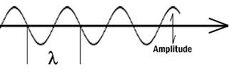
In microscopy we take advantage of waveform properties of light. These waves when produced at a particular source vibrate at right angles to the line of propagation. Each wave has a peak and trough. The distance traveled forward by the light ray is one wavelength (lambda). Wavelength varies with the color and intensity of the source.

How the image is formed
The structures the light microscope is called upon to resolve exert only a small influence on the light they transmit. What is changed is the phase of momentary vibration. Conventional bright field illumination will lack contrast and the details of the sample remain invisible. When the emerging waves have acquired a larger phase difference due to changes in refractive index, greater contrast is produced. This manifests itself by an edge effect (diffraction, refraction, and reflection). Sample details may be resolved in a number of ways. When a light passes through stained structures intensity is reduced selectively depending on the color and density of the sample as the light is absorbed. Selective absorption of wavelengths of white light produces colored light. Refraction changes the direction of a light ray as it passes from one medium to another. The shorter the wavelength, the greater the refractive angle. Adequate contrast must be achieved before the specimen can be resolved.
The Objective Lens is the first part of the imaging system; the objective lens forms a primary, enlarged image of the object. Very fine details are distinguished with the objective lens. The eyepiece sometimes called the ocular lens, is the second lens, which forms a secondary, further enlarged image. By multiplying the magnifying power of the objective lens and the magnifying power of the ocular the final magnification is found. A Substage Condenser lens is the third optical component. It is placed on a platform beneath the object. Light is directed through the substage condenser and converges to a point at the position of the specimen. The light rays diverge as they pass through the specimen and form an inverted cone, whose base is just large enough to fill the aperture of the objective. The size of the light beam is controlled by a diaphragm beneath the condenser called the aperture diaphragm.
The light source should contain both a lens to project an image of the lamp filament called a field condenser and a diaphragm to control the size of the illuminated field called a field diaphragm.

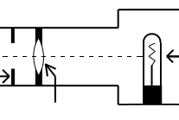

Light microscopes are used to study living cells and for regular use when relatively low magnification and resolution is enough. electron microscopes provide higher magnifications and higher resolution images but cannot be used to view living cells.
There are two main types of light microscopes: compound and stereo microscopes.

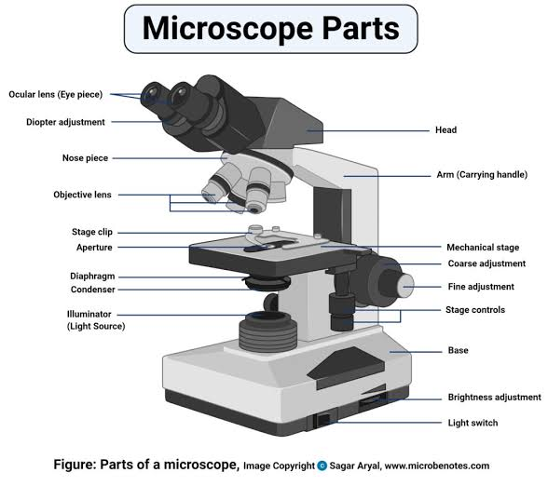

2a.
CENTRIFUGE:
A centrifuge is a piece of equipment that puts and object in rotation around a fixed axis, applying a force perpendicular to the axis of spin that can be very strong.
Principle:
The centrifuge works using a sedimentation principle, where the centrifugal acceleration causes denser substances and particles to move outward in a radical direction. At the same time, objects that are less dense are placed and moved to the center. In a laboratory centrifuge that uses sample tubes, the radial acceleration causes denser particles to settle at the bottom of the tube, while low density substances rise to the top.
Brand:
Ideal midi centrifuge
Refrigerated Centrifuge 5424 R
Frontier™ 5000 Series Multi Pro Powerful and Versatile Universal Centrifuges
The OHAUS Frontier 5306 Centrifuge
Care and maintenance:
Daily care:
Clean both the exterior and the interior of the centrifuge with a sponge, warm water and a mild detergent.
Do not use caustic detergents or a product that contains chlorine ions.
A plastic scrub brush should be used to avoid damaging the coatings.
When finished with the cleaning, you should use a centrifuge lubricant to lubricate the bucket grooves and rubber seals.
Only use approved disinfectants and/or spill kits to disinfect the centrifuge on a regular basis
Check for residue and corrosion on the rotors on a weekly or monthly basis.
Schedule Regular Preventative Maintenance:
Schedule regular preventative maintenance with a trained technician for your centrifuge is vital because it increases the durability and functionality.
Regular preventive maintenance also ensures accurate results and reliable performance
Regular preventive maintenance includes:
Inspection of the physical condition
Inspection of the electrical condition
Cleaning and testing of the centrifuge.
Regular preventive maintenance will not only prevent damage but can also identify damage that has already occurred and repair it before the centrifuge is no longer usable.
Cost:
It cost between 1000$ to 5000$ which is equivalent to 300,000naira to 1.8million naira

AUTOMATIC TISSUE PROCESSOR:
Principle:
Tissue processing is concern with the diffusion of various substances into and out of porous tissues. Diffusion results from the tendency of processing reagents to equalize concentration both inside and outside blocks of tissue.
Brand:
Leica tissue processors, Milestone tissue processors, Leica sample preparation systems, Milestone sample preparation systems, Bio-Optica sample preparation systems, Roche sample preparation systems.
Care and maintenance:
Use a moist cleaning cloth to clean platform, lac- quered instrument surfaces and control panel.
Clean the rims of the glass or aluminum reagent containers and of the paraffin containers.
Tissue processor maintenance is necessary to maintain well processed blocks and well stained tissues. This ensures definite report by the pathologist. The reagent change is crucial to obtain well processed blocks. When usage limit is reached, the yellow triangle alert will appear on the screen. The reagent should be changed before running the next process
Cost:
It ranges from 5950 to 11950$. Equivalent to 212,400 to 4.3million naira

MICROTOME:
It is a sectioning instrument that allows to cutting of extremely thin slices of material know as a section.
Principle:
When tissue is frozen water within the tissue turns to ice and in this state tissue is firm. The ice is acting as an embedding medium used in microscopy.
Brands:
Leica, Thermo Scientific, Breukhoven
Care and maintenance:
Before using your knife, take a lint free facial tissue saturated in either xylene, benzene or acetone to remove the protective oil coating on the knife. Do not use gauze or any other coarse material; it will destroy the edge of the knife
Cost:
The microtome are now available for 6900$ and about 2.5milliom naira

