Name: Ibe Chidumebi Theodora
Matric no: 17/mhs01/141
Course: Gross Anatomy of the head and neck
Date: 7th May, 2020
Assignment: 1. Write an essay on the carvanous sinus
2. Discuss the walls of the nose
1. The cavernous sinus is one of the dural venous sinuses of the head(cranial cavity), creating a cavity called the lateral sellar compartment bordered by the temporal bone of the skull and the sphenoid bone, lateral to the sella turcica. It is a network of veins that sit in a cavity, approximately 1 x 2 cm in size in an adult. The carotid siphon of the internal carotid artery, and cranial nerves III, IV, V (branches V1 and V2) and VI all pass through this blood filled space. It is divided by septa into small ‘caves’ – from which it gets its name.
Each cavernous sinus has a close anatomical relationship with several key structures in the head, and is arguably the most clinically important venous sinus. the anatomy of the cavernous sinus – its location, contents and clinical relevance.

The dural venous sinuses are channels between the two layers of dura mater which are responsible for the venous drainage of the brain, skull, orbit and internal ear. Read more about their anatomy and function here.

Anatomical Location and Borders

The cavernous sinuses are located within the middle cranial fossa, on either side of the sella turcica of the sphenoid bone (which contains the pituitary gland). They are enclosed by the endosteal and meningeal layers of the dura mater.

The borders of the cavernous sinus are as follows:
- Anterior – superior orbital fissure.

- Posterior – petrous part of the temporal bone.

- Medial – body of the sphenoid bone.

- Lateral – meningeal layer of the dura mater running from the roof to the floor of the middle cranial fossa.

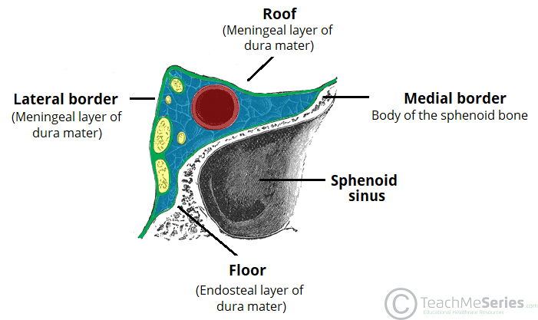

i.Roof – meningeal layer of the dura mater that attaches to the anterior and middle clinoid processes of the sphenoid bone.
ii. Floor – endosteal layer of dura mater that overlies the base of the greater wing of the sphenoid bone.
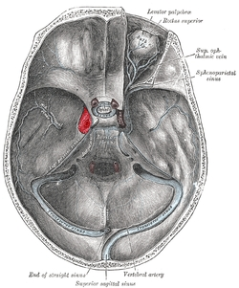

Fig 1 – Coronal section demonstrating the borders of the right cavernous sinus.
Several important structures pass through the cavernous sinus to enter the orbit. The can be sub-classified by whether they travel through the sinus itself, or through its lateral wall:

Travels through cavernous sinus: Travels through lateral wall of cavernous sinus:

Abducens nerve (CN VI)

Carotid plexus (post-ganglionic sympathetic nerve fibres)

Internal carotid artery (cavernous portion)

Oculomotor nerve (CN III)

Trochlear nerve (CN IV)

Ophthalmic (V1) and maxillary (V2) branches of the trigeminal nerve
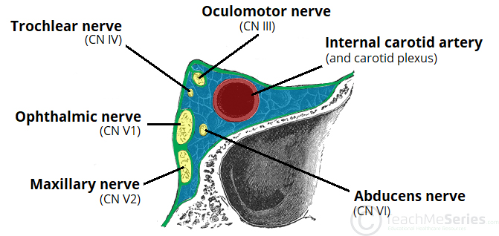

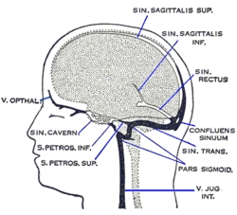
The cavernous sinus is the only site in the body where an artery (internal carotid) passes completely through a venous structure. This is thought to allow for heat exchange between the warm arterial blood and cooler venous circulation.
Fig 2 – Coronal section demonstrating the contents of the right cavernous sinus.

A useful mnemonic to remember the contents and their relation to one another is: O TOM CAT, where OTOM (oculomotor nerve, trochlear nerve, ophthalmic branch, maxillary branch) refers to the lateral wall contents from superior to inferior, and CAT (internal carotid artery, abducens nerve, trochlear nerve) refers to the horizontal contents, from medial to lateral.

Dural Venous Sinus System

Each cavernous sinus receives venous drainage from:

Ophthalmic veins (superior and inferior) – these enter the cavernous sinus via the superior orbital fissure.

Central vein of the retina – drains into the superior ophthalmic vein, or directly into the cavernous sinus.

Sphenoparietal sinus – empties into the anterior aspect of the cavernous sinus.

Superficial middle cerebral vein – contributes to the venous drainage of the cerebrum

Pterygoid plexus – located within the infratemporal fossa.

It is important to note that the superior ophthalmic vein forms an anastomosis with the facial vein. Therefore, the ophthalmic veins represent a potential route by which infection can spread from an extracranial to an intracranial site.

The cavernous sinuses empty into the superior and inferior petrosal sinuses, and ultimately, into the internal jugular vein. The left and right cavernous sinuses are connected in the midline by the anterior and posterior intercavernous sinuses. They travel through the sella turcica of the sphenoid bone.
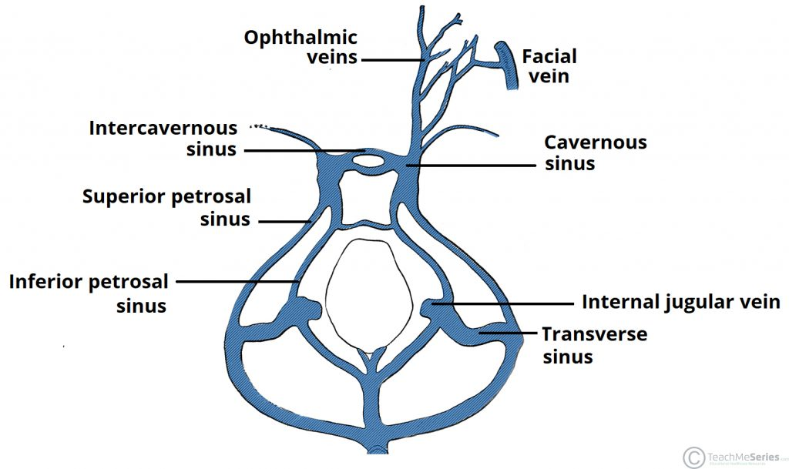

Fig 3 – Schematic of the dural venous system relating to the cavernous sinus. Note the anastomosis between the ophthalmic veins and the facial vein.

Clinical Significance - Cavernous Sinus Thrombosis

- Cavernous sinus thrombosis (CST) refers to the formation of a clot within the cavernous sinus.

This most common cause of CST is infection; which typically spreads from an extracranial location such as the orbit, paranasal sinuses, or the ‘danger zone’ of the face. Infection is able to spread in this manner due to the anastomosis between the facial vein and superior ophthalmic veins.

Common clinical features include headache, unilateral periorbital oedema, proptosis (eye bulging), photophobia and cranial nerve palsies. The abducens nerve (CN VI) is most commonly affected.

Treatment is typically with antibiotic therapy. Where the cause is infection, thrombosis of the carvanous sinus can rapidly progress to meningitis.

2. The wall of the nose
The human nose is the most protruding part of the face. It bears the nostrils and is the first organ of the respiratory system. It is also the principal organ in the olfactory system. The shape of the nose is determined by the nasal bones and the nasal cartilages, including the nasal septum which separates the nostrils and divides the nasal cavity into two. On average the nose of a male is larger than that of a female.

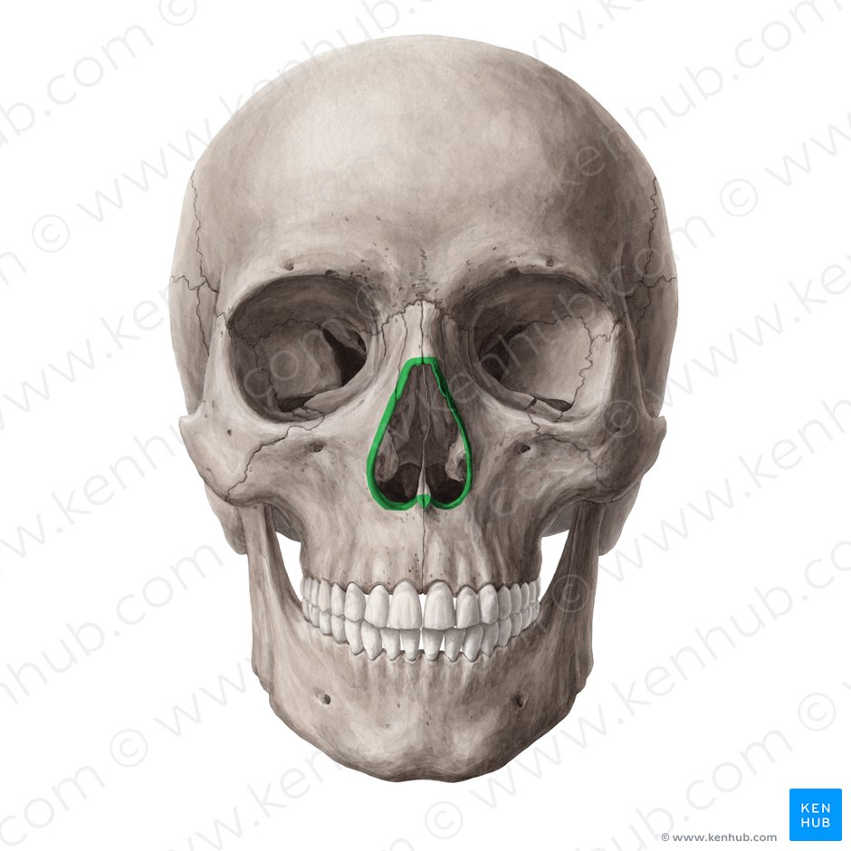
The main function of the nose is breathing, and the nasal mucosa lining the nasal cavity and the paranasal sinuses carries out the necessary conditioning of inhaled air by warming and moistening it. Nasal conchae, shell-like bones in the walls of the cavities, play a major part in this process. Filtering of the air by nasal hair in the nostrils prevents large particles from entering the lungs. Sneezing is a reflex to expel unwanted particles from the nose that irritate the mucosal lining. Sneezing can transmit infections, because aerosols are created in which the droplets can harbour pathogens.

Another major function of the nose is olfaction, the sense of smell. The area of olfactory epithelium, in the upper nasal cavity, contains specialised olfactory cells responsible for this function.

The nose is also involved in the function of speech. Nasal vowels and nasal consonants are produced in the process of nasalisation. The hollow cavities of the paranasal sinuses act as sound chambers that modify and amplify speech and other vocal sounds.

There are many plastic surgery procedures on the nose, known as rhinoplasties available to correct various structural defects or to change the shape of the nose. Defects may be congenital, or result from nasal disorders or from trauma. These procedures are a type of reconstructive surgery. Elective procedures to change a nose shape are a type of cosmetic surgery.
Lateral wall of the nasal cavity
The lateral wall of the nasal cavity is a region of the nasopharynx essential for humidifying and filtering the air we breathe in nasally.
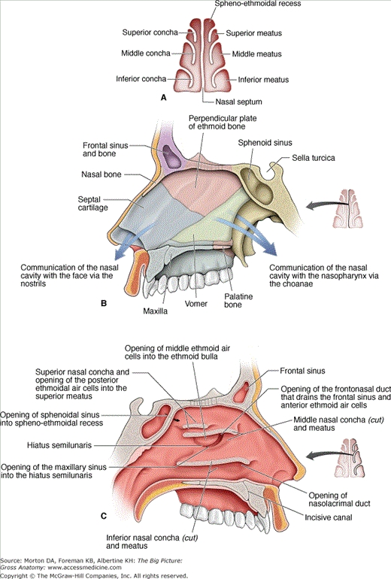
Here we can find a structure called agger nasi. The agger nasi is also referred to as the ‘nasoturbinal concha’ or ‘nasal ridge.’ It can be described as a small mound or ridge found in the lateral side of the nasal cavity. The structure is located midway along the anterior aspect of the middle nasal concha. An abnormally enlarged form may restrict the drainage of the frontal sinus by obstructing the frontal recess area.

Nasal septum
- Cartilages: lesser alar cartilages, greater alar cartilages, lateral nasal cartilages

- Bones: anterior nasal aperture (piriform aperture) formed by maxilla and nasal bones

Nasal conchae

- Superior nasal concha

- Middle nasal concha

- Inferior nasal concha

Bony framework of the nasal cavity

Ethmoid bone

Frontal bone

Lacrimal bone

Nasal bones

Palatine bones

Sphenoid bone

Nasal septum

Bones and cartilages

Nasal conchae

Associated structures

Nasal skeleton

Bones and cartilages

The anterior nasal aperture is simply the area where the anterior bony aspects of both the maxilla and the nasal bone terminate and form an opening into the cartilaginous nasal vestibule. The structure is also referred to as the piriform aperture.

Three cartilages contribute to the nasal septum:

lesser alar cartilages are paired cartilages suspended in the fibro-fatty tissue that forms the lateral aspect of the nostril. The structures lie free from the other cartilages and provide the nostril with stability and form.

greater alar cartilages are paired cartilages that form part of the antero-superior nostril as well as the nasal tip. The structures give the tip of the nose stability and flexibility and are a crucial element of the cartilaginous apparatus of the nose.

lateral nasal cartilages are structures that articulate inferiorly with the greater alar cartilages and superiorly with the anterior nasal aperture formed by both the nasal bone superiorly and for a short part of its border with the perpendicular plate of the ethmoid bone. These structures form the cartilaginous part of the bridge of the nose and form in conjunction with the greater alar cartilages, the major structural appearance of the nose.

Nasal conchae

3 types of nasal conchae in the nasal cavity. Those are:

- Inferior nasal concha. It is the longest and broadest of the conchae and is formed by an independent bone (of the same name, inferior concha). The concha is covered by a mucous membrane that contains large vascular spaces and is one of the three that work to both humidify and clear the air that passes into the nasopharynx.

- Superior and middle nasal conchae arise from the perpendicular plate of the ethmoid bone. The middle nasal concha is found in between the superior and inferior nasal concha and plays a role in humidifying and clearing inspired air of micro-particles such as dirt. The superior nasal concha is a bony shelf located above the middle nasal concha and below the sphenoethmoidal recess. Similar to the middle nasal concha the superior concha is itself part of the ethmoid bone.

Associated structures

The nasal surface of the maxilla forms the antero-lateral part of the bony nasal cavity. It is located inferior to the nasal bone and gives rise in part, to the inferior nasal concha. The sphenopalatine foramen is found in the posterior most region of the nasal cavity, at the back of the middle meatus. The foramen is formed by the processes on the superior border of the palatine bone, and the under surface of the sphenoidal body, which form a foramen. It connects the nasal cavity to the pterygopalatine fossa, and thus transmits the sphenopalatine artery and vein as well as the superior nasal and nasopalatine nerves.

The medial plate of the pterygoid process is an inferior projection of the sphenoid bone. The plate forms a laterally pointing hook like process at its most inferior point, known as the pterygoid halums. The tensor veli palatine muscle glides around this structure. The lateral surface of the medial plate forms the medial border of the pterygoid fossa, and the medial surface forms the lateral boundary of the choana of the adjacent nasal cavity.

The limen nasi is approximately 10mm in length and is defined as the boundary between the nasal cavity proper and the vestibule. It is relatively wide and superficial anteriorly but gradually narrows as it extends posteriorly towards the anterior region of the middle concha. It lies upon the upper edge of the lateral crus of the greater alar cartilage and detached pieces of cartilage may take part in its formation.

The inferior nasal meatus lies beneath the inferior nasal concha and the lateral nasal wall. It is broader in front than behind and extends the entire length of the lateral wall of the nose and the anterior third contains the termination of the nasolacrimal or ‘tear’duct. This opening is covered by a mucosal valve known as Hassner’s valve. The middle nasal meatus is located above the inferior and below the middle nasal concha. It is also part of the ethmoidal complex as it drains the maxillary, frontal and anterior ethmoidal sinuses. The superior meatus is located below the superior nasal concha and drains the posterior ethmoidal air cells.

The sphenoethmoidal recess is a small cleft like pocket located above the superior nasal concha and drains the sphenoid sinus. The sphenoethmoidal recess is a space found superior to the superior turbinate bone and drains the sphenoidal sinus as well as some of the ethmoidal sinuses. The frontal sinuses are situated between the brow ridges and lie between the two layers of the frontal bone. They are unlikely to be symmetrical and are not usually involved in sinusitis.

The sphenoidal sinus is contained within the body of the sphenoid bone itself. There is a great deal of variation in the shape and size of this sinus between individuals. The sinus drains into the sphenoethmoidal recess which is located superior to the choana. The main expansion of their size occurs during puberty and they perform a similar function to the other sinuses.

The nasal vestibule is the visible part of the internal nasal cavity from an external view. The vestibule is maintained by the greater and lesser alar cartilages and contains small hairs which trap dirt and small particles during inspiration. The vestibules are lined by stratified squamous epithelium, and are separate from the nasal cavity proper, which is lined with respiratory epithelium.

Nasal skeleton

Ethmoid bone

The ethmoid bone is located on the roof of the nose between the two orbits and is lightweight and spongy. It has three parts:

- cribriform plate which is pierced by fibres of the olfactory nerve;

- ethmoidal labyrinth which consists of numerous thin walled hollow cavities;

- perpendicular plate which forms part of the posterior nasal septum and gives rise to the superior and middle nasal conchae.

The bone articulates with many others including the frontal and sphenoid bone as part of the neurocranium, and the nasal and lacrimal bones anteriorly as well as the maxilla inferolaterally and the vomer and inferior nasal concha inferiorly. The bone also forms the deep medial part of the orbit.

Frontal bone

The frontal bone overlies the frontal lobe of the brain and lies anteriorly forming the brow, forehead and one third of the anterior scalp. The bone contains the frontal sinus, which in sinusitis and nasal infections can become filled with fluid. The bone articulates with the bones forming the calvaria as well as the zygomatic bone inferolaterally and the nasal and maxilla bones anteroinferiorly.

Bones of the nasal cavity - sagittal section showing lateral wall

Lacrimal bone

The lacrimal bone is the smallest bone of the face and forms part of the posterior nasal skeleton. The bone has a crest known as the ‘sulcus lacrimalis’ on its lateral surface. This crest gives rise to the aptly named lacrimal part of the orbicularis oculi muscle.

The anterior inner margin of the bone articulates with the frontal process of the maxilla and the upper part of the fossa contains the lacrimal sac, which drains into the nasolacrimal duct. The superior portion articulates with the frontal bone. The inferior border of the bone is divided by the lower edge of the posterior lacrimal crest into an anterior and posterior part. The posterior articulates with the orbital plate of the maxilla, and the anterior extends through a descending process which forms part of the canal for the nasolacrimal duct as well as articulating with the lacrimal process of the inferior nasal concha. The posterior portion of the bone is smooth and forms part of the medial wall of the orbit.

Nasal bones

The paired nasal bones form the bridge of the nose and with the frontal process of the maxilla laterally and the nasal process of the frontal bone superiorly. The inner surface is grooved by the passage of the nasociliary nerve.

The surface of the bone is convex anteriorly and is covered by both the compressor naris and procerus muscle. The bone articulates distally with the cartilages of the nose, namely the lateral cartilages and inferiorly with the quadrangular cartilage of the nasal septum in the midline. It also articulates posteroinferiorly in the midline with the perpendicular plate of the ethmoid bone.

Palatine bones

The palatine bones are paired ‘L’ shaped bones consisting of a perpendicular and horizontal plate. They are situated at the posterior part of the nasal cavity between the pterygoid process of the maxilla and the sphenoid.

Three protruding processes can also be found, namely the pyramidal process directed posterolaterally which can be found between the two parts and the orbital and sphenoidal processes.

The bones form the posterior part of the hard palate and form the floor of the nasal cavity and articulate with the maxillae anteriorly. The greater and lesser palatine foramina transmit the greater and lesser palatine nerves and blood vessels respectively. The greater palatine foramen is larger and more lateral than the lesser.

Sphenoid bone

The sphenoid bone is a wedge-like, complex bone with many articulations. It is one of the seven bones to form the orbit and also forms part of the mid lateral surface of the skull , anterior to the temporal bone. The bone forms the floor of the middle cranial fossa and contains numerous foramina for the passage of cranial nerves. The median portion of the bone contains the sella turcica or ‘Turkish saddle’ which resembles a four poster bed with its paired anterior and posterior clinoid processes. The pituitary gland sits in the sella turcica. In life, a layer of dura covers this space and its contents. The bone also possesses two greater and two lesser wings. The greater wings curve backward and laterally to articulate with the petrous portion of the temporal bone. The orbital surface of the great wings forms the lateral wall of the orbit.

The superior surface contains many foramina including which transmit different nerves and blood vessel:

superior orbital fissure which transmits the oculomotor nerve; trochlear and abducens nerves; and V1 (ophthalmic) branch of the trigeminal nerve.

optic canal transmits the optic nerve.

foramen rotundum found below the fissure transmits V2 (maxillary nerve) branch of the trigeminal nerve.

foramen ovale transmits V3 (mandibular nerve) branch of the trigeminal nerve.

foramen spinosum found posterolaterally like the point on an exclamation mark, allows entry of the middle meningeal artery (a branch of the maxillary artery which is the seventh branch of the external carotid artery).

The three branches of the trigeminal nerve branch at the trigeminal ganglion in the ‘Meckel’s cave’ found on the ridge of the middle and posterior cranial fossae. Dura covers the cavernous sinus, which contains the internal carotid artery travelling forwards as well as cranial nerves 3, 4, v1, v2 and 6. The region of the greater wing that extends from the body to the spine provides in its medial half the anterior margin of the foramen lacerum.

Clinical notes

Sinusitis

Sinusitis is an inflammation of the different sinuses found in the head. That type of inflammation may result in different symptoms including:

- plugged nose;

- nasal mucus;

- and pain in the facial region.

When we talked about the frontal bone we saw that it overlies the frontal lobe of the brain and lies anteriorly forming the brow, forehead and one third of the anterior scalp. The bone contains the frontal sinus, which in sinusitis and nasal infections can become filled with fluid.

