MATRIC NUMBER: 16/MHS06/055
COURSE CODE: MLS 410
COURSE TITLE: BIOMEDICAL ENGINEERING

QUESTION 1.
Physics of light microscope.
ANSWER.
Microscopes were first developed in the early 1600s by eyeglass makers in The Netherlands and Denmark. The simplest compound microscope is constructed from two convex lenses as shown schematically in Figure 2. The first lens is called the objective lens, and has typical magnification values from 5× to 100×. In standard microscopes, the objectives are mounted such that when you switch between objectives, the sample remains in focus. Objectives arranged in this way are described as parfocal. The second, the eyepiece, also referred to as the ocular, has several lenses which slide inside a cylindrical barrel. The focusing ability is provided by the movement of both the objective lens and the eyepiece. The purpose of a microscope is to magnify small objects, and both lenses contribute to the final magnification. Additionally, the final enlarged image is produced in a location far enough from the observer to be easily viewed, since the eye cannot focus on objects or images that are too close.
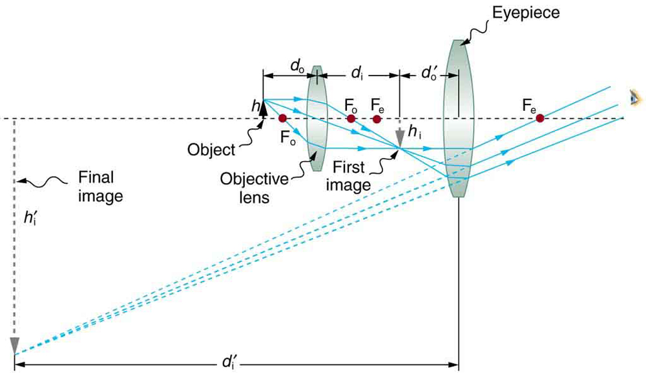
Figure 2. A compound microscope composed of two lenses, an objective and an eyepiece. The objective forms a case 1 image that is larger than the object. This first image is the object for the eyepiece. The eyepiece forms a case 2 final image that is further magnified.
To see how the microscope in Figure 2 forms an image, we consider its two lenses in succession. The object is slightly farther away from the objective lens than its focal length f_{o}, producing a case 1 image that is larger than the object. This first image is the object for the second lens, or eyepiece. The eyepiece is intentionally located so it can further magnify the image. The eyepiece is placed so that the first image is closer to it than its focal length f_{e}. Thus the eyepiece acts as a magnifying glass, and the final image is made even larger. The final image remains inverted, but it is farther from the observer, making it easy to view (the eye is most relaxed when viewing distant objects and normally cannot focus closer than 25 cm). Since each lens produces a magnification that multiplies the height of the image, it is apparent that the overall magnification m is the product of the individual magnifications: m = m_{o}m_{e}, where m_{o} is the magnification of the objective and m_{e} is the magnification of the eyepiece. This equation can be generalized for any combination of thin lenses and mirrors that obey the thin lens equations.
LIGHT MICROSCOPE.
A light microscope (LM) is an instrument that uses visible light and magnifying lenses to examine small objects not visible to the naked eye, or in finer detail than the naked eye allows. The light microscope is an important tool in the study of microorganisms, particularly for identification purposes. The compound light microscope uses visible light to directly illuminate specimens in a two-lens system, resulting in the illuminated specimen appearing dark against a bright background. The two lenses present in a compound microscope are the ocular lens in the eyepiece and the objective lens located in the revolving nosepiece. Compound light microscopes typically have the following components;
DIAGRAM OF A LIGHT MICROSCOPE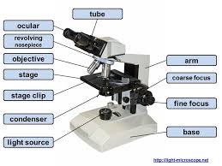
PARTS OF LIGHT MICROSCOPE.
1. Illuminator: the light source in the base of the microscope
2. Abbe Condenser: a two lens system that collects and concentrates light from the illuminator and directs it to the iris diaphragm
3. Iris diaphragm: regulates the amount of light entering the lens system
4.Mechanical stage: a platform used to place the slide on which has a hole in the center to let light from the illuminator pass through. Often contains stage clips to hold the slide in place
5. Body tube: houses the lens system that magnifies the specimens
6. Upper end of body tube—oculars/eye pieces: what you view through
7. Lower end of body tube—nose-piece: revolves and contains the objectives.
Essentially, a light microscope magnifies small objects and makes them visible. The science of microscopy is based on the following concepts and principles:
- Magnification is simply the enlargement of the specimen. In a compound lens system, each lens sequentially enlarges or magnifies the specimen
- The objective lens magnifies the specimen, producing a real image that is then magnified by the ocular lens resulting in the final image
- The total magnification can be calculated by multiplying the objective lens value by the ocular lens value.
Principle.
The light microscope is an instrument for visualizing fine detail of an object. It does this by creating a magnified image through the use of a series of glass lenses, which first focus a beam of light onto or through an object, and convex objective lenses to enlarge(magnify) the image.
An image of the object (specimen) is formed by the objective lens, which typically provides a magnification in the range 10x to 100x. This magnified image is then viewed through the eyepiece (ocular) whose magnification is usually 10x.
LIGHT MICROSCOPY.
Many types of microscopes fall under the category of light microscopes, which use light to visualize images. Examples of light microscopes include brightfield microscopes, darkfield microscopes, phase-contrast microscopes, differential interference contrast microscopes, fluorescence microscopes, confocal scanning laser microscopes, and two-photon microscopes. These various types of light microscopes can be used to complement each other in diagnostics and research.

Brightfield Microscopes
The brightfield microscope, perhaps the most commonly used type of microscope, is a compound microscope with two or more lenses that produce a dark image on a bright background. Some brightfield microscopes are monocular (having a single eyepiece), though most newer brightfield microscopes are binocular (having two eyepieces), like the one shown in Figure 1; in either case, each eyepiece contains a lens called an ocular lens. The ocular lenses typically magnify images 10 times (10×). At the other end of the body tube are a set of objective lenses on a rotating nosepiece. The magnification of these objective lenses typically ranges from 4× to 100×, with the magnification for each lens designated on the metal casing of the lens. The ocular and objective lenses work together to create a magnified image. The total magnification is the product of the ocular magnification times the objective magnification.
Darkfield Microscopy
A darkfield microscope is a brightfield microscope that has a small but significant modification to the condenser. A small, opaque disk (about 1 cm in diameter) is placed between the illuminator and the condenser lens. This opaque light stop, as the disk is called, blocks most of the light from the illuminator as it passes through the condenser on its way to the objective lens, producing a hollow cone of light that is focused on the specimen. The only light that reaches the objective is light that has been refracted or reflected by structures in the specimen. The resulting image typically shows bright objects on a dark background. Darkfield microscopy can often create high-contrast, high-resolution images of specimens without the use of stains, which is particularly useful for viewing live specimens that might be killed or otherwise compromised by the stains. For example, thin spirochetes like Treponema pallidum, the causative agent of syphilis, can be best viewed using a darkfield microscope.

Phase-Contrast Microscopes
Phase-contrast microscopes use refraction and interference caused by structures in a specimen to create high-contrast, high-resolution images without staining. It is the oldest and simplest type of microscope that creates an image by altering the wavelengths of light rays passing through the specimen. To create altered wavelength paths, an annular stop is used in the condenser. The annular stop produces a hollow cone of light that is focused on the specimen before reaching the objective lens. The objective contains a phase plate containing a phase ring. As a result, light traveling directly from the illuminator passes through the phase ring while light refracted or reflected by the specimen passes through the plate. This causes waves traveling through the ring to be about one-half of a wavelength out of phase with those passing through the plate. Because waves have peaks and troughs, they can add together (if in phase together) or cancel each other out (if out of phase). When the wavelengths are out of phase, wave troughs will cancel out wave peaks, which is called destructive interference. Structures that refract light then appear dark against a bright background of only unrefracted light. More generally, structures that differ in features such as refractive index will differ in levels of darkness. Because it increases contrast without requiring stains, phase-contrast microscopy is often used to observe live specimens. Certain structures, such as organelles in eukaryotic cells and endospores in prokaryotic cells, are especially well visualized with phase-contrast microscopy.

Differential Interference Contrast Microscopes
Differential interference contrast (DIC) microscopes (also known as Nomarski optics) are similar to phase-contrast microscopes in that they use interference patterns to enhance contrast between different features of a specimen. In a DIC microscope, two beams of light are created in which the direction of wave movement (polarization) differs. Once the beams pass through either the specimen or specimen-free space, they are recombined and effects of the specimens cause differences in the interference patterns generated by the combining of the beams. This results in high-contrast images of living organisms with a three-dimensional appearance. These microscopes are especially useful in distinguishing structures within live, unstained specimens.

Fluorescence Microscopes
A fluorescence microscope uses fluorescent chromophores called fluorochromes, which are capable of absorbing energy from a light source and then emitting this energy as visible light. Fluorochromes include naturally fluorescent substances (such as chlorophylls) as well as fluorescent stains that are added to the specimen to create contrast. Dyes such as Texas red and FITC are examples of fluorochromes. Other examples include the nucleic acid dyes 4′,6′-diamidino-2-phenylindole (DAPI) and acridine orange.
The microscope transmits an excitation light, generally a form of EMR with a short wavelength, such as ultraviolet or blue light, toward the specimen; the chromophores absorb the excitation light and emit visible light with longer wavelengths. The excitation light is then filtered out (in part because ultraviolet light is harmful to the eyes) so that only visible light passes through the ocular lens. This produces an image of the specimen in bright colors against a dark background.
Fluorescence microscopes are especially useful in clinical microbiology. They can be used to identify pathogens, to find particular species within an environment, or to find the locations of particular molecules and structures within a cell. Approaches have also been developed to distinguish living from dead cells using fluorescence microscopy based upon whether they take up particular fluorochromes. Sometimes, multiple fluorochromes are used on the same specimen to show different structures or features.
One of the most important applications of fluorescence microscopy is a technique called immunofluorescence, which is used to identify certain disease-causing microbes by observing whether antibodies bind to them. (Antibodies are protein molecules produced by the immune system that attach to specific pathogens to kill or inhibit them.) There are two approaches to this technique: direct immunofluorescence assay (DFA) and indirect immunofluorescence assay (IFA). In DFA, specific antibodies (e.g., those that the target the rabies virus) are stained with a fluorochrome. If the specimen contains the targeted pathogen, one can observe the antibodies binding to the pathogen under the fluorescent microscope. This is called a primary antibody stain because the stained antibodies attach directly to the pathogen.
In IFA, secondary antibodies are stained with a fluorochrome rather than primary antibodies. Secondary antibodies do not attach directly to the pathogen, but they do bind to primary antibodies. When the unstained primary antibodies bind to the pathogen, the fluorescent secondary antibodies can be observed binding to the primary antibodies. Thus, the secondary antibodies are attached indirectly to the pathogen. Since multiple secondary antibodies can often attach to a primary antibody, IFA increases the number of fluorescent antibodies attached to the specimen, making it easier visualize features in the specimen.

Confocal Microscopes
Whereas other forms of light microscopy create an image that is maximally focused at a single distance from the observer (the depth, or z-plane), a confocal microscope uses a laser to scan multiple z-planes successively. This produces numerous two-dimensional, high-resolution images at various depths, which can be constructed into a three-dimensional image by a computer. As with fluorescence microscopes, fluorescent stains are generally used to increase contrast and resolution. Image clarity is further enhanced by a narrow aperture that eliminates any light that is not from the z-plane. Confocal microscopes are thus very useful for examining thick specimens such as biofilms, which can be examined alive and unfixed.

Two-Photon Microscopes
While the original fluorescent and confocal microscopes allowed better visualization of unique features in specimens, there were still problems that prevented optimum visualization. The effective sensitivity of fluorescence microscopy when viewing thick specimens was generally limited by out-of-focus flare, which resulted in poor resolution. This limitation was greatly reduced in the confocal microscope through the use of a confocal pinhole to reject out-of-focus background fluorescence with thin (<1 μm), unblurred optical sections. However, even the confocal microscopes lacked the resolution needed for viewing thick tissue samples. These problems were resolved with the development of the two-photon microscope, which uses a scanning technique, fluorochromes, and long-wavelength light (such as infrared) to visualize specimens. The low energy associated with the long-wavelength light means that two photons must strike a location at the same time to excite the fluorochrome. The low energy of the excitation light is less damaging to cells, and the long wavelength of the excitation light more easily penetrates deep into thick specimens. This makes the two-photon microscope useful for examining living cells within intact tissues—brain slices, embryos, whole organs, and even entire animals.
Currently, use of two-photon microscopes is limited to advanced clinical and research laboratories because of the high costs of the instruments. A single two-photon microscope typically costs between $300,000 and $500,000, and the lasers used to excite the dyes used on specimens are also very expensive. However, as technology improves, two-photon microscopes may become more readily available in clinical settings.

Electron Microscopy
The maximum theoretical resolution of images created by light microscopes is ultimately limited by the wavelengths of visible light. Most light microscopes can only magnify 1000×, and a few can magnify up to 1500×, but this does not begin to approach the magnifying power of an electron microscope (EM), which uses short-wavelength electron beams rather than light to increase magnification and resolution.
Electrons, like electromagnetic radiation, can behave as waves, but with wavelengths of 0.005 nm, they can produce much better resolution than visible light. An EM can produce a sharp image that is magnified up to 100,000×. Thus, EMs can resolve subcellular structures as well as some molecular structures (e.g., single strands of DNA); however, electron microscopy cannot be used on living material because of the methods needed to prepare the specimens.
There are two basic types of EM: the transmission electron microscope (TEM) and the scanning electron microscope (SEM) (Figure 10). The TEM is somewhat analogous to the brightfield light microscope in terms of the way it functions. However, it uses an electron beam from above the specimen that is focused using a magnetic lens (rather than a glass lens) and projected through the specimen onto a detector. Electrons pass through the specimen, and then the detector captures the image (Figure 11).
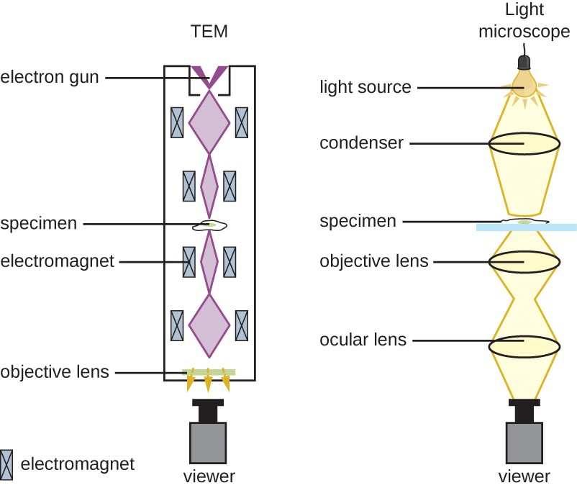

Figure 11. Electron microscopes use magnets to focus electron beams similarly to the way that light microscopes use lenses to focus light.
For electrons to pass through the specimen in a TEM, the specimen must be extremely thin (20–100 nm thick). The image is produced because of varying opacity in various parts of the specimen. This opacity can be enhanced by staining the specimen with materials such as heavy metals, which are electron dense. TEM requires that the beam and specimen be in a vacuum and that the specimen be very thin and dehydrated. The specific steps needed to prepare a specimen for observation under an EM are discussed in detail in the next section.
SEMs form images of surfaces of specimens, usually from electrons that are knocked off of specimens by a beam of electrons. This can create highly detailed images with a three-dimensional appearance that are displayed on a monitor (Figure 12).
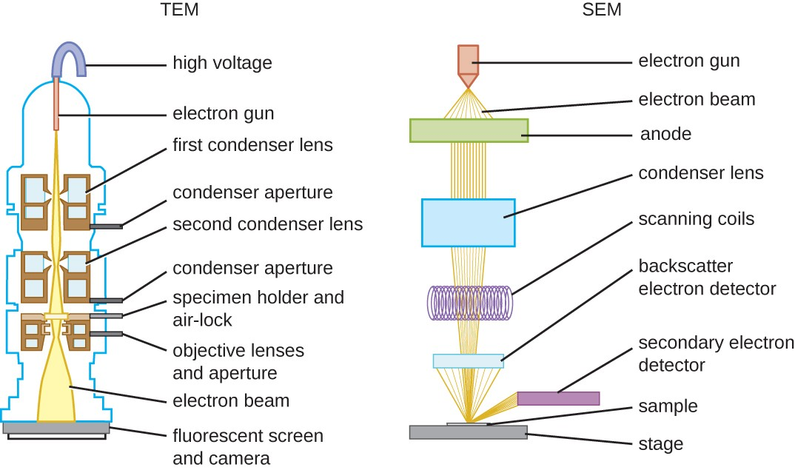
Figure 12. These schematic illustrations compare the components of transmission electron microscopes and scanning electron microscopes.
Typically, specimens are dried and prepared with fixatives that reduce artifacts, such as shriveling, that can be produced by drying, before being sputter-coated with a thin layer of metal such as gold. Whereas transmission electron microscopy requires very thin sections and allows one to see internal structures such as organelles and the interior of membranes, scanning electron microscopy can be used to view the surfaces of larger objects (such as a pollen grain) as well as the surfaces of very small samples (Figure 13). Some EMs can magnify an image up to 2,000,000×.

Scanning Probe Microscopy
A scanning probe microscope does not use light or electrons, but rather very sharp probes that are passed over the surface of the specimen and interact with it directly. This produces information that can be assembled into images with magnifications up to 100,000,000×. Such large magnifications can be used to observe individual atoms on surfaces. To date, these techniques have been used primarily for research rather than for diagnostics.
There are two types of scanning probe microscope: the scanning tunneling microscope (STM) and the atomic force microscope (AFM). An STM uses a probe that is passed just above the specimen as a constant voltage bias creates the potential for an electric current between the probe and the specimen. This current occurs via quantum tunneling of electrons between the probe and the specimen, and the intensity of the current is dependent upon the distance between the probe and the specimen. The probe is moved horizontally above the surface and the intensity of the current is measured. Scanning tunneling microscopy can effectively map the structure of surfaces at a resolution at which individual atoms can be detected.
Similar to an STM, AFMs have a thin probe that is passed just above the specimen. However, rather than measuring variations in the current at a constant height above the specimen, an AFM establishes a constant current and measures variation in the height of the probe tip as it passes over the specimen. As the probe tip is passed over the specimen, forces between the atoms (van der Waals forces, capillary forces, chemical bonding, electrostatic forces, and others) cause it to move up and down. Deflection of the probe tip is determined and measured using Hooke’s law of elasticity, and this information is used to construct images of the surface of the specimen with resolution at the atomic level.
The item being viewed is called a specimen. The specimen is placed on a glass slide, which is then clipped into place on the stage (a platform) of the microscope. Once the slide is secured, the specimen on the slide is positioned over the light using the x-y mechanical stage knobs. These knobs move the slide on the surface of the stage, but do not raise or lower the stage. Once the specimen is centered over the light, the stage position can be raised or lowered to focus the image. The coarse focusing knob is used for large-scale movements with 4× and 10× objective lenses; the fine focusing knob is used for small-scale movements, especially with 40× or 100× objective lenses.
When images are magnified, they become dimmer because there is less light per unit area of image. Highly magnified images produced by microscopes, therefore, require intense lighting. In a brightfield microscope, this light is provided by an illuminator, which is typically a high-intensity bulb below the stage. Light from the illuminator passes up through condenser lens (located below the stage), which focuses all of the light rays on the specimen to maximize illumination. The position of the condenser can be optimized using the attached condenser focus knob; once the optimal distance is established, the condenser should not be moved to adjust the brightness. If less-than-maximal light levels are needed, the amount of light striking the specimen can be easily adjusted by opening or closing a diaphragm between the condenser and the specimen. In some cases, brightness can also be adjusted using the rheostat, a dimmer switch that controls the intensity of the illuminator.
A brightfield microscope creates an image by directing light from the illuminator at the specimen; this light is differentially transmitted, absorbed, reflected, or refracted by different structures. Different colors can behave differently as they interact with chromophores (pigments that absorb and reflect particular wavelengths of light) in parts of the specimen. Often, chromophores are artificially added to the specimen using stains, which serve to increase contrast and resolution. In general, structures in the specimen will appear darker, to various extents, than the bright background, creating maximally sharp images at magnifications up to about 1000×. Further magnification would create a larger image, but without increased resolution. This allows us to see objects as small as bacteria, which are visible at about 400× or so, but not smaller objects such as viruses.
At very high magnifications, resolution may be compromised when light passes through the small amount of air between the specimen and the lens. This is due to the large difference between the refractive indices of air and glass; the air scatters the light rays before they can be focused by the lens. To solve this problem, a drop of oil can be used to fill the space between the specimen and an oil immersion lens, a special lens designed to be used with immersion oils. Since the oil has a refractive index very similar to that of glass, it increases the maximum angle at which light leaving the specimen can strike the lens. This increases the light collected and, thus, the resolution of the image (Figure 2). A variety of oils can be used for different types of light.

Question 2.
Write note on the different biomedical equipment, including its principle, brand, care, maintenance and cost of the following;
- Centrifuge
- Automatic tissue processor
- Microtome
Answer.
- CENTRIFUGE
A centrifuge is a laboratory device that is used for the separation of fluids, gas or liquid, based on density. Separation is achieved by spinning a vessel containing material at high speed; the centrifugal force pushes heavier materials to the outside of the vessel. This apparatus is found in most laboratories from academic to clinical to research and used to purify cells, subcellular organelles, viruses, proteins, and nucleic acids. There are multiple types of centrifuge, which can be classified by intended use or by rotor design. From the large floor variety to the micro-centrifuge, there are many varieties available for the researcher.
Centrifugation is the use of centrifugal force for the sedimentation of heterogeneous mixtures with a centrifuge.

Centrifuge Categories:
Benchtop Centrifuges are a broad class of centrifuges characterized by their small bench space footprint. Depending on the research need, a variety of different aspects can be considered. Maximum speed in RCFs can range from as low as a few hundred to over 50,000 x g. Tube volumes can range from under 1 mL (such as with PCR tubes) to a few liters. Different types of rotors such as fixed angle, swinging bucket, and continuous flow are also typically interchangeable.
Refrigerated benchtop centrifuge are compact instruments ideal for centrifugation of samples that may be temperature sensitive, such as live cells, animals or proteins. Many feature interchangeable rotors and adaptors to accommodate a wide range of sample volumes from under 1 mL to a few liters. Speeds can also vary, and some models can reach up to 60,000 x g.
Clinical benchtop centrifuge are compact, low-speed centrifuges ideal for the separation of whole blood components, such as serum, plasma, buffy coat, red blood cells, as well as other bodily fluids. Their speeds may range between around 200 rpm to 6,000 rpm. Most clinical centrifuges can accommodate common blood draw tubes, but be sure to check with each vendor for specific tube sizes or tube adaptors.
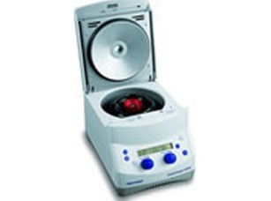Microcentrifuges are staple instruments in many research laboratories that generally accommodate small tube volumes such as 2 mL, 1.5 mL, 0.5 mL and PCR tubes. Microcentrifuges for routine laboratory procedures typically spin at speeds up to 16,000 x g, while more specialized instruments can reach speeds up to 30,000 x g. In addition, manufacturers may also offer interchangeable rotors and tube adaptors when compared with variety of different ambient temperature centrifuges and refrigerated micro centrifuge.
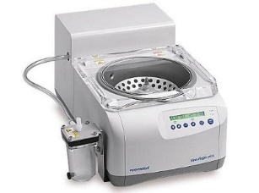Vacuum Centrifuges/concentrator can use vacuum, centrifugal force, temperature and/or gas to remove liquid solvent for the concentration or desiccation of samples. This instrument is ideal for purification or preparation of samples such as nucleic acids, proteins, peptides, and other compounds for a variety of research applications. For evaporation of solvents, vacuum centrifuges typically utilize built in heating systems.
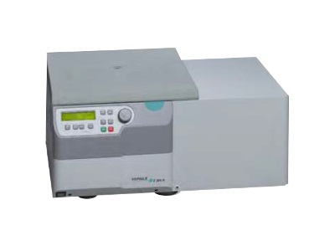
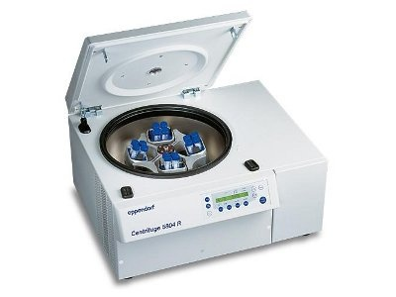
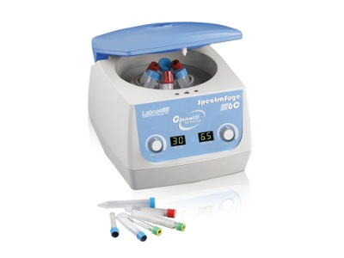
PRINCIPLE OF A CENTRIFUGE.
A centrifuge uses the principle of centrifugation. The centrifuge works using the sedimentation principle, where the centrifugal acceleration causes denser substances and particles to move to the bottom and lighter particles which are less dense to stay at the top when centrifugal machine rotates at high speed.
Brands of centrifuge.
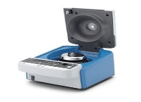LABORATORY CENTRIFUGE / BENCHTOP / HIGH-PERFORMANCEIKA G-L
Speed: 800 rpm - 15,700 rpm
Separating substances at medium rotational speeds: IKA G-L is the ideal midi centrifuge for all types of separation processes such as those found in molecular biology. It can be used with standard 1.5/2 ml vessels.
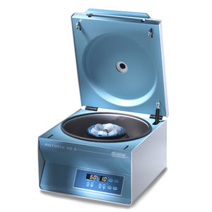LABORATORY CENTRIFUGE / MEDICAL / BENCHTOP / HIGH-PERFORMANCEROTOFIX 32 A
Speed: 0 rpm - 6,000 rpm
... decades, the ROTOFIX 32 A has set the standard in daily lab routine thanks to its versatility and solid construction. The benchtop centrifuge spins sample volumes up to 6 x 94 ml, 40 blood collection.

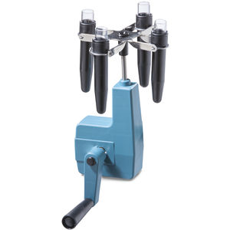LABORATORY CENTRIFUGE / BENCHTOP / MANUAL1011LABORATORY CENTRIFUGE
Speed: 0 rpm - 3,000 rpm
MANUAL CENTRIFUGE OPERATE INDEPENDENTLY ANYWHERE The adaptable manual centrifuge can be simply clamped to any benchtop, with no need for electricity. Its self-lubricating drive system.

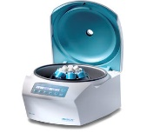LABORATORY CENTRIFUGE / BENCHTOPEBA 280 | 280 S
Speed: 0 rpm - 6,000 rpm
SIMPLE ROTOR CHANGE FOR GREATER VERSATILITY The EBA 280 and EBA 280 S offer exceptional user comfort and a choice of 6 rotors. The rotor can be removed and replaced easily thanks to the quick release system. The rotor locks in place.
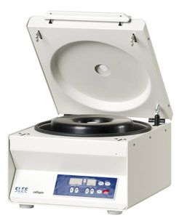CYTOLOGY CENTRIFUGE / BENCHTOPCS CENTRIFUGE I / II
Speed: 15,000, 6,000 rpm
Basic or advanced cytocentrifuge for monolayer cell preparation Flexible choice and handling of rotors Cytocentrifugation open or closed (12 loading positions) Easily removable rotor for outside loading Wide variety of rotors are available.

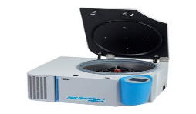LABORATORY CENTRIFUGE / MEDICAL / FOR BIOLOGY / VETERINARYNUWIND NU-C300R
Speed: 0 rpm - 12,100 rpm
... blood separation, microbiology and more. The NuWind™ General Purpose Bench Top 4 Liter Refrigerated Centrifuge is benchtop refrigerated centrifuge that can be used.

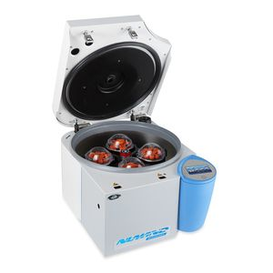LABORATORY CENTRIFUGE / MEDICAL / FOR BIOLOGY / FOR THE PHARMACEUTICAL INDUSTRYNUWIND NU-C300V
Speed: 0 rpm - 10,700 rpm
NuWind NU-C300V General Purpose Bench Top 4 Liter Ventilated Centrifuge Model NU-C300V is a general purpose benchtop centrifuge used in scientific and medical research.

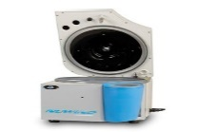LABORATORY CENTRIFUGE / BENCHTOP / VENTILATEDNUWIND
Speed: 15,300 rpm
NuWind NU-C200V General Purpose Bench Top 2 Liter Ventilated Centrifuge NuWind Centrifuges offer larger capacity in a smaller footprint. The ability to change rotors within seconds.
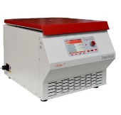LABORATORY CENTRIFUGE / UNIVERSAL / BENCHTOP / HIGH-SPEEDHICEN T
Speed: 500 rpm - 14,000 rpm
High-Speed Tabletop Centrifuge (without refrigeration) Maximum capacity: 4 x 500 ml 12 angle rotors, 2 swing-out rotors Speed: 500 – 14,000 rpm, in steps of 100 rpm g-force (RCF): 21,913 x g.

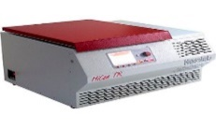LABORATORY CENTRIFUGE / UNIVERSAL / BENCHTOP / HIGH-SPEEDHICEN TR
Speed: 500 rpm - 16,000 rpm
HiCen TR Centrifuge Product Description High-Speed Tabletop Centrifuge - refrigerated Maximum capacity: 4 x 500 ml 12 angle rotors, 2 swing-out rotors Speed: 500 – 16,000 rpm.

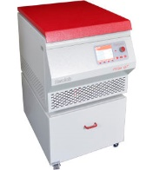LABORATORY CENTRIFUGE / BENCHTOP / HIGH-SPEED / HIGH-CAPACITYHICEN GT
Speed: 500 rpm - 14,000 rpm
Product Description Large High-Speed Centrifuge Maximum capacity: 4 x 1,000 ml 15 angle rotors, 4 swing-out rotors, 2 vertical rotors Speed: 500 – 14,000 rpm, in steps of 100 rpm g-force (RCF): 21,913 x g.
LABORATORY CENTRIFUGE / MULTIPURPOSE / BENCHTOP / COMPACTALPHATEC EOLO® 12
Speed: 0 rpm - 4,000 rpm
... * Microprocessor Control with Carbon-free Motor. * LCD display with speed, time, RCF and error code parameters. * ABS centrifuge body with light weight of 5Kg. * Safety mechanism, ALPHATEC EOLO® 12 will not work ...
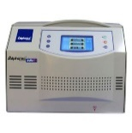LABORATORY CENTRIFUGE / MULTIPURPOSE / BENCHTOP / HIGH-PERFORMANCEALPHATEC EOLO® 24
Speed: 0 rpm - 5,000 rpm
... information Rotors, Program Information (Memory), Acceleration Information and Slowdown and error code. * Steel centrifuge body and stainless steel chamber autoclavable and resistant to detergents and disinfection.

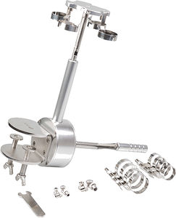MANUAL CENTRIFUGE / CLINICAL / MULTIFUNCTION / BENCHTOPCMONE
Speed: 100 rpm - 3,000 rpm
Manual Centrifuge LIPO-one® 5,10,20 & 60ml + sterilization box Made of aluminum and anodized stainless steel, the CMone centrifuge is fully autoclavable. Sold with its custom sterilization box.

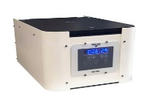CYTOLOGY CENTRIFUGE / BENCHTOPCITO-SPIN
Cytological centrifuge controlled by microprocessor. Program save and recall up to ten protocols. Gentle stop and fast braking: pre select 10 braking rates. Warning indicators for imbalance, over speed, door open and setting
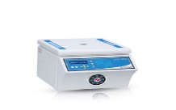LABORATORY CENTRIFUGE / BENCHTOP / FIXED-ANGLEM 415 P, M 4812 P
Speed: 500 rpm - 5,000 rpm
... 8 x 15 ml. Rotor type Vertical 35° fixed angle Speed control PID Digital Control Max. speed 5000 rpm Max. RCF (Relative centrifugal force x g) 2515 x g Timer range 1-99 min. Continuous running mode is available.

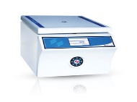LABORATORY CENTRIFUGE / BENCHTOP / FIXED-ANGLEM 450 PLABORATORY Speed: 500 rpm - 5,000 rpm
Capacity 4 x 50 ml Rotor Type Vertical 35° fixed angle Max. speed 5000 rpm Max. RCF 3075 x g Speed setting increment 10 rpm Speed setting range 500 - 5000 rpm Timer Starts when set speed achieved Timer range 1-99 min. In 1-minute step Continuous.
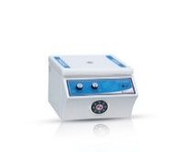LABORATORY CENTRIFUGE / BENCHTOP / FIXED-ANGLEM 415 M, 4812 M
Speed: 0 rpm - 5,000 rpm
Capacity 4x15 ml 6x15 ml 8x15 ml 12x15 ml Rotor Type Vertical 35° fixed angle Speed control Stepless electronic Max. speed 5000 rpm Max. RCF 2515 x g (3075 x g M4812M) Timer range 1-15 min Fuse 1 Amp Power rating 100 W Safety.
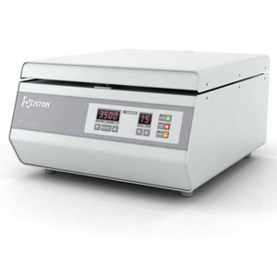LABORATORY CENTRIFUGE / MEDICAL / BENCHTOP / LOW-SPEEDC 2201LABORATORY CENTRIFUGE
Speed: 100 rpm - 3,600 rpm
Low-speed laboratory benchtop centrifuge with swing-out rotor for 12 tubes. Max speed 3600 RPM. Max RCF 2410 G. For standard type of tubes up to 18x110 mm.

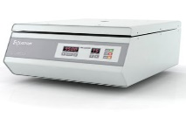LABORATORY CENTRIFUGE / UNIVERSAL / BENCHTOP / LOW-SPEEDC 2202LAB
Speed: 100 rpm - 3,500 rpm
Low-speed laboratory benchtop centrifuge with universal swing-out rotor CRS 490. Up to 32 tubes. Max speed 3500 rpm. Max RCF 2300 G. Max volume of the liquid - 360 ml.
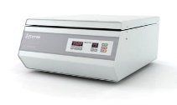LABORATORY CENTRIFUGE / BENCHTOP / HIGH-CAPACITY / LOW-SPEEDC 2203
Speed: 100 rpm - 3,000 rpm
High-capacity (up to 720 ml) low-speed laboratory benchtop centrifuge with swing-out bucket rotor. Up to 48 tubes (9 ml vacuum). Max speed 3000 rpm. Max RCF 1800 G. Max volume of the liquid - 720 ml.
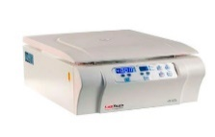CLINICAL CENTRIFUGE / BENCHTOP / COMPACT / LOW-SPEED406
... nowadays laboratory centrifuges are crucial instruments in countless applications from genetic engineering to hematology, from drug discovery to pathology, from marine science to agriculture.
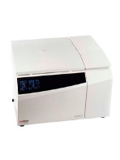LABORATORY CENTRIFUGE / BENCHTOP / FLOOR-STANDING / HIGH-SPEED2236R, 1696R
... laboratory centrifuges are crucial instruments in countless applications from genetic engineering to hematology, from drug discovery to pathology, from marine science to agriculture.

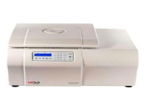LABORATORY CENTRIFUGE / MULTIPURPOSE / BENCHTOP / HIGH-SPEEDISBOR, 1580R
... laboratory centrifuges are crucial instruments in countless applications from genetic engineering to hematology, from drug discovery to pathology, from marine science to agriculture, and you name it.

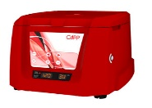LABORATORY CENTRIFUGE / CLINICAL / BENCHTOP / COMPACTCAPPRONDO
Speed: 500 rpm - 6,500 rpm
CappRondo Clinical Centrifuge is compact and reliable low-speed centrifuge ideal for blood centrifuge applications involving volumes below 15ml.
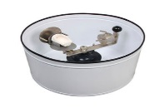LABORATORY CENTRIFUGE / FOR DENTAL LABORATORIES / BENCHTOP / MANUALEQ103-1003
LABORATORY CENTRIFUGE
... 500 x 300 mm. • Weight: 14 Kg. Accessories Ring Holder: Included Support for the Manual Centrifuge This optional accessory is used to elevate the centrifuge from the floor and improve the work position.
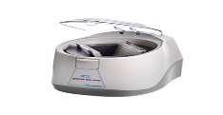LABORATORY CENTRIFUGE / MULTIFUNCTION / BENCHTOP / FOR MICROPLATES846070
Speed: 2,550 rpm
Description: PLATE CENTRIFUGE EU PLUG Sterile: non-sterile Packing unit: 1 Qty / inner pack: 1 Packaging weight: 0.00 kg Packaging dimension: 35 x 30 x 30 mm Packing unit: 1 Qty / inner pack: 1

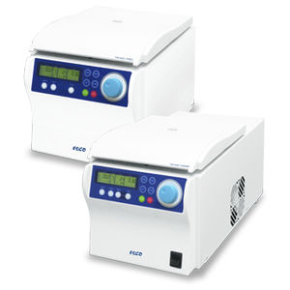LABORATORY CENTRIFUGE / MULTIFUNCTION / BENCHTOP / COMPACTVERSATITM MCV, VERSATITM MCR
Speed: 0 rpm - 16,000 rpm
Positioned as micro centrifuge, MCV and refrigerated MCR stand out with excellent feature and versatility. MCV and MCR have a capacity of up to 44 x 1.5/2.0ml and can accommodate 12 x 5ml reaction tube or 4 x 8-pcr strips.

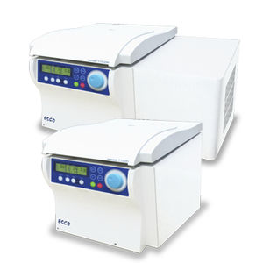LABORATORY CENTRIFUGE / MULTIFUNCTION / BENCHTOP / COMPACTVERSATITM TCV, VERSATITM TCR
Speed: 0 rpm - 16,000 rpm
... handling. It can act as different model to meet all your application needs: micro centrifuge for DNA precipitations, high-capacity and low-to-high speed general-purpose centrifuge for cell application. .

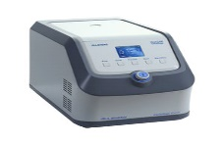MOLECULAR BIOLOGY CENTRIFUGE / BENCHTOP / AUTOMATIC / HIGH-SPEEDICEN-24R
Speed: 500 rpm - 15,000 rpm
iCEN-24R high speed centrifuge with 24-place capacity rotors are the new designed for the laboratory centrifuge. Their speed of up to 15,000rpm(21,400×g) allows for molecular biology applications in 0.2ml,0.5ml,1.5/2.0ml.

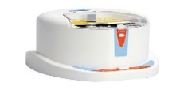LABORATORY CENTRIFUGE / MULTIFUNCTION / BENCHTOP / COMPACTMINI-P25
Speed: 2,500 rpm
The compact and economical Mini-P25 Mini-Plate Centrifuge with two-position rotor is available for many applications. It can quickly spin down droplets and condensation and is for use before and after thermal cycling.

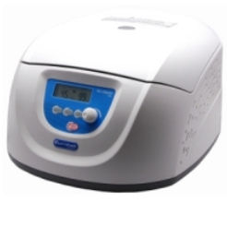LABORATORY CENTRIFUGE / CLINICAL / FOR TEACHING / VETERINARYCN-45L
Speed: 300 rpm - 4,500 rpm
The CN45 clinical centrifuges are practical centrifuges for use with small sample volumes. The centrifuges are supplied with an angle rotor that can hold up to 15mlx8 or 10ml/7ml/5mlx12 vacuum tubes.

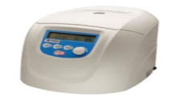CLINICAL CENTRIFUGE / HEMATOCRIT / FOR DNA / BENCHTOPCN-140HCN-140H
Speed: 200 rpm - 14,000 rpm
Our hematocrit centrifuge is used for determination of volume fractions of erythrocytes in blood for diagnostic purposes and doping tests. Also it is used to derive plasma for the photometric determination of the bilirubin .

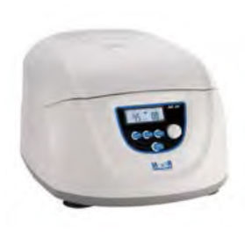LABORATORY CENTRIFUGE / BENCHTOPDC-01
Speed: 300 rpm - 4,500 rpm
Max. Speed 300-4500, increment: 100 [rpm] Temperature N/A Max. RCF [ x g] 2490 x g, increment: 100 x g Speed ± 20 rpm Accuracy[rpm] Rotor capacity 12x10ml/7ml/5ml; 8 x15ml

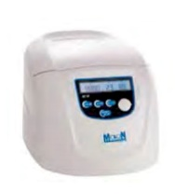LABORATORY CENTRIFUGE / BENCHTOPDC-02RATORY CENTRIFUGE
Speed: 200 rpm - 12,000 rpm
Max. Speed[rpm] 200-12000, increment: 100 Temperature N/A Max. RCF [ x g] 18260 x g, increment: 10 x g Speed Accuracy[rpm] ±30 rpm
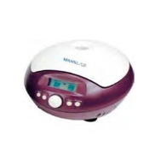LABORATORY CENTRIFUGE / BENCHTOPHC-01, HC-01 PLUS
Speed: 500 rpm - 15,000 rpm
Max. Speed [rpm] 15000 rpm (500 -15000rpm), increment: 100 rpm Temperature N/A Max. RCF [ x g] 151OOxg, increment: 100 x g

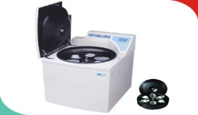LABORATORY CENTRIFUGE / HEMATOCRIT / BENCHTOP / REFRIGERATEDLBC-12, LBC-6
Speed: 4,200 rpm - 7,060 rpm
Name of Equipment LABTOP® Micro Controller Blood bank Refrigerated Centrifuge Control System Micro controller based temperature/speed controller with digital LED and Graphical Display Material of construction Mild

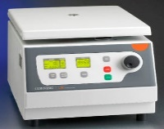LABORATORY CENTRIFUGE / BENCHTOP / COMPACT6755, 6758
Speed: 200 rpm - 6,000 rpm
The Corning LSE compact centrifuge is a space saving centrifuge ideal for use in life science and industrial research labs. Four angle rotors are available for this centrifuge.

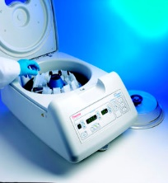CYTOLOGY CENTRIFUGE / BENCHTOPCYTOSPIN™ 4
Speed: 200 rpm - 2,000 rpm
Processes 12 specimens at one time Accepts all protocols from Cytospin 1, 2 and 3 Allows for one-handed opening and closing with a redesigned lid-release mechanism Enables viewing of the sealed head through the polycarbonate.

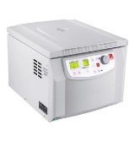LABORATORY CENTRIFUGE / CLINICAL / MULTIFUNCTION / BENCHTOPFRONTIER™ 5000 SERIES
Speed: 200 rpm - 18,000 rpm
performance at maximum volume, automatic rotor identification and safety features - these multi-purpose centrifuges are a must for any lab. Applications Centrifugal Separation, General Sample Preparation, ...

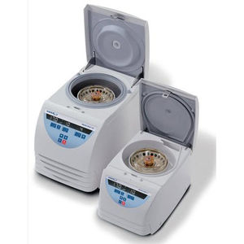LABORATORY CENTRIFUGE / BENCHTOP / COMPACT / HIGH-PERFORMANCEMICRO STAR 17, MICRO STAR 17R
Speed: 0 rpm - 13,300 rpm
The Micro Star 17 and 17R microcentrifuges combine power, versatility and convenience in a safe, compact, easy to use laboratory instrument. Both the ventilated Micro Star 17 and the refrigerated Micro Star 17R are designed

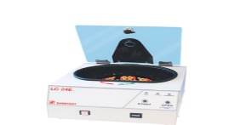LABORATORY CENTRIFUGE / BENCHTOP / SWING-OUTLC 24 E
Speed: 3,500 rpm
Product description Order number 90.184.710 Product description Centrifuge LC 24 E, 230 V, incl. 6-position swing-out rotor, 6x 4-position tube holders, 6 caps for tube holders Product.

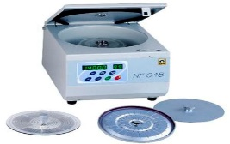LABORATORY CENTRIFUGE / MICROHEMATOCRIT / BENCHTOP / VENTILATEDNF 048

CARE AND MAINTENANCE OF A CENTRIFUGE
- clean your centrifuge daily. This includes cleaning both the exterior and the interior of the centrifuge daily or at least weekly. Interior cleaning includes the interior bucket, specimen holder, rotor and supports.

- A sponge, warm water, and a mild detergent (dishwashing liquid) can be used to clean the centrifuge. Do not use caustic detergents or a product that contains chlorine ions.
- A plastic scrub brush should be used to avoid damaging the coatings.
- When you are finished cleaning the centrifuge you should use a centrifuge lubricant to lubricate the bucket grooves and rubber seals.
- Use approved disinfectants and/or “spill” kits to disinfect the centrifuge on a regular basis.
- In addition to cleaning the centrifuge, you should also check for residue and corrosion on the rotors on a weekly or monthly basis.
Reasons why maintenance is carried out.
Scheduling regular preventive maintenance with a trained technician for your centrifuge is vital because it increases the durability and functionality of the centrifuge. Regular preventive maintenance also ensures accurate results and reliable performance, which will benefit your research. Regular preventive maintenance includes the inspection of the physical condition, inspection of the electrical condition, cleaning, and testing of the centrifuge. Regular preventive maintenance will not only prevent damage, but can also identify damage that has already occurred and repair it before the centrifuge is no longer usable. In order for your centrifuge to be in the best possible condition and to ensure the reliability of your research you should regularly schedule preventive maintenance with a trained technician.
COST OF A CENTRIFuge: Centrifuges ranges from $1,000 to $5,000.

- AUTOMATIC TISSUE PROCESSOR.

WHAT IS THE AUTOMATIC TISSUE PROCESSOR MACHINE (ATPM)?
A tissue processor is a device that prepares tissue samples for sectioning and microscopic examination in the diagnostic laboratory.
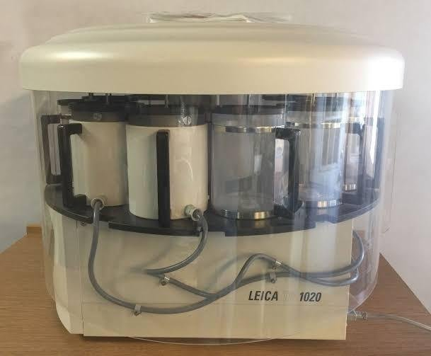
A PICTURE OF AN AUTOMATIC TISSUE PROCESSOR
Microscopic analysis of cells and tissues requires the preparation of very thin, high quality sections (slices) mounted on glass slides and appropriately stained to demonstrate normal and abnormal structures.
The automatic machine plays a big role in the preparation of the tissue by passing them through various chemicals; a major process called TISSUE PROCESSING.
Tissue processing” describes the steps required to take animal or human tissue from fixation to the state where it is completely infiltrated with a suitable histological wax and can be embedded ready for section cutting on the microtome. It is concerned with the diffusion of various substances into and out of porous tissues. Diffusion results from the tendency of processing reagents to equalize concentrations both inside and outside blocks of tissue.
The main aim of tissue processing is to remove the water from the tissue and eventually replace this with a medium which allows sections to be cut from the block (usually paraffin wax). Nowadays, most histology labs will be equipped with a dedicated tissue processing machine.
Tissues to be processed are cut into small pieces to ensure the tissue fits into the tissue cassettes
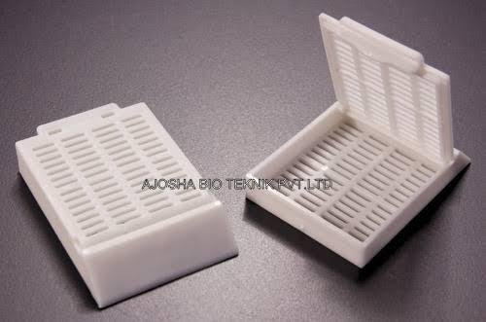
Smaller tissues (2-4 um) will be processed faster than the whole tissue or organ.
These tissue cassettes are packed into the oscillating tissue basket to tissue prior to fixation.
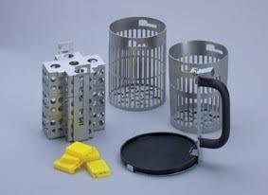
Picture of stainless tissue basket
STEPS IN TISSUE PROCESSING.
(i) FIXATION – this is the process of preserving or fixing tissues by passing them through chemicals called fixatives. The fixatives will help protect the tissue from decay and autolysis. Routine fixative of use is 10% formalin
(ii) DEHYDRATION – this is the process of removing water molecules from the tissue by passing the tissue through ascending grades of alcohol. E.g methanol, acetone, 70-100% alcohol
(iii) CLEARING – this is the process of removing alcohol from the tissue by passing it through chemicals that will remove the alcohol molecules. These agents are called clearing agents. Xylene is mostly used for clearing.
(iv) INFILTRATION – this is the process of filling intracellular spaces left in the tissue by paraffin wax. This will help confer a bit of rigidity to the processed tissue.
(v) EMBEDDING- this last step is manually done. This has to do with immersing the processed tissue into a mould containing liquid paraffin wax. This is for external support so that the tissue won’t crumble during microtomy.
PRINCIPLE
- principle of tissue processing.
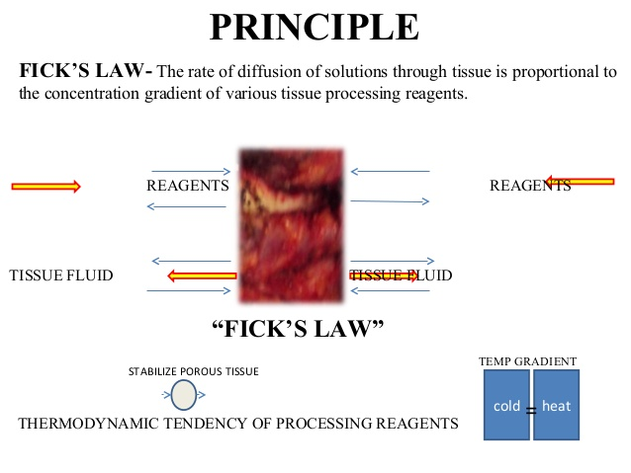

WORKING PRINCIPLE OF AUTOMATIC TISSUE PROCESSOR MACHINE – TP 1050 Leica processor model.

Most automatic tissue processors are easy-to-program interface. The Leica processor model has ten 1.8L (60.9oz.) reagent beakers and two 1.8L (60.9oz.) wax baths.
The tissue basket oscillates up and down in each station at three-second intervals to ensure thorough and even mixing of the reagents and optimum tissue infiltration.
Infiltration time is separately programmable for each station. Up to nine programs may be run with immediate or delayed starting times.
When it’s time for tissue to be transferred to the next beaker or jar, the cover of the machine is raised up, and the lifting mechanism carefully removes the tissue basket and gently transfers it to the next beaker.
When the infiltration time for any particular station is exceeded, a warning message will display, indicating the station number and excess time. Controls are arranged by functionality with an LCD to indicate operational parameters. Reagent container lids have seals to minimize operator exposure to hazardous fumes.
Tissue basket immediately immerses in a station in the event of power loss to protect samples from drying out. When power is restored, program will resume. In the event of long-term power failure, wax is liquefied. Capacity of tissue basket is 80 cassettes.
Vacuum configurations hasten infiltration, allowing pressure to be applied to any station in either manual or automatic operation. Fume control configurations extract fumes with a fan and pass them through an internal carbon filter.
For added efficiency, these models feature a two-part containment shield surrounding the reagent container platform.

Brands of tissue processors.
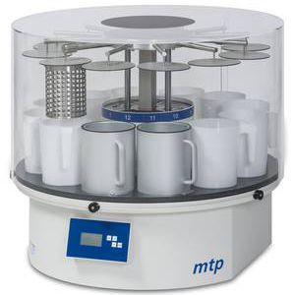AUTOMATIC SAMPLE PREPARATION SYSTEM / FOR HISTOLOGY / TISSUE / BENCHTOPMTP
Robust carousel tissue processor. The MTP carousel tissue processor guarantees gentle and highly reliable specimen processing in conjunction with state of the art control features.

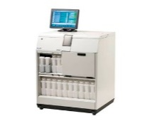AUTOMATIC SAMPLE PREPARATION SYSTEM / FOR HISTOLOGY / TISSUE / FLOOR-STANDINGMTM I / II
Fully automated tissue processor, The MTM II fast tissue processor offers a cost-efficient and user friendly alternative for fast biopsies processing and overnight batch tissue.

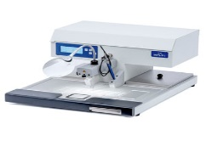AUTOMATIC SAMPLE PREPARATION SYSTEM / FOR HISTOLOGY / TISSUE / PARAFFIN EMBEDDINGMPS_P1
The space-saving MPS/P1 is a complete paraffin dispensing unit including a 3.8 liters’ paraffin container, a heated working area and a cooling spot. The ergonomically elevated heated working area is illuminated with adjustable LED light.
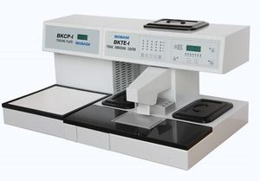EMBEDDING SYSTEM / AUTOMATIC / LABORATORY / TISSUEBK-TEI
Features: * Microprocessor Control for temperature, made in the USA * The Embedding Module and Cryo Module can be assembled freely * Flexible heating mechanism, Dual-protection; Safe, Reliable and Energy-Saving * Fully programmable.

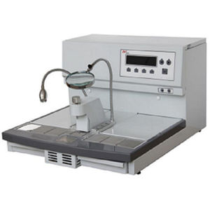EMBEDDING SYSTEM / AUTOMATED / LABORATORY / TISSUEBK-CPⅡ, BK-TEⅡ
... BK-CPⅡ& BK-TEⅡ Tissue Embedding&Cooling System Features: * Low-voltage, safe and bright LED lamp * Manual and automated operation modes * Flexible heating mechanism and PID technology * Trimming plates at both ...

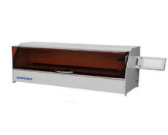SAMPLE STAINER / AUTOMATIC / LABORATORY / TISSUEBK-TS SERIES
BK-TS1/TS3 Fully Automated Tissue/Slide Stainer Features: * Imported high-quality parts, smooth operation, low noise, ergonomic design * Intelligent automatic water influx/efflux/drainage control system.

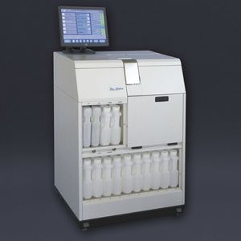AUTOMATIC SAMPLE PREPARATION SYSTEM / FOR HISTOLOGY / TISSUE / DEHYDRATIONVTP300
The automatic processor VTP300 is a vacuum underfloor processor designed for histopathological work routine. To make easier the use and the maintenance, the instrument is distinguished by a high standard.

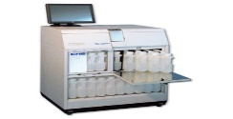AUTOMATIC SAMPLE PREPARATION SYSTEM / FOR HISTOLOGY / TISSUE / DEHYDRATIONFTP300
The automatic processor VFTP300 is a vacuum underfloor processor designed for histopathological work routine. To make easier the use and the maintenance, the instrument is distinguished by its high standard.
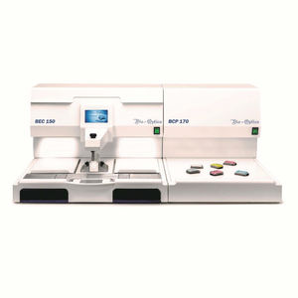AUTOMATIC SAMPLE PREPARATION SYSTEM / FOR HISTOLOGY / TISSUE / PARAFFIN EMBEDDINGBEC150
... accommodating embedding molds for large samples - Double thermal unit capable of accommodating the racks of any floor-standing processor - Double jack for heated forceps or pestle - Touch-screen monitor - Fully lite.

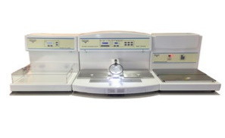AUTOMATIC SAMPLE PREPARATION SYSTEM / FOR HISTOLOGY / TISSUE / PARAFFIN EMBEDDINGTEC2900
TEC 2900 trimodular embedding center incorporates three separate components in a modular design: Main Console (paraffin dispenser), Cryo Console (cold plate for cooling blocks), Thermal Console (Thermal plate stationary samples).
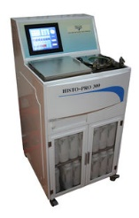AUTOMATIC SAMPLE PROCESSOR / TISSUE / DEHYDRATION / FLOOR-STANDINGHISTO-PRO300
Histo-Pro 300 Vacuum Tissue Processor Histo-Pro 300 set a new standard in vacuum tissue processing. His unique reagent monitoring and management delivers significant reagent cost.
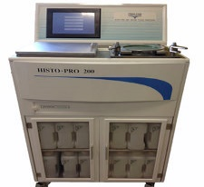AUTOMATIC SAMPLE PREPARATION SYSTEM / FOR HISTOLOGY / TISSUE / FLOOR-STANDINGHISTO-PRO200
Histo-Pro 200 Vacuum Tissue Processor Histo-Pro 200 set a new standard in vacuum tissue processing. His unique reagent monitoring and management delivers significant reagent cost.
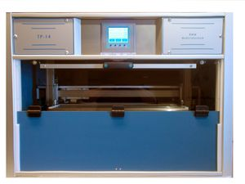AUTOMATIC SAMPLE PROCESSOR / TISSUE / FIXATION / PARAFFIN EMBEDDINGTP12, TP14
Small Table Top Tissue Processor 100 Cassettes / Run Closed Cabinet Can be connected to an exhaust air system 5 Programs Only 980mm in width

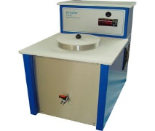TISSUE PROCESSOR / FREEZING / FLOOR-STANDINGCRYOFIX
Instrument for rapid freezing of human tissue. Isopentane is cooled down to -45°C, any tissue will freeze very fast. The formation of ice crystals is reduced to a minimum. A time saving instrument.

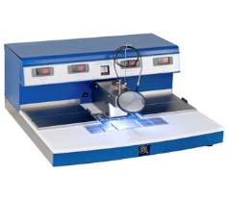TISSUE PROCESSOR / PARAFFIN EMBEDDING / MODULAR / FOR CASSETTESAGS2000
... 4.5 liters. One heating unit with an extra-large heat tray to warm up cassettes big enough to hold the most common tissue processor baskets. Cooling unit to cool the cassettes down to -13°C.

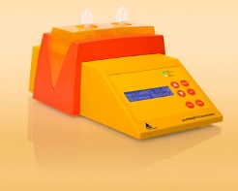AUTOMATIC SAMPLE PREPARATION SYSTEM / SEMI-AUTOMATED / LABORATORY / TISSUEGENTLEMACS™... dissociation or homogenization of tissues in a closed system. The instrument offers optimized gentle MACS Programs for a variety of specific applications. Special protocols have been developed for various tissues.

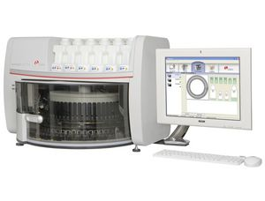AUTOMATIC SAMPLE PREPARATION SYSTEM / FOR HISTOLOGY / TISSUE / STAININGARTISAN™ LINK PROThis unit consists of a slide processor, a computer system with DakoLink workflow compatibility and a printer. Up to three Artisan Link Pro Special Staining Systems can be connected to one touch screen computer.
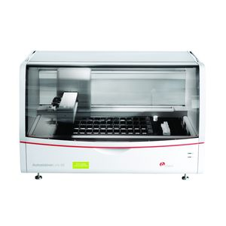AUTOMATIC SAMPLE PREPARATION SYSTEM / IHC / FOR HISTOLOGY / TISSUEAUTOSTAINER LINK 48
Add this automatic slide system to your laboratory for improved efficiency and cost savings. Compact, the Auto-stainer Link 48 takes up little room but is very reliable and dependable. For added convenience.

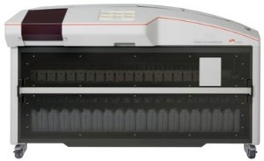AUTOMATIC SAMPLE PREPARATION SYSTEM / FOR HISTOLOGY / TISSUE / STAININGDAKO COVERSTAINER
Fully automated staining equipment the Dako CoverStainer automates the entire process of the H&E process, baking, dewaxing, staining, dehydrating, cover slipped and dry slide all ready for the examination.
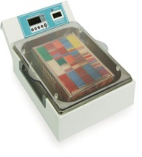AUTOMATIC SAMPLE PREPARATION SYSTEM / FOR HISTOLOGY / TISSUE / FIXATIONFIXSTATION LINE
... optimization, standardization and full documentation of this process. All fixation devices accept the racks utilized by major tissue processor manufacturers.

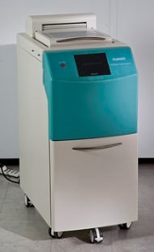AUTOMATIC SAMPLE PREPARATION SYSTEM / FOR HISTOLOGY / TISSUE / FIXATIONFIXMATE
... placing specimens in an automatic tissue processor. This meant holding a high performance instrument almost idle for hours/days waiting for the fixation process to be completed and documented.

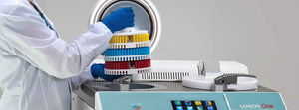AUTOMATIC SAMPLE PREPARATION SYSTEM / FOR HISTOLOGY / TISSUE / EMBEDDINGLOGOS ONE
The LOGOS One tissue processing unit has it all: it makes use of the latest heat resistance technology, can run quickly and simultaneously on dual retort and full automation single retort. It has the most advanced retort.

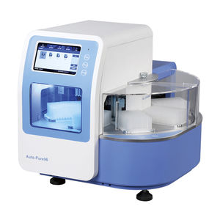AUTOMATIC SAMPLE PREPARATION SYSTEM / AUTOMATED / LABORATORY / TISSUEAUTO-PURE24
... an automated system for purifying DNA, RNA, proteins and cells from a variety of sample materials, such as blood, cells and tissue samples. The Auto-Pure purification technology is automated and enables high-speed, high-quality.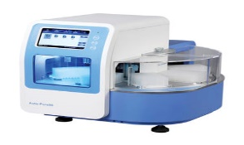AUTOMATED SAMPLE PREPARATION SYSTEM / LABORATORY / TISSUE / PURIFICATIONAUTO-PURE96
... an automated system for purifying DNA, RNA, proteins and cells from a variety of sample materials, such as blood, cells and tissue samples. The Auto-Pure purification technology is automated and enables high-speed, high-quality.
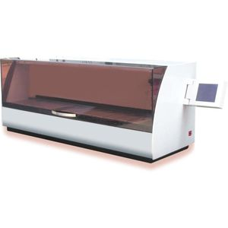AUTOMATIC SAMPLE PREPARATION SYSTEM / LABORATORY / TISSUE / STAININGOPTI-DYE
OPTI-DYE Automatic Tissue Slide Stainer is an instrument that combines the compactness of a small in line stainer to the technology of continuous loading for histology and cytology dyeing.
AUTOMATIC SAMPLE PREPARATION SYSTEM / LABORATORY / TISSUE / STAININGOPTI-WAX
OPTI-WAX Tissue Processor is an automatic linear tissue processor with 12 tanks, which allows to process 150 tissue cassettes in each cycle. Basket is ...

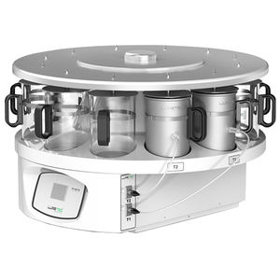TISSUE PROCESSOR / AUTOMATIC / LABORATORY / PARAFFIN EMBEDDINGPT09 TS
... histological processing consists in diffusing reactants to the interior of the tissues and the removal of tissue fluid that, after fixation of the material itself is employed fixative.

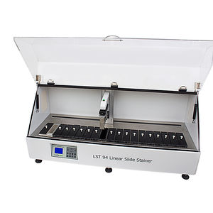SAMPLE STAINER / LABORATORY / TISSUE / LINEAR ARRAYLST94
... dyes are key to view the tissue under the light microscope. After the microtome, the cells and extracellular material are typically transparent and dyes enhance visualization of tissue structures.

TISSUE PROCESSOR / AUTOMATIC / LABORATORY / PARAFFIN EMBEDDINGPT05 TSPT05 TS
... histological processing consists in diffusing reactants to the interior of the tissues and the removal of tissue fluid that, after fixation of the material itself is employed fixative.

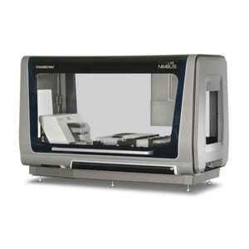AUTOMATED SAMPLE PREPARATION SYSTEM / LABORATORY / TISSUE / FOR DNA EXTRACTIONNIMBUS PRESTO
.. workstation for fully automated and parallel nucleic acid and protein extraction of a variety of biological samples. Blood, plasma, tissue, saliva, FFPE and buccal swabs may be automatically processed on a single and integrated work station.

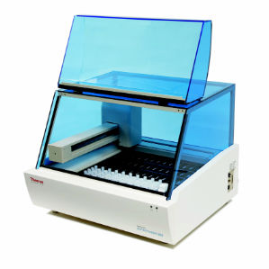AUTOMATIC SAMPLE PREPARATION SYSTEM / LABORATORY / FOR HISTOLOGY / TISSUELAB VISION™ AUTOSTAINER 360-2D
Stain at least 108 slides per day with Thermo Scientific™ Autostainer 360-2D, a fast, space-saving unit that provides flexible options to meet the workflow needs of any laboratory. Autostainers are renowned for their consistency and reliability.
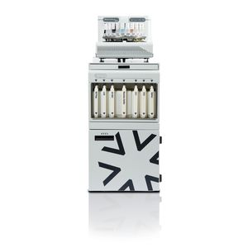AUTOMATED SAMPLE PREPARATION SYSTEM / IHC / FOR HISTOLOGY / TISSUEBENCHMARK GX
BenchMark GX instrument provides an option to expand test menu, process more slides, and boost turnaround times. It has easy to change transition system from manual or semi computerized staining systems to do the current IHC and ISH testing. Key ...

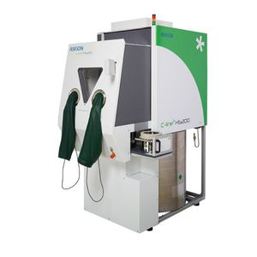FULLY AUTOMATED SAMPLE PREPARATION SYSTEM / LABORATORY / TISSUE / CELLC-LINE® HS200
Automated cryogenic sample storage/biobank The ASKION C-line® hermetic storage HS200 product family provides semi- and fully automated cryo-storage systems at temperatures of below -150°C to -185°C. The storage takes place in the gas

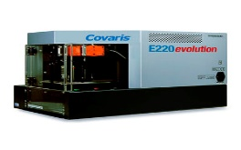TISSUE SAMPLE PROCESSOR / DISSOLUTION / SHEARING / HOMOGENIZATIONE220EVOLUTION
The Platform for High-Performance, High Throughput Sample Preparation Process 1 to 8 samples in a batch Upgrade to 96 samples when workload increases When workload requirements increase, upgrade your throughput without purchasing.

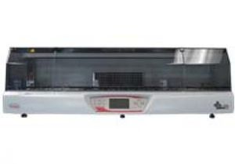AUTOMATIC SAMPLE PREPARATION SYSTEM / LABORATORY / TISSUE / STAININGSHURSTAIN 2030
Tissue Staining Productivity and Ease of Use in a Compact Footprint The SHURStain™ 2030 Automated Slide Stainer was intelligently designed for today's crowded lab workspaces, as well as addressing the demand for speed.

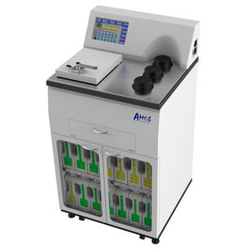VACUUM SAMPLE PROCESSOR / AUTOMATIC / FOR HISTOLOGY / TISSUEAVTP 2500
AVTP 2500 Vacuum Tissue Processor is an advanced equipment for paraffin infiltration of tissue specimens in histopathology applications. This enhanced PLC technology is user-friendly.

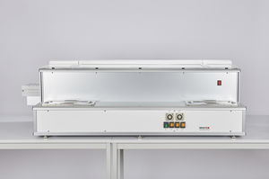AUTOMATIC SAMPLE PREPARATION SYSTEM / FOR HISTOLOGY / TISSUE / STAININGCOT 20
The worldwide first continuous linear stainer saves you precious time by processing up to 1,000 samples per hour. Key product features The worldwide first continuous linear stainer Processing up to 1,000 samples per hour.

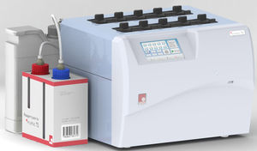SAMPLE STAINER / AUTOMATIC / FOR HISTOLOGY / TISSUEMYTHIC TS
Mythic TS - Stainer for hematology • Dedicated for smears • Up to 10 slides at the same time • Traditional staining • Integrated Giemsa dilution • No cross contamination Specifications.

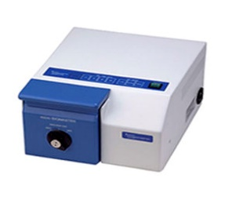TISSUE SAMPLE PROCESSOR / FOR MICROBIOLOGY / FOR LIQUID HANDLING / TISSUESTOMACHER 80
Small tissue processing solutions for clinical and life science microbiology The Stomacher® 80 Biomaster and Stomacher® 80 microBiomaster laboratory paddle blenders provide small tissue processing solutions.

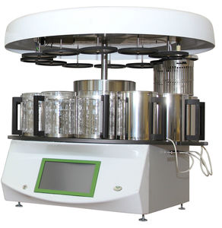AUTOMATIC SAMPLE PROCESSOR / TISSUE / FIXATION / DEHYDRATIONАGОТ-1
CONTACT
... for tissue processing, fixation, dehydration, bleaching in solutions, soaking in paraffin and other types of chemical treatment in the process of making preparations for further microscopic examination.
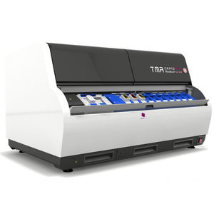TISSUE PROCESSOR / AUTOMATED / LABORATORY / DIAGNOSTICTMA GRAND MASTER
... brings major economies in time quality and costs of tissue preparation, slide preparation and staining. The real advantages of tissue microarrays can only be achieved when using an advanced automated.
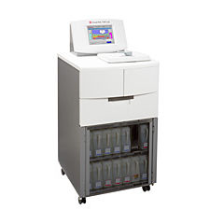TISSUE SAMPLE PROCESSOR / ON CASTERS / WITH TOUCHSCREEN / VACUUMTISSUE-TEK VIP 6 AIVIP 6 AI
The Tissue-Tek VIP 6 AI, is the next level in reliability and safety from Tissue-Tek VIP processors and is a great investment for superior quality tissue processing.

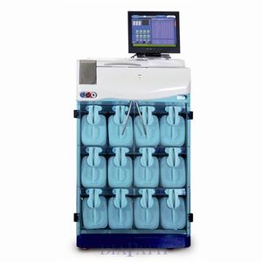AUTOMATIC SAMPLE PROCESSOR / FOR HISTOLOGY / TISSUE / FLOOR-STANDINGDONATELLO

Care and maintenance of an automatic tissue processor.
- Care should be taken to avoid cross contamination of specimens from used forceps.
- Any spillage or overflow should be cleaned immediately.
- Accumulation of wax on any surface should be removed.
- The temperature of the paraffin wax bath should be set to 3֯c above the melting point of the wax.
- Timings should be checked when placing the cassette in the tissue processor.

Cost of an automatic tissue processor.

The price ranges from US $3600- $9,800.
- microtome.
A microtome is a tool used to cut extremely thin slices of materials known as sections. Microtomes are used in microscopy, allowing for the preparation of samples for observation under transmitted light or electron radiation. Microtomes use steel, glass, or diamond blades depending upon the specimen being sliced and the desired thickness of the sections being cut. Steel blades are used to prepare sections of animal or plant tissues for light microscopy histology. Glass knives are used to slice sections for light microscopy and to slice very thin sections for electron microscopy. Industrial grade diamond knives are used to slice hard materials such as bone, teeth and plant matter for both light microscopy and for electron microscopy. Gem quality diamond knives are used for slicing thin sections for electron microscopy.
Microtomy is a method for the preparation of thin sections for materials such as bones, minerals and teeth, and an alternative to electro polishing and ion milling. Microtome sections can be made thin enough to section a human hair across its breadth, with section thickness between 50 nm and 100 μm.

Types

Sledge
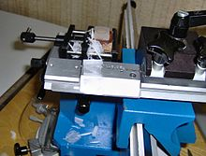
A sledge microtome
A sledge microtome is a device where the sample is placed into a fixed holder (shuttle), which then moves backwards and forwards across a knife. Modern sled microtomes have the sled placed upon a linear bearing, a design that allows the microtome to readily cut many coarse sections. By adjusting the angles between the sample and the microtome knife, the pressure applied to the sample during the cut can be reduced. Typical applications for this design of microtome are of the preparation of large samples, such as those embedded in paraffin for biological preparations. Typical cut thickness achievable on a sledge microtome is between 1 and 60 μm.

Rotary
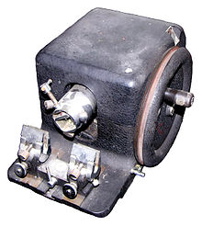
A rotary microtome of older construction
This instrument is a common microtome design. This device operates with a staged rotary action such that the actual cutting is part of the rotary motion. In a rotary microtome, the knife is typically fixed in a horizontal position.^{[14]}
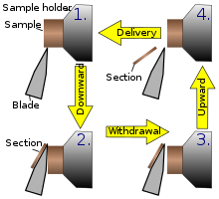
Principle of sample movement for making a cut on a rotary microtome
In the figure to the left, the principle of the cut is explained. Through the motion of the sample holder, the sample is cut by the knife position 1 to position 2, at which point the fresh section remains on the knife. At the highest point of the rotary motion, the sample holder is advanced by the same thickness as the section that is to be made, allowing the next section to be made.
The flywheel in many microtomes can be operated by hand. This has the advantage that a clean cut can be made, as the relatively large mass of the flywheel prevents the sample from being stopped during the sample cut. The flywheel in newer models is often integrated inside the microtome casing. The typical cut thickness for a rotary microtome is between 1 and 60 μm. For hard materials, such as a sample embedded in a synthetic resin, this design of microtome can allow good "semi-thin" sections with a thickness of as low as 0.5 μm.

Cryomicrotome
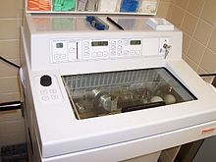
A cryomicrotome
For the cutting of frozen samples, many rotary microtomes can be adapted to cut in a liquid-nitrogen chamber, in a so-called cryomicrotome setup. The reduced temperature allows the hardness of the sample to be increased, such as by undergoing a glass transition, which allows the preparation of semi-thin samples. However, the sample temperature and the knife temperature must be controlled in order to optimize the resultant sample thickness.

Ultra microtome
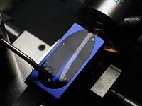
A ribbon of ultrathin sections prepared by room-temperature ultramicrotomy, floating on water in the boat of a diamond knife used to cut the sections. The knife blade is the edge at the upper end of the trough of water.
An ultramicrotome is a main tool of ultramicrotome. It allows the preparation of extremely thin sections, with the device functioning in the same manner as a rotational microtome, but with very tight tolerances on the mechanical construction. As a result of the careful mechanical construction, the linear thermal expansion of the mounting is used to provide very fine control of the thickness.
These extremely thin cuts are important for use with transmission electron microscope and serial block-face scanning electron microscopy (SBFSEM), and are sometimes also important for light-optical microscopy. The typical thickness of these cuts is between 40 and 100 nm for transmission electron microscopy and often between 30 and 50 nm for SBFSEM. Thicker sections up to 500 nm thick are also taken for specialized TEM applications or for light-microscopy survey sections to select an area for the final thin sections. Diamond knives (preferably) and glass knives are used with ultra-microtomes. To collect the sections, they are floated on top of a liquid as they are cut and are carefully picked up onto grids suitable for TEM specimen viewing. The thickness of the section can be estimated by the thin-film interference colors of reflected light that are seen as a result of the extremely low sample thickness.

Vibrating
The vibrating microtome operates by cutting using a vibrating blade, allowing the resultant cut to be made with less pressure than would be required for a stationary blade. The vibrating microtome is usually used for difficult biological samples. The cut thickness is usually around 30–500 μm for live tissue and 10–500 μm for fixed tissue.
A variation on the vibrating microtome is the Compresstome microtome. The Compresstome uses a specimen syringe or "lipstick-like" tube to hold the tissue. The tissue specimen is completely embedded in agarose (a polysaccharide), and the tissue is slowly and gently pressed out of the tube for the vibrating blade to cut. The device operates in the following way: the end of the specimen tube where the tissue emerges is slightly narrower than the loading end, which allows gentle "compression" of the tissue as it comes out of the tube. The slight compression prevents shearing, uneven cutting, and vibration artifacts from forming. Note that the compression technology does not damage or affect the tissue being sectioned.
There are several advantages of the Compresstome microtome:
1) the agarose embedding provides stability to the entire specimen on all sides, which prevents uneven slicing or shearing of tissue
2) the compression technology gently compresses tissue for even cutting, so that the blade doesn't push against the tissue
3) faster sectioning than most vibrating microtomes
4) it cuts tissue from older or more mature animals well to provide healthier tissues.

Saw
The saw microtome is especially for hard materials such as teeth or bones. The microtome of this type has a recessed rotating saw, which slices through the sample. The minimal cut thickness is approximately 30 μm and can be made for comparatively large samples.

Laser
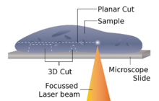
A conceptual diagram of laser microtome operation
The laser microtome is an instrument for contact-free slicing. Prior preparation of the sample through embedding, freezing or chemical fixation is not required, thereby minimizing the artifacts from preparation methods. Alternately this design of microtome can also be used for very hard materials, such as bones or teeth, as well as some ceramics. Dependent upon the properties of the sample material, the thickness achievable is between 10 and 100 μm.
The device operates using a cutting action of an infrared laser. As the laser emits a radiation in the near infrared, in this wavelength regime the laser can interact with biological materials. Through sharp focusing of the probe within the sample, a focal point of very high intensity, up to TW /cm², can be achieved. Through the non-linear interaction of the optical penetration in the focal region a material separation in a process known as photo-disruption is introduced. By limiting the laser pulse durations to the femtoseconds range, the energy expended at the target region is precisely controlled, thereby limiting the interaction zone of the cut to under a micrometre. External to this zone the ultra-short beam application time introduces minimal to no thermal damage to the remainder of the sample.
The laser radiation is directed onto a fast scanning mirror-based optical system, which allows three-dimensional positioning of the beam crossover, whilst allowing beam traversal to the desired region of interest. The combination of high power with a high raster rate allows the scanner to cut large areas of sample in a short time. In the laser microtome the laser-microdissection of internal areas in tissues, cellular structures, and other types of small features is also possible.

Knives[edit]
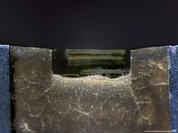
A diamond knife blade used for cutting ultrathin sections (typically 70 to 350 nm) for transmission electron microscopy.
The selection of microtome knife blade profile depends upon the material and preparation of the samples, as well as the final sample requirements (e.g. cut thickness and quality).

Design and cut types
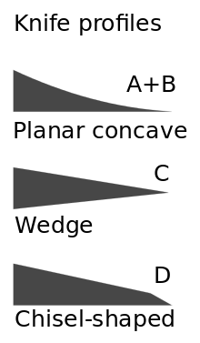
Profiles of microtome knives.
Generally, knives are characterized by the profile of the knife blade, which falls under the categories of planar concave, wedge shaped or chisel shaped designs.
Planar concave microtome knives are extremely sharp, but are also very delicate and are therefore only used with very soft samples. The wedge profile knives are somewhat more stable and find use in moderately hard materials, such as in epoxy or cryogenic sample cutting. Finally, the chisel profile with its blunt edge, raises the stability of the knife, whilst requiring significantly more force to achieve the cut.
For ultra-microtomes, glass and diamond knives are required, the cut breadth of the blade is therefore on the order of a few millimeters and is therefore significantly smaller than for classical microtome knives. Glass knives are usually manufactured by the fracture of glass bars using special "knife-maker" fracturing devices. Glass knives may be used for initial sample preparations even where diamond knives may be used for final sectioning. Glass knives usually have small troughs, made with plastic tape, which are filled with water to allow the sample to float for later collection. Diamond blades may be built into such an existing trough, allowing for the same collection method.

WORKING PRINCIPLE OF ROTARY MICROTOME –
⇒ It is used for slicing paraffin tissue sections of uniform thickness.
⇒ This method is designed to cut 1-60 micron thick sections.
⇒ A knob on the device (typically at the backside) is used to modify the thickness of the sections.
⇒ A knife is constant inside the knife holder and clamped tightly.
⇒ The tissue block is drawn throughout the knife-edge and it is mechanically advanced. The top and bottom of the block have to be parallel and horizontal and as a minimum 1mm of paraffin has to be present in all aspects beyond the tissue.
⇒ The trimming of the edges of the block is usually completed with a single-sided razor blade and the block face is trimmed with the microtome knife.
⇒ The technician decides the type of section to be made in line with the nature of tissue and instructions received from the pathologist.
⇒ At some stage in section slicing, as the wheel of the microtome turns, sections are cut and slide on the knife. A ribbon of sections is produced.
⇒ The ribbon of sections is transferred to warm water inside the tissue floatation bath to put off any wrinkles present in the section.
⇒ The best quality section that is free from any scratches and cracks can be decided on from the tissue ribbons. The tissue ribbons are then taken on smooth glass slides with a respective identification number.
⇒ The slides are pulled from the water and the preferred sections are positioned flat on the surface of glass slides. The slides with the sections are positioned on a rack in a hot air oven to dry.
Brands of microtome.
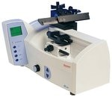

HM 450 Sliding Microtome, HM 450 Sliding Microtome, Steel Knife Holder, Dust Cover, Operator Manual Thermo Scientific™
Section paraffin and frozen sections in biological, botanical and materials science applications with the Thermo Scientific™ HM 450 Sliding Microtome. This microtome includes automatic fine sectioning and trimming features with selectable specimen retraction. The integrated knife carrier design of the HM 450 Sliding Microtome ensures fast, comfortable and nontiring operation.

HM 450 Sliding Microtome Thermo Scientific™
Section paraffin and frozen sections in biological, botanical and materials science applications with the Thermo Scientific™ HM 450 Sliding Microtome. This microtome includes automatic fine sectioning and trimming features with selectable specimen retraction. The integrated knife carrier design of the HM 450 Sliding Microtome ensures fast, comfortable and nontiring operation.
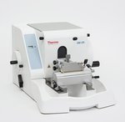

HM 325 Rotary Microtome Thermo Scientific™
Cut high-quality paraffin sections without a power supply with the robust Thermo Scientific™ HM 325 Rotary Microtome. The HM 325 features retraction at the return travel to protect the specimen and manual coarse advance for fast working.
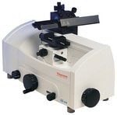

HM 430 Sliding Microtome Thermo Scientific™
Ensure fast, comfortable, and nontiring operation with the automatic or manual fine sectioning abilities of the Thermo Scientific™ HM 430 Sliding Microtome.
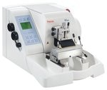

HM 355S Automatic Microtome Thermo Scientific™
Section even the largest specimens with unmatched quality by using the electronic Thermo Scientific™ HM 355S Automatic Microtome. It is designed for all applications of paraffin and hard specimens in clinical, research, and industrial labs.
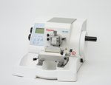

HM 340E Electronic Rotary Microtome Thermo Scientific™
Designed for precision and stability which yields quality ribbons even for difficult to cut paraffin sections, the Thermo Scientific™ HM 340E Electronic Microtome is an ergonomically designed, electronic rotary microtome with stepping-motor advance technology for precision and stability to provide superior sectioning results.
Care and maintenance.
USE AND CARE OF YOUR MICROTOME KNIFE
BEFORE USING YOUR MICROTOME KNIFE
A. Your microtome knife has been coated with an oil mixture to prevent rust and corrosion when not in use.
B. Before using your knife, take a lint-free facial tissue saturated in either zylene, benzene or acetone to remove the protective oil coating on the knife.
C. Use a dry, lint-free, facial tissue to wipe your knife clean. DO NOT USE GAUZE or any other coarse material; it will destroy the edge of your knife.
D. Your knife has already been stropped and is now ready for immediate use.
CARING FOR YOUR MICROTOME KNIFE
A. Keep the edge of your knife clean at all times.
B. Spray or brush any household oil on your knife to prevent rust when not in use.
C. Store your knife in its case to prevent oxidation from occurring.
D. If you are using a lab sharpener, periodically send your knife out to be professionally reconditioned.
1. Extremely wide facets result from the continuous use of a lab sharpener. The optimum bevel angle becomes distorted as a result of the facet changes. This diminishes your cutting performance.
2. Double facets may develop on your knife’s edge, creating distorted sections.
Care of a microtome.
- Dust accumulation must be prevented by putting a cover when not in use.
- Wipe the moving parts regularly with good neutral oil to lubricate and avoid rust.
- After cutting, clean frequently from accumulated paraffin using a soft brush with xylene.
- Never adjust the screw too tightly that they may cause binding.
Cost of microtome.
The price varies depending on the type of microtome. Most of products of rotatory microtome ranges from Rs11000 to 100000. Semi- automatic rotary microtome ranges from $2000-$5000

