Name: Bilkisu Sani
Matric number:16/mhs01/062
Assignment
A light microscope is a biology laboratory instrument or tool, that uses visible light to detect and magnify very small objects, and enlarging them.They use lenses to focus light on the specimen, magnifying it thus producing an image. The specimen is normally placed close to the microscopic lens. Microscopic magnification varies greatly depending on the types and number of lenses that make up the microscope. Depending on the number of lenses, there are two types of microscopes i. e Simple light microscope (it has low magnification because it uses a single lens) and the Compound light microscope (it has a higher magnification compared to the simple microscope because it uses at least two sets of lenses, an objective lens, and an eyepiece). The lenses are aligned in that, they can be able to bend light for efficient magnification of the image. The The functioning of the light microscope is based on its ability to focus a beam of light through a specimen, which is very small and transparent, to produce an image. The image is then passed through one or two lenses for magnification for viewing. The transparency of the specimen allows easy and quick penetration of light. Specimens can vary from bacterial to cells and other microbial particles.
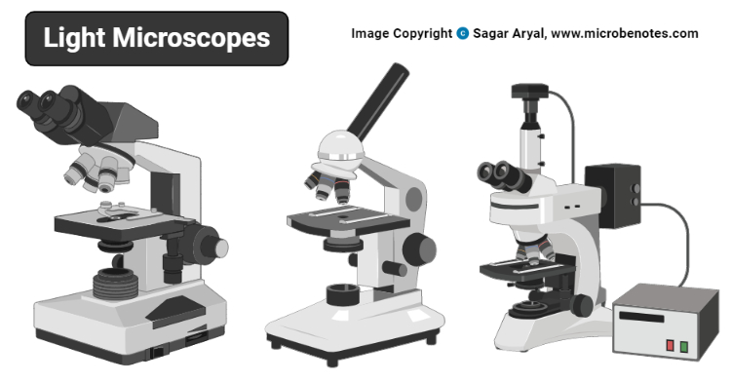

Principle of a light microscope (optical microscope)
As mentioned earlier, light microscopes visualize an image by using a glass lens and magnification is determined by, the lens’s ability to bend light and focus it on the specimen, which forms an image. When a ray of light passes through one medium into another, the ray bends at the interface causing refraction. The bending of light is determined by the refractive index, which is a measure of how great a substance slows the speed of light. The direction and magnitude of the bending of the light are determined by the refractive indexes of the two mediums that form the interface.
A medium with a lower refractive index such as glass to air, it normally speeds up the light penetration and making light bend away from the normal and when light is passed through a medium with a greater refractive index such as air to glass, it normally slows down and bends towards the normal, perpendicularly to the surface.
If an object is put between these two mediums i.e between water and air, in this case, a prism, the prism will bend the light at an angle. This is how the microscopic lenses work, they bend the light at an angle. The lens (convex) on receiving the light rays, it focuses the rays at a specific point known as the focal point (F-point). The measure of distance from the center of the lens and the focal point is known as the focal length.
A microscope uses lenses whose strength is predetermined, in that, the strength of a lens is directly related to the focal length i.e short focal length magnifies objects more than lenses with a long focal length.
Microscopy works strictly with a factor of resolution whereby resolution being the ability of a lens to be able to differentiate small objects that are closely packed together. The resolution of a light microscope is determined by a numerical aperture of its lens system and by the wavelength of the light it employs; a numerical aperture a definition of the light wavelengths produced when the specimen is illuminated.
A minimum distance (d) between two objects that distinguishes then to be two separate entities, determined by the wavelengths of the light can be calculated by an Abbe equation using the wavelength of the light that illuminated the specimen (Lambda, λ) and the numerical aperture (NA, n sin Ɵ) i.e. d=0.5 λ/n sin Ɵ

Types of light microscopes (optical microscope)
With the evolved field of Microbiology, the microscopes
used to view specimens are both simple and compound light microscopes, all using lenses. The difference is simple light microscopes use a single lens for magnification while compound lenses use two or more lenses for magnifications. This means, that a series of lenses are placed in an order such that, one lens magnifies the image further than the initial lens.
The modern types of Light Microscopes include:
- Bright field Light Microscope
- Phase Contrast Light Microscope
- Dark-Field Light Microscope
- Fluorescence Light Microscope

Brightfield Light Microscope (Compound light microscope)
- This is the most basic optical Microscope used in microbiology laboratories which produces a dark image against a bright background. Made up of two lenses, it is widely used to view plant and animal cell organelles including some parasites such as Paramecium after staining with basic stains.
- Its functionality is based on being able to provide a high-resolution image, which highly depends on the proper use of the microscope. This means that an adequate amount of light will enable sufficient focusing of the image, to produce a quality image.
- It is also known as a compound light microscope.

Parts of a bright-field microscope (Compound light microscope)
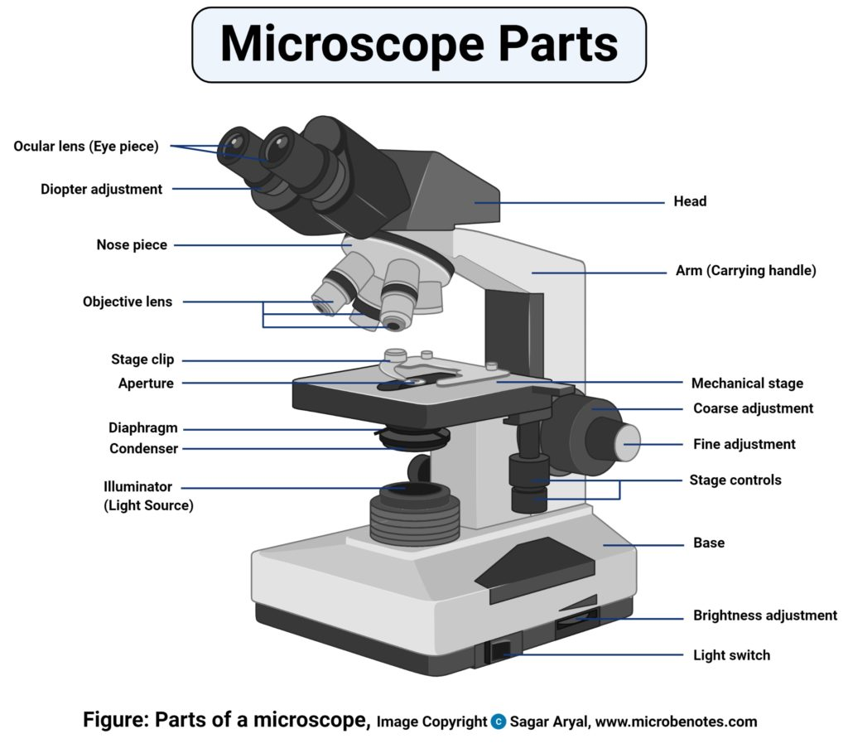

It is composed of:
- Two lenses which include the objective lens and the eyepiece or ocular lens.
- Objective lens is made up of six or more glasses, which make the image clear from the object
- The condenser is mounted below the stage which focuses a beam of light onto the specimen. It can be fixed or movable, to adjust the quality of light, but this entirely depends on the microscope.
- They are held together by a sturdy metallic curved back used as an arm and a stand at the bottom, known as the base, of the microscope. The arm and the base hold all the parts of the microscope.
- The stage where the specimen is placed, allowing movement of the specimen around for better viewing with the flexible knobs and it is where the light is focused on.
- Two focusing knobs i.e the fine adjustment knob and the coarse adjustment knob, found on the microscopes’ arm, which can move the stage or the nosepiece to focus on the image. the sharpen the image clarity.
- It has a light illuminator or a mirror found at the base or on the microbes of the nosepiece.
- The nosepiece has about three to five objective lenses with different magnifying power. It can move round to any position depending on the objective lens to focus on the image.
- An aperture diaphragm also is known as the contrast, which controls the diameter of the beam of light that passes through the condenser, in that, when the condenser is almost closed, the light comes through to the center of the condenser creating high contrast. But when the condenser is widely open, the image is very bright with very low contrast.

Magnification by Bright field Microscope (Compound light microscope)
During visualization, the objective lens remains parfocal which means, when the objective lens is changed, the image still remains in focus. The objective lens plays a major role in focusing the image on the condenser forming an enlarged clear image within the microscope, which is then further magnified by the eyepiece to a primary image.
What is seen in the microscope as an enlarged clear image of the specimen is known as the virtual image. To calculate the magnification, multiply the objective and eyepiece objective magnification together. The magnification is standard, i.e not too high nor too low, and therefore depending on the magnification power of the lenses, it will range between 40X and 100oX.
Calculation of magnification = Magnification of objective lens/magnification of the eyepiece lens
The objective lens plays a vital role in not only enlarging the image but also making it clear for viewing, a feature known as resolution. Resolution according to Prescott, is the ability of a lens to separate or distinguish between small objects closely linked together.
Whereas the eyepiece magnifies the image at the end of the viewing, its magnification range is lower than that of the objective lens at 8X-12X (10X standard) and that of the objective lens at 40X-100X, magnification, and resolution of the microscope is highly dependant on the objective lens.

Applications of the Bright Field Light Microscope (Compound light microscope)
Vastly used in Microbiology, this microscope is used to view fixed and live specimens, that have been stained with basic stains. This gives contrast for easy visibility under the microscope. Therefore it can be used to identify basic bacteria cells and parasitic protozoans such as Paramecium.

Phase Contrast Microscope
- This is a type of optical microscope whereby small light deviations know as phase shifts occur during light penetration into the unstained specimen. These phase shifts are converted into the image to mean, when light passes through the opaque specimen, the phase shifts brighten the specimen forming an illuminated (bright) image in the background.
- The phase-contrast microscope produces high contrast images when using a transparent specimen more so those of microbial cultures, thin tissue fragments, cell tissues, and subcellular particles.
- The principle behind the working of the phase-contrast microscope is the use of an optical method to transform a specimen into an amplitude image, that’s viewed by the eyepiece of the microscope.
- The PCM can be used to view unstained cells also known as the phase objects, which means that the morphology of the cell is maintained and the cells can be observed in their natural state, in high contrast and efficient clarity. This is because if the specimens are stained and fixed, they kill most cells, a characteristic that is uniquely undone by the brightfield light microscope.
- The shifts that occur during light penetration, become converted to changes in amplitude which causes the image contrast.
- Coupled with contrast-enhancing elements such as fluorescence, they produce better visuals of the specimens’ image.

Parts of the Phase Contrast Microscope
The instrumentation of the Phase Contrast Microscope is based on its light pathways from receiving the source of light to the visualization of the image.
Therefore its sequentially made up of:
- Light source (Mercury arc lamp)
- Collective lens
- Aperture
- Condenser
- Condenser annular
- Specimen
- Objective
- Phase plate
- Deflected light
- Phase ring

The functioning of the Phase Contrast microscope
- The change caused by the deviated scattered (Deflected) light and the undeviated light that reaches the specimen which is absorbed, create at a certain wavelength, producing color. The difference created by the scattered light and that of the absorbed light is known as amplitude variations. These amplitude variations are sensitive to allowing visualization by photographic equipment like the Phase Contrast Microscope, hence seen by the human eye.
- The Condenser of the phase-contrast microscope has an opaque disk that is known as an annular ring, with a transparent ring that produces a cone of light, that passes through a specimen. Due to light variations some light bend at the specimen, caused by variations in light density, forming an image at the objective lens. The undeviated light will strike the phase ring on the phase plate and the deviated light will miss the phase ring passing through the phase plate directly, this forms an image.
The Phase-Contrast Microscope is designed with objective lenses that have the ability to perform multiple functions when combined with contrast-enhancing techniques, for example, fluorescence. The objective lenses are located in the internal phase plate with variation in the light absorption and phase displacement i.e undiffraction, creating a wide spectrum for contrasting the specimen and forming a strong contrast in the background.

Applications of Phase-Contrast Microscope
- Determine morphologies of living cells such as plant and animal cells
- Studying microbial motility and structures of locomotion
- To detect certain microbial elements such as the bacterial endospores

Dark-Field Light Microscope
This is a specialized type of bright field light microscope which has several similarities to the Phase-Contrast Microscope. To make a dark field Microscope, place a darkfield stop underneath and a condenser lens which produces a hollow cone beam of light that enters the objective only, from the specimen
This technique is used to visualize living unstained cells. This is effected by the way illumination is done on the specimen in that, when a hollow cone beam of light is transmitted to the specimen, deviated light (unreflected/unrefracted) rays do not pass through the objectives but the undeviated (reflected/refracted) light passes through the objectives to the specimen forming an image.
This makes the surrounding field of the specimen appear black while the specimen will appear illuminated. This is enabled by the dark background this the name, dark-field Microscopy.

Applications of the Dark Field Microscope
- It is used to visualize the internal organs of larger cells such as the eukaryotic cells
- Identification of bacterial cells with distinctive shapes such as Treponema pallidum, a causative agent of syphilis.

The Fluorescent Microscope
The above-discussed microscopes will normally produce images after a light has been transmitted and passed through the specimen.
In the case of the fluorescent Microscope, the specimen emits light. How? By adding a dye molecule to the specimen. This dye molecule will normally become excited when it absorbs light energy, hence it releases any trapped energy as light. The light energy that is released by the excited molecule has a long wavelength compared to its radiating light. The dye molecule is normally a fluorochrome, that fluoresces when exposed to the light of a certain specific wavelength. The image formed is a fluorochrome-labeled image from the emitted light
The principle behind this working mechanism is that the fluorescent microscope will expose the specimen to ultra or violet or blue light, which forms an image of the specimen that is emanated by the fluorescent light. They have a mercury vapor arc lamp that produces an intense beam of light that passes through an exciter filter. The exciter filter functions to transmit a specific wavelength to the fluorochrome stained specimen, producing the fluorochrome-labeled image, at the objective.
After the objective, there is a barrier filter that functions primarily to remove any ultraviolet radiation that may be harmful to the viewer’s light, thus reducing the contrast of the image.
Figure created with biorender.com

Applications of the Fluorescent Microscope
- Used in the visualization of bacterial agents such as Mycobacterium tuberculosis.
- Used to identify specific antibodies produced against bacterial antigens/pathogens in immunofluorescence techniques by labeling the antibodies with fluorochromes.
- Used in ecological studies to identify and observe microorganisms labeled by the fluorochromes
- It can also be used to differentiate between dead and live bacteria by the color they emit when treated with special stains
Besides the above-discussed microscopes, there is one not commonly used microscope known as the Differential Interference Contrast Microscopy. It is very similar to the phase-contrast microscope whereby the images are formed from the variations in the light either deviated and or undeviated. The difference is, here two beams of light are emitted to the specimen and focused by a prism. One beam passes through the prism to the specimen while another passes through the glass slide clear area without the specimen. The two beams then combine and interfere with each other to form an image. It can be used to view cell structures such as endospores, bacterial cell walls, nuclei and granules for unstained specimens
2) Centrifuge
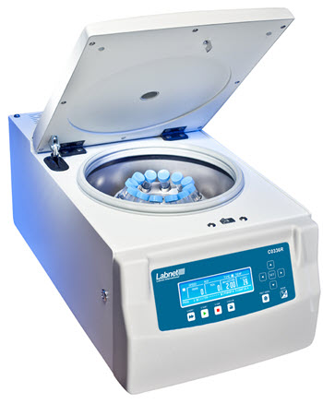
Centrifuges are used in various laboratories to separate fluids, gases, or liquids based on density. In research and clinical laboratories, centrifuges are often used for cell, organelle, virus, protein, and nucleic acid purification.
An example of centrifuge use in a clinical setting is for the separation of whole blood components. Different assays necessitate serum or plasma, which may be obtained with centrifugation.
Serum is obtained by letting a whole blood sample clot at room temperature. The sample is then centrifuged and the clot is removed, leaving a serum supernatant.
Unlike serum, plasma is obtained from whole blood that is not left to clot, and contains serum along with clotting factors. To obtain plasma, a whole blood sample is collected in tubes treated with anticoagulants. Following centrifugation, cells are removed and plasma supernatant remains.

Principles of centrifugation
A centrifuge is used to separate particles suspended in a liquid according to particle size and density, viscosity of the medium, and rotor speed.
Within a solution, gravitational force will cause particles of higher density than the solvent to sink, and those less dense than the solvent to float to the top. Centrifugation takes advantage of even minute differences in density to separate particles within a solution.
As the rotor spins around a central axis, it generates a centrifugal force acting to move particles away from the axis of rotation. If the centrifugal force exceeds the buoyant forces of liquid media and the frictional force created by the particle, the particles will sediment.

Centrifuge Rotor Types
There are two very common rotor designs: fixed angle, and swinging bucket. The fixed angle rotor is designed to hold tubes in a fixed position at a fixed angle relative to the vertical axis of rotation (up to about 45°). Centrifugation will cause particles to sediment along the side and bottom of the tube. The swinging bucket design allows the tubes to swing out from a vertical resting position to become parallel to the horizontal during centrifugation. As a result, sediment will form along the bottom of the tube.
Fixed angle rotors are ideal for pelleting applications either to remove particles from a suspension and discard the debris or to recover the pellet, whereas swinging bucket rotors are best for separating large volume samples at low speeds and resolving samples in rate-zonal (density) gradients.

How to choose a centrifuge

Centrifuge speed
(RPM). Speeds range from 0-7,500 RPM for low-speed centrifuges, all the way to 20,000 RPM or higher.
Centrifuge rotor speed is often expressed as RCF in units of gravity (x g) for various procedures. However, many centrifuges display speed as revolutions per minute (RPM), necessitating conversion to ensure the correct experimental conditions. The following formula is used to convert RPM to RCF, where R is the rotor radius (cm) and S is the speed (RPM):
g = (1.118 x 10⁻⁵) R S²

Centrifuge size
Centrifuges are available as various benchtop or floor-standing models.
Floor-standing models offer greater sample capacity and can achieve high speeds. Superspeed centrifuges can achieve a maximum g-force (relative centrifugal force, RCF) of over 70,000 x g, and ultracentrifuges often used for DNA or RNA fractionation, can achieve up to 1,000,000 x g. For large-capacity, low-speed applications, low-speed centrifuges reaching approximately 7000 x g are available.
Benchtop models have a smaller footprint, and general-purpose models are ideal for a wide range of applications. There are many benchtop models available, including high-speed, microcentrifuge, clinical, and cell washer models. Clinical benchtop models and cell washers typically operate at lower speeds, and are suited to diagnostic applications, and washing debris from red blood cells.

Centrifuges for different applications
It is essential to select a centrifuge that is suited to the specific application. When purchasing a centrifuge, it is important to consider the following questions:
- What sample volumes are you working with? For processes involving large or varying volumes, a floor-standing model with higher capacity and different rotor configurations may be the best solution.
- Are samples temperature sensitive? If so, a centrifuge with refrigeration and temperature control options is required.
- Will the centrifuge be used for processing clinical or blood banking samples? Cell washers or clinical models are available for these specific applications.
- How much laboratory space is available vs the centrifuge footprint?
- What is the maximum g-force the centrifuge is capable of generating? Low-speed centrifuges are ideal for separating whole cells, while ultracentrifuges are necessary for separating DNA and RNA.

Precautions to be taken while working with a centrifuge

Ensure a sturdy, level worksurface
Always ensure the centrifuge is on an appropriate surface prior to operation.

Balance the centrifuge
Running an unbalanced centrifuge may cause significant damage, and injure the operator and other laboratory personnel. The total mass of each tube should be as close as possible- this becomes increasingly important at very high rotor speeds. Balancing masses to the nearest 0.1 gram is advisable, and it is important to balance tubes by mass, not volume. For example, do not balance a sample consisting of liquid with a higher or lower density than water with an equal volume of water.

Do not open the lid while the rotor is moving
Many centrifuges have a “safety shutoff”. However, this will only stop power to the rotor, which will still spin due to its own inertia for some time until it is slowed to a stop by friction.

If the centrifuge is wobbling or shaking, pull the plug
A little vibration is normal, but excessive amounts can mean danger. First, double check that the tubes are correctly balanced. If this does not resolve the issue, do not operate the centrifuge until it has been serviced by the manufacturer or dealer.

Why you need to balance a centrifuge
Prior to starting the centrifuge, it is necessary to load it correctly. Balancing the centrifuge prevents potential damage to the instrument, and is crucial for safe operation.

How to balance a centrifuge
- Ensure all sample tubes are evenly filled. If additional tubes are required for balancing, fill them with water or a liquid of similar density to the sample, and ensure the mass is balanced to the nearest 0.1 grams.
- For each tube inserted in the rotor, add a tube of equal weight directly opposite it. This will ensure the center of gravity remains in the center of the rotor.
- Rotate the rotor 90° and add two additional tubes directly opposite one another.
- Repeat.

Centrifuge care and maintenance
A few simple steps can keep a centrifuge functioning properly and reduce the risk of damage or injury.
- Keep the centrifuge properly lubricated. O-rings are the main source of protection against sample leakage, and must be lubricated prior to installation of a new rotor or following cleaning. Any threaded components should also be cleaned regularly and lubricated with an approved grease to ensure proper operation and to prevent cross-threading and corrosion.
- Ensure all users are aware of how to properly operate the centrifuge, including ensuring buckets are properly seated in their pins, balancing tubes in the rotor, operating rotors within stated guidelines for speed and maximum compartment mass, and avoiding scratching the rotor.
- Inspect critical components, and look for signs of wear including scratches, or effects of chemical exposure on the rotor.
- Pay close attention to noise, vibration, shaking, or grinding and stop the unit immediately if this occurs.

Centrifuge cleaning
Regularly clean the centrifuge with neutral cleaning solutions (alcohol or alcohol-based disinfectant) applied with a soft cloth to rotors and accessories. Daily cleaning should include the interior portion of the centrifuge, the rotor chamber, and surfaces with electronic components, such as touchscreens and keypads.
It is important to be aware of the different types of samples used with the centrifuge and any specific products or protocols necessary for cleaning spills.

2) Automatic tissue processor
An automatic tissue processor is used to process animal and human tissues automatically. It is accurate and easy to use and maintain. It is an excellent choice for histology and pathology labs of hospitals and research institutions.
Tissue processing is the technique of getting fixed tissue into paraffin is called tissue processing. The main steps in this process are dehydration and clearing. Wet fixed tissues (in aqueous solutions) cannot be directly infiltrated with paraffin.
Principle of tissue processing :Tissue processing is concerned with the diffusion of various substances into and out of porous tissues. Diffusion results from the tendency of processing reagents to equalize concentrations both inside and outside blocks of tissue.
There are two main types of processors, the tissue-transfer (or “dip and dunk”) machines where specimens are transferred from container to container to be processed, or the fluid-transfer (or “enclosed”) types where specimens are held in a single process chamber or retort and fluids are pumped in and out as required. Most modern fluid-transfer processors employ raised temperatures, effective fluid circulation and incorporate vacuum/pressure cycles to enhance processing and reduce processing times.
Modern enclosed tissue processor
Modern enclosed tissue processor
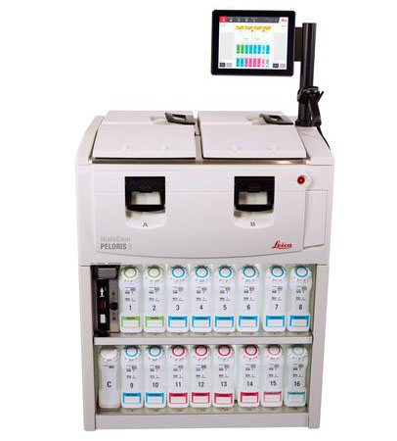
"Dip and dunk" processors are still a good option for smaller labs.
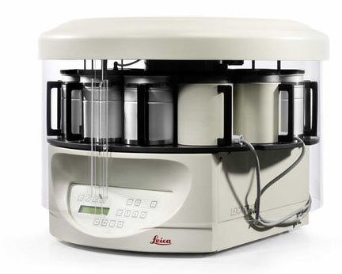
Patients rely on quality tissue processing

The importance of tissue processing
Most laboratory supervisors would emphasize to their staff the importance of tissue processing. It is worthwhile to stress that use of an inappropriate processing schedule or the making of a fundamental mistake (perhaps in replenishing or sequencing of processing reagents) can result in the production of tissue specimens that cannot be sectioned and therefore will not provide any useful microscopic information. This can be disastrous if you are dealing with diagnostic human tissue where the whole of the specimen has been processed (“all in”). There is no spare tissue. There is no diagnosis. There is however a patient to whom an explanation has to be provided.
Although mechanical or electrical faults occasionally occur in tissue processors, processing mishaps where tissues are actually compromised, mainly occur because of human error. It is important to emphasize the value of proper education and training for those carrying out tissue processing and the need to apply particular care when setting up a processor for any processing run.
.
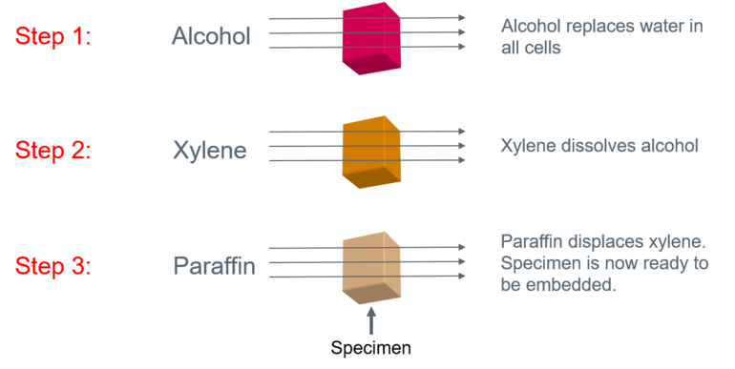

Overview of the steps in tissue processing for paraffin sections
1. Obtaining a fresh specimen
Fresh tissue specimens will come from various sources. It should be noted that they can very easily be damaged during removal from patient or experimental animal. It is important that they are handled carefully and appropriately fixed as soon as possible after dissection. Ideally fixation should take place at the site of removal, perhaps in the operating theatre, or, if this is not possible, immediately following transport to the laboratory.
2. Fixation
The specimen is placed in a liquid fixing agent (fixative) such as formaldehyde solution (formalin). This will slowly penetrate the tissue causing chemical and physical changes that will harden and preserve the tissue and protect it against subsequent processing steps.² There are a limited number of reagents that can be used for fixation as they must possess particular properties that make them suitable for this purpose. For example tissue components must retain some chemical reactivity so that specific staining techniques can be applied subsequently.³ Formalin, usually as a phosphate-buffered solution, is the most popular fixative for preserving tissues that will be processed to prepare paraffin sections. Ideally specimens should remain in fixative for long enough for the fixative to penetrate into every part of the tissue and then for an additional period to allow the chemical reactions of fixation to reach equilibrium (fixation time). Generally this will mean that the specimen should fix for between 6 and 24 hours. Most laboratories will use a fixative step as the first station on their processor.
Following fixation the specimens may require further dissection to select appropriate areas for examination. Specimens that are to be processed will be placed in suitable labelled cassettes (small perforated baskets) to segregate them from other specimens. The duration of the processing schedule used to process the specimens will depend on the type and dimensions of the largest and smallest specimens, the particular processor employed, the solvents chosen, the solvent temperatures and other factors. The following example is based on a six hour schedule suitable for use on a Leica Peloris™ rapid tissue processor.
3. Dehydration
Because melted paraffin wax is hydrophobic (immiscible with water), most of the water in a specimen must be removed before it can be infiltrated with wax. This process is commonly carried out by immersing specimens in a series of ethanol (alcohol) solutions of increasing concentration until pure, water-free alcohol is reached. Ethanol is miscible with water in all proportions so that the water in the specimen is progressively replaced by the alcohol. A series of increasing concentrations is used to avoid excessive distortion of the tissue.
A typical dehydration sequence for specimens not more than 4mm thick would be:
- 70% ethanol 15 min
- 90% ethanol 15 min
- 100% ethanol 15 min
- 100% ethanol 15 min
- 100% ethanol 30 min
- 100% ethanol 45 min
At this point all but a tiny residue of tightly bound (molecular) water should have been removed from the specimen.
4. Clearing
Unfortunately, although the tissue is now essentially water-free, we still cannot infiltrate it with wax because wax and ethanol are largely immiscible. We therefore have to use an intermediate solvent that is fully miscible with both ethanol and paraffin wax. This solvent will displace the ethanol in the tissue, then this in turn will be displaced by molten paraffin wax. This stage in the process is called “clearing” and the reagent used is called a “clearing agent”. The term “clearing” was chosen because many (but not all) clearing agents impart an optical clarity or transparency to the tissue due to their relatively high refractive index. Another important role of the clearing agent is to remove a substantial amount of fat from the tissue which otherwise presents a barrier to wax infiltration.
A popular clearing agent is xylene and multiple changes are required to completely displace ethanol.
A typical clearing sequence for specimens not more than 4mm thick would be:
- xylene 20 min
- xylene 20 min
- xylene 45 min
5. Wax infiltration
The tissue can now be infiltrated with a suitable histological wax. Although many different reagents have been evaluated and used for this purpose over many years, the paraffin wax-based histological waxes are the most popular. A typical wax is liquid at 60°C and can be infiltrated into tissue at this temperature then allowed to cool to 20°C where it solidifies to a consistency that allows sections to be consistently cut. These waxes are mixtures of purified paraffin wax and various additives that may include resins such as styrene or polyethylene. It should be appreciated that these wax formulations have very particular physical properties which allow tissues infiltrated with the wax to be sectioned at a thickness down to at least 2 µm, to form ribbons as the sections are cut on the microtome, and to retain sufficient elasticity to flatten fully during flotation on a warm water bath.
A typical infiltration sequence for specimens not more than 4mm thick would be:
- wax 30 min
- wax 30 min
- wax 45 min
6. Embedding or blocking out
Now that the specimen is thoroughly infiltrated with wax it must be formed into a “block” which can be clamped into a microtome for section cutting. This step is carried out using an “embedding centre” where a mould is filled with molten wax and the specimen placed into it. The specimen is very carefully orientated in the mould because its placement will determine the “plane of section”, an important consideration in both diagnostic and research histology. A cassette is placed on top of the mould, topped up with more wax and the whole thing is placed on a cold plate to solidify. When this is completed the block with its attached cassette can be removed from the mould and is ready for microtomy. It should be noted that, if tissue processing is properly carried out, the wax blocks containing the tissue specimens are very stable and represent an important source of archival material.

TISSUE PROCESSOR MAINTENANCE PRINCIPLE Tissue processor maintenance is necessary to maintain well processed blocks and well stained slides. This ensures definite reporting by the pathologist. Reagent change is crucial to obtain well processed blocks. The processor is present for quality control of the reagents based on specific gravity, block counts and day of the week. When the usage limit is reached the ‘yellow triangle alert’ will appear on the screen. You should change the reagents before running the next process.
REAGENTS
1. Formalin 2. Absolute alcohol 3. Xylene 4. Melted paraffin wax
REPLACING FIXATIVE REAGENTS FIX 1&2
When you see the yellow warning triangle alert, open the lower doors – the quality control screen appears. Then:
1. Remove the reagents Fix 1&2 and discard them 2. Highlight Fix 1 and select (REMOVE) 3. Highlight Fix 2 and select (REMOVE) 4. Put new bottles of fixative in positions of Fix 1& Fix 2 5. Highlight Fix 2 and select (NEW)
PROCESS FLOW PRINTMATE Start Choose color of cassette in TDHC Etc cassette Grossing End SLIDEMATE Start Change date

3) Microtome
Microtomy is a method for the preparation of thin sections for materials such as bones, minerals and teeth, and an alternative to electropolishing and ion milling. Microtome sections can be made thin enough to section a human hair across its breadth, with section thickness between 50 nm and 100 μm. Microtome is the machine used
Principle: The device operates using a cutting action of an infra-red,in this wavelength regime the laser can interact with biological materials

TYPES OF MICROTOMES –
1.) Rotary microtome
The Rotary microtome is so-called because of a Rotary action of the handwheel responsible for the cutting moment. The block holder is mounted on a steel carriage, which makes up and down in groves this type of instrument is the most ideal for routine and research work it is excellent for cutting serial sections.
Parts of the rotary microtomes
- Block holder
- Knife clamp screw
- Knife clamps
- Block adjustment
- Thickness gauge
- The angle of tilt adjustment
- Operating handle
ROTARY MICROTOME
Here the feed mechanism is activated by turning a wheel on one side of the machine. The knife is fixed with its edge fixed upwards and the object is moved against the knife rising and falling vertically.
One rotation of the operating wheel produces a complete cycle downwards cutting stroke and an upward return stroke and activation of the advanced mechanism. It is often modified to cut ultrathin sections between 50Å – 200Å
The wheel may be electrically operated or manually. In the former case the hands may be made free for tissue maintenance, makes it available for incorporation in automated
Advantages of the Rotary microtome
- Heavy and stable.
- Ideal for serial sections in large numbers.
- Paraffin-embedded tissues are cut by a rotary microtome.
- The knife holder is movable.
- The sections are cut are flat.
- It is useful for routine and research papers.
2.) Sliding or Base Sledge Microtome
This is a large heavy instrument with a fixed knife beneath which the object moves mounted on a heavy sliding base containing the feed mechanism used primarily for cutting the sections of cellulose nitrate embedded tissues with an obliquely set knife.
Parts of Base-sledge microtome
- Angular tilt adjustment
- Knife clamps
- Block holder
- Coarse feed adjustment
- Operating handle
- Thickness gauge
- Adjustment locking nut
- Block adjustment screw
- Split nut clasp
The blocks holder is mounted on a steel carriage which slides backward and forwards on groups against a fixed horizontal knife this microtome is heavy and very stable. The block is raised towards the knife at a predetermined thickness. This type of microtome is designed for cutting sections of very large blocks of tissues for example whole brain, this microtome has become popular for routine use.
Advantages of Base-sledge microtome
- It is useful for cutting extremely hard blocks and large sections.
- The microtome is heavy and stable.
- The knife used is sledge shaped which requires less honing.
3.) Cambridge rocking microtome
The instrument is so named because the arm has to move in a rocking motion while cutting the sections. The instrument was invented by Sir Horace Darwin in 1881 was developed by Cambridge company hence it is called the Cambridge rocking microtome. It is a simple machine in which the knife is held by means of microtome thread. The rocking microtome was designed primarily for cutting paraffin wax sections but in an emergency use frozen section by inserting a wooden block in which the tissue is frozen.
Parts of the rocking microtomes
- Knife holder
- Block holder or chuck
- Upper arm
- Screw
- Lever
- Pawl
- Ratchet wheel
- Mil head microtome screw
- Sleeve
- Lower Arm
- Scale

It cuts the sections between 1 to 20 microns. The knife is fixed with the edge, while the object is moved against this knife circularly, producing a sharply curved surface to the block with each stroke the tissue holder automatically moves vertically towards the life. Cutting stroke is Spring operated and is easy to handle. The microtome must be placed on a solid non-slippery surface to allow a better hold
Advantages of Cambridge rocking microtomes
- The cost of a knife and microtome is low.
- Celloidin embedded tissues can be sectioned easily.
4.) Freezing microtomes
This type has been designed for the production or preparation of frozen sections of fluid and non-fluid tissues usually without preliminary embedding. The object stage is connected to the cylinder of compressed carbon dioxide for the rapid cooling of the tissues and provisions are also made for the cooling of the knife.
Part of freezing type microtome
- Knife clamps
- Operating handle
- Thickness gauge
- Stage
- Stage valve
- Coarse adjustment
The movement of the knife takes place horizontally across the surface of the tissues. Ribbon sections cannot be prepared using this microtome. All freezing microtomes have the feature of employing a non-movable tissue block and cooling system.
Advantages of Freezing microtome
- It is used for sections required for Rapid diagnosis
- It cuts non-dehydrated fresh tissue in a frozen state.
- The method is useful for Rapid histopathological diagnosis during operation
- This type of microtome is also used when lipids, enzymes, and neurological structures are to be demonstrated.
Nowadays, the most commonly used type of microtome is a Rotary microtome which is easy to operate and ideal for routine use for diagnosis and research purposes.

WORKING PRINCIPLE OF ROTARY MICROTOME –
⇒ It is used for slicing paraffin tissue sections of uniform thickness.
⇒ This method is designed to cut 1-60 micron thick sections.
⇒ A knob on the device (typically at the backside) is used to modify the thickness of the sections.
⇒ A knife is constant inside the knife holder and clamped tightly.
⇒ The tissue block is drawn throughout the knife-edge and it is mechanically advanced. The top and bottom of the block have to be parallel and horizontal and as a minimum 1mm of paraffin has to be present in all aspects beyond the tissue.
⇒ The trimming of the edges of the block is usually completed with a single-sided razor blade and the block face is trimmed with the microtome knife.
⇒ The technician decides the type of section to be made in line with the nature of tissue and instructions received from the pathologist.
⇒ At some stage in section slicing, as the wheel of the microtome turns, sections are cut and slide on the knife. A ribbon of sections is produced.
⇒ The ribbon of sections is transferred to warm water inside the tissue floatation bath to put off any wrinkles present in the section.
⇒ The best quality section that is free from any scratches and cracks can be decided on from the tissue ribbons. The tissue ribbons are then taken on smooth glass slides with a respective identification number.
⇒ The slides are pulled from the water and the preferred sections are positioned flat on the surface of glass slides. The slides with the sections are positioned on a rack in a hot air oven to dry.
Safety
Working with microtomes, whether preparing or cutting a sample, is a true art. You need specific hands-on training from your supervisor before using a microtome. Because of the associated hazards, safety must be incorporated into every step of the process to keep fingers and hands protected. Follow the safety tips provided below to keep your fingers, hands, and your artistic touch in perfect condition and to prevent exposure to solvents and biologicals.
- Handle blades very carefully when installing or removing. Follow the manufacturer’s guidelines explicitly.
- Tungsten-Carbide knives can cut through your shoes if dropped. Be careful where your feet are positioned when installing or removing blades.
- Store blades in a covered container. Use a container that has guides to hold the blades rigid.
- Never leave blades on countertops. Lacerations can occur when reaching across the countertop and inadvertently contacting an unprotected blade.
- When setting up the microtome, position the sample first then put in the blade. Never the other way around.
- When applying the brake, ensure that it is tight. Most accidents occur when the brake slips and the operator’s hand is drawn into the blade.
- When leaving the microtome, even for a short time, ensure that the blade guard is in place.
- When preparing a paraffin sample for the Microtome, remember to clamp the sample down tight. The movement allowed by a loose clamp increases your risks of cuts.
- Use forceps to retrieve slices from the boat and to retrieve ribbons, thereby keeping your hands free from the moving parts of the microtome.
- To avoid compression or knife marks, ensure that your blade is clean. Follow the manufacturer’s guidelines for cleaning. A high-density polystyrene rod can be used to clean the blade, freeing your hands from potential contact.
- Prions are not deactivated by the standard microtome preparation steps. You must wear gloves and use appropriate decontamination procedures when samples may contain prions.
Use and Care of a microtome
A. Your microtome knife has been coated with an oil mixture to prevent rust and corrosion when not in use.
B. Before using your knife, take a lint-free facial tissue saturated in either zylene, benzene or acetone to remove the protective oil coating on the knife.
C. Use a dry, lint-free, facial tissue to wipe your knife clean. DO NOT USE GAUZE or any other coarse material; it will destroy the edge of your knife.
D. Your knife has already been stropped and is now ready for immediate use.
CARING FOR YOUR MICROTOME KNIFE
A. Keep the edge of your knife clean at all times.
B. Spray or brush any household oil on your knife to prevent rust when not in use.
C. Store your knife in its case to prevent oxidation from occurring.
D. If you are using a lab sharpener, periodically send your knife out to be professionally reconditioned.
1. Extremely wide facets result from the continuous use of a lab sharpener. The optimum bevel angle becomes distorted as a result of the facet changes. This diminishes your cutting performance.
2. Double facets may develop on your knife’s edge, creating distorted sections.
HINTS FOR USING YOUR MICROTOME KNIFE
A. To maximize the sharpness of your knife’s edge, use an old knife to trim your first block, or use the extreme end of your new or reconditioned knife.
B. Continuously remove the paraffin, or other embedding medium, on the front and back of your knife to maximize your cutting performance.
C. Depending on the texture of the tissue you have been cutting, you may be able to use the other side of your knife for extended use.
D. Setting your knife at the proper clearance angle will obviously not only enhance your output but it will also extend the life of your knife’s edge.
E. Maintain a sharp edge on your knife. Even the most highly skilled technologists cannot overcome the handicaps created from using a dull or bruised knife.
F. Based on the facet / bevel angle created in our reconditioning process, we recommend a clearance angle between 6 and 8 degrees.
G. When your knife is reaching its dimensional maturity, i.e., the width of the knife’s surface is less than 7/8 of an inch, proper knife stability is difficult to achieve in the holder. Placing a hexagonal pencil at the base of the knife within the holder will act as a filler and provides it with the support required.

