NAME: Aibangbee Efeosa Anthonia
DEPARTMENT: Pharmacy
MATRIC NO.: 19/MHS11/021
COURSE: CHEMISTRY (CHM 102)
Assignment
- Alcohols are very important organic compounds. Discuss briefly their classification and give one example each.
Alcohols can be classified according to their number of alkyl group surrounding the functional groups which are;
Primary alcohols- 2 or 3 hydrogen atoms attached to carbon bearing the hydroxyl group e.g. methanol
Secondary alcohols- 1 hydrogen atoms attached to carbon bearing the hydroxyl group e.g. propan-2-ol
Tertiary alcohols- no hydrogen atoms attached to carbon bearing the hydroxyl group e.g. MethylPropan-2-ol

Or according to the number of hydroxyl group in a compound which are;
Monohydric alcohols- 1 hydroxyl group present e.g. propanol
Dihydric alcohols- 2 hydroxyl groups present also known as glycol e.g. ethan-1,2-diol
Polyhydric alcohols- more than 2 hydroxyl groups present. Also known as polyol e.g. propan-1,2,3-triol

- Discuss the solubility of alcohols in water, organic solvents
Polar dissolves polar and non polar dissolves non polar but the case is different for alcohols. They are soluble in water due to the hydroxyl group present via strong hydrogen bond. Their solubility decreases with increasing alkyl groups. All monohydric alcohols are soluble in organic solvents.
- Show the three steps in the industrial manufacture of ethanol. Equations of reaction are mandatory
i. Hydrolysis of starch
Starch is hydrolyzed to maltose by an enzyme called diastase
2(C₆H₁₀O₅) + _{n}H₂O $\underset{→}{diastase}$ n (C₁₂H₂₂O₁₁) 1st step
Starch 60$℃$ Maltose

ii. Fermentation
Finally, yeast is added to maltose
C₁₂H₂₂O₁₁ + H₂O $\underset{→}{maltase}$ 2C₆H₁₂O₆ 2nd step
Maltose 15$℃$ glucose

C₆H₁₂O₆ $\underset{→}{zymase}$ C₂H₅OH + 2CO₂ 3rd step
Glucose 15$℃$ ethanol

- Show the reaction between 2-methylpropanal and butylmagnesiumchloride Hint: Grignard synthesis
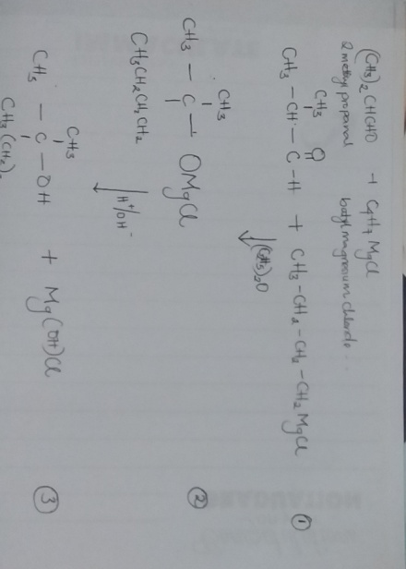

5. Show the reduction reaction of 2-methylpropanal
The product of reduction of aldehyde is primary alcohol by usual reducing agent such as lithiumtetrahydridoaluminate(iii) in ethoxyethane
(CH3)₂CHCHO + 2[H] $\underset{→}{LiAlH4/(c2h5)2o}$ (CH₃)₂CHCH₂OH

6. Propose a scheme for the conversion of propan-1-ol to propan-2-ol.
Propan-1-ol is dehydrated to propene which is then hydrolysed following markonikoff’s rule
