16/MHS06/022

QUESTION 1.
PHYSICS OF THE LIGHT MICROSCOPE.
The basic principle of the light microscope is: the microscope consists of two lens systems, the objective and the eyepiece. The objective forms a real image of the specimen, and this image is
viewed through the eyepiece forming a virtual image at infinity.
Τηε οϖεραλλ μαγνιφιχατιον οφ α μυλτιπλε−ελεμεντ σψστεμ (λικε αν οπτιχαλ μιχροσχοπε) ισ τηε προδυχτ οφ τηε μαγνιφιχατιονσ οφ ιτσ ινδιϖιδυαλ ελεμεντσ. Τηε σιμπλεστ χομπουνδ μιχροσχοπε ισ χονστρυχτεδ φρομ τωο χονϖεξ λενσεσ; Τηε φιρστ λενσ ισ χαλλεδ τηε οβϕεχτιϖε λενσ, ανδ ηασ τψπιχαλ μαγνιφιχατιον ϖαλυεσ φρομ 5× το 100×. Ιν στανδαρδ μιχροσχοπεσ, τηε οβϕεχτιϖεσ αρε μουντεδ συχη τηατ ωηεν ψου σωιτχη βετωεεν οβϕεχτιϖεσ, τηε σαμπλε ρεμαινσ ιν φοχυσ. Οβϕεχτιϖεσ αρρανγεδ ιν τηισ ωαψ αρε δεσχριβεδ ασ παρφοχαλ. Τηε σεχονδ, τηε εψεπιεχε, αλσο ρεφερρεδ το ασ τηε οχυλαρ, ηασ σεϖεραλ λενσεσ ωηιχη σλιδε ινσιδε α χψλινδριχαλ βαρρελ. Τηε φοχυσινγ αβιλιτψ ισ προϖιδεδ βψ τηε μοϖεμεντ οφ βοτη τηε οβϕεχτιϖε λενσ ανδ τηε εψεπιεχε. Τηε πυρποσε οφ α μιχροσχοπε ισ το μαγνιφψ σμαλλ οβϕεχτσ, ανδ βοτη λενσεσ χοντριβυτε το τηε φιναλ μαγνιφιχατιον. Αδδιτιοναλλψ, τηε φιναλ ενλαργεδ ιμαγε ισ προδυχεδ ιν α λοχατιον φαρ ενουγη φρομ τηε οβσερϖερ το βε εασιλψ ϖιεωεδ, σινχε τηε εψε χαννοτ φοχυσ ον οβϕεχτσ ορ ιμαγεσ τηατ αρε τοο χλοσε.

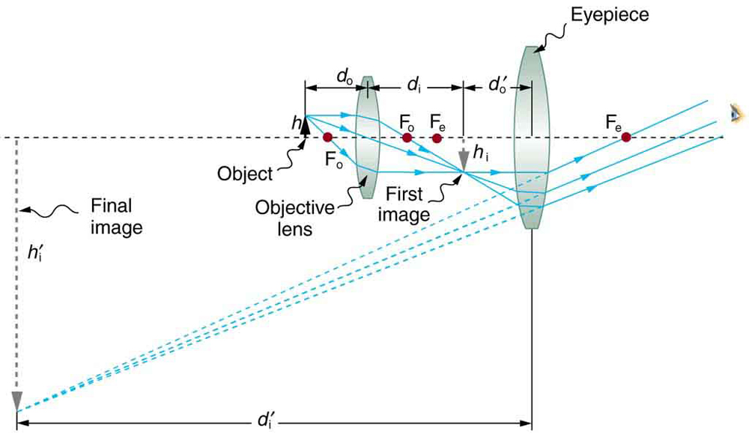
Α χομπουνδ μιχροσχοπε χομποσεδ οφ τωο λενσεσ, αν οβϕεχτιϖε ανδ αν εψεπιεχε. Τηε οβϕεχτιϖε φορμσ α χασε 1 ιμαγε τηατ ισ λαργερ τηαν τηε οβϕεχτ. Τηισ φιρστ ιμαγε ισ τηε οβϕεχτ φορ τηε εψεπιεχε. Τηε εψεπιεχε φορμσ α χασε 2 φιναλ ιμαγε τηατ ισ φυρτηερ μαγνιφιεδ.

Τηε οβϕεχτ ισ σλιγητλψ φαρτηερ αωαψ φρομ τηε οβϕεχτιϖε λενσ τηαν ιτσ φοχαλ λενγτη φο, προδυχινγ α χασε 1 ιμαγε τηατ ισ λαργερ τηαν τηε οβϕεχτ. Τηισ φιρστ ιμαγε ισ τηε οβϕεχτ φορ τηε σεχονδ λενσ, ορ εψεπιεχε. Τηε εψεπιεχε ισ ιντεντιοναλλψ λοχατεδ σο ιτ χαν φυρτηερ μαγνιφψ τηε ιμαγε. Τηε εψεπιεχε ισ πλαχεδ σο τηατ τηε φιρστ ιμαγε ισ χλοσερ το ιτ τηαν ιτσ φοχαλ λενγτη φε. Τηυσ τηε εψεπιεχε αχτσ ασ α μαγνιφψινγ γλασσ, ανδ τηε φιναλ ιμαγε ισ μαδε εϖεν λαργερ. Τηε φιναλ ιμαγε ρεμαινσ ινϖερτεδ, βυτ ιτ ισ φαρτηερ φρομ τηε οβσερϖερ, μακινγ ιτ εασψ το ϖιεω (τηε εψε ισ μοστ ρελαξεδ ωηεν ϖιεωινγ δισταντ οβϕεχτσ ανδ νορμαλλψ χαννοτ φοχυσ χλοσερ τηαν 25 χμ). Σινχε εαχη λενσ προδυχεσ α μαγνιφιχατιον τηατ μυλτιπλιεσ τηε ηειγητ οφ τηε ιμαγε, ιτ ισ αππαρεντ τηατ τηε οϖεραλλ μαγνιφιχατιον μ ισ τηε προδυχτ οφ τηε ινδιϖιδυαλ μαγνιφιχατιονσ: Μ = ΜοΜε, ωηερε μο ισ τηε μαγνιφιχατιον οφ τηε οβϕεχτιϖε ανδ με ισ τηε μαγνιφιχατιον οφ τηε εψεπιεχε. Τηισ εθυατιον χαν βε γενεραλιζεδ φορ ανψ χομβινατιον οφ τηιν λενσεσ ανδ μιρρορσ τηατ οβεψ τηε τηιν λενσ εθυατιονσ, συχη ασ φορ α μιχροσχοπε.
The total magnification of a microscope is obtained by multiplying the objective and eyepiece magnifications. The image formed is (usually) not presented as a real image, but rather as a virtual image viewed through the eyepiece. The somewhat arbitrary definition for microscope magnification is the following:

Magnification = The angle subtended by a (small) object as seen through the microscope
The angle when the same object is viewed by the naked eye at a distance of 250 mm.
we can express the magnifications of the objective, Mo, and eyepiece, Me, as
Mo= H/h = b/a,

Me = 250(mm)/ fe(mm).
The numerical aperture is defined by: N.A. = νσιν α
ωηερε ν ισ τηε ρεφραχτιϖε ινδεξ ανδ α τηε ανγλε οφ αχχεπτανχε.

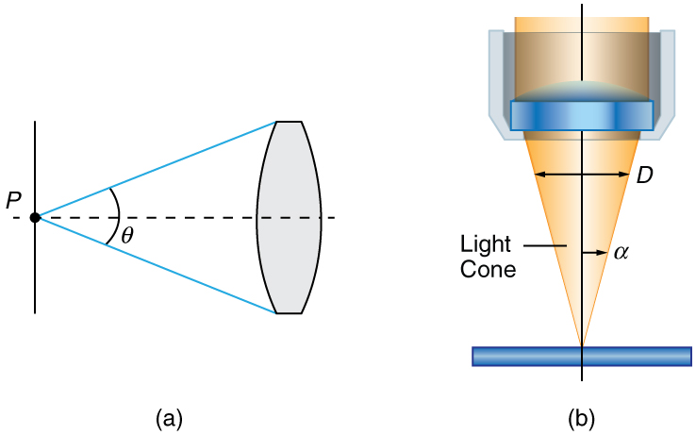

(α) Τηε νυμεριχαλ απερτυρε οφ α μιχροσχοπε οβϕεχτιϖε λενσ ρεφερσ το τηε λιγητ−γατηερινγ αβιλιτψ οφ τηε λενσ ανδ ισ χαλχυλατεδ υσινγ ηαλφ τηε ανγλε οφ αχχεπτανχε . (β) Ηερε, ισ ηαλφ τηε αχχεπτανχε ανγλε φορ λιγητ ραψσ φρομ α σπεχιμεν εντερινγ α χαμερα λενσ, ανδ ισ τηε διαμετερ οφ τηε απερτυρε τηατ χοντρολσ τηε λιγητ εντερινγ τηε λενσ.

Ιμμερσιον τεχηνιθυεσ αρε οφτεν υσεδ το ιμπροϖε τηε λιγητ γατηερινγ αβιλιτψ οφ μιχροσχοπεσ. Τηε σπεχιμεν ισ ιλλυμινατεδ βψ τρανσμιττεδ, σχαττερεδ ορ ρεφλεχτεδ λιγητ τηουγη α χονδενσερ.
Τηε φ/# δεσχριβεσ τηε λιγητ γατηερινγ αβιλιτψ οφ α λενσ. Ιτ ισ γιϖεν βψ :
φ/# = φ/Δ ≈ 1/2ΝΑ

QUESTION 2.

CENTRIFUGE.
A centrifuge is a piece of equipment that puts an object in rotation around a fixed axis (spins it in a circle), applying a force perpendicular to the axis of spin (outward) that can be very strong. The centrifuge works using the sedimentation principle, where the centrifugal acceleration causes denser substances and particles to move outward in the radial direction. At the same time, objects that are less dense are displaced and move to the center. In a laboratory centrifuge that uses sample tubes, the radial acceleration causes denser particles to settle to the bottom of the tube, while low-density substances rise to the top.
Centrifuges are used in various laboratories to separate fluids, gases, or liquids based on density. In research and clinical laboratories, centrifuges are often used for cell, organelle, virus, protein, and nucleic acid purification. An example of centrifuge use in a clinical setting is for the separation of whole blood components. Different assays necessitate serum or plasma, which may be obtained with centrifugation.
There are multiple types of centrifuge, which can be classified by intended use or by rotor design:
Types by rotor design:
1.)Fixed-angle centrifuges are designed to hold the sample containers at a constant angle relative to the central axis.
2.)Swinging head (or swinging bucket) centrifuges, in contrast to fixed-angle centrifuges, have a hinge where the sample containers are attached to the central rotor. This allows all of the samples to swing outwards as the centrifuge is spun.
3.)Continuous tubular centrifuges do not have individual sample vessels and are used for high volume applications.

Types by intended use:
1.)Laboratory centrifuges, are general-purpose instruments of several types with distinct, but overlapping, capabilities. These include clinical centrifuges, superspeed centrifuges and preparative ultracentrifuges.
2.) Analytical ultracentrifuges are designed to perform sedimentation analysis of macromolecules using the principles devised by Theodor Svedberg.
3.) Haematocrit centrifuges are used to measure the volume percentage of red blood cells in whole blood.
4.) Gas centrifuges, including Zippe-type centrifuges, for isotopic separations in the gas phase.

Principle.
The centrifuge spins with a high centrifugal force, which enables the separation of the components of a mixture or substance based on their specific gravity.
As the rotor spins around a central axis, it generates a centrifugal force acting to move particles away from the axis of rotation. If the centrifugal force exceeds the buoyant forces of liquid media and the frictional force created by the particle, the particles will sediment.
A centrifuge is used to separate particles suspended in a liquid according to particle size and density, viscosity of the medium, and rotor speed.
Within a solution, gravitational force will cause particles of higher density than the solvent to sink, and those less dense than the solvent to float to the top. Centrifugation takes advantage of even minute differences in density to separate particles within a solution.

Care and Maintenance.
▪︎Keep the centrifuge properly lubricated. O-rings are the main source of protection against sample leakage, and must be lubricated prior to installation of a new rotor or following cleaning. ▪︎Any threaded components should also be cleaned regularly and lubricated with an approved grease to ensure proper operation and to prevent cross-threading and corrosion.
▪︎Ensure all users are aware of how to properly operate the centrifuge, including ensuring buckets are properly seated in their pins, balancing tubes in the rotor, operating rotors within stated guidelines for speed and maximum compartment mass, and avoiding scratching the rotor.
▪︎Inspect critical components, and look for signs of wear including scratches, or effects of chemical exposure on the rotor.
▪︎Pay close attention to noise, vibration, shaking, or grinding and stop the unit immediately if this occurs.
▪︎Regularly clean the centrifuge with neutral cleaning solutions (alcohol or alcohol-based disinfectant) applied with a soft cloth to rotors and accessories. Daily cleaning should include the interior portion of the centrifuge, the rotor chamber, and surfaces with electronic components, such as touchscreens and keypads.
▪︎It is important to be aware of the different types of samples used with the centrifuge and any specific products or protocols necessary for cleaning spills.
▪The centrifuge should be professionally inspected and worked on at least every 6months, in order to prevent a likely foreseeable accident.

Brand.
- Vision scientific.
-HFS.
- Olayer.
- Beckman.
- Argos.
- Digtor 22
- Plasma 22.
- Vetcen.
- Microcen 22.
- Biocen 22.

Cost.
Hematocrit centrifuge cost ranges from 180,000 naira to 400,000naira.
The cheapest bucket centrifuge costs about 50,000naira; with the most advanced and expensive ranging from about 300,000 to 500,000 naira. An average centrifuge will cost from about 250,000 to 300,000 naira.

AUTOMATIC TISSUE PROCESSOR.
A tissue processor is a device that prepares tissue samples for sectioning and microscopic examination in the diagnostic laboratory. Microscopic analysis of cells and tissues requires the preparation of very thin, high quality sections (slices) mounted on glass slides and appropriately stained to demonstrate normal and abnormal structures.
The ATP machine plays a big role in the preparation of the tissue by passing them through various chemicals; a major process called TISSUE PROCESSING.
PARTS OF THE ATPM:
(i) Oscillating tissue basket.
(ii) 10 beakers or jars
(iii) 2 thermostatically controlled beakers.
(iv) An electric rotor at the base
(v) Lifting mechanism
(vi) Time disc and alarm system
(vii) Control unit - with display screen and control buttons

Principle.
The principle of tissue processing is to remove the extractable water from tissue specimens and replace it with a medium that solidifies to allow easy sectioning by the microtome. It consists of 3 stages which are dehydration, clearingand infiltrating.
The purpose of dehydrating is to remove water from the tissue using graded alcohols from a lower to a higher concentration. Clearing is to remove alcohol from the tissue with a solvent that is miscible with paraffin wax such as xylene. Infiltrating is to infiltrate the tissue with paraffin wax to allow sectioning of tissues.

Care and Maintenance.
▪︎Replace all reagents every 2 weeks with fresh reagent.
▪︎Check the solutions and paraffin level, if needed add it.
▪︎Lubricate reagent bottle "O" rings and check for damage.
▪︎Clean exterior of instrument with soft cloth and minimal amount of xylene daily.
▪︎Remove residual paraffin from inner surface of wax bath lid daily.
▪︎Inspect and, if necessary, clean inside reagent bottles.
▪︎Check that the bottle caps and seals of the reagent bottles are in place and tight.
▪︎Inspect and empty condensate bottle. Clear inlet holes if necessary.

Brands.
- Hacker
- Innovative.
- Leica ASP 300S.
- Sakura Finetek.
- Shandon Lipshaw.
- Carl Zeiss.
- Tissue-tek.
- Slee.
- Biobase.
- Keedee.

Costs.
Automatic tissue processor ranges at a cost of 500,000naira to about 1.4million naira.

MICROTOME.
A microtome is a specialized precision cutting instrument, which accurately and repeatedly slices sections from a block of embedded tissue. Different kinds of microtomes are used to section paraffin and plastic embedded tissues as well as the specialized microtomes used to section frozen tissues.
In any microtome a sharp knife and the tissue block are held in a fixed relation to each other. With each pass of the tissue past the knife it advances the tissue block a preset amount—the section thickness. For frozen sections the section thickness typically ranges from 8 to 15 µm, for wax sections 4–10 µm, and for plastic histological sections 0.5–3 µm. In electron microscopy sections must be extremely thin, about 200× thinner than wax sections. Typically plastic sections used in transmission electron microscopy (TEM) are cut in the range 60–100 nm

Types of microtome.
1.) Rotary microtome: is so-called because of a Rotary action of the handwheel responsible for the cutting moment. The block holder is mounted on a steel carriage, which makes up and down in groves this type of instrument is the most ideal for routine and research work it is excellent for cutting serial sections.
Parts of the rotary microtomes: Block holder, Knife clamp screw, Knife clamps, Block adjustment, Thickness gauge, The angle of tilt adjustment, Operating handle
2.) Sliding or Base Sledge Microtome: This is a large heavy instrument with a fixed knife beneath which the object moves mounted on a heavy sliding base containing the feed mechanism used primarily for cutting the sections of cellulose nitrate embedded tissues with an obliquely set knife.
Parts of Base-sledge microtome: Angular tilt adjustment, Knife clamps, Block holder, Coarse feed adjustment, Operating handle, Thickness gauge, Adjustment locking nut, Block adjustment screw, Split nut clasp.
3.) Cambridge rocking microtome: The instrument is so named because the arm has to move in a rocking motion while cutting the sections. It is also known as the Cambridge rocking microtome. It is a simple machine in which the knife is held by means of microtome thread. The rocking microtome was designed primarily for cutting paraffin wax sections but in an emergency use frozen section by inserting a wooden block in which the tissue is frozen.
Parts of the rocking microtomes: Knife holder, Block holder or chuck, Upper arm, Screw, Lever, Pawl, Ratchet wheel, Mil head microtome screw, Sleeve, Lower Arm, Scale
4.) Freezing microtomes: This type has been designed for the production or preparation of frozen sections of fluid and non-fluid tissues usually without preliminary embedding. The object stage is connected to the cylinder of compressed carbon dioxide for the rapid cooling of the tissues and provisions are also made for the cooling of the knife.
Part of freezing type microtome: Knife clamps, Operating handle, Thickness gauge, Stage, Stage valve, Coarse adjustment

Principle.
For Rotary microtomes: when maintained and used properly, they are capable of cutting sections from paraffin blocks as thin as 1μm. The rotary action of the handle (via the internal mechanism) causes the head of the microtome to which the paraffin block is secured, to advance by the number of microns set on the section thickness dial. As the block passes through the blade, a section will be produced according to this thickness setting. Once the sections are placed on a water bath, the expansion of wax due to surface tension and heat helps to remove wrinkles and folds.

Maintenance.
▪︎ Section waste should be removed with a dry brush. Any mild detergent may be used for cleaning. The microtome can also be cleaned with alcohol or xylene. Disinfectant can also be used after cleaning.
▪︎ All moving parts should be lubricated once a month. This includes the clamping levers and their shafts screws, slide ways of the knife holder, base, sliding surface between knife holder bases.
▪︎ Change the blade if visible scratch or lines along the section are seen, and nicks on the blade edge.
▪︎ To avoid contamination/ carryover, change daily the water in the float bath.
▪︎ Store microtome knife in its case to prevent oxidation from occurring.
▪︎ Use a dry, lint-free, facial tissue to wipe your knife clean. DO NOT USE GAUZE or any other coarse material; it will destroy the edge of your knife.

Brand.
- Histoline.
- Leica.
- Histocore.
- DiaPath Galileo.
- Tanner Scientific.
- Microm.
- Cuttec.
- Sakura.
- Thermo.

Cost.
The cheapest microtome costs about 100,000 naira; and the most advanced and expensive costs about 18,000,000 naira. Basically, an average microtome costs 1.5 million naira.

